UNITED STATES
SECURITIES AND EXCHANGE COMMISSION
WASHINGTON, D.C. 20549

FORM 8-K

CURRENT REPORT
Pursuant to Section 13 or 15(d)
of the Securities Exchange Act of 1934

Date of Report (Date of earliest event reported): August 11, 2026
Autolus Therapeutics plc
(Exact name of registrant as specified in its Charter)

England and Wales |  |  | 001-38547 |  |  |  |  |  | Not applicable
(State or other jurisdiction of incorporation or organization) |  |  | (Commission File Number) |  |  |  |  |  | (I.R.S. Employer Identification No.)
The Mediaworks
191 Wood Lane
London |  |  |  |  |  | W12 7FP
United Kingdom
(Address of principal executive offices)(Zip Code)
(44) 20 |  |  |  |  |  | 3829 6230
(Registrant's telephone number, including area code)
Not Applicable
(Former name or former address, if changed since last report)

Check the appropriate box below if the Form 8-K filing is intended to simultaneously satisfy the filing obligation of the registrant under any of the following provisions (see General Instruction A.2. below):
☐ |  |  | Written communications pursuant to Rule 425 under the Securities Act (17 CFR 230.425)
☐ |  |  | Soliciting material pursuant to Rule 14a-12 under the Exchange Act (17 CFR 240.14a-12)
☐ |  |  | Pre-commencement communications pursuant to Rule 14d-2(b) under the Exchange Act (17 CFR 240.14d-2(b))
☐ |  |  | Pre-commencement communications pursuant to Rule 13e-4(c) under the Exchange Act (17 CFR 240.13e-4(c))

Securities registered pursuant to Section 12(b) of the Act:
Title of each class |  |  | Trading Symbol(s) |  |  | Name of each exchange on which registered
American Depositary Shares, each representing one ordinary share, nominal value $0.000042 per share |  |  | AUTL |  |  | The Nasdaq Global Select Market
Ordinary shares, nominal value $0.000042 per share* |  |  | * |  |  | The Nasdaq Stock Market LLC*
* |  |  |  |  |  | Not for trading, but only in connection with the listing of the American Depositary Shares on The Nasdaq Global Select Market. The American Depositary Shares represent the right to receive ordinary shares and are being registered under the Securities Act of 1933, as amended, pursuant to a separate Registration Statement on Form F-6. Accordingly, the American Depositary Shares are exempt from the operation of Section 12(a) of the Securities Exchange Act of 1934, as amended, pursuant to Rule 12a-8 thereunder.
Indicate by check mark whether the registrant is an emerging growth company as defined in Rule 405 of the Securities Act of 1933 (§230.405 of this chapter) or Rule 12b-2 of the Securities Exchange Act of 1934 (§240.12b-2 of this chapter).
Emerging growth company ☐

If an emerging growth company, indicate by check mark if the registrant has elected not to use the extended transition period for complying with any new or revised financial accounting standards provided pursuant to Section 13(a) of the Exchange Act. ☐

Item 2.02 Results of Operations and Financial Conditions.
On August 11, 2026, Autolus Therapeutics plc (the “Company”) announced its financial results for the quarter ended June 30, 2026 and provided a corporate update. A copy of the press release is being furnished as Exhibit 99.1 hereto and is incorporated by reference herein.
The information in this Item 2.02, including Exhibit 99.1 attached hereto, is being furnished and shall not be deemed “filed” for purposes of Section 18 of the Securities Exchange Act of 1934, as amended (the “Exchange Act”), or otherwise subject to the liabilities of that section. The information contained herein and in the accompanying exhibit is not incorporated by reference in any filing of the Company under the Securities Act of 1933, as amended (the “Securities Act”), or the Exchange Act, whether made before or after the date hereof, regardless of any general incorporation language in such filing, except as shall be expressly set forth by specific reference in such filing.

Item 7.01 Regulation FD Disclosure.
In connection with its conference call on August 11, 2026 to discuss its results for the quarter ended June 30, 2026, the Company will utilize an updated corporate presentation, a copy of which is furnished as Exhibit 99.2 to this Current Report on Form 8-K and incorporated herein by reference.
The information in this Item 7.01, including Exhibit 99.2 attached hereto, is being furnished and shall not be deemed “filed” for purposes of Section 18 of the Exchange Act, or otherwise subject to the liabilities of that section. The information contained herein and in the accompanying exhibit is not incorporated by reference in any filing of the Company under the Securities Act or the Exchange Act, whether made before or after the date hereof, regardless of any general incorporation language in such filing, except as shall be expressly set forth by specific reference in such filing.

Item 9.01 Financial Statements and Exhibits
d) Exhibits
Exhibit No. |  |  |  |  |  | Description of Exhibit
99.1 |  |  |  |  |  | Press release dated August 11, 2026
99.2 |  |  |  |  |  | Corporate Presentation dated August 11 2026
104 |  |  |  |  |  | Cover Page Interactive Date File (embedded within the Inline XBRL document)

SIGNATURES
Pursuant to the requirements of the Securities Exchange Act of 1934, as amended, the registrant has duly caused this report to be signed on its behalf by the undersigned hereunto duly authorized.
 |  |  |  |  |  | AUTOLUS THERAPEUTICS PLC
Dated: August 11, 2026 |  |  | By: |  |  | /s/Christian Itin, Ph.D.
 |  |  |  |  |  | Name: Christian Itin, Ph.D.
 |  |  |  |  |  | Title: Chief Executive Officer

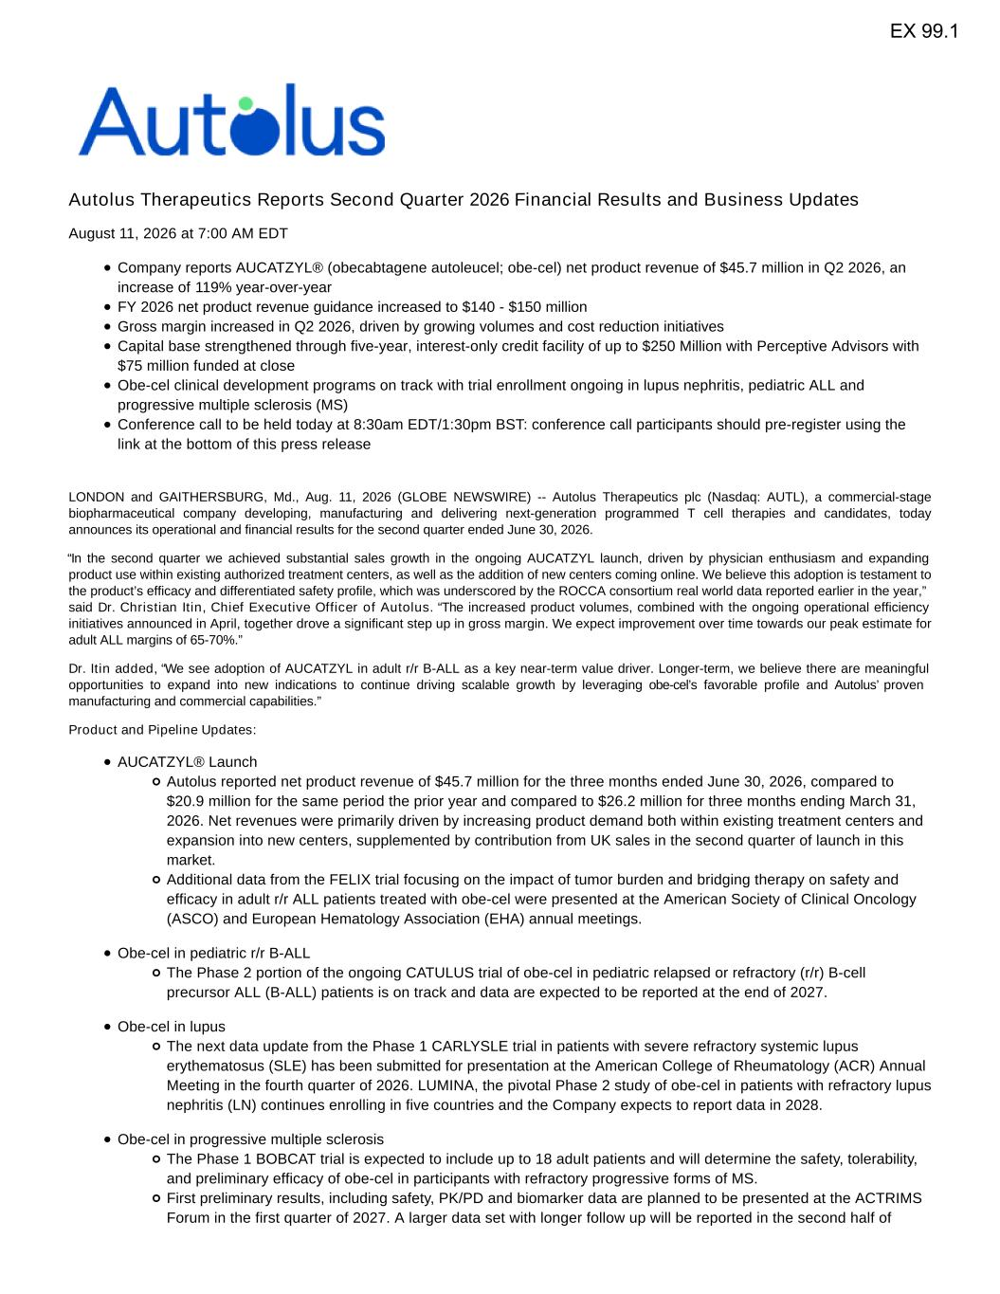

Autolus Therapeutics Reports Second Quarter 2026 Financial Results and Business Updates August 11, 2026 at 7:00 AM EDT Company reports AUCATZYL® (obecabtagene autoleucel; obe-cel) net product revenue of $45.7 million in Q2 2026, an increase of 119% year-over-year FY 2026 net product revenue guidance increased to $140 - $150 million Gross margin increased in Q2 2026, driven by growing volumes and cost reduction initiatives Capital base strengthened through five-year, interest-only credit facility of up to $250 Million with Perceptive Advisors with $75 million funded at close Obe-cel clinical development programs on track with trial enrollment ongoing in lupus nephritis, pediatric ALL and progressive multiple sclerosis (MS) Conference call to be held today at 8:30am EDT/1:30pm BST: conference call participants should pre-register using the link at the bottom of this press release LONDON and GAITHERSBURG, Md., Aug. 11, 2026 (GLOBE NEWSWIRE) -- Autolus Therapeutics plc (Nasdaq: AUTL), a commercial-stage biopharmaceutical company developing, manufacturing and delivering next-generation programmed T cell therapies and candidates, today announces its operational and financial results for the second quarter ended June 30, 2026. “In the second quarter we achieved substantial sales growth in the ongoing AUCATZYL launch, driven by physician enthusiasm and expanding product use within existing authorized treatment centers, as well as the addition of new centers coming online. We believe this adoption is testament to the product’s efficacy and differentiated safety profile, which was underscored by the ROCCA consortium real world data reported earlier in the year,” said Dr. Christian Itin, Chief Executive Officer of Autolus. “The increased product volumes, combined with the ongoing operational efficiency initiatives announced in April, together drove a significant step up in gross margin. We expect improvement over time towards our peak estimate for adult ALL margins of 65-70%.” Dr. Itin added, “We see adoption of AUCATZYL in adult r/r B-ALL as a key near-term value driver. Longer-term, we believe there are meaningful opportunities to expand into new indications to continue driving scalable growth by leveraging obe-cel’s favorable profile and Autolus’ proven manufacturing and commercial capabilities.” Product and Pipeline Updates: AUCATZYL® Launch Autolus reported net product revenue of $45.7 million for the three months ended June 30, 2026, compared to $20.9 million for the same period the prior year and compared to $26.2 million for three months ending March 31, 2026. Net revenues were primarily driven by increasing product demand both within existing treatment centers and expansion into new centers, supplemented by contribution from UK sales in the second quarter of launch in this market. Additional data from the FELIX trial focusing on the impact of tumor burden and bridging therapy on safety and efficacy in adult r/r ALL patients treated with obe-cel were presented at the American Society of Clinical Oncology (ASCO) and European Hematology Association (EHA) annual meetings. Obe-cel in pediatric r/r B-ALL The Phase 2 portion of the ongoing CATULUS trial of obe-cel in pediatric relapsed or refractory (r/r) B-cell precursor ALL (B-ALL) patients is on track and data are expected to be reported at the end of 2027. Obe-cel in lupus The next data update from the Phase 1 CARLYSLE trial in patients with severe refractory systemic lupus erythematosus (SLE) has been submitted for presentation at the American College of Rheumatology (ACR) Annual Meeting in the fourth quarter of 2026. LUMINA, the pivotal Phase 2 study of obe-cel in patients with refractory lupus nephritis (LN) continues enrolling in five countries and the Company expects to report data in 2028. Obe-cel in progressive multiple sclerosis The Phase 1 BOBCAT trial is expected to include up to 18 adult patients and will determine the safety, tolerability, and preliminary efficacy of obe-cel in participants with refractory progressive forms of MS. First preliminary results, including safety, PK/PD and biomarker data are planned to be presented at the ACTRIMS Forum in the first quarter of 2027. A larger data set with longer follow up will be reported in the second half of EX 99.1

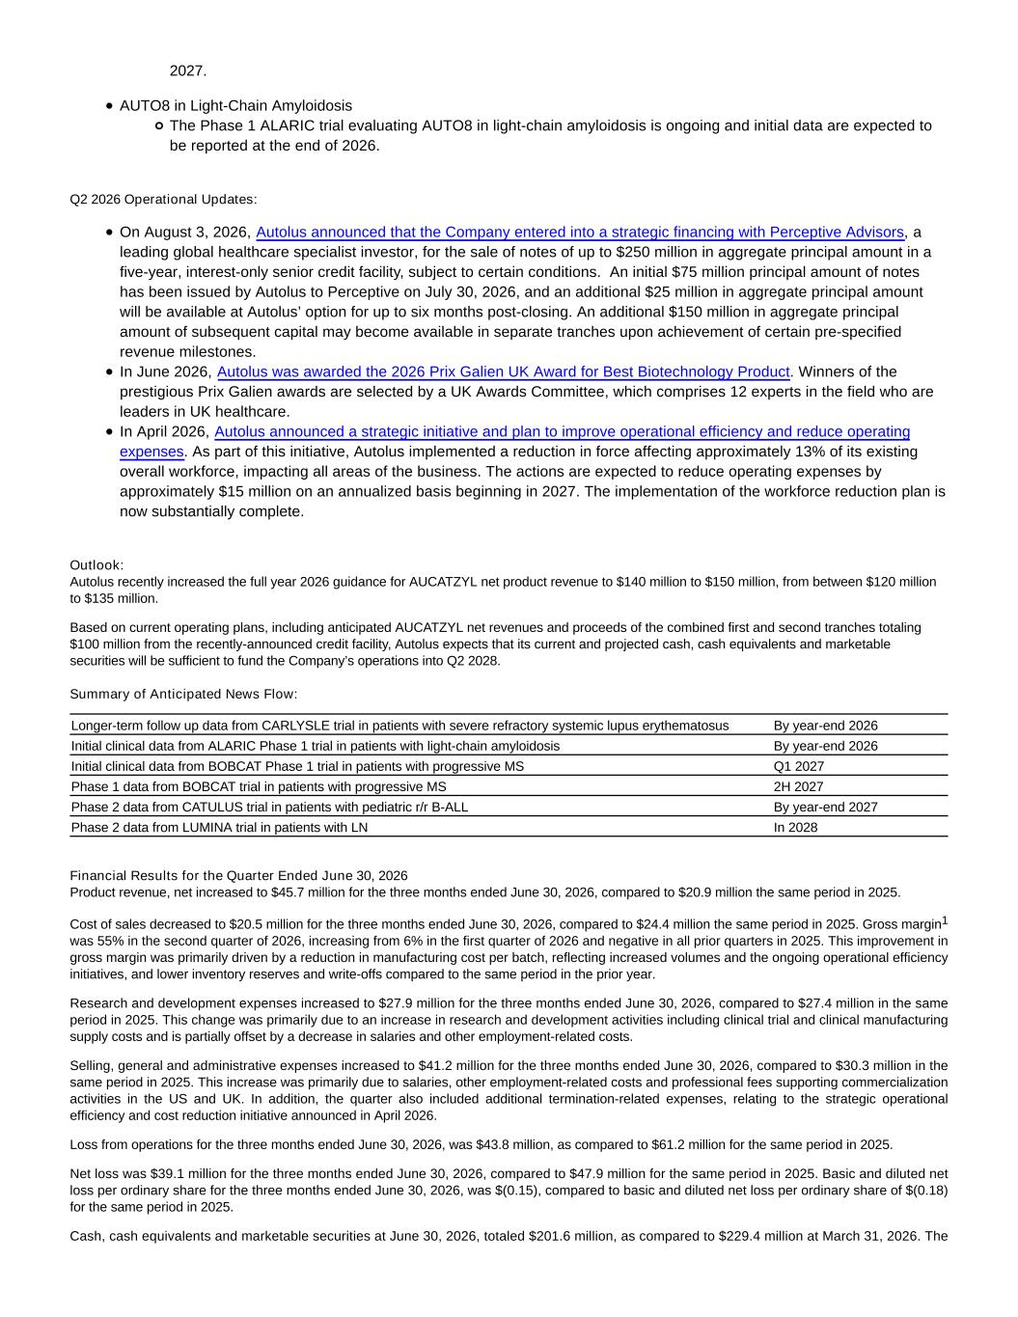
2027. AUTO8 in Light-Chain Amyloidosis The Phase 1 ALARIC trial evaluating AUTO8 in light-chain amyloidosis is ongoing and initial data are expected to be reported at the end of 2026. Q2 2026 Operational Updates: On August 3, 2026, Autolus announced that the Company entered into a strategic financing with Perceptive Advisors, a leading global healthcare specialist investor, for the sale of notes of up to $250 million in aggregate principal amount in a five-year, interest-only senior credit facility, subject to certain conditions. An initial $75 million principal amount of notes has been issued by Autolus to Perceptive on July 30, 2026, and an additional $25 million in aggregate principal amount will be available at Autolus’ option for up to six months post-closing. An additional $150 million in aggregate principal amount of subsequent capital may become available in separate tranches upon achievement of certain pre-specified revenue milestones. In June 2026, Autolus was awarded the 2026 Prix Galien UK Award for Best Biotechnology Product. Winners of the prestigious Prix Galien awards are selected by a UK Awards Committee, which comprises 12 experts in the field who are leaders in UK healthcare. In April 2026, Autolus announced a strategic initiative and plan to improve operational efficiency and reduce operating expenses. As part of this initiative, Autolus implemented a reduction in force affecting approximately 13% of its existing overall workforce, impacting all areas of the business. The actions are expected to reduce operating expenses by approximately $15 million on an annualized basis beginning in 2027. The implementation of the workforce reduction plan is now substantially complete. Outlook: Autolus recently increased the full year 2026 guidance for AUCATZYL net product revenue to $140 million to $150 million, from between $120 million to $135 million. Based on current operating plans, including anticipated AUCATZYL net revenues and proceeds of the combined first and second tranches totaling $100 million from the recently-announced credit facility, Autolus expects that its current and projected cash, cash equivalents and marketable securities will be sufficient to fund the Company’s operations into Q2 2028. Summary of Anticipated News Flow: Longer-term follow up data from CARLYSLE trial in patients with severe refractory systemic lupus erythematosus By year-end 2026 Initial clinical data from ALARIC Phase 1 trial in patients with light-chain amyloidosis By year-end 2026 Initial clinical data from BOBCAT Phase 1 trial in patients with progressive MS Q1 2027 Phase 1 data from BOBCAT trial in patients with progressive MS 2H 2027 Phase 2 data from CATULUS trial in patients with pediatric r/r B-ALL By year-end 2027 Phase 2 data from LUMINA trial in patients with LN In 2028 Financial Results for the Quarter Ended June 30, 2026 Product revenue, net increased to $45.7 million for the three months ended June 30, 2026, compared to $20.9 million the same period in 2025. Cost of sales decreased to $20.5 million for the three months ended June 30, 2026, compared to $24.4 million the same period in 2025. Gross margin1 was 55% in the second quarter of 2026, increasing from 6% in the first quarter of 2026 and negative in all prior quarters in 2025. This improvement in gross margin was primarily driven by a reduction in manufacturing cost per batch, reflecting increased volumes and the ongoing operational efficiency initiatives, and lower inventory reserves and write-offs compared to the same period in the prior year. Research and development expenses increased to $27.9 million for the three months ended June 30, 2026, compared to $27.4 million in the same period in 2025. This change was primarily due to an increase in research and development activities including clinical trial and clinical manufacturing supply costs and is partially offset by a decrease in salaries and other employment-related costs. Selling, general and administrative expenses increased to $41.2 million for the three months ended June 30, 2026, compared to $30.3 million in the same period in 2025. This increase was primarily due to salaries, other employment-related costs and professional fees supporting commercialization activities in the US and UK. In addition, the quarter also included additional termination-related expenses, relating to the strategic operational efficiency and cost reduction initiative announced in April 2026. Loss from operations for the three months ended June 30, 2026, was $43.8 million, as compared to $61.2 million for the same period in 2025. Net loss was $39.1 million for the three months ended June 30, 2026, compared to $47.9 million for the same period in 2025. Basic and diluted net loss per ordinary share for the three months ended June 30, 2026, was $(0.15), compared to basic and diluted net loss per ordinary share of $(0.18) for the same period in 2025. Cash, cash equivalents and marketable securities at June 30, 2026, totaled $201.6 million, as compared to $229.4 million at March 31, 2026. The

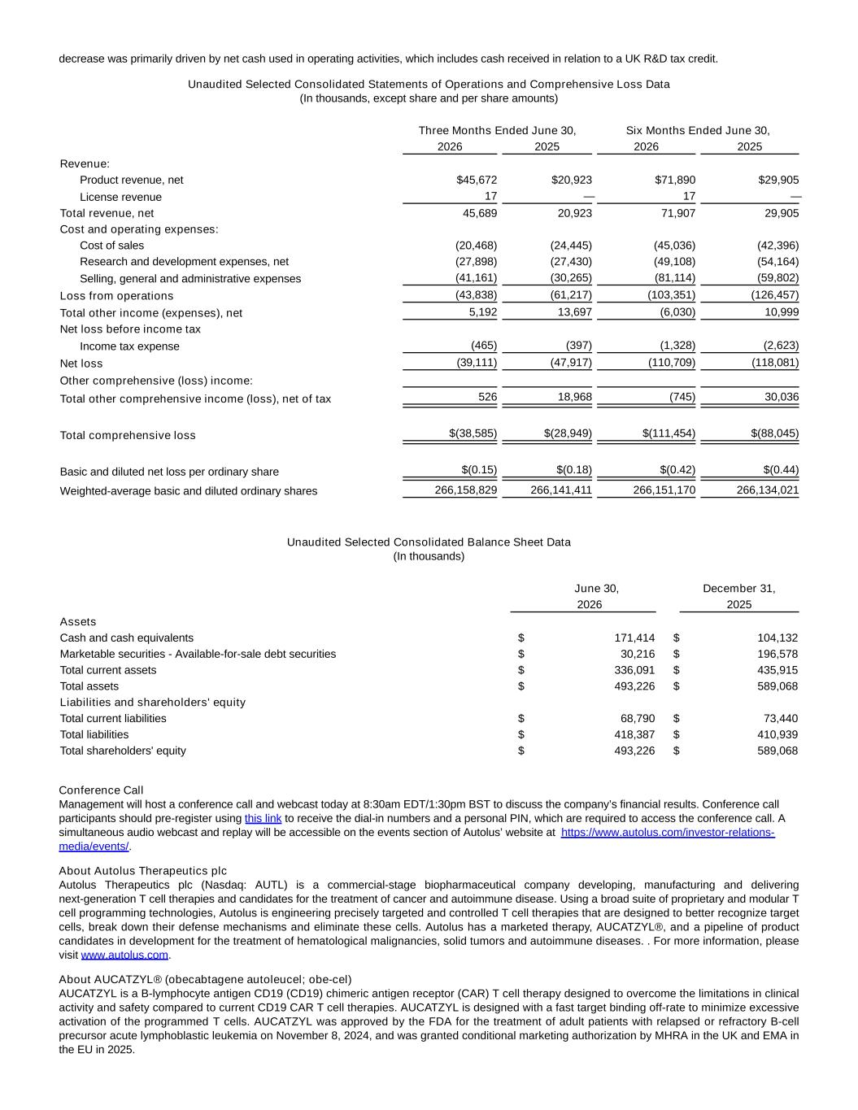
decrease was primarily driven by net cash used in operating activities, which includes cash received in relation to a UK R&D tax credit. Unaudited Selected Consolidated Statements of Operations and Comprehensive Loss Data (In thousands, except share and per share amounts) Three Months Ended June 30, Six Months Ended June 30, 2026 2025 2026 2025 Revenue: Product revenue, net $45,672 $20,923 $71,890 $29,905 License revenue 17 — 17 — Total revenue, net 45,689 20,923 71,907 29,905 Cost and operating expenses: Cost of sales (20,468) (24,445) (45,036) (42,396) Research and development expenses, net (27,898) (27,430) (49,108) (54,164) Selling, general and administrative expenses (41,161) (30,265) (81,114) (59,802) Loss from operations (43,838) (61,217) (103,351) (126,457) Total other income (expenses), net 5,192 13,697 (6,030) 10,999 Net loss before income tax Income tax expense (465) (397) (1,328) (2,623) Net loss (39,111) (47,917) (110,709) (118,081) Other comprehensive (loss) income: Total other comprehensive income (loss), net of tax 526 18,968 (745) 30,036 Total comprehensive loss $(38,585) $(28,949) $(111,454) $(88,045) Basic and diluted net loss per ordinary share $(0.15) $(0.18) $(0.42) $(0.44) Weighted-average basic and diluted ordinary shares 266,158,829 266,141,411 266,151,170 266,134,021 Unaudited Selected Consolidated Balance Sheet Data (In thousands) June 30, December 31, 2026 2025 Assets Cash and cash equivalents $ 171,414 $ 104,132 Marketable securities - Available-for-sale debt securities $ 30,216 $ 196,578 Total current assets $ 336,091 $ 435,915 Total assets $ 493,226 $ 589,068 Liabilities and shareholders' equity Total current liabilities $ 68,790 $ 73,440 Total liabilities $ 418,387 $ 410,939 Total shareholders' equity $ 493,226 $ 589,068 Conference Call Management will host a conference call and webcast today at 8:30am EDT/1:30pm BST to discuss the company’s financial results. Conference call participants should pre-register using this link to receive the dial-in numbers and a personal PIN, which are required to access the conference call. A simultaneous audio webcast and replay will be accessible on the events section of Autolus’ website at https://www.autolus.com/investor-relations- media/events/. About Autolus Therapeutics plc Autolus Therapeutics plc (Nasdaq: AUTL) is a commercial-stage biopharmaceutical company developing, manufacturing and delivering next-generation T cell therapies and candidates for the treatment of cancer and autoimmune disease. Using a broad suite of proprietary and modular T cell programming technologies, Autolus is engineering precisely targeted and controlled T cell therapies that are designed to better recognize target cells, break down their defense mechanisms and eliminate these cells. Autolus has a marketed therapy, AUCATZYL®, and a pipeline of product candidates in development for the treatment of hematological malignancies, solid tumors and autoimmune diseases. . For more information, please visit www.autolus.com. About AUCATZYL® (obecabtagene autoleucel; obe-cel) AUCATZYL is a B-lymphocyte antigen CD19 (CD19) chimeric antigen receptor (CAR) T cell therapy designed to overcome the limitations in clinical activity and safety compared to current CD19 CAR T cell therapies. AUCATZYL is designed with a fast target binding off-rate to minimize excessive activation of the programmed T cells. AUCATZYL was approved by the FDA for the treatment of adult patients with relapsed or refractory B-cell precursor acute lymphoblastic leukemia on November 8, 2024, and was granted conditional marketing authorization by MHRA in the UK and EMA in the EU in 2025.

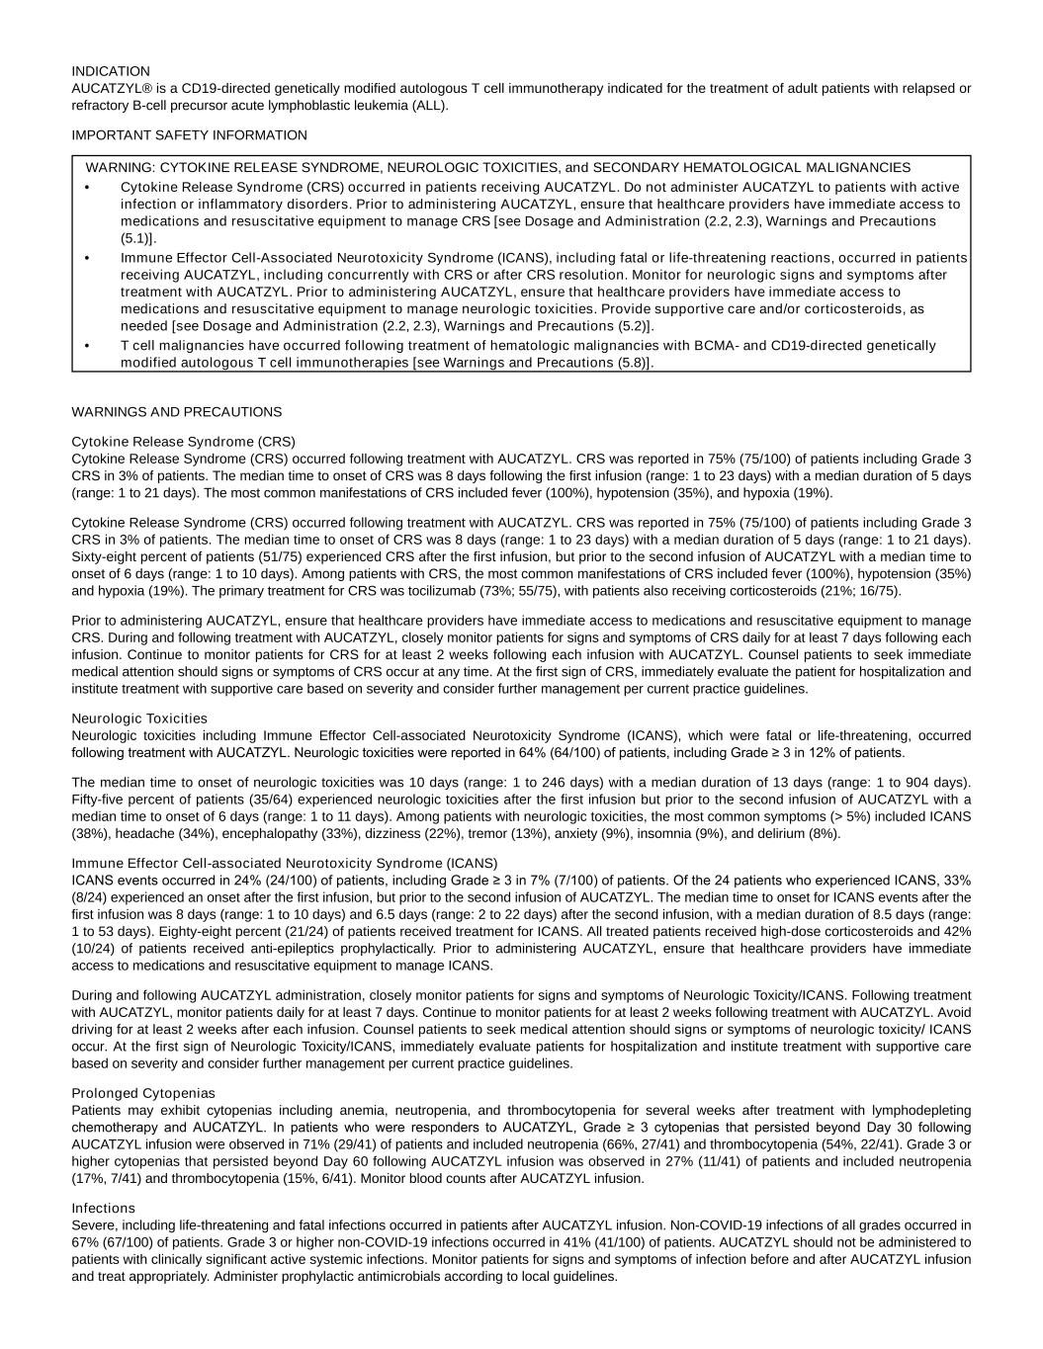
INDICATION AUCATZYL® is a CD19-directed genetically modified autologous T cell immunotherapy indicated for the treatment of adult patients with relapsed or refractory B-cell precursor acute lymphoblastic leukemia (ALL). IMPORTANT SAFETY INFORMATION WARNING: CYTOKINE RELEASE SYNDROME, NEUROLOGIC TOXICITIES, and SECONDARY HEMATOLOGICAL MALIGNANCIES • Cytokine Release Syndrome (CRS) occurred in patients receiving AUCATZYL. Do not administer AUCATZYL to patients with active infection or inflammatory disorders. Prior to administering AUCATZYL, ensure that healthcare providers have immediate access to medications and resuscitative equipment to manage CRS [see Dosage and Administration (2.2, 2.3), Warnings and Precautions (5.1)]. • Immune Effector Cell-Associated Neurotoxicity Syndrome (ICANS), including fatal or life-threatening reactions, occurred in patients receiving AUCATZYL, including concurrently with CRS or after CRS resolution. Monitor for neurologic signs and symptoms after treatment with AUCATZYL. Prior to administering AUCATZYL, ensure that healthcare providers have immediate access to medications and resuscitative equipment to manage neurologic toxicities. Provide supportive care and/or corticosteroids, as needed [see Dosage and Administration (2.2, 2.3), Warnings and Precautions (5.2)]. • T cell malignancies have occurred following treatment of hematologic malignancies with BCMA- and CD19-directed genetically modified autologous T cell immunotherapies [see Warnings and Precautions (5.8)]. WARNINGS AND PRECAUTIONS Cytokine Release Syndrome (CRS) Cytokine Release Syndrome (CRS) occurred following treatment with AUCATZYL. CRS was reported in 75% (75/100) of patients including Grade 3 CRS in 3% of patients. The median time to onset of CRS was 8 days following the first infusion (range: 1 to 23 days) with a median duration of 5 days (range: 1 to 21 days). The most common manifestations of CRS included fever (100%), hypotension (35%), and hypoxia (19%). Cytokine Release Syndrome (CRS) occurred following treatment with AUCATZYL. CRS was reported in 75% (75/100) of patients including Grade 3 CRS in 3% of patients. The median time to onset of CRS was 8 days (range: 1 to 23 days) with a median duration of 5 days (range: 1 to 21 days). Sixty-eight percent of patients (51/75) experienced CRS after the first infusion, but prior to the second infusion of AUCATZYL with a median time to onset of 6 days (range: 1 to 10 days). Among patients with CRS, the most common manifestations of CRS included fever (100%), hypotension (35%) and hypoxia (19%). The primary treatment for CRS was tocilizumab (73%; 55/75), with patients also receiving corticosteroids (21%; 16/75). Prior to administering AUCATZYL, ensure that healthcare providers have immediate access to medications and resuscitative equipment to manage CRS. During and following treatment with AUCATZYL, closely monitor patients for signs and symptoms of CRS daily for at least 7 days following each infusion. Continue to monitor patients for CRS for at least 2 weeks following each infusion with AUCATZYL. Counsel patients to seek immediate medical attention should signs or symptoms of CRS occur at any time. At the first sign of CRS, immediately evaluate the patient for hospitalization and institute treatment with supportive care based on severity and consider further management per current practice guidelines. Neurologic Toxicities Neurologic toxicities including Immune Effector Cell-associated Neurotoxicity Syndrome (ICANS), which were fatal or life-threatening, occurred following treatment with AUCATZYL. Neurologic toxicities were reported in 64% (64/100) of patients, including Grade ≥ 3 in 12% of patients. The median time to onset of neurologic toxicities was 10 days (range: 1 to 246 days) with a median duration of 13 days (range: 1 to 904 days). Fifty-five percent of patients (35/64) experienced neurologic toxicities after the first infusion but prior to the second infusion of AUCATZYL with a median time to onset of 6 days (range: 1 to 11 days). Among patients with neurologic toxicities, the most common symptoms (> 5%) included ICANS (38%), headache (34%), encephalopathy (33%), dizziness (22%), tremor (13%), anxiety (9%), insomnia (9%), and delirium (8%). Immune Effector Cell-associated Neurotoxicity Syndrome (ICANS) ICANS events occurred in 24% (24/100) of patients, including Grade ≥ 3 in 7% (7/100) of patients. Of the 24 patients who experienced ICANS, 33% (8/24) experienced an onset after the first infusion, but prior to the second infusion of AUCATZYL. The median time to onset for ICANS events after the first infusion was 8 days (range: 1 to 10 days) and 6.5 days (range: 2 to 22 days) after the second infusion, with a median duration of 8.5 days (range: 1 to 53 days). Eighty-eight percent (21/24) of patients received treatment for ICANS. All treated patients received high-dose corticosteroids and 42% (10/24) of patients received anti-epileptics prophylactically. Prior to administering AUCATZYL, ensure that healthcare providers have immediate access to medications and resuscitative equipment to manage ICANS. During and following AUCATZYL administration, closely monitor patients for signs and symptoms of Neurologic Toxicity/ICANS. Following treatment with AUCATZYL, monitor patients daily for at least 7 days. Continue to monitor patients for at least 2 weeks following treatment with AUCATZYL. Avoid driving for at least 2 weeks after each infusion. Counsel patients to seek medical attention should signs or symptoms of neurologic toxicity/ ICANS occur. At the first sign of Neurologic Toxicity/ICANS, immediately evaluate patients for hospitalization and institute treatment with supportive care based on severity and consider further management per current practice guidelines. Prolonged Cytopenias Patients may exhibit cytopenias including anemia, neutropenia, and thrombocytopenia for several weeks after treatment with lymphodepleting chemotherapy and AUCATZYL. In patients who were responders to AUCATZYL, Grade ≥ 3 cytopenias that persisted beyond Day 30 following AUCATZYL infusion were observed in 71% (29/41) of patients and included neutropenia (66%, 27/41) and thrombocytopenia (54%, 22/41). Grade 3 or higher cytopenias that persisted beyond Day 60 following AUCATZYL infusion was observed in 27% (11/41) of patients and included neutropenia (17%, 7/41) and thrombocytopenia (15%, 6/41). Monitor blood counts after AUCATZYL infusion. Infections Severe, including life-threatening and fatal infections occurred in patients after AUCATZYL infusion. Non-COVID-19 infections of all grades occurred in 67% (67/100) of patients. Grade 3 or higher non-COVID-19 infections occurred in 41% (41/100) of patients. AUCATZYL should not be administered to patients with clinically significant active systemic infections. Monitor patients for signs and symptoms of infection before and after AUCATZYL infusion and treat appropriately. Administer prophylactic antimicrobials according to local guidelines.

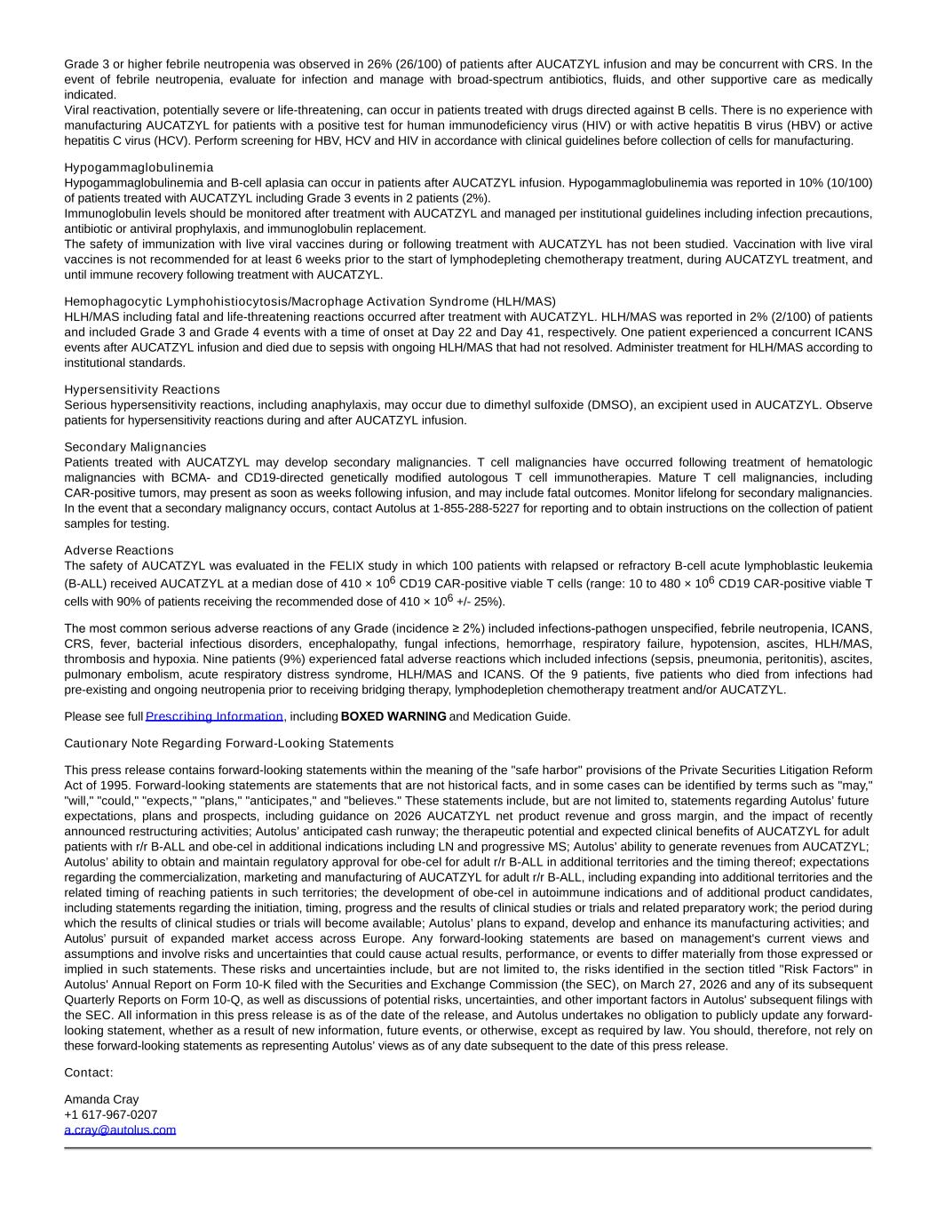
Grade 3 or higher febrile neutropenia was observed in 26% (26/100) of patients after AUCATZYL infusion and may be concurrent with CRS. In the event of febrile neutropenia, evaluate for infection and manage with broad-spectrum antibiotics, fluids, and other supportive care as medically indicated. Viral reactivation, potentially severe or life-threatening, can occur in patients treated with drugs directed against B cells. There is no experience with manufacturing AUCATZYL for patients with a positive test for human immunodeficiency virus (HIV) or with active hepatitis B virus (HBV) or active hepatitis C virus (HCV). Perform screening for HBV, HCV and HIV in accordance with clinical guidelines before collection of cells for manufacturing. Hypogammaglobulinemia Hypogammaglobulinemia and B-cell aplasia can occur in patients after AUCATZYL infusion. Hypogammaglobulinemia was reported in 10% (10/100) of patients treated with AUCATZYL including Grade 3 events in 2 patients (2%). Immunoglobulin levels should be monitored after treatment with AUCATZYL and managed per institutional guidelines including infection precautions, antibiotic or antiviral prophylaxis, and immunoglobulin replacement. The safety of immunization with live viral vaccines during or following treatment with AUCATZYL has not been studied. Vaccination with live viral vaccines is not recommended for at least 6 weeks prior to the start of lymphodepleting chemotherapy treatment, during AUCATZYL treatment, and until immune recovery following treatment with AUCATZYL. Hemophagocytic Lymphohistiocytosis/Macrophage Activation Syndrome (HLH/MAS) HLH/MAS including fatal and life-threatening reactions occurred after treatment with AUCATZYL. HLH/MAS was reported in 2% (2/100) of patients and included Grade 3 and Grade 4 events with a time of onset at Day 22 and Day 41, respectively. One patient experienced a concurrent ICANS events after AUCATZYL infusion and died due to sepsis with ongoing HLH/MAS that had not resolved. Administer treatment for HLH/MAS according to institutional standards. Hypersensitivity Reactions Serious hypersensitivity reactions, including anaphylaxis, may occur due to dimethyl sulfoxide (DMSO), an excipient used in AUCATZYL. Observe patients for hypersensitivity reactions during and after AUCATZYL infusion. Secondary Malignancies Patients treated with AUCATZYL may develop secondary malignancies. T cell malignancies have occurred following treatment of hematologic malignancies with BCMA- and CD19-directed genetically modified autologous T cell immunotherapies. Mature T cell malignancies, including CAR-positive tumors, may present as soon as weeks following infusion, and may include fatal outcomes. Monitor lifelong for secondary malignancies. In the event that a secondary malignancy occurs, contact Autolus at 1-855-288-5227 for reporting and to obtain instructions on the collection of patient samples for testing. Adverse Reactions The safety of AUCATZYL was evaluated in the FELIX study in which 100 patients with relapsed or refractory B-cell acute lymphoblastic leukemia (B-ALL) received AUCATZYL at a median dose of 410 × 106 CD19 CAR-positive viable T cells (range: 10 to 480 × 106 CD19 CAR-positive viable T cells with 90% of patients receiving the recommended dose of 410 × 106 +/- 25%). The most common serious adverse reactions of any Grade (incidence ≥ 2%) included infections-pathogen unspecified, febrile neutropenia, ICANS, CRS, fever, bacterial infectious disorders, encephalopathy, fungal infections, hemorrhage, respiratory failure, hypotension, ascites, HLH/MAS, thrombosis and hypoxia. Nine patients (9%) experienced fatal adverse reactions which included infections (sepsis, pneumonia, peritonitis), ascites, pulmonary embolism, acute respiratory distress syndrome, HLH/MAS and ICANS. Of the 9 patients, five patients who died from infections had pre-existing and ongoing neutropenia prior to receiving bridging therapy, lymphodepletion chemotherapy treatment and/or AUCATZYL. Please see full Prescribing Information, including BOXED WARNING and Medication Guide. Cautionary Note Regarding Forward-Looking Statements This press release contains forward-looking statements within the meaning of the "safe harbor" provisions of the Private Securities Litigation Reform Act of 1995. Forward-looking statements are statements that are not historical facts, and in some cases can be identified by terms such as "may," "will," "could," "expects," "plans," "anticipates," and "believes." These statements include, but are not limited to, statements regarding Autolus’ future expectations, plans and prospects, including guidance on 2026 AUCATZYL net product revenue and gross margin, and the impact of recently announced restructuring activities; Autolus’ anticipated cash runway; the therapeutic potential and expected clinical benefits of AUCATZYL for adult patients with r/r B-ALL and obe-cel in additional indications including LN and progressive MS; Autolus’ ability to generate revenues from AUCATZYL; Autolus’ ability to obtain and maintain regulatory approval for obe-cel for adult r/r B-ALL in additional territories and the timing thereof; expectations regarding the commercialization, marketing and manufacturing of AUCATZYL for adult r/r B-ALL, including expanding into additional territories and the related timing of reaching patients in such territories; the development of obe-cel in autoimmune indications and of additional product candidates, including statements regarding the initiation, timing, progress and the results of clinical studies or trials and related preparatory work; the period during which the results of clinical studies or trials will become available; Autolus’ plans to expand, develop and enhance its manufacturing activities; and Autolus’ pursuit of expanded market access across Europe. Any forward-looking statements are based on management's current views and assumptions and involve risks and uncertainties that could cause actual results, performance, or events to differ materially from those expressed or implied in such statements. These risks and uncertainties include, but are not limited to, the risks identified in the section titled "Risk Factors" in Autolus' Annual Report on Form 10-K filed with the Securities and Exchange Commission (the SEC), on March 27, 2026 and any of its subsequent Quarterly Reports on Form 10-Q, as well as discussions of potential risks, uncertainties, and other important factors in Autolus' subsequent filings with the SEC. All information in this press release is as of the date of the release, and Autolus undertakes no obligation to publicly update any forward- looking statement, whether as a result of new information, future events, or otherwise, except as required by law. You should, therefore, not rely on these forward-looking statements as representing Autolus’ views as of any date subsequent to the date of this press release. Contact: Amanda Cray +1 617-967-0207 a.cray@autolus.com


1 Gross margin percentage represents gross margin (net product revenue less cost of sales) divided by net product revenue

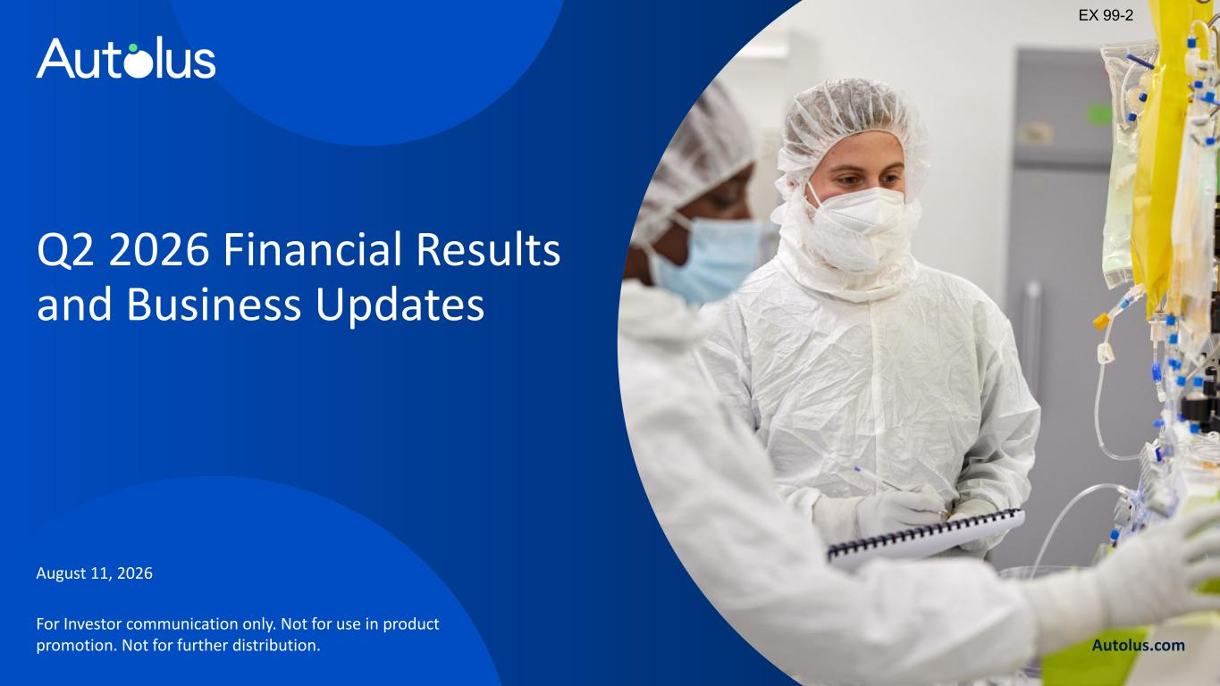
Q2 2026 Financial Results and Business Updates August 11, 2026 Autolus.com For Investor communication only. Not for use in product promotion. Not for further distribution. EX 99-2

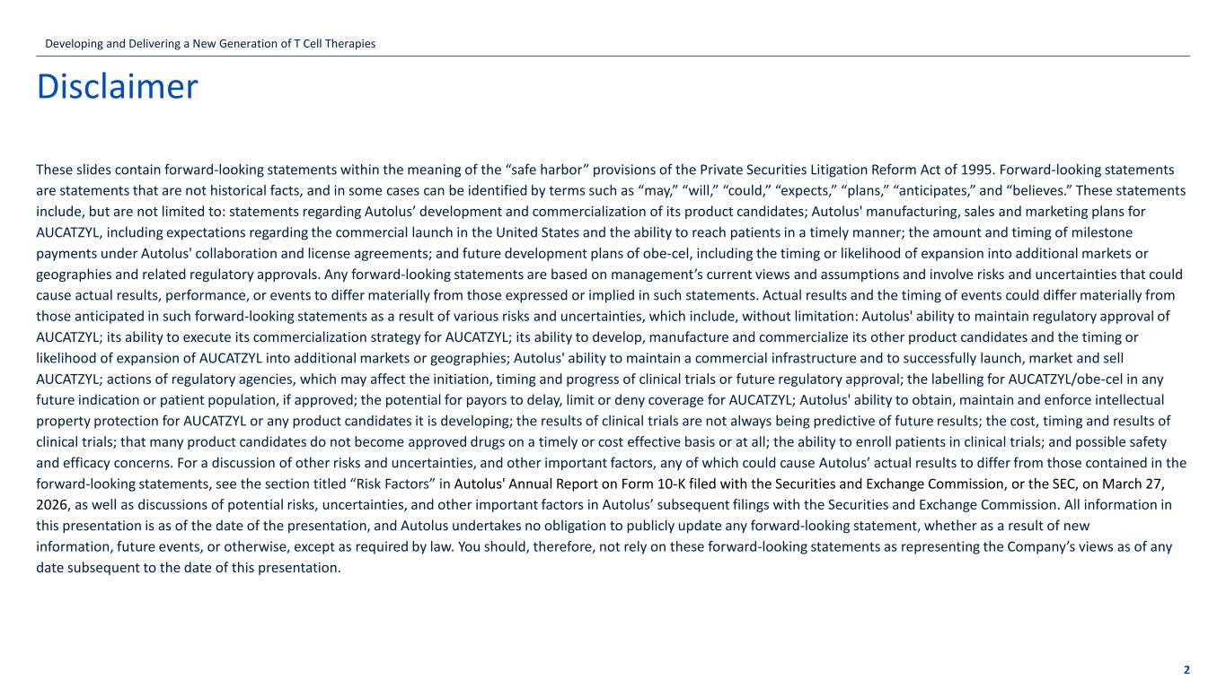
Disclaimer These slides contain forward-looking statements within the meaning of the “safe harbor” provisions of the Private Securities Litigation Reform Act of 1995. Forward-looking statements are statements that are not historical facts, and in some cases can be identified by terms such as “may,” “will,” “could,” “expects,” “plans,” “anticipates,” and “believes.” These statements include, but are not limited to: statements regarding Autolus’ development and commercialization of its product candidates; Autolus' manufacturing, sales and marketing plans for AUCATZYL, including expectations regarding the commercial launch in the United States and the ability to reach patients in a timely manner; the amount and timing of milestone payments under Autolus' collaboration and license agreements; and future development plans of obe-cel, including the timing or likelihood of expansion into additional markets or geographies and related regulatory approvals. Any forward-looking statements are based on management’s current views and assumptions and involve risks and uncertainties that could cause actual results, performance, or events to differ materially from those expressed or implied in such statements. Actual results and the timing of events could differ materially from those anticipated in such forward-looking statements as a result of various risks and uncertainties, which include, without limitation: Autolus' ability to maintain regulatory approval of AUCATZYL; its ability to execute its commercialization strategy for AUCATZYL; its ability to develop, manufacture and commercialize its other product candidates and the timing or likelihood of expansion of AUCATZYL into additional markets or geographies; Autolus' ability to maintain a commercial infrastructure and to successfully launch, market and sell AUCATZYL; actions of regulatory agencies, which may affect the initiation, timing and progress of clinical trials or future regulatory approval; the labelling for AUCATZYL/obe-cel in any future indication or patient population, if approved; the potential for payors to delay, limit or deny coverage for AUCATZYL; Autolus' ability to obtain, maintain and enforce intellectual property protection for AUCATZYL or any product candidates it is developing; the results of clinical trials are not always being predictive of future results; the cost, timing and results of clinical trials; that many product candidates do not become approved drugs on a timely or cost effective basis or at all; the ability to enroll patients in clinical trials; and possible safety and efficacy concerns. For a discussion of other risks and uncertainties, and other important factors, any of which could cause Autolus’ actual results to differ from those contained in the forward-looking statements, see the section titled “Risk Factors” in Autolus' Annual Report on Form 10-K filed with the Securities and Exchange Commission, or the SEC, on March 27, 2026, as well as discussions of potential risks, uncertainties, and other important factors in Autolus’ subsequent filings with the Securities and Exchange Commission. All information in this presentation is as of the date of the presentation, and Autolus undertakes no obligation to publicly update any forward-looking statement, whether as a result of new information, future events, or otherwise, except as required by law. You should, therefore, not rely on these forward-looking statements as representing the Company’s views as of any date subsequent to the date of this presentation. 2 Developing and Delivering a New Generation of T Cell Therapies

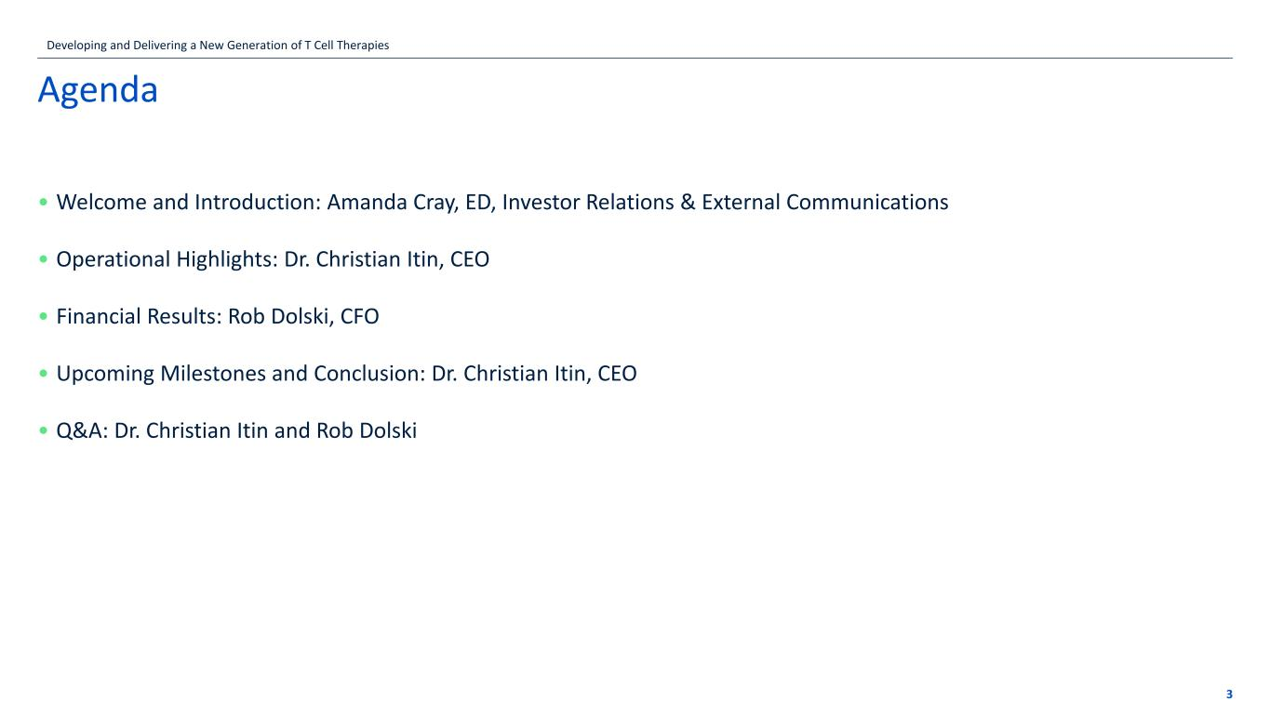
Agenda 3 • Welcome and Introduction: Amanda Cray, ED, Investor Relations & External Communications • Operational Highlights: Dr. Christian Itin, CEO • Financial Results: Rob Dolski, CFO • Upcoming Milestones and Conclusion: Dr. Christian Itin, CEO • Q&A: Dr. Christian Itin and Rob Dolski Developing and Delivering a New Generation of T Cell Therapies

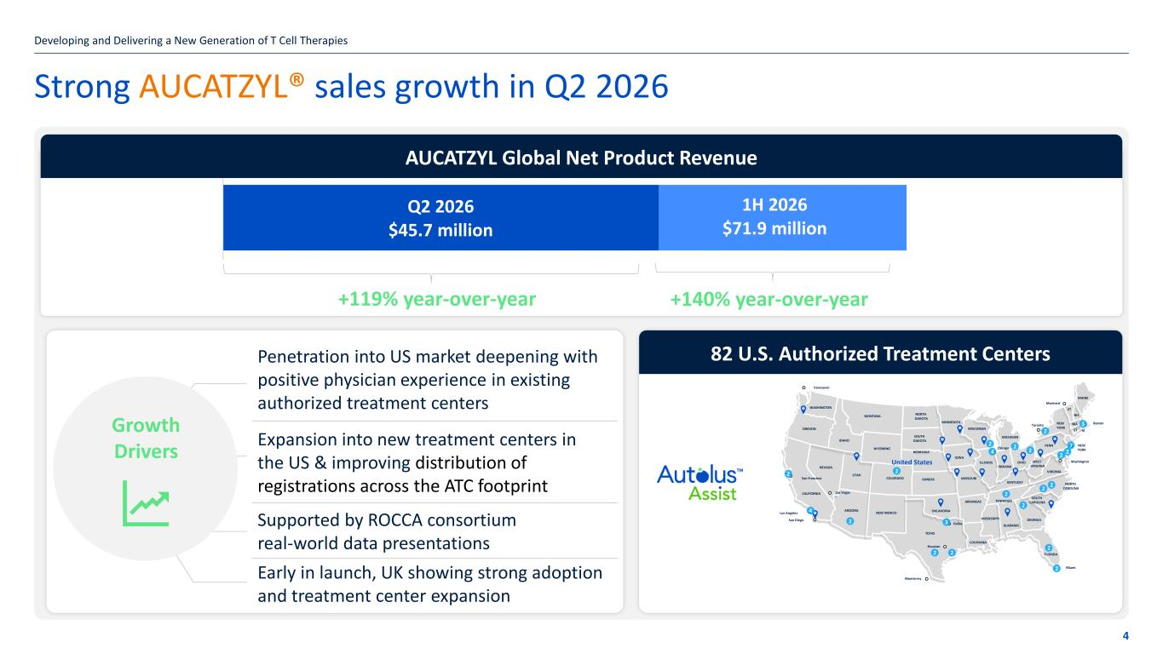
Strong AUCATZYL® sales growth in Q2 2026 Developing and Delivering a New Generation of T Cell Therapies 4 +119% year-over-year +140% year-over-year 82 U.S. Authorized Treatment Centers Q2 2026 $45.7 million 1H 2026 $71.9 million Penetration into US market deepening with positive physician experience in existing authorized treatment centers Expansion into new treatment centers in the US & improving distribution of registrations across the ATC footprint Supported by ROCCA consortium real-world data presentations Early in launch, UK showing strong adoption and treatment center expansion Growth Drivers AUCATZYL Global Net Product Revenue WASHINGTON OREGON CALIFORNIA NEVADA IDAHO MONTANA ARIZONA UTAH WYOMING COLORADO NEW MEXICO TEXAS NORTH DAKOTA SOUTH DAKOTA NEBRASKA KANSAS OKLAHOMA MINNESOTA IOWA MISSOURI ARKANSAS LOUISIANA WISCONSIN ILLINOIS MISSISSIPPI MICHIGAN OHIO INDIANA KENTUCKY TENNESSEE ALABAMA GEORGIA FLORIDA WEST VIRGINIA VIRGINIA NORTH CAROLINA SOUTH CAROLINA PENN NEW YORK VT NH MAINE MA CT RI NEW YORK Washington Vancouver San Francisco Las Vegas Monterrey Houston Dallas Chicago Miami Toronto Montreal Boston Los Angeles San Diego United States 4 2 2 3 2 2 2 2 2 2 2 2 2 4 2 2 2 2 2 7 3 2

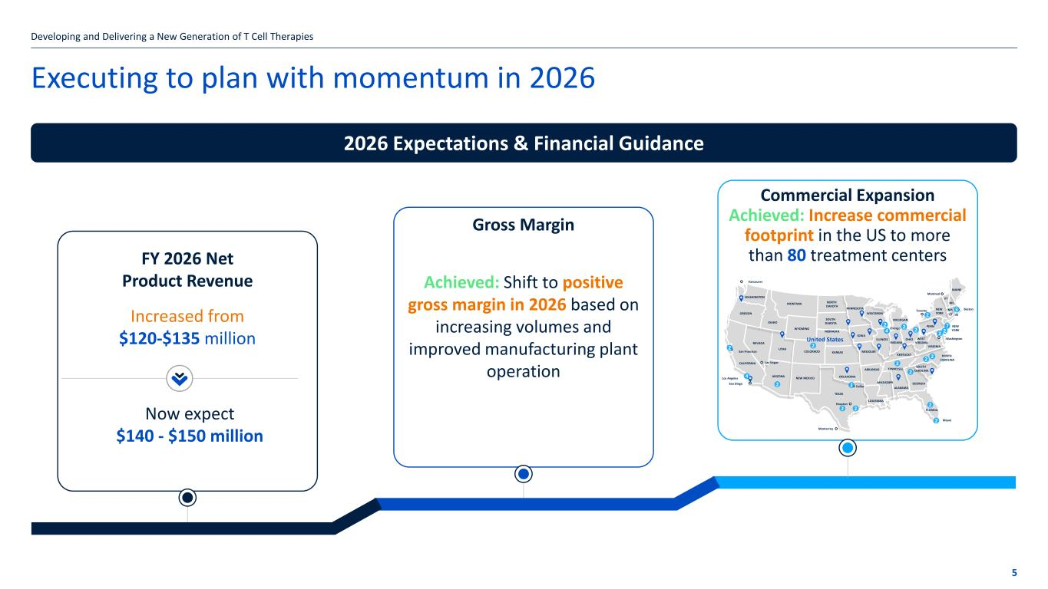
Executing to plan with momentum in 2026 Developing and Delivering a New Generation of T Cell Therapies 2026 Expectations & Financial Guidance FY 2026 Net Product Revenue Increased from $120-$135 million Gross Margin Achieved: Shift to positive gross margin in 2026 based on increasing volumes and improved manufacturing plant operation Commercial Expansion Achieved: Increase commercial footprint in the US to more than 80 treatment centers 5 WASHINGTON OREGON CALIFORNIA NEVADA IDAHO MONTANA ARIZONA UTAH WYOMING COLORADO NEW MEXICO TEXAS NORTH DAKOTA SOUTH DAKOTA NEBRASKA KANSAS OKLAHOMA MINNESOTA IOWA MISSOURI ARKANSAS LOUISIANA WISCONSIN ILLINOIS MISSISSIPPI MICHIGAN OHIO INDIANA KENTUCKY TENNESSEE ALABAMA GEORGIA FLORIDA WEST VIRGINIA VIRGINIA NORTH CAROLINA SOUTH CAROLINA PENN NEW YORK VT NH MAINE MA CT RI NEW YORK Washington Vancouver San Francisco Las Vegas Monterrey Houston Dallas Chicago Miami Toronto Montreal Boston Los Angeles San Diego United States 4 2 2 3 2 2 2 2 2 2 2 2 2 4 2 2 2 2 2 7 3 2 Now expect $140 - $150 million

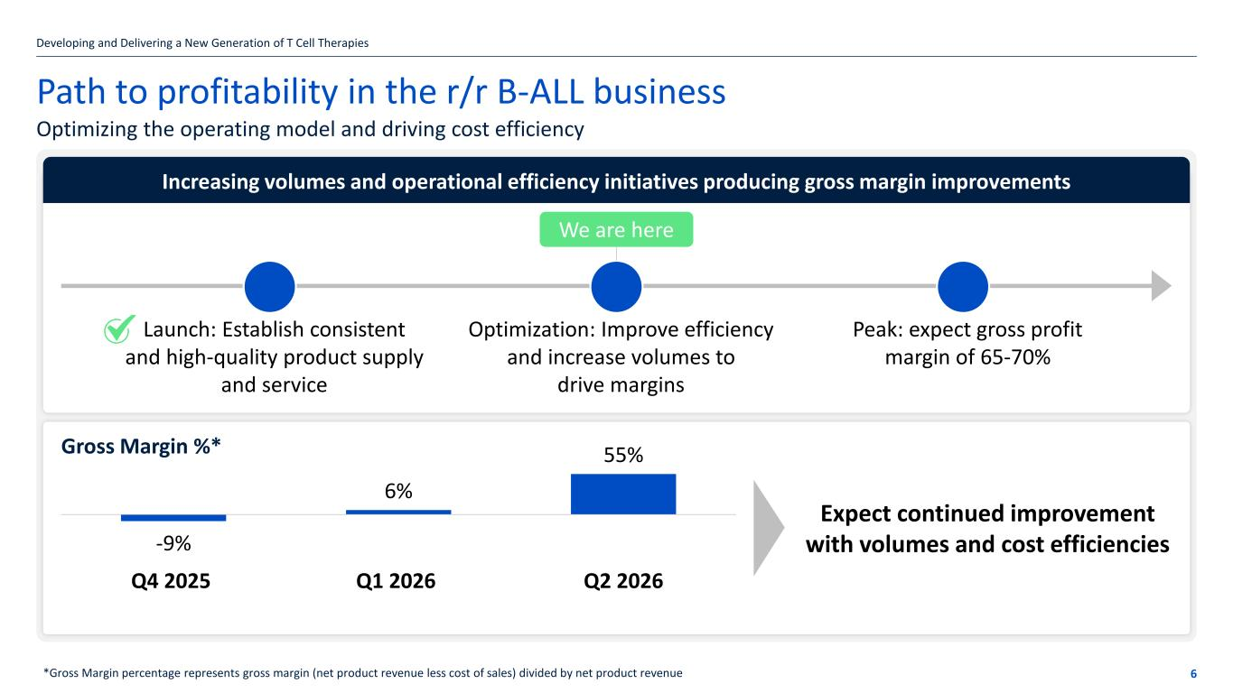
Path to profitability in the r/r B-ALL business Developing and Delivering a New Generation of T Cell Therapies 6 Optimizing the operating model and driving cost efficiency *Gross Margin percentage represents gross margin (net product revenue less cost of sales) divided by net product revenue Increasing volumes and operational efficiency initiatives producing gross margin improvements Peak: expect gross profit margin of 65-70% Optimization: Improve efficiency and increase volumes to drive margins Launch: Establish consistent and high-quality product supply and service We are here Expect continued improvement with volumes and cost efficiencies-9% 6% 55% Q4 2025 Q1 2026 Q2 2026 Gross Margin %*

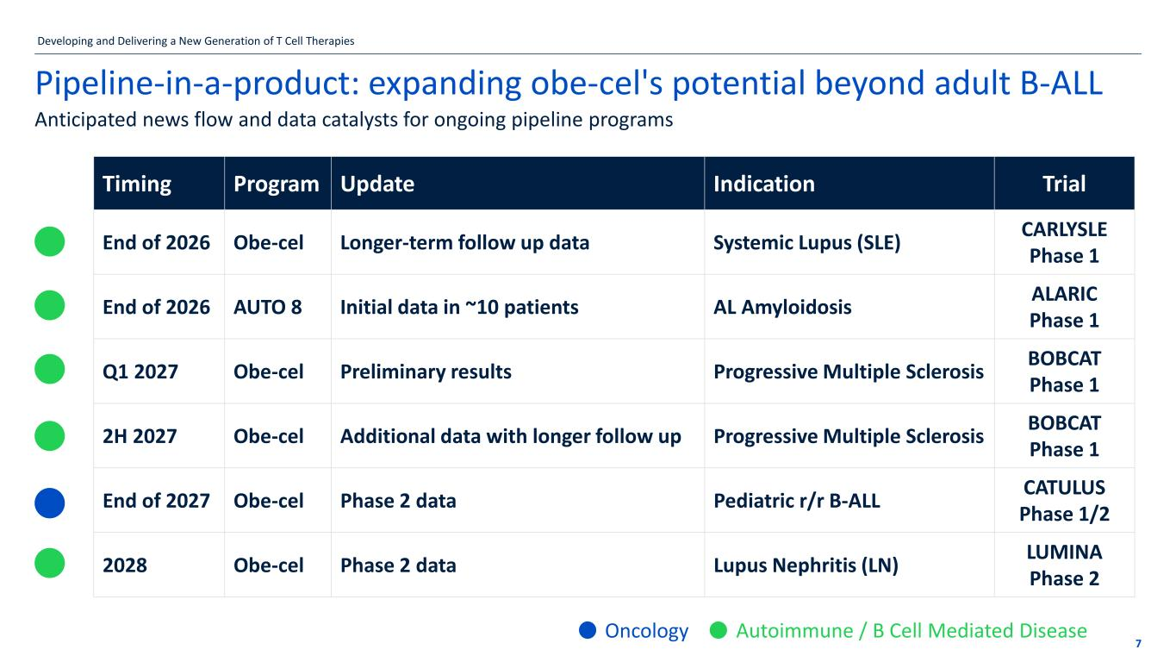
7 Pipeline-in-a-product: expanding obe-cel's potential beyond adult B-ALL Anticipated news flow and data catalysts for ongoing pipeline programs Timing Program Update Indication Trial End of 2026 Obe-cel Longer-term follow up data Systemic Lupus (SLE) CARLYSLE Phase 1 End of 2026 AUTO 8 Initial data in ~10 patients AL Amyloidosis ALARIC Phase 1 Q1 2027 Obe-cel Preliminary results Progressive Multiple Sclerosis BOBCAT Phase 1 2H 2027 Obe-cel Additional data with longer follow up Progressive Multiple Sclerosis BOBCAT Phase 1 End of 2027 Obe-cel Phase 2 data Pediatric r/r B-ALL CATULUS Phase 1/2 2028 Obe-cel Phase 2 data Lupus Nephritis (LN) LUMINA Phase 2 Oncology Autoimmune / B Cell Mediated Disease Developing and Delivering a New Generation of T Cell Therapies

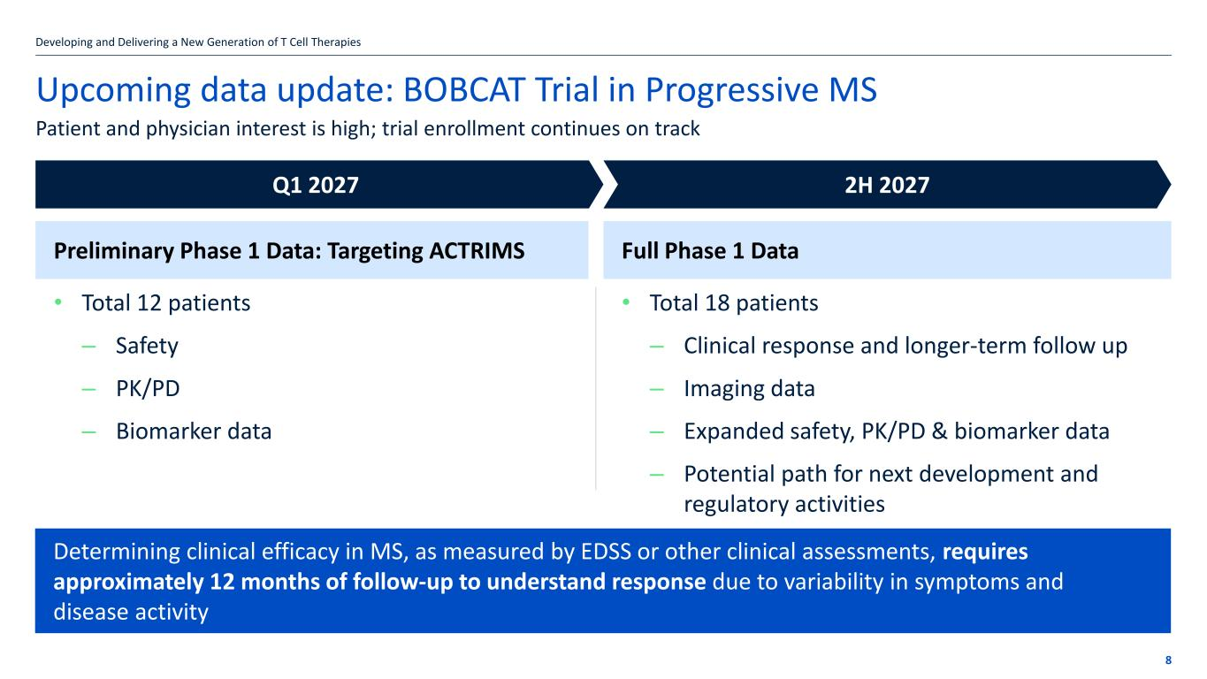
Upcoming data update: BOBCAT Trial in Progressive MS 8 Patient and physician interest is high; trial enrollment continues on track Determining clinical efficacy in MS, as measured by EDSS or other clinical assessments, requires approximately 12 months of follow-up to understand response due to variability in symptoms and disease activity Q1 2027 2H 2027 Preliminary Phase 1 Data: Targeting ACTRIMS Full Phase 1 Data • Total 12 patients ‒ Safety ‒ PK/PD ‒ Biomarker data • Total 18 patients ‒ Clinical response and longer-term follow up ‒ Imaging data ‒ Expanded safety, PK/PD & biomarker data ‒ Potential path for next development and regulatory activities Developing and Delivering a New Generation of T Cell Therapies


Financial Results

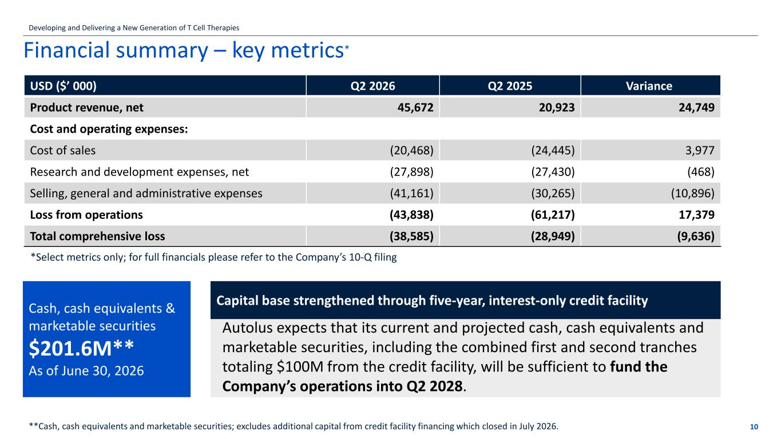
Financial summary – key metrics* 10 *Select metrics only; for full financials please refer to the Company’s 10-Q filing Autolus expects that its current and projected cash, cash equivalents and marketable securities, including the combined first and second tranches totaling $100M from the credit facility, will be sufficient to fund the Company’s operations into Q2 2028. Capital base strengthened through five-year, interest-only credit facility **Cash, cash equivalents and marketable securities; excludes additional capital from credit facility financing which closed in July 2026. Developing and Delivering a New Generation of T Cell Therapies Cash, cash equivalents & marketable securities $201.6M** As of June 30, 2026 USD ($’ 000) Q2 2026 Q2 2025 Variance Product revenue, net 45,672 20,923 24,749 Cost and operating expenses: Cost of sales (20,468) (24,445) 3,977 Research and development expenses, net (27,898) (27,430) (468) Selling, general and administrative expenses (41,161) (30,265) (10,896) Loss from operations (43,838) (61,217) 17,379 Total comprehensive loss (38,585) (28,949) (9,636)


Conclusion

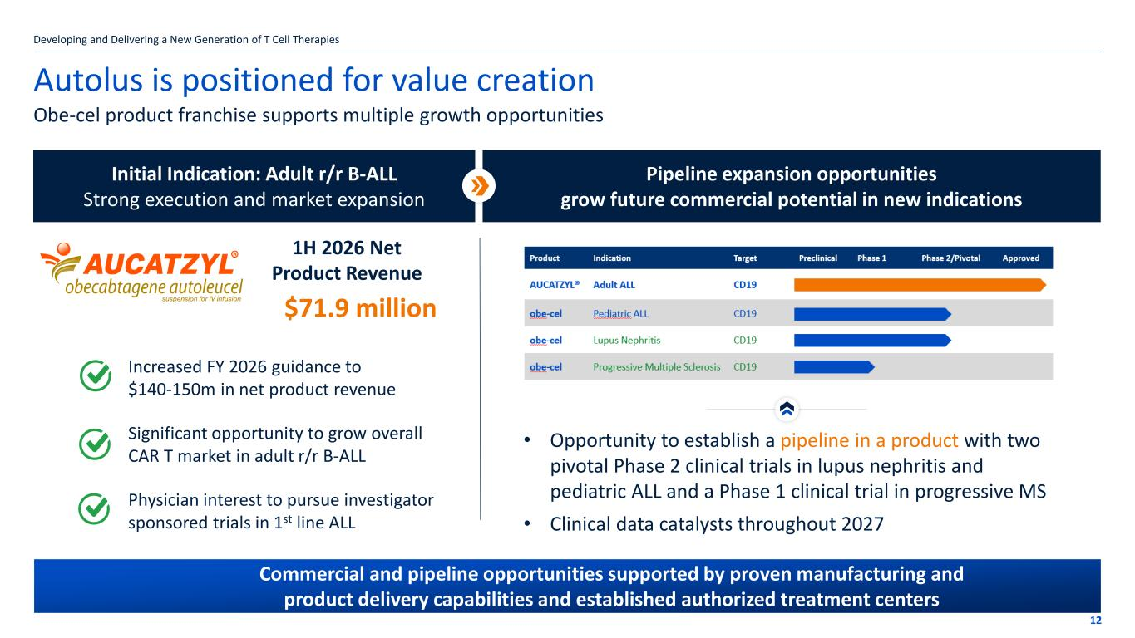
Autolus is positioned for value creation Obe-cel product franchise supports multiple growth opportunities 12 Developing and Delivering a New Generation of T Cell Therapies Initial Indication: Adult r/r B-ALL Strong execution and market expansion Increased FY 2026 guidance to $140-150m in net product revenue Significant opportunity to grow overall CAR T market in adult r/r B-ALL Physician interest to pursue investigator sponsored trials in 1st line ALL 1H 2026 Net Product Revenue Pipeline expansion opportunities grow future commercial potential in new indications Commercial and pipeline opportunities supported by proven manufacturing and product delivery capabilities and established authorized treatment centers • Opportunity to establish a pipeline in a product with two pivotal Phase 2 clinical trials in lupus nephritis and pediatric ALL and a Phase 1 clinical trial in progressive MS • Clinical data catalysts throughout 2027 $71.9 million


Autolus.com Thank you

