Table of contents

UNITED STATES
SECURITIES AND EXCHANGE COMMISSION
Washington, D.C. 20549
FORM 10-Q
(Mark One)
☒ |  |  | QUARTERLY REPORT PURSUANT TO SECTION 13 OR 15(d) OF THE SECURITIES EXCHANGE ACT OF 1934

For the quarterly period ended June 30, 2025

OR
☐ |  |  | TRANSITION REPORT PURSUANT TO SECTION 13 OR 15(d) OF THE SECURITIES EXCHANGE ACT OF 1934
For the transition period from __________ to __________

Commission File Number 001-38547

AUTOLUS THERAPEUTICS PLC
(Exact name of registrant as specified in its charter)
England and Wales |  |  |  |  |  |  |  |  | Not applicable
(State or other jurisdiction of incorporation or organization) |  |  |  |  |  |  |  |  | (I.R.S. Employer Identification No.)
The Mediaworks
191 Wood Lane
London |  |  | W12 7FP |  |  |  |  |  | United Kingdom
(Address of principal executive offices)
(44) 20 |  |  |  |  |  | 3829 6230
(Registrant's telephone number, including area code)

Securities registered pursuant to Section 12(b) of the Act:
Title of each class |  |  | Trading Symbol(s) |  |  | Name of each exchange on which registered
American Depositary Shares, each representing one ordinary share, par value $0.000042 per share |  |  | AUTL |  |  | The Nasdaq Global Select Market
Ordinary shares, nominal value $0.000042 per share* |  |  | * |  |  | The Nasdaq Stock Market LLC*
* |  |  |  |  |  | Not for trading, but only in connection with the listing of the American Depositary Shares on The Nasdaq Stock Market LLC.
Indicate by check mark whether the registrant (1) has filed all reports required to be filed by Section 13 or 15(d) of the Securities Exchange Act of 1934 during the preceding 12 months (or for such shorter period that the registrant was required to file such reports), and (2) has been subject to such filing requirements for the past 90 days.
Yes ☒ No ☐
1
Table of contents
Indicate by check mark whether the registrant has submitted electronically, every Interactive Data File required to be submitted pursuant to Rule 405 of Regulation S-T (§232.405 of this chapter) during the preceding 12 months (or for such shorter period that the registrant was required to submit such files). Yes ☒ No ☐

Indicate by check mark whether the registrant is a large accelerated filer, an accelerated filer, a non-accelerated filer, a smaller reporting company or an emerging growth company. See the definitions of “large accelerated filer,” “accelerated filer,” “smaller reporting company” and “an emerging growth company” in Rule 12b-2 of the Exchange Act:
Large accelerated filer |  |  | ☐ |  |  | Accelerated filer |  |  | ☐
Non-accelerated filer |  |  | ☒ |  |  | Smaller reporting company |  |  | ☒
 |  |  |  |  |  | Emerging growth company |  |  | ☐

If an emerging growth company, indicate by check mark if the registrant has elected not to use the extended transition period for complying with any new or revised financial accounting standards provided pursuant to Section 13(a) of the Exchange Act.
Yes ☐ No ☐

Indicate by check mark whether the registrant is a shell company (as defined in Rule 12b-2 of the Act). Yes ☐ No ☒

As of August 11, 2025, the registrant had 266,141,411 ordinary shares (including shares in form of ADSs), par value $0.000042 per share, outstanding.

2
Table of contents
EXPLANATORY NOTE

Autolus Therapeutics plc (the “Company”) qualifies as a “Foreign Private Issuer,” as defined in Rule 3b-4 under the Securities Exchange Act of 1934 (the “Exchange Act”) and is exempt from filing quarterly reports on Form 10-Q by virtue of Rules 13a-13 and 15d-13 under the Exchange Act. The Company has voluntarily elected to file this Quarterly Report on Form 10-Q for the quarter ended June 30, 2025.

TABLE OF CONTENTS
Part I – Financial Information |  |  | 6
Item 1. Financial Information |  |  | 6
Condensed Consolidated Balance Sheets as of June 30, 2025 and December 31, 2024 (Unaudited) |  |  | 6
Condensed Consolidated Statements of Operations and Comprehensive Loss for the Three and Six Months Ended June 30, 2025 and 2024 (Unaudited) |  |  | 7
Condensed Consolidated Statements of Changes in Shareholders’ Equity for the Three and Six Months Ended June 30, 2025 and 2024 (Unaudited) |  |  | 8
Condensed Consolidated Statements of Cash Flows for the Six Months Ended June 30, 2025 and 2024 (Unaudited) |  |  | 10
Notes to the Unaudited Condensed Consolidated Interim Financial Statements |  |  | 12
Item 2. Management’s Discussion and Analysis of Financial Condition and Results of Operations |  |  | 33
Item 3. Quantitative and Qualitative Disclosures About Market Risk |  |  | 48
Item 4. Controls and Procedures |  |  | 49
Part II – Other Information |  |  | 49
Item 1. Legal Proceedings |  |  | 49
Item 1A. Risk Factors |  |  | 49
Item 2. Unregistered Sales of Equity Securities and Use of Proceeds |  |  | 51
Item 3. Defaults Upon Senior Securities |  |  | 51
Item 4. Mine Safety Disclosures |  |  | 52
Item 5. Other Information |  |  | 52
Item 6. Exhibits |  |  | 52
Signatures |  |  | 53

GENERAL INFORMATION
Unless context otherwise requires, all references in this Quarterly Report on Form 10-Q to “Autolus,” the “Group,” the “company,” “we,” “us” and “our” refer to Autolus Therapeutics plc and its consolidated subsidiaries, except where the context otherwise requires.
Autolus, AUCATZYL® and our other trademarks or service marks appearing in this Quarterly Report on Form 10-Q are our property. Solely for convenience, the trademarks and trade names in this Quarterly Report on Form 10-Q are referred to without the ® and TM symbols, but such references should not be construed as any indicator that their respective owners will not assert, to the fullest extent under applicable law, their rights thereto. Products or service names of other companies mentioned in this Quarterly Report on Form 10-Q may be trademarks, trade names or service marks of their respective owners.

CAUTIONARY NOTE REGARDING FORWARD-LOOKING STATEMENTS
This Quarterly Report on Form 10-Q contains forward-looking statements about us and our industry that involve substantial risks and uncertainties. All statements other than statements of historical facts contained in this Quarterly Report on Form 10-Q, including statements regarding our strategy, future financial condition, future operations, research and development costs, plans and objectives of management, are forward-looking statements. In some cases, you can identify forward-looking statements by terminology such as “aim,” “anticipate,” “assume,” “believe,” “contemplate,” “continue,” “could,” “design,” “due,” “estimate,” “expect,” “goal,” “intend,” “may,” “objective,” “plan,” “predict,” “positioned,” “potential,” “seek,” “should,” “target,” “will,” “would” and other similar expressions that are predictions of or indicate future events and future trends, or the negative of these terms or other comparable terminology. Although we believe that we have a reasonable basis for each forward-looking statement contained in this Quarterly Report on Form 10-Q, we caution you that these statements are based on a combination of facts and factors currently known by us and our expectations of the future, about which we cannot be certain.
3
Table of contents
The forward-looking statements in this Quarterly Report on Form 10-Q include, among other things, statements about:
•the therapeutic potential and expected clinical benefits of AUCATZYL/obe-cel (obecabtagene autoleucel) for adult patients with relapsed or refractory B-cell precursor acute lymphoblastic leukemia (“r/r B-ALL”);
•our ability to generate revenues from AUCATZYL, which is dependent upon maintaining significant market acceptance among physicians, patients and healthcare payors;
•our ability to maintain regulatory approval of AUCATZYL in the United States, to obtain and maintain regulatory approval for obe-cel for adult r/r B-ALL in additional territories and the timing thereof, and to obtain and maintain regulatory approval of our other product candidates in the indications for which we plan to develop them, and any related restrictions, limitations or warnings in the label of an approved drug or therapy;
•our expectations regarding the commercialization and marketing of AUCATZYL for adult r/r B-ALL, including expanding into additional territories and the related timing of reaching patients in such territories;
•the development of our commercial product and product candidates, including statements regarding the initiation, timing, progress and the results of clinical studies or trials and related preparatory work, the period during which the results of the trials will become available and our research and development programs;
•our estimates regarding expenses, future revenue, capital requirements and needs for additional financing;
•our commercialization, marketing and manufacturing capabilities and strategy for AUCATZYL, including our ability to successfully recruit and retain sales and marketing personnel and to successfully build the market for AUCATZYL;
•our expectations about the willingness of healthcare providers to recommend AUCATZYL to people with adult r/r B-ALL;
•the impacts of public health crises and their effects on our operations and business, including interruption of key clinical trial activities, such as clinical trial site monitoring, access to capital, and potential disruption in the operations and business of third-party manufacturers, clinical sites, contract research organizations (“CROs”), other service providers and collaborators with whom we conduct business;
•our expectations regarding our ability to obtain and maintain intellectual property protection and our ability to license additional intellectual property relating to our product candidates from third parties and to comply with our existing license agreements;
•our plans to research, develop, manufacture and commercialize our product candidates;
•the potential benefits of our commercial product and product candidates;
•the timing or likelihood of regulatory filings and approvals for our product candidates, along with regulatory developments in the US, European Union (“EU”), the United Kingdom (“U.K.”) and other foreign countries;
•the size and growth potential of the markets for our commercial product and product candidates, if approved, and the rate and degree of market acceptance of our commercial product and product candidates, including reimbursement that may be received from payors;
•our need for and ability to obtain additional funding, on favorable terms or at all,
•our plans to collaborate, or statements regarding our current collaborations with BioNTech SE (“BioNTech”) and others;
•our license and option agreement with BioNTech, including our potential to receive milestone payments and royalties under the agreement;
•our ability to attract collaborators with development, regulatory and commercialization expertise;
•our ability to identify, recruit and retain qualified employees and key personnel;
•our ability to contract with third-party suppliers and manufacturers and their ability to perform adequately;
•the scalability and commercial viability of our manufacturing methods and processes;
•the success of competing therapies that are or may become available;
•whether we are classified as a Passive Foreign Investment Company, for current and future periods;
•additional costs and expenses related to our decision to voluntarily comply with certain United States domestic issuer reporting obligations before we are required to do so; and
•any other factors which may impact our financial results or future trading prices of our American Depositary Shares (“ADSs”), and the impact of securities analysts’ reports on these prices.

4
Table of contents
Although we believe that the expectations reflected in these forward-looking statements are reasonable, these statements relate to our strategy, future operations, future financial position, future revenue, projected costs, prospects, plans, objectives of management and expected market growth, and involve known and unknown risks, uncertainties and other factors including, without limitation, risks, uncertainties and assumptions regarding the impact of macroeconomic events, including inflation, changes in interest rates, changes in trade policies, political changes, unfavorable general market conditions and the impacts of the war in Ukraine, the conflicts involving Israel, and global geopolitical tensions, on our business, operations, strategy, goals and anticipated timelines, our ongoing and planned preclinical activities, our ability to initiate, enroll, conduct or complete ongoing and planned clinical trials, our timelines for regulatory submissions and our financial position that may cause our actual results, levels of activity, performance or achievements to be materially different from any future results, levels of activity, performance or achievements expressed or implied by these forward-looking statements. You are urged to carefully review the disclosures we make concerning these risks and other factors that may affect our business and operating results in this Quarterly Report on Form 10-Q. You are cautioned not to place undue reliance on these forward-looking statements, which speak only as of the date of this document. Except as required by law, we do not intend, and undertake no obligation, to update any forward-looking information to reflect events or circumstances.

5
Table of contents
PART I - FINANCIAL INFORMATION

Item 1. Financial statements

AUTOLUS THERAPEUTICS PLC
Unaudited Condensed Consolidated Balance Sheets
(In thousands, except share and per share amounts)
 |  |  |  |  |  | Note |  |  |  |  |  | June 30,  2025 |  |  |  |  |  | December 31,  2024
Assets
Current assets:
Cash and cash equivalents |  |  |  |  |  |  |  |  |  |  |  | $ | 123,825 |  |  |  |  | $ | 227,380
Marketable securities - Available-for-sale debt securities |  |  |  |  |  | 7 |  |  |  |  |  | 330,454 |  |  |  |  |  | 360,643
Restricted cash |  |  |  |  |  |  |  |  |  |  |  | 1,507 |  |  |  |  |  | 1,425
Accounts receivable, net |  |  |  |  |  | 3 |  |  |  |  |  | 26,644 |  |  |  |  |  | 15
Inventories, net |  |  |  |  |  | 8 |  |  |  |  |  | 23,943 |  |  |  |  |  | 4,138
Prepaid expenses and other current assets |  |  |  |  |  | 9 |  |  |  |  |  | 67,877 |  |  |  |  |  | 67,328
Total current assets |  |  |  |  |  |  |  |  |  |  |  | 574,250 |  |  |  |  |  | 660,929
Non-current assets:
Property and equipment, net |  |  |  |  |  | 10 |  |  |  |  |  | 66,467 |  |  |  |  |  | 49,553
Intangible assets, net |  |  |  |  |  | 11 |  |  |  |  |  | 12,933 |  |  |  |  |  | 12,373
Prepaid expenses and other non-current assets |  |  |  |  |  |  |  |  |  |  |  | 5,258 |  |  |  |  |  | 170
Operating lease right-of-use assets, net |  |  |  |  |  |  |  |  |  |  |  | 58,619 |  |  |  |  |  | 55,498
Long-term deposits |  |  |  |  |  |  |  |  |  |  |  | 1,052 |  |  |  |  |  | 963
Deferred tax asset |  |  |  |  |  |  |  |  |  |  |  | 2,402 |  |  |  |  |  | 3,239
Total assets |  |  |  |  |  |  |  |  |  |  |  | $ | 720,981 |  |  |  |  | $ | 782,725
Liabilities and shareholders’ equity
Current liabilities:
Accounts payable |  |  |  |  |  |  |  |  |  |  |  | $ | 5,408 |  |  |  |  | $ | 1,969
Accrued expenses and other liabilities |  |  |  |  |  | 12 |  |  |  |  |  | 51,366 |  |  |  |  |  | 52,276
Deferred revenue |  |  |  |  |  | 3 |  |  |  |  |  | 2,100 |  |  |  |  |  | —
Operating lease liabilities, current |  |  |  |  |  |  |  |  |  |  |  | 3,277 |  |  |  |  |  | 2,998
Liabilities related to future royalties and milestones, net - current |  |  |  |  |  | 15 |  |  |  |  |  | 6,000 |  |  |  |  |  | 3,500
Total current liabilities |  |  |  |  |  |  |  |  |  |  |  | 68,151 |  |  |  |  |  | 60,743
Non-current liabilities:
Operating lease liabilities, non-current |  |  |  |  |  |  |  |  |  |  |  | 61,258 |  |  |  |  |  | 49,631
Liabilities related to future royalties and milestones, net - non-current |  |  |  |  |  | 15 |  |  |  |  |  | 244,631 |  |  |  |  |  | 244,600
Other long-term payables |  |  |  |  |  |  |  |  |  |  |  | 477 |  |  |  |  |  | 426
Total liabilities |  |  |  |  |  |  |  |  |  |  |  | 374,517 |  |  |  |  |  | 355,400
Commitments and contingencies |  |  |  |  |  | 17
Shareholders’ equity:
Ordinary shares, $0.000042 par value; 490,909,783 and 490,909,783 shares authorized as of June 30, 2025 and as of December 31, 2024, respectively; 266,137,837 and 266,121,689, shares issued at June 30, 2025 and December 31, 2024, respectively; 266,141,411 and 266,125,337, shares outstanding at June 30, 2025 and December 31, 2024, respectively |  |  |  |  |  |  |  |  |  |  |  | 12 |  |  |  |  |  | 12
Deferred shares, £0.00001 par value; 34,425 shares authorized, issued and outstanding at June 30, 2025 and December 31, 2024 |  |  |  |  |  |  |  |  |  |  |  | — |  |  |  |  |  | —
Deferred B shares, £0.00099 par value; 88,893,548 shares authorized, issued and outstanding at June 30, 2025 and December 31, 2024 |  |  |  |  |  |  |  |  |  |  |  | 118 |  |  |  |  |  | 118
Deferred C shares, £0.000008 par value; 1 share authorized, issued and outstanding at June 30, 2025 and December 31, 2024 |  |  |  |  |  |  |  |  |  |  |  | — |  |  |  |  |  | —
Additional paid-in capital |  |  |  |  |  |  |  |  |  |  |  | 1,562,774 |  |  |  |  |  | 1,555,593
Accumulated other comprehensive loss |  |  |  |  |  |  |  |  |  |  |  | 862 |  |  |  |  |  | (29,174)
Accumulated deficit |  |  |  |  |  |  |  |  |  |  |  | (1,217,302) |  |  |  |  |  | (1,099,224)
Total shareholders’ equity |  |  |  |  |  |  |  |  |  |  |  | 346,464 |  |  |  |  |  | 427,325
Total liabilities and shareholders’ equity |  |  |  |  |  |  |  |  |  |  |  | $ | 720,981 |  |  |  |  | $ | 782,725
The accompanying notes are an integral part of these unaudited condensed consolidated interim financial statements.

6
Table of contents
AUTOLUS THERAPEUTICS PLC
Unaudited Condensed Consolidated Statements of Operations and Comprehensive Loss
(In thousands, except share and per share amounts)

 |  |  |  |  |  |  |  |  |  |  |  | Three Months Ended June 30, |  |  |  |  |  |  |  |  |  |  |  | Six Months Ended June 30,
 |  |  |  |  |  | Note |  |  |  |  |  | 2025 |  |  |  |  |  | 2024 |  |  |  |  |  | 2025 |  |  |  |  |  | 2024
Revenue: |  |  |  |  |  | 3
Product revenue, net |  |  |  |  |  |  |  |  |  |  |  | $ | 20,923 |  |  |  |  | $ | — |  |  |  |  | $ | 29,905 |  |  |  |  | $ | —
License revenue |  |  |  |  |  |  |  |  |  |  |  | — |  |  |  |  |  | — |  |  |  |  |  | — |  |  |  |  |  | 10,091
Total revenue, net |  |  |  |  |  |  |  |  |  |  |  | 20,923 |  |  |  |  |  | — |  |  |  |  |  | 29,905 |  |  |  |  |  | 10,091
Cost and operating expenses:
Cost of sales |  |  |  |  |  |  |  |  |  |  |  | (24,445) |  |  |  |  |  | — |  |  |  |  |  | (42,396) |  |  |  |  |  | —
Research and development expenses, net |  |  |  |  |  |  |  |  |  |  |  | (27,430) |  |  |  |  |  | (36,612) |  |  |  |  |  | (54,164) |  |  |  |  |  | (67,283)
Selling, general and administrative expenses |  |  |  |  |  |  |  |  |  |  |  | (30,265) |  |  |  |  |  | (21,903) |  |  |  |  |  | (59,799) |  |  |  |  |  | (40,080)
Loss on disposal of property and equipment |  |  |  |  |  |  |  |  |  |  |  | — |  |  |  |  |  | — |  |  |  |  |  | (3) |  |  |  |  |  | —
Impairment of operating lease right-of-use assets and related property and equipment |  |  |  |  |  |  |  |  |  |  |  | — |  |  |  |  |  | (414) |  |  |  |  |  | — |  |  |  |  |  | (414)
Loss from operations |  |  |  |  |  |  |  |  |  |  |  | (61,217) |  |  |  |  |  | (58,929) |  |  |  |  |  | (126,457) |  |  |  |  |  | (97,686)
Other income (expense):
Other income, net |  |  |  |  |  |  |  |  |  |  |  | 135 |  |  |  |  |  | 56 |  |  |  |  |  | 262 |  |  |  |  |  | 106
Foreign exchange gains (losses), net |  |  |  |  |  |  |  |  |  |  |  | 1,499 |  |  |  |  |  | 1,170 |  |  |  |  |  | 2,680 |  |  |  |  |  | (485)
Interest income |  |  |  |  |  |  |  |  |  |  |  | 5,234 |  |  |  |  |  | 9,656 |  |  |  |  |  | 11,371 |  |  |  |  |  | 16,589
Interest expense, net |  |  |  |  |  | 4 |  |  |  |  |  | 6,829 |  |  |  |  |  | (10,174) |  |  |  |  |  | (3,314) |  |  |  |  |  | (29,443)
Total other income (expenses), net |  |  |  |  |  |  |  |  |  |  |  | 13,697 |  |  |  |  |  | 708 |  |  |  |  |  | 10,999 |  |  |  |  |  | (13,233)
Net loss before income tax |  |  |  |  |  |  |  |  |  |  |  | (47,520) |  |  |  |  |  | (58,221) |  |  |  |  |  | (115,458) |  |  |  |  |  | (110,919)
Income tax expenses |  |  |  |  |  |  |  |  |  |  |  | (397) |  |  |  |  |  | (51) |  |  |  |  |  | (2,623) |  |  |  |  |  | (43)
Net loss |  |  |  |  |  |  |  |  |  |  |  | (47,917) |  |  |  |  |  | (58,272) |  |  |  |  |  | (118,081) |  |  |  |  |  | (110,962)
Other comprehensive income (loss):
Foreign currency exchange translation adjustment |  |  |  |  |  |  |  |  |  |  |  | 18,990 |  |  |  |  |  | 1,026 |  |  |  |  |  | 29,658 |  |  |  |  |  | 1,084
Unrealized holding (losses) gains on available-for-sale debt securities, net of tax of $0, $0, $0 and $0, respectively |  |  |  |  |  |  |  |  |  |  |  | (22) |  |  |  |  |  | — |  |  |  |  |  | 378 |  |  |  |  |  | —
Total other comprehensive income, net of tax |  |  |  |  |  |  |  |  |  |  |  | 18,968 |  |  |  |  |  | 1,026 |  |  |  |  |  | 30,036 |  |  |  |  |  | 1,084
Total comprehensive loss |  |  |  |  |  |  |  |  |  |  |  | $ | (28,949) |  |  |  |  | $ | (57,246) |  |  |  |  | $ | (88,045) |  |  |  |  | $ | (109,878)
Basic and diluted net loss per ordinary share |  |  |  |  |  | 5 |  |  |  |  |  | $ | (0.18) |  |  |  |  | $ | (0.22) |  |  |  |  | $ | (0.44) |  |  |  |  | $ | (0.43)
Weighted-average basic and diluted ordinary shares |  |  |  |  |  | 5 |  |  |  |  |  | 266,141,411 |  |  |  |  |  | 266,025,783 |  |  |  |  |  | 266,134,021 |  |  |  |  |  | 255,131,873
The accompanying notes are an integral part of these unaudited condensed consolidated interim financial statements.

7
Table of contents
AUTOLUS THERAPEUTICS PLC
Unaudited Condensed Consolidated Statements of Changes in Shareholders’ Equity
(In thousands, except share amounts)
 |  |  | Ordinary Shares |  |  |  |  |  |  |  |  |  |  |  | Deferred Shares |  |  |  |  |  |  |  |  |  |  |  | Deferred B Shares |  |  |  |  |  |  |  |  |  |  |  | Deferred C Shares |  |  |  |  |  |  |  |  |  |  |  | Additional Paid in Capital |  |  |  |  |  | Accumulated other comprehensive loss |  |  |  |  |  | Accumulated deficit |  |  |  |  |  | Total Shareholders' Equity
 |  |  | Shares |  |  |  |  |  | Amount |  |  |  |  |  | Shares |  |  |  |  |  | Amount |  |  |  |  |  | Shares |  |  |  |  |  | Amount |  |  |  |  |  | Shares |  |  |  |  |  | Amount
Balance at December 31, 2024 |  |  | 266,121,689 |  |  |  |  |  | $ | 12 |  |  |  |  | 34,425 |  |  |  |  |  | $ | — |  |  |  |  | 88,893,548 |  |  |  |  |  | $ | 118 |  |  |  |  | 1 |  |  |  |  |  | $ | — |  |  |  |  | $ | 1,555,593 |  |  |  |  | $ | (29,174) |  |  |  |  | $ | (1,099,224) |  |  |  |  | $ | 427,325
Share-based compensation expense |  |  | — |  |  |  |  |  | — |  |  |  |  |  | — |  |  |  |  |  | — |  |  |  |  |  | — |  |  |  |  |  | — |  |  |  |  |  | — |  |  |  |  |  | — |  |  |  |  |  | 2,876 |  |  |  |  |  | — |  |  |  |  |  | — |  |  |  |  |  | 2,876
Vesting of restricted stock unit awards net of shares withheld to cover tax withholding |  |  | 3,648 |  |  |  |  |  | — |  |  |  |  |  | — |  |  |  |  |  | — |  |  |  |  |  | — |  |  |  |  |  | — |  |  |  |  |  | — |  |  |  |  |  | — |  |  |  |  |  | — |  |  |  |  |  | — |  |  |  |  |  | — |  |  |  |  |  | —
Other comprehensive income |  |  | — |  |  |  |  |  | — |  |  |  |  |  | — |  |  |  |  |  | — |  |  |  |  |  | — |  |  |  |  |  | — |  |  |  |  |  | — |  |  |  |  |  | — |  |  |  |  |  | — |  |  |  |  |  | 11,068 |  |  |  |  |  | — |  |  |  |  |  | 11,068
Net loss |  |  | — |  |  |  |  |  | — |  |  |  |  |  | — |  |  |  |  |  | — |  |  |  |  |  | — |  |  |  |  |  | — |  |  |  |  |  | — |  |  |  |  |  | — |  |  |  |  |  | — |  |  |  |  |  | — |  |  |  |  |  | (70,161) |  |  |  |  |  | (70,161)
Balance at March 31, 2025 |  |  | 266,125,337 |  |  |  |  |  | $ | 12 |  |  |  |  | 34,425 |  |  |  |  |  | $ | — |  |  |  |  | 88,893,548 |  |  |  |  |  | $ | 118 |  |  |  |  | 1 |  |  |  |  |  | $ | — |  |  |  |  | $ | 1,558,469 |  |  |  |  | $ | (18,106) |  |  |  |  | $ | (1,169,385) |  |  |  |  | $ | 371,108
Share-based compensation expense |  |  | — |  |  |  |  |  | — |  |  |  |  |  | — |  |  |  |  |  | — |  |  |  |  |  | — |  |  |  |  |  | — |  |  |  |  |  | — |  |  |  |  |  | — |  |  |  |  |  | 4,305 |  |  |  |  |  | — |  |  |  |  |  | — |  |  |  |  |  | 4,305
Vesting of restricted stock unit awards net of shares withheld to cover tax withholding |  |  | 12,500 |  |  |  |  |  | — |  |  |  |  |  | — |  |  |  |  |  | — |  |  |  |  |  | — |  |  |  |  |  | — |  |  |  |  |  | — |  |  |  |  |  | — |  |  |  |  |  | — |  |  |  |  |  | — |  |  |  |  |  | — |  |  |  |  |  | —
Other comprehensive income |  |  | — |  |  |  |  |  | — |  |  |  |  |  | — |  |  |  |  |  | — |  |  |  |  |  | — |  |  |  |  |  | — |  |  |  |  |  | — |  |  |  |  |  | — |  |  |  |  |  | — |  |  |  |  |  | 18,968 |  |  |  |  |  | — |  |  |  |  |  | 18,968
Net loss |  |  | — |  |  |  |  |  | — |  |  |  |  |  | — |  |  |  |  |  | — |  |  |  |  |  | — |  |  |  |  |  | — |  |  |  |  |  | — |  |  |  |  |  | — |  |  |  |  |  | — |  |  |  |  |  | — |  |  |  |  |  | (47,917) |  |  |  |  |  | (47,917)
Balance at June 30, 2025 |  |  | 266,137,837 |  |  |  |  |  | $ | 12 |  |  |  |  | 34,425 |  |  |  |  |  | $ | — |  |  |  |  | 88,893,548 |  |  |  |  |  | $ | 118 |  |  |  |  | 1 |  |  |  |  |  | $ | — |  |  |  |  | $ | 1,562,774 |  |  |  |  | $ | 862 |  |  |  |  | $ | (1,217,302) |  |  |  |  | $ | 346,464

8
Table of contents
AUTOLUS THERAPEUTICS PLC
Unaudited Condensed Consolidated Statements of Changes in Shareholders’ Equity
(In thousands, except share amounts)
 |  |  | Ordinary Shares |  |  |  |  |  |  |  |  |  |  |  | Deferred Shares |  |  |  |  |  |  |  |  |  |  |  | Deferred B Shares |  |  |  |  |  |  |  |  |  |  |  | Deferred C Shares |  |  |  |  |  |  |  |  |  |  |  | Additional Paid in Capital |  |  |  |  |  | Accumulated other comprehensive loss |  |  |  |  |  | Accumulated deficit |  |  |  |  |  | Total Shareholders' Equity
 |  |  | Shares |  |  |  |  |  | Amount |  |  |  |  |  | Shares |  |  |  |  |  | Amount |  |  |  |  |  | Shares |  |  |  |  |  | Amount |  |  |  |  |  | Shares |  |  |  |  |  | Amount
Balance at December 31, 2023 |  |  | 174,101,361 |  |  |  |  |  | $ | 8 |  |  |  |  | 34,425 |  |  |  |  |  | $ | — |  |  |  |  | 88,893,548 |  |  |  |  |  | $ | 118 |  |  |  |  | 1 |  |  |  |  |  | $ | — |  |  |  |  | $ | 1,018,902 |  |  |  |  | $ | (28,992) |  |  |  |  | $ | (878,562) |  |  |  |  | $ | 111,474
Issuance of ordinary shares, net of issuance costs |  |  | 91,666,669 |  |  |  |  |  | 4 |  |  |  |  |  | — |  |  |  |  |  | — |  |  |  |  |  | — |  |  |  |  |  | — |  |  |  |  |  | — |  |  |  |  |  | — |  |  |  |  |  | 520,613 |  |  |  |  |  | — |  |  |  |  |  | — |  |  |  |  |  | 520,617
Share-based compensation expense |  |  | — |  |  |  |  |  | — |  |  |  |  |  | — |  |  |  |  |  | — |  |  |  |  |  | — |  |  |  |  |  | — |  |  |  |  |  | — |  |  |  |  |  | — |  |  |  |  |  | 2,286 |  |  |  |  |  | — |  |  |  |  |  | — |  |  |  |  |  | 2,286
Vesting of restricted stock unit awards net of shares withheld to cover tax withholding |  |  | 57,524 |  |  |  |  |  | — |  |  |  |  |  | — |  |  |  |  |  | — |  |  |  |  |  | — |  |  |  |  |  | — |  |  |  |  |  | — |  |  |  |  |  | — |  |  |  |  |  | — |  |  |  |  |  | — |  |  |  |  |  | — |  |  |  |  |  | —
Exercise of share options |  |  | 102,469 |  |  |  |  |  | — |  |  |  |  |  | — |  |  |  |  |  | — |  |  |  |  |  | — |  |  |  |  |  | — |  |  |  |  |  | — |  |  |  |  |  | — |  |  |  |  |  | 285 |  |  |  |  |  | — |  |  |  |  |  | — |  |  |  |  |  | 285
Other comprehensive income |  |  | — |  |  |  |  |  | — |  |  |  |  |  | — |  |  |  |  |  | — |  |  |  |  |  | — |  |  |  |  |  | — |  |  |  |  |  | — |  |  |  |  |  | — |  |  |  |  |  | — |  |  |  |  |  | 58 |  |  |  |  |  | — |  |  |  |  |  | 58
Net loss |  |  | — |  |  |  |  |  | — |  |  |  |  |  | — |  |  |  |  |  | — |  |  |  |  |  | — |  |  |  |  |  | — |  |  |  |  |  | — |  |  |  |  |  | — |  |  |  |  |  | — |  |  |  |  |  | — |  |  |  |  |  | (52,690) |  |  |  |  |  | (52,690)
Balance at March 31, 2024 |  |  | 265,928,023 |  |  |  |  |  | $ | 12 |  |  |  |  | 34,425 |  |  |  |  |  | $ | — |  |  |  |  | 88,893,548 |  |  |  |  |  | $ | 118 |  |  |  |  | 1 |  |  |  |  |  | $ | — |  |  |  |  | $ | 1,542,086 |  |  |  |  | $ | (28,934) |  |  |  |  | $ | (931,252) |  |  |  |  | $ | 582,030
Share-based compensation expense |  |  | — |  |  |  |  |  | — |  |  |  |  |  | — |  |  |  |  |  | — |  |  |  |  |  | — |  |  |  |  |  | — |  |  |  |  |  | — |  |  |  |  |  | — |  |  |  |  |  | 2,935 |  |  |  |  |  | — |  |  |  |  |  | — |  |  |  |  |  | 2,935
Vesting of restricted stock unit awards net of shares withheld to cover tax withholding |  |  | 73,604 |  |  |  |  |  | — |  |  |  |  |  | — |  |  |  |  |  | — |  |  |  |  |  | — |  |  |  |  |  | — |  |  |  |  |  | — |  |  |  |  |  | — |  |  |  |  |  | — |  |  |  |  |  | — |  |  |  |  |  | — |  |  |  |  |  | —
Exercise of share options |  |  | 43,841 |  |  |  |  |  | — |  |  |  |  |  | — |  |  |  |  |  | — |  |  |  |  |  | — |  |  |  |  |  | — |  |  |  |  |  | — |  |  |  |  |  | — |  |  |  |  |  | 125 |  |  |  |  |  | — |  |  |  |  |  | — |  |  |  |  |  | 125
Other comprehensive income |  |  | — |  |  |  |  |  | — |  |  |  |  |  | — |  |  |  |  |  | — |  |  |  |  |  | — |  |  |  |  |  | — |  |  |  |  |  | — |  |  |  |  |  | — |  |  |  |  |  | — |  |  |  |  |  | 1,026 |  |  |  |  |  | — |  |  |  |  |  | 1,026
Net loss |  |  | — |  |  |  |  |  | — |  |  |  |  |  | — |  |  |  |  |  | — |  |  |  |  |  | — |  |  |  |  |  | — |  |  |  |  |  | — |  |  |  |  |  | — |  |  |  |  |  | — |  |  |  |  |  | — |  |  |  |  |  | (58,272) |  |  |  |  |  | (58,272)
Balance at June 30, 2024 |  |  | 266,045,468 |  |  |  |  |  | $ | 12 |  |  |  |  | 34,425 |  |  |  |  |  | $ | — |  |  |  |  | 88,893,548 |  |  |  |  |  | $ | 118 |  |  |  |  | 1 |  |  |  |  |  | $ | — |  |  |  |  | $ | 1,545,146 |  |  |  |  | $ | (27,908) |  |  |  |  | $ | (989,524) |  |  |  |  | $ | 527,844

The accompanying notes are an integral part of these unaudited condensed consolidated interim financial statements.

9
Table of contents
AUTOLUS THERAPEUTICS PLC
Unaudited Condensed Consolidated Statements of Cash Flows
(In thousands)
 |  |  | Six Months Ended June 30,
 |  |  | 2025 |  |  |  |  |  | 2024
Cash flows from operating activities:
Net loss |  |  | $ | (118,081) |  |  |  |  | $ | (110,962)
Adjustments to reconcile net loss to net cash used in operating activities:
Depreciation on property and equipment |  |  | 4,075 |  |  |  |  |  | 3,701
Amortization of intangible assets |  |  | 570 |  |  |  |  |  | —
Inventory reserves and write-offs |  |  | 3,244 |  |  |  |  |  | —
Loss on disposal of property and equipment |  |  | 3 |  |  |  |  |  | —
Share-based compensation net of amounts capitalized |  |  | 7,160 |  |  |  |  |  | 5,219
Interest expense accrued on liabilities related to future royalties and milestones, net |  |  | 3,294 |  |  |  |  |  | 29,428
Accretion of available-for-sale securities |  |  | (5,103) |  |  |  |  |  | —
Foreign exchange differences |  |  | (5,702) |  |  |  |  |  | 1,142
Amortization of right-of-use assets |  |  | 1,943 |  |  |  |  |  | 2,289
Impairment of operating lease right-of-use assets and related property and equipment |  |  | — |  |  |  |  |  | 414
Deferred income tax |  |  | 871 |  |  |  |  |  | (158)
Changes in operating assets and liabilities:
Decrease (increase) in prepaid expenses and other current assets |  |  | 5,452 |  |  |  |  |  | (16,936)
Decrease in prepaid expenses and other non-current assets |  |  | (4,701) |  |  |  |  |  | 159
Increase in inventories, net |  |  | (21,538) |  |  |  |  |  | —
Increase in accounts receivable, net |  |  | (26,726) |  |  |  |  |  | —
Increase in accounts payable |  |  | 3,395 |  |  |  |  |  | 983
Increase in deferred revenue |  |  | 2,100 |  |  |  |  |  | —
Decrease in accrued expenses and other liabilities |  |  | (5,237) |  |  |  |  |  | (4,276)
Increase (decrease) in operating lease liability |  |  | 6,635 |  |  |  |  |  | (2,600)
Net cash used in operating activities |  |  | (148,346) |  |  |  |  |  | (91,597)
Cash flows from investing activities:
Acquisition of property and equipment |  |  | (15,520) |  |  |  |  |  | (1,374)
Purchases of marketable securities: available-for-sale debt securities |  |  | (119,299) |  |  |  |  |  | —
Proceeds from maturities and redemptions of marketable securities: available-for-sale debt securities |  |  | 171,187 |  |  |  |  |  | —
Net cash provided by (used in) investing activities |  |  | 36,368 |  |  |  |  |  | (1,374)
Cash flows from financing activities:
Proceeds of issuance of ordinary shares |  |  | — |  |  |  |  |  | 549,977
Payments of equity issuance costs |  |  | — |  |  |  |  |  | (29,360)
Proceeds from the exercise of share options |  |  | — |  |  |  |  |  | 410
Proceeds from liabilities related to future royalties and milestones, net |  |  | — |  |  |  |  |  | 40,000
Payments of issuance costs related to the liabilities related to future royalties and milestones, net |  |  | — |  |  |  |  |  | (1,665)
Payments of revenue share |  |  | (768) |  |  |  |  |  | —
Net cash (used in) provided by financing activities |  |  | (768) |  |  |  |  |  | 559,362
Effect of exchange rate changes on cash, cash equivalents and restricted cash |  |  | 9,273 |  |  |  |  |  | 233
Net (decrease) increase in cash, cash equivalents and restricted cash |  |  | (103,473) |  |  |  |  |  | 466,624
Cash, cash equivalents and restricted cash, beginning of period |  |  | 228,805 |  |  |  |  |  | 240,335
Cash, cash equivalents and restricted cash, end of period |  |  | $ | 125,332 |  |  |  |  | $ | 706,959
10
Table of contents
 |  |  | Six Months Ended June 30,
 |  |  | 2025 |  |  |  |  |  | 2024
Unaudited supplemental cash flow information
Cash paid for income taxes |  |  | $ | 1,038 |  |  |  |  | $ | 984
Unaudited supplemental non-cash flow information
Property and equipment purchases included in accounts payable or accrued  expenses |  |  | $ | 2,114 |  |  |  |  | $ | 989
Capitalized implementation costs included in accrued expenses |  |  | $ | 494 |  |  |  |  | $ | 168
Reconciliation of cash, cash equivalents and restricted cash reported within the consolidated balance sheets:
Cash and cash equivalents |  |  | $ | 123,825 |  |  |  |  | $ | 705,939
Restricted cash |  |  | 1,507 |  |  |  |  |  | 1,020
Total cash, cash equivalents and restricted cash |  |  | $ | 125,332 |  |  |  |  | $ | 706,959

The accompanying notes are an integral part of these unaudited condensed consolidated interim financial statements.

11
Table of contents

AUTOLUS THERAPEUTICS PLC
Notes to the Unaudited Condensed Consolidated Interim Financial Statements

Note 1. Nature of the Business
Autolus Therapeutics plc (with its subsidiaries, collectively, “Autolus” or the “Company”) is an early commercial-stage biopharmaceutical company developing next-generation programmed T cell therapies for the treatment of cancer and autoimmune diseases. Using its broad suite of proprietary and modular T cell programming technologies, the Company is engineering precisely targeted, controlled and highly active T cell therapies that are designed to better recognize target cells, break down their defense mechanisms and attack and kill these cells. The Company believes its programmed T cell therapies have the potential to be best-in- class and to offer patients substantial benefits over the existing standard of care, including the potential for cure in some patients. On November 8, 2024 Autolus was notified by the United States Food and Drug Administration (the “FDA”) that its biologics license application (“BLA”) was approved, allowing for the marketing of AUCATZYL (obecabtagene autoleucel, also known as obe-cel) in the United States for the treatment of adult patients (18 years and older) with relapsed or refractory B-cell precursor acute lymphoblastic leukemia (“r/r B-ALL”). The commercial launch and first sale of AUCATZYL in the United States occurred in January 2025. The United Kingdom Medicines and Healthcare products Regulatory Agency (“MHRA”) granted AUCATZYL conditional marketing authorization in April 2025, and subject to the National Institute for Health and Care Excellence (“NICE”) recommending National Health Service (“NHS”) funding. Autolus anticipates commercial launch in the United Kingdom in the second half of 2025. In July 2025, the Company was granted marketing approval in the EU by the European Commission for AUCATZYL for the treatment of adult patients (26 years and older) with r/r B-ALL.
Autolus is registered in England and Wales. Its registered office is The MediaWorks, 191 Wood Lane, London, W12 7FP, United Kingdom.
The Company is subject to risks and uncertainties common to companies in the biotechnology industry, including, but not limited to, development by competitors of new technological innovations, dependence on key personnel, protection of proprietary technology, compliance with government regulations and the ability to secure additional capital to fund operations. The Company’s product candidates currently under development will require significant additional research and development efforts, including preclinical and clinical testing and regulatory approval, prior to commercialization. The Company also expects to incur significant additional costs as it expands its commercialization efforts for AUCATZYL. These efforts will require significant amounts of capital, as well as additional personnel, infrastructure, and compliance capabilities. Even if the Company’s product development efforts for obe-cel and its other product candidates are successful, it is uncertain when, if ever, the Company will become profitable.
The Company is a public limited company incorporated under the laws of England and Wales, and qualifies as a “foreign private issuer,” as such term is defined in Rule 405 under the Securities Act of 1933, as amended (the “Securities Act”), and Rule 3b-4 under the Securities Exchange Act of 1934, as amended (the “Exchange Act”), and, therefore, is not subject to the same requirements that are imposed upon United States domestic issuers by the Securities and Exchange Commission (the “SEC”). The Company has decided to voluntarily file periodic reports, such as annual reports on Form 10-K, quarterly reports on Form 10-Q, and current reports on Form 8-K on United States domestic issuer forms, which are more detailed and extensive in certain respects, and which must be filed more promptly than the forms currently required for foreign private issuers. Although the Company has voluntarily chosen to file periodic reports and current reports on United States domestic issuer forms, the Company will maintain its status as a foreign private issuer and is not subject to certain other requirements imposed on United States domestic issuers including its officers, directors, and principal shareholders are not subject to the reporting and short-swing profit recovery provisions contained in Section 16 of the Exchange Act.

Note 2. Summary of Significant Accounting Policies
Basis of Presentation
The accompanying unaudited condensed consolidated interim financial statements of the Company have been prepared in accordance with generally accepted accounting principles in the United States (“U.S. GAAP”) for interim financial information and with the instructions to Form 10-Q and Article 10 of Regulation S-X, and are presented in US dollars. Accordingly, they do not include all of the information and footnotes required by generally accepted accounting principles for complete financial statements.
The condensed consolidated balance sheet at December 31, 2024, has been derived from the audited consolidated financial statements at that date but does not include all of the information and footnotes required by generally accepted accounting principles for complete financial statements.

12
Table of contents
AUTOLUS THERAPEUTICS PLC
Notes to the Unaudited Condensed Consolidated Interim Financial Statements - Continued
The significant accounting policies used in the preparation of these unaudited condensed consolidated interim financial statements are consistent with those discussed in Note 2, “Summary of Significant Accounting Policies” in the Company’s Annual Report on Form 10-K for the year ended December 31, 2024, as filed with the SEC on March 20, 2025 (the “Annual Report”). The information included in these unaudited condensed consolidated interim financial statements should be read in conjunction with the audited consolidated financial statements and the related notes thereto as of and for the year ended December 31, 2024, included in the Annual Report.
These condensed consolidated interim financial statements include all adjustments, consisting of normal recurring adjustments, which, in the opinion of management, are necessary to fairly state the Company’s financial position as of June 30, 2025, and the results of its operation for the three-month and six-month period ended June 30, 2025, and cash flows for the six-month period ended June 30, 2025. The interim results and cash flows are not necessarily indicative of results and cash flows that may be expected for the year ending December 31, 2025.
Going Concern
The Company has incurred recurring losses since its inception, including net losses of $47.9 million and $58.3 million for the three months ended June 30, 2025 and 2024, respectively and $118.1 million and $111.0 million for the six months ended June 30, 2025 and 2024, respectively. The Company had an accumulated deficit of $1,217.3 million and $1,099.2 million as of June 30, 2025 and December 31, 2024, respectively. The Company expects to continue to generate operating losses in the foreseeable future. The Company’s inability to raise additional capital as and when needed could have a negative impact on its financial condition and ability to pursue its business strategies. There can be no assurances, however, that the current operating plan will be achieved or that additional funding will be available on terms acceptable to the Company, or at all. The Company expects that its cash and cash equivalents and marketable securities of $123.8 million and $330.5 million, respectively, as of June 30, 2025, will be sufficient to fund the Company’s operations for at least twelve months from the issuance date of these unaudited condensed consolidated interim financial statements and accordingly they have been prepared on a going concern basis. As the Company continues to incur losses, the transition to profitability is dependent upon the successful development, approval and commercialization of its product candidates and achieving a level of revenues adequate to support its cost structure. Even if the Company is successful in its current and future commercialization efforts for obe-cel and even if the Company's planned regulatory submissions for its current or future products are approved, additional funding may be needed before the Company is expected to become profitable.
Use of Estimates
The preparation of condensed consolidated interim financial statements in conformity with U.S. GAAP requires management to make estimates and assumptions that affect the reported amounts of assets and liabilities, the disclosure of contingent assets and liabilities at the date of the consolidated financial statements and the reported amounts of income and expenses during the reporting periods. Significant estimates and assumptions reflected in these condensed consolidated interim financial statements include, but are not limited to, the accrual for research and development expenses, income taxes, initial fair value of warrants, and present value of liabilities related to future royalties and milestones, net including the related interest expense and cumulative catch-up adjustment, incremental borrowing rates related to the Company’s leased properties, allocation of transaction price using the relative standalone selling price relating to license revenue and the estimated expected rebate and chargeback percentage for revenue deductions related to product revenue, net. Estimates are periodically reviewed in light of changes in circumstances, facts and experience. Actual results could differ from those estimates.
Expected rebate and chargeback percentage for product revenue deductions
Since approval of AUCATZYL in November 2024, Autolus has a short history of actual rebate claims or chargebacks, and such information may have limited predictive value. The Company uses the expected value method to estimate expected rebate and chargeback percentages for revenue deductions, which considers the likelihood of a rebate or chargeback being applicable to sales. The proportion of sales subject to a rebate or chargeback is inherently uncertain and estimates are based on internal assumptions, which may change as it develops more product revenue experience, and third-party data, which we assess for reliability and relevance.
The Company is subject to state government Medicaid and TriCare programs and other qualifying federal and state programs in the United States requiring rebates to be paid to participating state and local government entities, depending on the eligibility and circumstances of patients treated with AUCATZYL.

13
Table of contents
AUTOLUS THERAPEUTICS PLC
Notes to the Unaudited Condensed Consolidated Interim Financial Statements - Continued
The Company's wholly-owned subsidiary in the United States also participates in programs with government entities, which are the US Department of Defense (the “DoD”), the US Department of Veterans Affairs (the “VA”) and TriCare, and other parties, including covered entities under the 340B Drug Pricing Program (the “340B Program”), whereby pricing on AUCATZYL is extended below list price to participating entities, including Authorized Treatment Centers (“ATCs”). These entities are entitled to purchase AUCATZYL at the lower program price by charging the Company the difference between their acquisition cost and the lower program price. Estimating expected rebate and chargeback percentages for revenue deductions is judgmental due to the time delay between the date of the sale to ATCs and the subsequent dates on which we are able to determine actual amounts of chargebacks and rebates.
The Company forms estimates of the 340B Program, the DoD and the VA chargeback deductions by analyzing sell-through data relating to the hospital mix of onward sales made by ATCs. For Medicaid and other rebates, the Company forms estimates based on information obtained from claims received, historical and estimated payor mix, setting of care, discount rates and other industry data, and external health coverage statistics. Judgment is applied to consider the relevance and reliability of information used to make these estimates.
Total accrued product revenue deductions for the six months ended June 30, 2025 of $2.1 million were related to critical estimates subject to significant estimation uncertainty and judgment, as described above. The Company recorded $1.6 million within accrued expenses and other current liabilities in the unaudited condensed consolidated balance sheet related to these deductions as of June 30, 2025.
Segment Information
The Company’s chief operating decision maker (the “CODM”), its Chief Executive Officer and Executive Team members, manages the Company’s operations on an integrated basis for the purpose of appropriately allocating resources. When evaluating the Company’s financial performance, the CODM reviews total revenue, total expenses and expenses by function and makes decisions using this information on a global basis. The Company and the CODM view the Company’s operations and manage its business as a single operating and reportable segment, which is the business of developing and commercializing CAR T therapies.
Inventories, Net
The Company commences capitalization of inventory once regulatory approval for a product candidate is received. Prior to regulatory approval, the Company expenses all such costs as incurred as research and development expenses. The Company capitalizes material costs, labor and applicable overheads that are incurred in the production of its commercial product. Inventory that can be used for either clinical, research or commercial purposes is classified initially as inventory. Inventory that is subsequently used in clinical trials or research activities is expensed once it has been used for research and development purposes.
On November 8, 2024, the Company received FDA approval for AUCATZYL and commenced capitalization of inventory for AUCATZYL from such date.
Inventories are measured at the lower of cost or net realizable value, with cost determined using a weighted average method for different components of inventory. The Company reviews the recoverability of inventory at each reporting period to determine any changes to net realizable value arising from excess, slow-moving or obsolete inventory. If net realizable value is lower than cost, the inventory will be written down to net realizable value and an impairment charge will be recognized in cost of sales.
Consumables consist of materials used primarily in the quality acceptance testing of AUCATZYL and cleaning of the Company’s commercial manufacturing facility and research and development facilities.
Raw materials inventory consists of completed materials purchased directly from third party suppliers.
Work in progress inventory consists of materials manufactured either by the Company or at contract manufacturing organizations that are either partially manufactured or fully manufactured but are pending quality acceptance release.
Finished goods are completed and quality approved drug products that are either awaiting shipment or are in-transit and therefore have not been delivered to the ATCs.

14
Table of contents
AUTOLUS THERAPEUTICS PLC
Notes to the Unaudited Condensed Consolidated Interim Financial Statements - Continued
Product revenue, net
Product revenue
The Company accounts for its revenues pursuant to the provisions of ASC Topic 606, Revenue from Contracts with Customers (“ASC 606”). The Company has identified a single performance obligation which is satisfied upon delivery of the product to the authorized treatment centers. However, the performance obligation is constrained by the right of return/credit eligibility. The Company recognizes revenue from product sales upon administration to the patient, when the customers’ ability to either cancel the order or request a refund has ceased. Revenue from product sales that are invoiced and constrained is recorded as deferred revenue on the balance sheet.
On April 1, 2025, the Centers for Medicare and Medicaid Services (“CMS”) included AUCATZYL in their published Healthcare Common Procedure Coding System (“HCPCS”) coding determinations and Hospital Outpatient Prospective Payment System (“OPPS”) payment rates, formalizing reimbursement for patients on government programs. The CMS policy splits the therapeutic dose of AUCATZYL into two administrations for coding and billing purposes. As a result, effective from the second quarter of 2025, the Company recognizes 50% of revenue upon administration of the first dose and the remaining 50% of revenue upon administration of the second dose, when the customers’ ability to either cancel the order or request a refund has ceased for each respective dose.
Product revenue, net of gross-to-net deductions, are recognized only to the extent that a significant reversal in the amount of cumulative revenue recognized is not probable of occurring when the uncertainty associated with gross-to-net deductions is subsequently resolved. Product revenue is recognized net of estimated rebates and chargebacks, patient travel assistance and patient co-pay assistance deductions. These deductions to product revenue are referred to as gross-to-net deductions and are estimated and recorded in the period in which the related product revenue occurs.
Gross-to-net deductions
Rebates and chargebacks
Rebates and chargebacks are based on contractual arrangements or statutory requirements and include amounts due to payors and healthcare providers under various programs. These amounts may vary by payor and individual plans. Providers qualified under certain programs can purchase the Company's products through the Company's third-party logistics partner at a discount. The Company's third-party logistics partner then charge the discount back to the Company.
Rebates and chargebacks are estimated primarily based on product sales, including pricing, historical and estimated payor mix, setting of care and discount rates, among other inputs, which require significant estimates and judgment. The Company assesses and updates its estimates each reporting period to reflect actual claims and other current information.
The Company's wholly-owned subsidiary in the United States also participates in programs with government entities, the most significant of which are the DOD, the VA and TriCare, and other parties, including covered entities under the 340B Program, whereby pricing on products is extended below list price to participating entities. These entities purchase products at the lower program price then charge the Company the difference between their acquisition cost and the lower program price. Accounts receivable is reduced for the estimated amount of unprocessed charge-back claims attributable to a sale.
The Company's wholly-owned subsidiary in the United States further participates in state government Medicaid programs and the Tricare program requiring discounts and rebates to participating government entities. All discounts and rebates provided through these programs are included in the Company's Medicaid and Tricare rebate accrual. The estimated amount of unpaid or unbilled rebates are to be recognized and presented as a liability.
Patient Travel, Lodging and Meal Assistance
Travel, lodging, and meal assistance represents financial assistance to qualified patients and their caregiver by reimbursing certain travel, lodging, and meal expenses incurred during their treatment. The Company expenses the actual expenses made during the period and accrues the estimated unreported or unrecorded expenses at period end.
Patient Co-Pay Assistance
Co-pay assistance represents financial assistance to qualified patients, assisting them with cost sharing obligations for the Company's product based on benefit design structure required by insurance. The Company's accrual for copay is based on an estimate of claims and the cost per claim that the Company expects to receive associated with qualified patients that exist at each reporting period.

15
Table of contents
AUTOLUS THERAPEUTICS PLC
Notes to the Unaudited Condensed Consolidated Interim Financial Statements - Continued
Foreign Currency Translation
The reporting currency of the Company is U.S. dollars. The Company has determined that its functional currency of the ultimate parent company, Autolus Therapeutics plc, is British Pound Sterling. The functional currency of each subsidiary’s operations is the applicable local currency. Monetary assets and liabilities denominated in currencies other than the Company’s functional currency are translated into the functional currency at rates of exchange prevailing at the balance sheet dates. Non-monetary assets and liabilities denominated in foreign currencies are translated into the functional currency at the exchange rates prevailing at the date of the transaction. Translation adjustments are not included in determining net income (loss) but are included in foreign currency translation to other comprehensive loss, a component of shareholders’ equity.
The Company recorded foreign exchange gain of $1.5 million and foreign exchange gain of $1.2 million for the three months ended June 30, 2025 and 2024, respectively, and foreign exchange gain of $2.7 million and foreign exchange losses of $0.5 million for the six months ended June 30, 2025 and 2024, respectively, which are included in foreign exchange gains (losses), net in the unaudited condensed consolidated statements of operations and comprehensive loss.
Recently Issued Accounting Pronouncements
In January 2025, the Financial Accounting Standards Board (the “FASB”) issued the Accounting Standards Update (“ASU”) 2025-01—Income Statement—Reporting Comprehensive Income—Expense Disaggregation Disclosures (Subtopic 220-40): Clarifying the Effective Date, to clarify the effective date of ASU No. 2024-03, Income Statement—Reporting Comprehensive Income—Expense Disaggregation Disclosures (Subtopic 220-40): Disaggregation of Income Statement Expenses. FASB clarified that all public business entities should initially adopt the disclosure requirements in the ASU 2024-04 in the first annual reporting period beginning after December 15, 2026, and interim reporting periods within annual reporting periods beginning after December 15, 2027. The Company is currently assessing the effect of this ASU on its consolidated financial statements and related disclosures.
In November 2024, the FASB issued ASU 2024-03—Income Statement—Reporting Comprehensive Income—Expense Disaggregation Disclosures (Subtopic 220-40): Disaggregation of Income Statement Expenses, to improve the disclosures about entity’s expenses. The amendments apply to all public business entities. The ASU is effective for annual reporting periods beginning after December 15, 2026, and interim reporting periods beginning after December 15, 2027 with early adoption permitted. The Company is currently assessing the effect of this ASU on its consolidated financial statements and related disclosures.
In March 2024, the FASB issued ASU 2024-02—Codification Improvements—Amendments to Remove References to the Concepts Statements, that contains amendments to the Codification that remove references to various FASB Concepts Statements. This effort facilitates Codification updates for technical corrections such as conforming amendments, clarifications to guidance, simplifications to wording or the structure of guidance, and other minor improvements. The amendments are effective for public business entities for fiscal years beginning after December 15, 2024, with early adoption permitted. Early application of the amendments in this ASU is permitted for all entities, for any fiscal year or interim period for which financial statements have not yet been issued (or made available for issuance). If an entity adopts the amendments in an interim period, it must adopt them as of the beginning of the fiscal year that includes that interim period. The Company adopted ASU 2024-02 on January 1, 2025 and will apply ASU 2024-02 prospectively to all new transactions recognized on or after the adoption date. The adoption of ASU 2024-02 did not have material effect on the Company's condensed consolidated financial statements and related disclosures for the three and six months ended June 30, 2025.
In March 2024, the FASB issued ASU 2024-01—Compensation—Stock Compensation (Topic 718): Scope Application of Profits Interest and Similar Awards, to improve GAAP by adding an illustrative example that includes four fact patterns to demonstrate how an entity should apply the scope guidance in paragraph 718-10-15-3 to determine whether a profits interest award should be accounted for in accordance with Topic 718, Compensation—Stock Compensation. For public business entities, the amendments in this ASU are effective for annual periods beginning after December 15, 2024, and interim periods within those annual periods. Early adoption is permitted for both interim and annual financial statements that have not yet been issued or made available for issuance. If an entity adopts the amendments in an interim period, it should adopt them as of the beginning of the annual period that includes that interim period. The Company adopted ASU 2024-01 on January 1, 2025. The adoption of ASU 2024-01 did not have material effect on the Company's condensed consolidated financial statements and related disclosures for the three and six months ended June 30, 2025.
In December 2023, the FASB issued ASU 2023-09—Improvements to Income Tax Disclosures. This ASU improves the transparency of income tax disclosure by requiring consistent categories and greater disaggregation of information in the rate reconciliation, and income taxes paid disaggregated by jurisdiction. This guidance is effective for the Company for the year beginning January 1, 2025, with early adoption permitted. The Company does not expect the adoption of ASU 2023-09 to have a material effect on condensed consolidated financial statements and related disclosures for the three and six months ended June 30, 2025.
Unless otherwise discussed, the impact of recently issued standards that are not yet effective are not expected to have a material impact on the Company’s condensed consolidated financial statements and disclosures.

16
Table of contents
AUTOLUS THERAPEUTICS PLC
Notes to the Unaudited Condensed Consolidated Interim Financial Statements - Continued
Note 3. Revenue
Product revenue, net
On November 8, 2024, the Company was notified by the FDA that the Company’s BLA was approved, allowing for the marketing of AUCATZYL in the United States for the treatment of adult patients with r/r B-ALL.
Product revenue, net recognized after estimated deductions for rebates, chargebacks and returns for the three months and six months ended June 30, 2025, and 2024, is presented in the table below by geographical location (in thousands):
 |  |  |  |  |  | Three Months Ended June 30, |  |  |  |  |  |  |  |  |  |  |  | Six Months Ended June 30,
 |  |  |  |  |  | 2025 |  |  |  |  |  | 2024 |  |  |  |  |  | 2025 |  |  |  |  |  | 2024
Product revenue, net
United States of America |  |  |  |  |  | $ | 20,923 |  |  |  |  | $ | — |  |  |  |  | $ | 29,905 |  |  |  |  | $ | —
Total Product revenue, net |  |  |  |  |  | $ | 20,923 |  |  |  |  | $ | — |  |  |  |  | $ | 29,905 |  |  |  |  | $ | —
During the three and six months ended June 30, 2025, 100% of the Company's product revenue, net was generated through the Company's agent Cardinal Health 105, LLC (“Cardinal Health”) from ATCs on behalf of patients.
Accounts receivable from contracts with customers
Accounts receivable as of June 30, 2025 and December 31, 2024 was $26.6 million and less than $0.1 million, respectively. An allowance for lifetime expected credit losses on accounts receivable is measured using historical credit loss experience, conditions at the end of each reporting period, and reasonable and supportable forecasts that affect collectability. Expected credit losses as of June 30, 2025 and December 31, 2024, based on the Company's third-party agreements are immaterial.
Deferred revenue
The table below shows the movements in deferred revenue (in thousands):
Balance as of December 31, 2024 |  |  |  |  |  | $ | —
Customers invoiced |  |  |  |  |  | 4,725
Balance as of March 31, 2025 |  |  |  |  |  | $ | 4,725
Revenue recognized in the period from amounts included in the deferred revenue at the beginning of the period |  |  |  |  |  | (4,463)
Customers invoiced |  |  |  |  |  | 1,838
Balance as of June 30, 2025 |  |  |  |  |  | $ | 2,100
Accruals for rebates, chargebacks and returns
Current accruals for rebates and chargebacks as of June 30, 2025 were as follows (in thousands):
 |  |  |  |  |  | Rebates |  |  |  |  |  | Chargebacks |  |  |  |  |  | Total
As of December 31, 2024 |  |  |  |  |  | $ | — |  |  |  |  | $ | — |  |  |  |  | $ | —
Rebate and chargeback accruals related to sales in the period |  |  |  |  |  | 1,555 |  |  |  |  |  | 565 |  |  |  |  |  | 2,120
Payments and credits made |  |  |  |  |  | (366) |  |  |  |  |  | (121) |  |  |  |  |  | (487)
As of June 30, 2025 |  |  |  |  |  | $ | 1,189 |  |  |  |  | $ | 444 |  |  |  |  | $ | 1,633

17
Table of contents
AUTOLUS THERAPEUTICS PLC
Notes to the Unaudited Condensed Consolidated Interim Financial Statements - Continued
License revenue, net
License revenue for the three and six months ended June 30, 2025, and 2024, is presented in the table below by geographical location (in thousands):
 |  |  |  |  |  | Three Months Ended June 30, |  |  |  |  |  |  |  |  |  |  |  | Six Months Ended June 30,
 |  |  |  |  |  | 2025 |  |  |  |  |  | 2024 |  |  |  |  |  | 2025 |  |  |  |  |  | 2024
License revenue
Europe |  |  |  |  |  | $ | — |  |  |  |  | $ | — |  |  |  |  | $ | — |  |  |  |  | $ | 10,091
Total License revenue |  |  |  |  |  | $ | — |  |  |  |  | $ | — |  |  |  |  | $ | — |  |  |  |  | $ | 10,091
Major customers
The Company did not recognize any license revenue during the three and six months ended June 30, 2025. During the three and six months ended June 30, 2024, 100% of the Company’s license revenues were generated from BioNTech.

License and Option Agreement with BioNTech
On February 6, 2024, the Company concurrently entered into a (i) Securities Purchase Agreement (the “BioNTech Securities Purchase Agreement”), (ii) Registration Rights Agreement, (iii) Letter Agreement and (iv) License and Option Agreement (the “BioNTech License and Option Agreement”), collectively called the “BioNTech Agreements”, with BioNTech.
For further details on the terms and accounting treatment considerations for the BioNTech Agreements, refer to following notes to these interim condensed consolidated financial statements:
•Note 2, “Summary of significant accounting policies”
•Note 13, “Shareholders’ equity”
•Note 15, “Liabilities related to future royalties and milestones, net”
•Note 17, “Commitments and contingencies”
As the BioNTech License and Option Agreement has been accounted for as one freestanding financial instrument with various embedded features, including the Binder License and related transfer of know-how, Technology Options, and Product Options, the Company is required to consider if the embedded features are required to be bifurcated from the host contract and therefore accounted for as a separate derivative. The Company concluded the Binder License and related transfer of know-how, Technology Options, and Product Options meet the scope exception set out in ASC 815-10-15-59(d) and therefore not accounted for as derivatives under ASC 815, Derivatives and Hedging (“ASC 815”).
Binder License
The Company applied ASC 606 to account for the Binder License and related know-how as functional intellectual property. The Binder License and related transfer of know-how were not distinct from one another and must be combined as a performance obligation, as BioNTech requires the know-how to derive benefit from the license. Based on these determinations, the Company identified one combined distinct performance obligation at the inception of the BioNTech License and Option Agreement.
The Company further determined the consideration received included in the transaction price at contract inception, is to be allocated to the one combined performance obligation. The Company determined that the performance obligation was recognized at a point-in-time, upon the delivery of the transfer of know-how and Binder License to BioNTech. The Company recognized total license revenue of $10.1 million (net of foreign exchange differences), related to the BioNTech License and Option Agreement during the three months ended March 31, 2024. No license revenue was recognized during the three and six months ended June 30, 2025.
The Company is eligible to receive milestone payments of up to $32.0 million in the aggregate upon the achievement of specified clinical development and regulatory milestones for each Binder Licensed Product that achieves such milestones. The Company is also eligible to receive a low single-digit royalty on net sales of Binder Licensed Products, subject to customary reductions, which are subject to specified limits. The royalty will be increased if BioNTech, its affiliates or sublicensees commercialize a Binder Licensed Product in an indication and country in which the Company or its affiliates or licensees also commercializes a product containing the same binders. Under the BioNTech License and Option Agreement, BioNTech is solely responsible for, and has sole decision-making authority with respect to, at its own expense, the exploitation of Binder Licensed Products. Milestone payments and royalty payments are regarded as variable consideration and will be evaluated under the most likely amount method. Milestone payments and royalty payments were not included in the transaction price, as these amounts were fully constrained as of June 30, 2025 and 2024, respectively.
18
Table of contents
AUTOLUS THERAPEUTICS PLC
Notes to the Unaudited Condensed Consolidated Interim Financial Statements - Continued
Technology Options
As the Binder Option and the Activity Enhancement Option, referred to as the “Technology Options”, are outside the scope of ASC 815, the Company considered other relevant accounting guidance to apply to this component of the BioNTech License and Option Agreement. The Company therefore applied ASC 606, considering particularly the accounting guidance related to any options granted to customers to purchase additional goods or services at a future date as this could provide a material right to the customer. A material right is a promise embedded in a current contract that should be accounted for as a separate performance obligation. The Company determined the Technology Options were not offered at a significant and incremental discount. Accordingly, the Technology Options granted to BioNTech do not represent a material right and, therefore, were not a performance obligation at the outset of the arrangement. The Technology Options exercise fee equates to the standalone selling price of the technologies underlying each option and consequently, the transaction price of $10.0 million was not allocated to the Technology Options’ performance obligation. No Technology Options were exercised during the three and six months ended June 30, 2025 and 2024, respectively.
Product Options
As the option to obtain exclusive rights to co-fund development costs of the Company’s development-stage programs AUTO1/22 and AUTO6NG (“Product Options”) are precluded from being accounted for under ASC 815 due to the scope exception, management considered the terms of the Product Options and concluded that they should be accounted for as a gain contingency under the scope of ASC 450, Contingencies (“ASC 450”). The Product Options, unlike the Technology Options, are 1) still subject to negotiation as to the specific activities to be performed by each party, which will be determined and agreed before the Product Options can be exercised, and 2) have not been exercised upon signature of the BioNTech License and Option Agreement. As a result, Product Options are not accounted for under ASC 606, and no recognition is required under ASC 450, until the Product Options are exercised. No Product Options were exercised during the three and six months ended June 30, 2025 and 2024, respectively. The product option for AUTO1/22 was not exercised and expired on February 8, 2025.

Note 4. Interest Expense, Net
Interest expense consisted of the following (in thousands):
 |  |  |  |  |  | Three Months Ended June 30, |  |  |  |  |  |  |  |  |  |  |  | Six Months Ended June 30,
 |  |  |  |  |  | 2025 |  |  |  |  |  | 2024 |  |  |  |  |  | 2025 |  |  |  |  |  | 2024
Interest expense accrued on liabilities related to future royalties and milestones, net |  |  |  |  |  | $ | 10,681 |  |  |  |  | $ | 10,169 |  |  |  |  | $ | 20,819 |  |  |  |  | $ | 18,559
Cumulative catch-up adjustment arising from the liabilities related to future royalties and milestones, net |  |  |  |  |  | (17,525) |  |  |  |  |  | — |  |  |  |  |  | (17,525) |  |  |  |  |  | 10,870
Other interest expense |  |  |  |  |  | 15 |  |  |  |  |  | 5 |  |  |  |  |  | 20 |  |  |  |  |  | 14
Total interest expense |  |  |  |  |  | $ | (6,829) |  |  |  |  | $ | 10,174 |  |  |  |  | $ | 3,314 |  |  |  |  | $ | 29,443

Note 5. Net Loss Per Share
Basic and diluted net loss per share was calculated as follows (in thousands, except share and per share amounts):
 |  |  | Three Months Ended June 30, |  |  |  |  |  |  |  |  |  |  |  | Six Months Ended June 30,
 |  |  | 2025 |  |  |  |  |  | 2024 |  |  |  |  |  | 2025 |  |  |  |  |  | 2024
Numerator
Net loss |  |  | $ | (47,917) |  |  |  |  | $ | (58,272) |  |  |  |  | $ | (118,081) |  |  |  |  | $ | (110,962)
Net loss - basic and diluted |  |  | $ | (47,917) |  |  |  |  | $ | (58,272) |  |  |  |  | $ | (118,081) |  |  |  |  | $ | (110,962)
Denominator
Weighted-average number of ordinary shares used in net loss per share - basic and diluted |  |  | 266,141,411 |  |  |  |  |  | 266,025,783 |  |  |  |  |  | 266,134,021 |  |  |  |  |  | 255,131,873
Basic and diluted net loss per ordinary share |  |  | $ | (0.18) |  |  |  |  | $ | (0.22) |  |  |  |  | $ | (0.44) |  |  |  |  | $ | (0.43)
19
Table of contents
AUTOLUS THERAPEUTICS PLC
Notes to the Unaudited Condensed Consolidated Interim Financial Statements - Continued
For all periods presented, outstanding but unvested restricted stock units, share options and warrants have been excluded from the calculation, because their effects would be anti-dilutive. Therefore, the weighted average number of ordinary shares used to calculate both basic and diluted loss per share is the same for all periods presented.
The following potentially dilutive securities have been excluded from the calculation of diluted net loss per share due to their anti-dilutive effect:
 |  |  | June 30, |  |  |  |  |  | June 30,
 |  |  | 2025 |  |  |  |  |  | 2024
Unvested restricted stock units |  |  | 16,250 |  |  |  |  |  | 41,905
Share options |  |  | 30,870,682 |  |  |  |  |  | 19,558,856
Warrants |  |  | 3,265,306 |  |  |  |  |  | 3,265,306
Total potentially dilutive securities |  |  | 34,152,238 |  |  |  |  |  | 22,866,067

Note 6. Fair Value Measurements
The Company uses valuation approaches that maximize the use of observable inputs and minimize the use of unobservable inputs to the extent possible. The Company determines fair value based on assumptions that market participants would use in pricing an asset or liability in the principal or most advantageous market. When considering market participant assumptions in fair value measurements, the following fair value hierarchy distinguishes between observable and unobservable inputs, which are categorized in the following levels:
• Level 1 — Quoted prices in active markets for identical assets or liabilities.
• Level 2 — Inputs other than quoted prices included within Level 1 that are observable for the asset or liability, either directly or indirectly.
• Level 3 — Unobservable inputs that reflect the Company’s own assumptions about the assumptions market participants would use in pricing the asset or liability.
The carrying amounts reported in the balance sheet for cash and cash equivalents, restricted cash, prepaid expenses and other assets, accounts payable and accrued expenses and other liabilities approximate their fair value because of the short-term nature of these instruments.
The following tables present information about the Company’s financial assets measured at fair value on a recurring basis and indicate the level of the fair value hierarchy utilized to determine such fair values (in thousands):
 |  |  | June 30, 2025
 |  |  | Aggregate estimated fair value |  |  |  |  |  | Quoted Prices in Active Markets for Identical Assets (Level 1) |  |  |  |  |  | Significant Other Observable Inputs (Level 2) |  |  |  |  |  | Significant Unobservable Inputs (Level 3)
Assets classified as cash equivalents:
Money market funds |  |  | $ | 87,546 |  |  |  |  | $ | 87,546 |  |  |  |  | $ | — |  |  |  |  | $ | —
Commercial paper |  |  | 3,966 |  |  |  |  |  | — |  |  |  |  |  | 3,966 |  |  |  |  |  | —
United Kingdom Government Securities |  |  | 20,640 |  |  |  |  |  | — |  |  |  |  |  | 20,640 |  |  |  |  |  | —
 |  |  | $ | 112,152 |  |  |  |  | $ | 87,546 |  |  |  |  | $ | 24,606 |  |  |  |  | $ | —
Assets classified as marketable securities: available-for-sale debt securities
Commercial paper |  |  | $ | 37,777 |  |  |  |  | $ | — |  |  |  |  | $ | 37,777 |  |  |  |  | $ | —
Corporate debt securities |  |  | 123,740 |  |  |  |  |  | — |  |  |  |  |  | 123,740 |  |  |  |  |  | —
United Kingdom Government Securities |  |  | 149,501 |  |  |  |  |  | — |  |  |  |  |  | 149,501 |  |  |  |  |  | —
United States Treasury Bills |  |  | 19,436 |  |  |  |  |  | 19,436 |  |  |  |  |  | — |  |  |  |  |  | —
 |  |  | $ | 330,454 |  |  |  |  | $ | 19,436 |  |  |  |  | $ | 311,018 |  |  |  |  | $ | —
 |  |  | $ | 442,606 |  |  |  |  | $ | 106,982 |  |  |  |  | $ | 335,624 |  |  |  |  | $ | —
20
Table of contents
AUTOLUS THERAPEUTICS PLC
Notes to the Unaudited Condensed Consolidated Interim Financial Statements - Continued
 |  |  | December 31, 2024
 |  |  | Aggregate estimated fair value |  |  |  |  |  | Quoted Prices in Active Markets for Identical Assets (Level 1) |  |  |  |  |  | Significant Other Observable Inputs (Level 2) |  |  |  |  |  | Significant Unobservable Inputs (Level 3)
Assets classified as cash equivalents:
Money market funds |  |  | $ | 113,447 |  |  |  |  | $ | 113,447 |  |  |  |  | $ | — |  |  |  |  | $ | —
Commercial paper |  |  | 14,301 |  |  |  |  |  | — |  |  |  |  |  | 14,301 |  |  |  |  |  | —
United Kingdom Government Securities |  |  | 84,255 |  |  |  |  |  | — |  |  |  |  |  | 84,255 |  |  |  |  |  | —
United States Treasury Bills |  |  | 7,989 |  |  |  |  |  | 7,989 |  |  |  |  |  | — |  |  |  |  |  | —
 |  |  | $ | 219,992 |  |  |  |  | $ | 121,436 |  |  |  |  | $ | 98,556 |  |  |  |  | $ | —
Assets classified as marketable securities: available-for-sale debt securities
Commercial paper |  |  | $ | 21,141 |  |  |  |  | $ | — |  |  |  |  | $ | 21,141 |  |  |  |  | $ | —
Corporate debt securities |  |  | 151,124 |  |  |  |  |  | — |  |  |  |  |  | 151,124 |  |  |  |  |  | —
United Kingdom Government Securities |  |  | 141,307 |  |  |  |  |  | — |  |  |  |  |  | 141,307 |  |  |  |  |  | —
United States Treasury Bills |  |  | 47,071 |  |  |  |  |  | 47,071 |  |  |  |  |  | — |  |  |  |  |  | —
 |  |  | $ | 360,643 |  |  |  |  | $ | 47,071 |  |  |  |  | $ | 313,572 |  |  |  |  | $ | —
 |  |  | $ | 580,635 |  |  |  |  | $ | 168,507 |  |  |  |  | $ | 412,128 |  |  |  |  | $ | —
The Company estimates the fair value of available-for-sale debt securities using actual trade and indicative prices sourced from third-party providers on a daily basis to estimate the fair value. If observable market prices are not available (such as for securities with short maturities and limited second market activity), the securities are priced using a valuation model that maximizes the use of observable inputs, such as market interest rates.
As of June 30, 2025 and December 31, 2024, the Company did not have non-financial assets measured at fair value on a recurring basis. During the three and six months ended June 30, 2025 and the year ended December 31, 2024, there were no transfers between fair value levels.

Note 7. Marketable Securities: Available-For-Sale Debt Securities
As of June 30, 2025 and December 31, 2024, the Company has the following investments in available-for-sale debt securities, which are categorized as marketable securities: available-for-sale debt securities on the balance sheet depending on their maturity at acquisition (in thousands):
 |  |  |  |  |  | June 30, 2025
 |  |  |  |  |  | Remaining contractual maturity |  |  |  |  |  | Amortized cost |  |  |  |  |  | Gross unrealized gains |  |  |  |  |  | Gross unrealized losses |  |  |  |  |  | Aggregate estimated fair value
Marketable securities: available-for-sale debt securities:
Commercial paper |  |  |  |  |  | within 1 year |  |  |  |  |  | $ | 37,782 |  |  |  |  | $ | — |  |  |  |  | $ | (5) |  |  |  |  | $ | 37,777
Corporate debt securities |  |  |  |  |  | within 1 year |  |  |  |  |  | 110,579 |  |  |  |  |  | 14 |  |  |  |  |  | (50) |  |  |  |  |  | 110,543
United Kingdom Government Securities |  |  |  |  |  | within 1 year |  |  |  |  |  | 149,436 |  |  |  |  |  | 67 |  |  |  |  |  | (2) |  |  |  |  |  | 149,501
United States Treasury Bills |  |  |  |  |  | within 1 year |  |  |  |  |  | 14,390 |  |  |  |  |  | 23 |  |  |  |  |  | — |  |  |  |  |  | 14,413
Corporate debt securities |  |  |  |  |  | 1 to 5 years |  |  |  |  |  | 13,196 |  |  |  |  |  | 12 |  |  |  |  |  | (11) |  |  |  |  |  | 13,197
United States Treasury Bills |  |  |  |  |  | 1 to 5 years |  |  |  |  |  | 5,010 |  |  |  |  |  | 13 |  |  |  |  |  | — |  |  |  |  |  | 5,023
Total |  |  |  |  |  |  |  |  |  |  |  | $ | 330,393 |  |  |  |  | $ | 129 |  |  |  |  | $ | (68) |  |  |  |  | $ | 330,454
21
Table of contents
AUTOLUS THERAPEUTICS PLC
Notes to the Unaudited Condensed Consolidated Interim Financial Statements - Continued
 |  |  |  |  |  | December 31, 2024
 |  |  |  |  |  | Remaining contractual maturity |  |  |  |  |  | Amortized cost |  |  |  |  |  | Gross unrealized gains |  |  |  |  |  | Gross unrealized losses |  |  |  |  |  | Aggregate estimated fair value
Marketable securities: available-for-sale debt securities:
Commercial paper |  |  |  |  |  | within 1 year |  |  |  |  |  | $ | 21,145 |  |  |  |  | $ | 3 |  |  |  |  | $ | (7) |  |  |  |  | $ | 21,141
Corporate debt securities |  |  |  |  |  | within 1 year |  |  |  |  |  | 91,853 |  |  |  |  |  | 5 |  |  |  |  |  | (70) |  |  |  |  |  | 91,788
United Kingdom Government Securities |  |  |  |  |  | within 1 year |  |  |  |  |  | 141,376 |  |  |  |  |  | — |  |  |  |  |  | (69) |  |  |  |  |  | 141,307
United States Treasury Bills |  |  |  |  |  | within 1 year |  |  |  |  |  | 29,663 |  |  |  |  |  | 12 |  |  |  |  |  | — |  |  |  |  |  | 29,675
Corporate debt securities |  |  |  |  |  | 1 to 5 years |  |  |  |  |  | 59,530 |  |  |  |  |  | — |  |  |  |  |  | (194) |  |  |  |  |  | 59,336
United States Treasury Bills |  |  |  |  |  | 1 to 5 years |  |  |  |  |  | 17,393 |  |  |  |  |  | 7 |  |  |  |  |  | (4) |  |  |  |  |  | 17,396
Total |  |  |  |  |  |  |  |  |  |  |  | $ | 360,960 |  |  |  |  | $ | 27 |  |  |  |  | $ | (344) |  |  |  |  | $ | 360,643
The number of securities held by the Company and aggregate fair value (in thousands) and in an unrealized loss position as of June 30, 2025 and December 31, 2024 are as follows (in thousands):
 |  |  |  |  |  | June 30, 2025
 |  |  |  |  |  | Number of securities held |  |  |  |  |  | Gross unrealized losses |  |  |  |  |  | Fair market value of investments in an unrealized loss position
Marketable securities: available-for-sale debt securities in a continuous loss position for less than 12 months:
Commercial paper |  |  |  |  |  | 11 |  |  |  |  |  | $ | (5) |  |  |  |  | $ | 31,576
Corporate debt securities |  |  |  |  |  | 28 |  |  |  |  |  | (61) |  |  |  |  |  | 95,902
United Kingdom Government Securities |  |  |  |  |  | 3 |  |  |  |  |  | (2) |  |  |  |  |  | 32,303
Total |  |  |  |  |  | 42 |  |  |  |  |  | $ | (68) |  |  |  |  | $ | 159,781

 |  |  |  |  |  | December 31, 2024
 |  |  |  |  |  | Number of securities held |  |  |  |  |  | Gross unrealized losses |  |  |  |  |  | Fair market value of investments in an unrealized loss position
Marketable securities: available-for-sale debt securities in a continuous loss position for less than 12 months:
Commercial paper |  |  |  |  |  | 3 |  |  |  |  |  | $ | (7) |  |  |  |  | $ | 8,944
Corporate debt securities |  |  |  |  |  | 41 |  |  |  |  |  | (264) |  |  |  |  |  | 133,078
United Kingdom Government Securities |  |  |  |  |  | 8 |  |  |  |  |  | (69) |  |  |  |  |  | 141,307
United States Treasury Bills |  |  |  |  |  | 4 |  |  |  |  |  | (4) |  |  |  |  |  | 9,905
Total |  |  |  |  |  | 56 |  |  |  |  |  | $ | (344) |  |  |  |  | $ | 293,234
The aggregated net unrealized loss on available-for-sale debt securities in the amount of $0.1 million has been recognized in accumulated other comprehensive loss in the Company's condensed consolidated balance sheet as of June 30, 2025.

22
Table of contents
AUTOLUS THERAPEUTICS PLC
Notes to the Unaudited Condensed Consolidated Interim Financial Statements - Continued
At June 30, 2025, the Company held 42 marketable securities: available-for-sale debt securities out of its total investment portfolio that were in a continuous unrealized loss position. As of June 30, 2025, no allowance for expected credit losses has been recognized in relation to securities in an unrealized loss position. The related unrealized losses are not severe, have been for a short duration and are due to normal market, exchange rate fluctuations and all securities have an investment-grade credit rating. The Company neither intends to sell these investments nor has concluded that it will more-likely-than-not have to sell them before recovery of their carrying values. The Company also believes that it will be able to collect both principal and interest amounts due to the Company at maturity.
There were no amounts reclassified out of other comprehensive income (loss), net of tax during the three and six months ended June 30, 2025 and during the year ended December 31, 2024.

Note 8. Inventories, Net
Inventories, net consisted of the following (in thousands):
 |  |  |  |  |  | June 30, |  |  |  |  |  | December 31,
 |  |  |  |  |  | 2025 |  |  |  |  |  | 2024
Consumables |  |  |  |  |  | $ | 7,439 |  |  |  |  | $ | 2,026
Raw materials |  |  |  |  |  | 8,203 |  |  |  |  |  | 1,956
Work in progress |  |  |  |  |  | 6,474 |  |  |  |  |  | 16
Finished goods |  |  |  |  |  | 1,827 |  |  |  |  |  | 140
Total inventories, net |  |  |  |  |  | $ | 23,943 |  |  |  |  | $ | 4,138
Inventory reserves as of June 30, 2025 and December 31, 2024 amounted to $2.4 million and nil, respectively. Inventory reserves for the three and six months ended June 30, 2025 amounted to $2.5 million and $3.2 million, respectively as a charge to cost of sales, reflecting estimated obsolescence and lower market values. There were no inventory reserves recorded for the three and six months ended June 30, 2024.

Note 9. Prepaid Expenses and Other Current Assets
Prepaid expenses and other current assets consisted of the following (in thousands):
 |  |  | June 30, |  |  |  |  |  | December 31,
 |  |  | 2025 |  |  |  |  |  | 2024
Research and development claims receivable |  |  | $ | 41,836 |  |  |  |  | $ | 38,242
Prepayments |  |  | 13,069 |  |  |  |  |  | 15,212
VAT receivable |  |  | 5,221 |  |  |  |  |  | 5,996
Deferred cost |  |  | 2,860 |  |  |  |  |  | 2,320
Accrued interest income |  |  | 1,969 |  |  |  |  |  | 2,566
Other taxes receivable |  |  | 1,719 |  |  |  |  |  | —
Other receivables |  |  | 665 |  |  |  |  |  | 491
Lease and lease deposit receivable |  |  | 538 |  |  |  |  |  | 930
Other assets |  |  | — |  |  |  |  |  | 1,571
Total prepaid expenses and other current assets |  |  | $ | 67,877 |  |  |  |  | $ | 67,328

23
Table of contents
AUTOLUS THERAPEUTICS PLC
Notes to the Unaudited Condensed Consolidated Interim Financial Statements - Continued
Note 10. Property and Equipment, Net
Property and equipment, net consisted of the following (in thousands):
 |  |  | June 30, |  |  |  |  |  | December 31,
 |  |  | 2025 |  |  |  |  |  | 2024
Lab equipment |  |  | $ | 47,012 |  |  |  |  | $ | 41,728
Office equipment |  |  | 6,908 |  |  |  |  |  | 6,330
Furniture and fixtures |  |  | 2,597 |  |  |  |  |  | 2,359
Leasehold improvements |  |  | 15,442 |  |  |  |  |  | 14,116
Assets under construction |  |  | 36,233 |  |  |  |  |  | 19,638
Less: accumulated depreciation |  |  | (41,725) |  |  |  |  |  | (34,618)
Total property and equipment, net |  |  | $ | 66,467 |  |  |  |  | $ | 49,553
Depreciation expense for the three months ended June 30, 2025 and 2024 was $2.1 million and $1.9 million, respectively, and for the six months ended June 30, 2025 and 2024 was $4.1 million and $3.7 million, respectively.

Note 11. Intangible Assets, Net
The following table summarizes the carrying amount of the Company's intangible assets, net of accumulated amortization (in thousands):
 |  |  |  |  |  | June 30, |  |  |  |  |  | December 31,
 |  |  |  |  |  | 2025 |  |  |  |  |  | 2024
Licensed IP rights |  |  |  |  |  | $ | 13,713 |  |  |  |  | $ | 12,535
Software licenses |  |  |  |  |  | 50 |  |  |  |  |  | —
Less: accumulated amortization |  |  |  |  |  | (830) |  |  |  |  |  | (162)
Total intangibles assets, net |  |  |  |  |  | $ | 12,933 |  |  |  |  | $ | 12,373
Amortization expense for the three months ended June 30, 2025 and 2024 was $0.3 million and nil, respectively, and for the six months ended June 30, 2025 and 2024 was $0.6 million and nil, respectively. The estimated annual amortization expense related to this asset is $1.2 million for each of the five years ending in 2029.

Note 12. Accrued Expenses and Other Liabilities
Accrued expenses and other liabilities consisted of the following (in thousands):
 |  |  | June 30, |  |  |  |  |  | December 31,
 |  |  | 2025 |  |  |  |  |  | 2024
Compensation and benefits |  |  | $ | 17,792 |  |  |  |  | $ | 19,681
Research and development costs |  |  | 11,516 |  |  |  |  |  | 13,372
Professional fees |  |  | 7,017 |  |  |  |  |  | 9,075
Manufacturing accruals |  |  | 7,004 |  |  |  |  |  | 6,075
VAT accrual |  |  | 4,256 |  |  |  |  |  | 3,594
Other liabilities |  |  | 2,148 |  |  |  |  |  | 479
Rebates, chargebacks and returns |  |  | 1,633 |  |  |  |  |  | —
Total accrued expenses and other liabilities |  |  | $ | 51,366 |  |  |  |  | $ | 52,276

24
Table of contents
AUTOLUS THERAPEUTICS PLC
Notes to the Unaudited Condensed Consolidated Interim Financial Statements - Continued
Note 13. Shareholders’ Equity
Ordinary Shares
Each holder of ordinary shares is entitled to one vote per ordinary share and to receive dividends when and if such dividends are recommended by the Company’s board of directors and declared by the shareholders. As of June 30, 2025, the Company has not declared any dividends.
Restricted Stock Units
At June 30, 2025, restricted stock unit awards for 3,574 ordinary shares had vested but the underlying shares had not been issued. However, these vested restricted stock unit awards have been included in the calculation of the Company’s outstanding shares at June 30, 2025 as they are considered issuable for little or no cash consideration. Subsequent to June 30, 2025, 3,574 of the underlying ordinary shares were issued.
February 2024 Underwritten Offering
On February 12, 2024, the Company completed an underwritten offering of 58,333,336 ADSs representing 58,333,336 ordinary shares at an offering price of $6.00 per ADS. Aggregate net proceeds to the Company, after underwriting discounts and offering expenses, were $326.8 million.
BioNTech Securities Purchase Agreement
Concurrently with the execution of the BioNTech License and Option Agreement (see Note 3 and Note 15), the Company and BioNTech entered into the BioNTech Securities Purchase Agreement pursuant to which the Company sold ADSs, each representing one ordinary share, to BioNTech in a private placement transaction (the “Private Placement”). On February 13, 2024, the Company completed the Private Placement of 33,333,333 ADSs representing 33,333,333 ordinary shares at an offering price of $6.00 per ADS. Aggregate net proceeds to the Company, after underwriting discounts and offering expenses, were $193.8 million.
In the event that BioNTech and the Company enter into a joint manufacturing and commercial services agreement within 18 months of the initial closing of the Private Placement, BioNTech will purchase up to 15,000,000 ADSs for an aggregate purchase price of up to $20.0 million, subject to additional limitations and restrictions.

Note 14. Share-Based Compensation
The following table summarizes the total share-based compensation expense included in the unaudited condensed consolidated statements of operations and comprehensive loss (in thousands):
 |  |  | Three Months Ended June 30, |  |  |  |  |  |  |  |  |  |  |  | Six Months Ended June 30,
 |  |  | 2025 |  |  |  |  |  | 2024 |  |  |  |  |  | 2025 |  |  |  |  |  | 2024
Research and development expenses |  |  | $ | 1,528 |  |  |  |  | $ | 1,048 |  |  |  |  | $ | 2,526 |  |  |  |  | $ | 1,498
Selling, general and administrative expenses |  |  | 2,309 |  |  |  |  |  | 1,887 |  |  |  |  |  | 4,041 |  |  |  |  |  | 3,723
Cost of sales |  |  | 468 |  |  |  |  |  | — |  |  |  |  |  | 614 |  |  |  |  |  | —
Capitalized to intangibles, net / property and equipment, net |  |  | (12) |  |  |  |  |  | — |  |  |  |  |  | (21) |  |  |  |  |  | (2)
Total share-based compensation expense |  |  | $ | 4,293 |  |  |  |  | $ | 2,935 |  |  |  |  | $ | 7,160 |  |  |  |  | $ | 5,219

25
Table of contents
AUTOLUS THERAPEUTICS PLC
Notes to the Unaudited Condensed Consolidated Interim Financial Statements - Continued
Share Options
The table below summarizes Company’s share option activity during the six months ended June 30, 2025:
 |  |  |  |  |  | Number of  Options |  |  |  |  |  | Weighted-  Average  Exercise  Price per share |  |  |  |  |  | Weighted-  Average  Remaining  Contractual  Term  (Years) |  |  |  |  |  | Aggregate  Intrinsic  Value (1)  (in thousands)
Outstanding as of December 31, 2024 |  |  |  |  |  | 20,754,316 |  |  |  |  |  | $ | 5.41 |  |  |  |  | 7.78 |  |  |  |  |  | $ | 1,536
Granted |  |  |  |  |  | 11,343,597 |  |  |  |  |  | 1.92 |  |  |  |  |  |  |  |  |  |  |  | 4,136
Forfeited |  |  |  |  |  | (505,251) |  |  |  |  |  | 2.55 |  |  |  |  |  |  |  |  |  |  |  | 93
Expired |  |  |  |  |  | (721,980) |  |  |  |  |  | 4.94 |  |  |  |  |  |  |  |  |  |  |  | 26
Outstanding as of June 30, 2025 |  |  |  |  |  | 30,870,682 |  |  |  |  |  | $ | 4.19 |  |  |  |  | 8.17 |  |  |  |  |  | $ | 5,157
Exercisable as of June 30, 2025 |  |  |  |  |  | 12,649,123 |  |  |  |  |  | $ | 6.76 |  |  |  |  | 6.71 |  |  |  |  |  | $ | 673
Vested and expected to vest as of June 30, 2025 |  |  |  |  |  | 30,870,682 |  |  |  |  |  | $ | 4.19 |  |  |  |  | 8.17 |  |  |  |  |  | $ | 5,157
(1) Aggregate intrinsic value is calculated as the difference between the exercise price of the underlying options and the fair value of ordinary shares for those options in the money as of June 30, 2025.
The weighted average grant-date fair value of share options granted was $1.38 per share option for the six months ended June 30, 2025. The weighted average grant-date fair value of share options granted was $3.12, per share option for the six months ended June 30, 2024.
The total intrinsic value of share options exercised was nil for the six months ended June 30, 2025. The total intrinsic value of options exercised was $0.4 million for the six months ended June 30, 2024.
As of June 30, 2025, the total unrecognized compensation expense related to unvested share options without performance conditions was $19.0 million, which the Company expects to recognize over a weighted average vesting period of 3.19 years.
Restricted Stock Units
The table below summarizes Company’s restricted stock unit (“RSU”) awards activity during the six months ended June 30, 2025:
 |  |  |  |  |  | Number of  restricted  units |  |  |  |  |  | Weighted average  grant date  fair value
Unvested and outstanding at December 31, 2024 |  |  |  |  |  | 32,412 |  |  |  |  |  | $ | 4.22
Vested |  |  |  |  |  | (16,074) |  |  |  |  |  | 4.67
Forfeited |  |  |  |  |  | (88) |  |  |  |  |  | 6.20
Unvested and outstanding at June 30, 2025 |  |  |  |  |  | 16,250 |  |  |  |  |  | $ | 3.77
As of June 30, 2025, there was less than $0.1 million of unrecognized share-based compensation expense related to unvested RSUs without performance conditions, which is expected to be recognized over a weighted average period of 0.82 years.

Note 15. Liabilities Related to Future Royalties and Milestones, Net
The following table summarizes the carrying amount of the Company's liabilities related to future royalties and milestones, net (in thousands):
Balance at December 31, 2024 |  |  |  |  |  |  |  |  | $ | 248,100
Interest expense accrued on liabilities related to future royalties and milestones, net |  |  |  |  |  |  |  |  | 20,819
Cumulative catch-up adjustment |  |  |  |  |  |  |  |  | (17,525)
Revenue share payments (royalties) |  |  |  |  |  |  |  |  | (763)
Balance at June 30, 2025 |  |  |  |  |  |  |  |  | $ | 250,631

26
Table of contents
AUTOLUS THERAPEUTICS PLC
Notes to the Unaudited Condensed Consolidated Interim Financial Statements - Continued
The following table summarizes the current versus non-current split of the liabilities related to future royalties and milestones, net (in thousands):
 |  |  | June 30, |  |  |  |  |  | December 31,
 |  |  | 2025 |  |  |  |  |  | 2024
Current portion of liabilities related to future royalties and milestones, net |  |  | $ | 6,000 |  |  |  |  | $ | 3,500
Non-current portion of liabilities related to future royalties and milestones, net |  |  | 244,631 |  |  |  |  |  | 244,600
Total liabilities related to future royalties and milestones, net |  |  | $ | 250,631 |  |  |  |  | $ | 248,100
During the three months ended June 30, 2025 and 2024, interest expense on liabilities related to future royalties and milestones, net amounted to $10.7 million and $10.2 million, respectively. During the six months ended June 30, 2025 and 2024, interest expense on liabilities related to future royalties and milestones, net amounted to $20.8 million and $18.6 million, respectively.
During the three months ended June 30, 2025 and 2024, the cumulative catch-up adjustment amounted to $17.5 million and nil, respectively. During the six months ended June 30, 2025 and 2024, the cumulative catch-up adjustment amounted to $17.5 million and $10.9 million, respectively.
Blackstone Collaboration Agreement
On November 6, 2021, the Company concurrently entered into the following agreements with BXLS V - Autobahn L.P, (“Blackstone”): (i) Strategic Collaboration Agreement (the “Blackstone Collaboration Agreement”), (ii) Securities Purchase Agreement (the “Blackstone Securities Purchase Agreement”), (iii) Warrant Agreement (the “Blackstone Warrant”) and (iv) Registration Rights Agreement (the “Blackstone Registration Rights Agreement”). The Blackstone Collaboration Agreement, the Blackstone Securities Purchase Agreement, the Blackstone Warrant and the Blackstone Registration Rights Agreement are collectively referred to as the “Blackstone Agreements”. The Blackstone Agreements were entered into and in contemplation of one another and, accordingly, the Company assessed the accounting for the Blackstone Agreements in the aggregate.
For further details on the terms and accounting treatment considerations for these contracts, please refer to following notes to the Company’s consolidated financial statements contained in the Company’s Annual Report:
•Note 2, “Summary of significant accounting policies”
•Note 12, “Liabilities related to future royalties and milestones, net”
•Note 13, “Warrants”
•Note 14, “Shareholders’ equity”
In November 2021, the upfront payment of $50.0 million was paid by Blackstone upon execution of the Blackstone Collaboration Agreement. In December 2022, two Blackstone Development Payments were paid by Blackstone of $35.0 million each as a result of (i) the joint steering committee’s review of the Company’s interim analysis of pivotal FELIX Phase 2 clinical trial of obe-cel in r/r B-ALL and (ii) achievement of a pre-agreed manufacturing milestone as a result of completion of planned activities demonstrating the performance and qualification of the Company’s obe-cel’s manufacturing process. On November 8, 2024, the Company was notified by the FDA that the Company has been granted marketing approval for AUCATZYL for the treatment of adult patients (18 years and older) with r/r B-ALL. The remaining $30.0 million of Blackstone Development Payments due upon such approval were paid to the Company in December 2024.
BioNTech Agreements
On February 6, 2024, the Company concurrently entered into the BioNTech Agreements. The BioNTech Agreements were entered into and in contemplation of one another and, accordingly, the Company assessed the accounting for these agreements in the aggregate. The following descriptions of the BioNTech Agreements do not purport to be complete and are qualified in their entirety by reference to the full texts of such agreements.

27
Table of contents
AUTOLUS THERAPEUTICS PLC
Notes to the Unaudited Condensed Consolidated Interim Financial Statements - Continued
For further details on the terms and accounting treatment considerations for these contracts, please refer to following notes to the Company’s consolidated financial statements contained in the Company’s Annual Report:
•Note 1, “Nature of the business”
•Note 2, “Summary of significant accounting policies”
•Note 3, “Revenue”
•Note 12, “Liabilities related to future royalties and milestones, net”
•Note 14, “Shareholders’ equity”
•Note 20, “Commitments and contingencies”
Obe-cel Product Revenue Interest
Under the BioNTech License and Option Agreement, BioNTech has agreed to financially support the expansion of the clinical development program for, and planned commercialization of obe-cel. In exchange for the grant of rights to future revenues from the sales of obe-cel products, BioNTech made an upfront payment to the Company of $40.0 million. The Company will pay BioNTech a low single-digit percentage of annual net sales of obe-cel products, which may be increased up to a mid-single digit percentage in exchange for milestone payments of up to $100.0 million in the aggregate on achievement of certain regulatory events for specific new indications upon BioNTech's election. The Company has accounted for the Obe-cel Product Revenue Interest as a liability primarily due to the Company’s significant continuing involvement in generating the royalty stream. In February 2024, the Company initially recognized the BioNTech Liability at $38.3 million being the face value less debt issuance costs.
Manufacturing and Commercial Services Agreement
Under the terms of the BioNTech License and Option Agreement, the Company has agreed to grant BioNTech the option to negotiate a joint manufacturing and commercial services agreement pursuant to which the parties may access and leverage each other’s manufacturing and commercial capabilities, in addition to Autolus’ commercial site network and infrastructure, with respect to certain of each parties’ CAR T products, including BioNTech’s product candidate BNT211 (the “Manufacturing and Commercial Services Agreement” or “MCSA”). The MCSA, if entered into, would also grant BioNTech access to the Company’s commercial site network and infrastructure. On August 6, 2025, the MCSA option expired unexercised.
The carrying amount of the Blackstone Collaboration Liability and BioNTech Liability is based on the Company’s estimate of the future royalties to be paid to BioNTech to be received over the life of the arrangement as discounted using an effective interest rate. The excess or deficit of estimated present value of future royalties over the initial carrying amount, is recognized using the cumulative catch-up method within interest expense using the initial effective interest rate. The imputed rate of interest on the unamortized portion of the Blackstone Collaboration Liability and BioNTech Liability was approximately 15.80% and 28.70% as of June 30, 2025, respectively.
On a quarterly basis, the Company assesses the amount and timing of expected royalty using a combination of internal projections and forecasts from external sources. To the extent the present value of such payments is greater or less than its initial estimates or the timing of such payments is materially different than its original estimates, the Company will adjust the amortization of the BioNTech Liability using the cumulative catch-up method.

Note 16. Leases
Operating leases - Lessee
The Company leases certain office space, laboratory space, and equipment. At the inception of an arrangement, the Company determines whether the arrangement is or contains a lease based on the unique facts and circumstances present.
The Company’s costs as a lessee for the three and six months ended June 30, 2025 and 2024 were as follows (in thousands):
 |  |  |  |  |  | Three Months Ended June 30, |  |  |  |  |  |  |  |  |  |  |  | Six Months Ended June 30,
 |  |  |  |  |  | 2025 |  |  |  |  |  | 2024 |  |  |  |  |  | 2025 |  |  |  |  |  | 2024
Operating lease costs |  |  |  |  |  | $ | 2,136 |  |  |  |  | $ | 2,087 |  |  |  |  | $ | 4,308 |  |  |  |  | $ | 4,185
Variable costs |  |  |  |  |  | 256 |  |  |  |  |  | 484 |  |  |  |  |  | 752 |  |  |  |  |  | 1,028
Short term lease costs |  |  |  |  |  | 99 |  |  |  |  |  | 103 |  |  |  |  |  | 114 |  |  |  |  |  | 204
Total lease costs |  |  |  |  |  | $ | 2,491 |  |  |  |  | $ | 2,674 |  |  |  |  | $ | 5,174 |  |  |  |  | $ | 5,417
28
Table of contents
AUTOLUS THERAPEUTICS PLC
Notes to the Unaudited Condensed Consolidated Interim Financial Statements - Continued
Supplemental cash flow information for the three months ended June 30, 2025 and 2024 were as follows (in thousands):
 |  |  |  |  |  |  |  |  |  |  |  | Six Months Ended June 30,
Other information |  |  |  |  |  |  |  |  |  |  |  | 2025 |  |  |  |  |  | 2024
Cash paid for amounts included in the measurement of lease liabilities:
Operating cash (inflows) outflows from operating leases(1) |  |  |  |  |  |  |  |  |  |  |  | $ | (4,429) |  |  |  |  | $ | 4,485
(1) Includes lease incentives received during the six months ended June 30, 2025 relating to the Company's Nucleus facility lease.
The weighted average remaining lease term and weighted average discount rate of operating leases as of June 30, 2025 and 2024 were as follows:
 |  |  |  |  |  |  |  |  |  |  |  | Six Months Ended June 30,
 |  |  |  |  |  |  |  |  |  |  |  | 2025 |  |  |  |  |  | 2024
Weighted-average remaining lease term - operating leases |  |  |  |  |  |  |  |  |  |  |  | 16.1 years |  |  |  |  |  | 15.9 years
Weighted-average discount rate - operating leases |  |  |  |  |  |  |  |  |  |  |  | 8.17 |  | % |  |  |  | 7.44 |  | %
The maturities of operating lease liabilities as of June 30, 2025 were as follows (in thousands):
2025(1) |  |  |  |  |  |  |  |  |  |  |  | $ | 1,577
2026 |  |  |  |  |  |  |  |  |  |  |  | 9,763
2027 |  |  |  |  |  |  |  |  |  |  |  | 9,142
2028 |  |  |  |  |  |  |  |  |  |  |  | 8,359
2029 |  |  |  |  |  |  |  |  |  |  |  | 6,285
Thereafter |  |  |  |  |  |  |  |  |  |  |  | 84,697
Total lease payments |  |  |  |  |  |  |  |  |  |  |  | 119,823
Less: imputed interest |  |  |  |  |  |  |  |  |  |  |  | (55,288)
Present value of lease liabilities |  |  |  |  |  |  |  |  |  |  |  | $ | 64,535
(1) Includes lease incentives from the Nucleus facility lease variation amounting to $3.3 million for the year ending December 31, 2025.

Note 17. Commitments and Contingencies
License Agreements
The Company has entered into an exclusive license agreement, as amended (the “UCLB License Agreement”), with UCL Business Ltd (“UCLB”). In connection with the UCLB License Agreement, the Company is required to make annual license payments and may be required to make payments to UCLB upon the achievement of specified milestones, including upon regulatory approval for obe-cel. During the three and six months ended June 30, 2025, nil paid or payable to UCLB by the Company, relating to the income allocable to the value of the sublicensed intellectual property rights.
On July 18, 2025, the Company was notified by the European Commission that the Company has been granted marketing approval for AUCATZYL (obecabtagene autoleucel) for the treatment of adult patients (26 years and older) with r/r B-ALL which triggered a £6.0 million ($8.2 million translated at the balance sheet date spot rate) regulatory milestone payment in accordance with the UCLB License Agreement.
Contractual obligations
In July 2022, the Company renegotiated a master services agreement with Adaptive Biotechnologies Corporation (“Adaptive”), under which Adaptive's assay is used to analyze patient samples from r/r B-ALL patients. During the year ended December 31, 2023, the Company recognized all contractual milestones relating to this contract. Under the then-current agreement, the Company would be obligated to make specified payments to Adaptive upon the achievement and receipt of certain regulatory approvals and achievement of commercial milestones in connection with the Company’s use of the Adaptive assay.
In previous periods, the Company has entered into agreements with certain advisory firms. The Company is obligated to make specified payments upon the achievement of certain strategic transactions involving the Company. During the three and six months ended June 30, 2024, the Company paid a fee under these agreements. There were no fees paid or payable to strategic advisory firms during the three and six months ended June 30, 2025.
29
Table of contents
AUTOLUS THERAPEUTICS PLC
Notes to the Unaudited Condensed Consolidated Interim Financial Statements - Continued
The Company has estimated the probability of the Company achieving each potential milestone in relation to the agreements with UCLB, Miltenyi and its agreements with certain advisory firms in accordance with ASC 450. The Company considers regulatory approval, commercial milestones and execution of collaboration agreements probable when actually achieved. Furthermore, the Company recognizes expenses for clinical milestones when their achievement is deemed probable. The Company concluded that, as of June 30, 2025, there were no other milestones for which the likelihood of achievement was currently probable.
Capital Commitments
As of June 30, 2025, the Company’s unconditional purchase obligations for capital expenditures totaled $13.0 million and included signed orders for capital equipment and capital expenditures for construction and related expenditures relating to its properties in the United Kingdom and the United States. The Company expects to incur the full amount of these obligations within one year.
Master Supply Commitments
As of June 30, 2025, the Company’s unconditional purchase obligations with Miltenyi Biotec GmbH for reagents and consumables totaled $3.5 million, which the Company expects to incur within one year.
BioNTech Agreements
BioNTech License and Option Agreement - Product Options gain contingency
As the Product Options within the BioNTech License and Option Agreement were an embedded feature within a freestanding financial instrument, the Company assessed if the Product Options should be accounted for as a derivative under ASC 815. However, the Company determined the Product Options met the scope exception for derivative accounting under ASC 815 and therefore should be accounted for a gain contingency under the scope of ASC 450. As of June 30, 2025 and December 31, 2024, the Product Options were not exercised and, therefore, no amounts were recognized.
Refer to Note 15, “Liabilities related to future royalties and milestones, net” for further details about the BioNTech Agreements.
Legal Proceedings
From time to time, the Company may be a party to litigation or subject to claims incident to the ordinary course of business. Regardless of the outcome, litigation can have an adverse impact on the Company because of defense and settlement costs, diversion of management resources and other factors. The Company was not a party to any litigation and did not have contingency reserves established for any liabilities as of June 30, 2025 and December 31, 2024.
Indemnification Agreements
In the normal course of business, the Company enters into contracts and agreements that contain a variety of representations and warranties and provide for general indemnification. The Company’s exposure under these agreements is unknown because they involve claims that may be made against the Company in the future. To date, the Company has not paid any claims or been required to defend any action related to its indemnification obligations. However, the Company may record charges in the future as a result of these indemnification obligations.
In accordance with the indemnification agreements entered into with relevant individuals in accordance with the Company’s Articles of Association, the Company has indemnification obligations to its directors, officers and members of senior management for certain events or occurrences, subject to certain limits, while they are serving at the Company’s request in such capacity.
There have been no claims to date under these indemnification agreements, and the Company has director and officer insurance that may enable it to recover a portion of any amounts paid for future potential claims.
SME R&D tax credit
In the accounting period to December 2023, based on the relevant tax legislation, the Company met the conditions of the R&D intensive scheme, and therefore submitted its corporate tax return on this basis. This is subject to agreement by the United Kingdom tax authority. The tax authority's non-statutory guidance, includes some expenditure in the calculation of whether a company meets the R&D intensive scheme, which is in conflict with the criteria in the tax legislation. The position is uncertain and the legislation is currently untested in the United Kingdom courts. If the Company's claim is unsuccessful, normal SME relief will be available and there will be a material reduction in the value of the tax credit obtained (18.6% as opposed to 26.97% net benefit). Should the uncertainty be resolved in the Company’s favor, this would result in a gain and would be accounted for as a gain contingency under the scope of ASC 450. This uncertainty only applies to one accounting period.

30
Table of contents
AUTOLUS THERAPEUTICS PLC
Notes to the Unaudited Condensed Consolidated Interim Financial Statements - Continued
Note 18. Segment Reporting
Long-lived assets
Long-lived assets (excluding intangibles, deferred tax and financial instruments) were located as follows (in thousands):
 |  |  |  |  |  |  |  |  |  |  |  | June 30, |  |  |  |  |  | December 31,
 |  |  |  |  |  |  |  |  |  |  |  | 2025 |  |  |  |  |  | 2024
United Kingdom |  |  |  |  |  |  |  |  |  |  |  | $ | 124,493 |  |  |  |  | $ | 104,160
United States of America |  |  |  |  |  |  |  |  |  |  |  | 593 |  |  |  |  |  | 891
Total long-lived assets |  |  |  |  |  |  |  |  |  |  |  | $ | 125,086 |  |  |  |  | $ | 105,051
Revenue
Revenue recognized by geographic area are disclosed in Note 3, “Revenue”.
Segment loss
The table below is a summary of the segment loss, including significant segment expenses (in thousands):
 |  |  | Three Months Ended June 30, |  |  |  |  |  |  |  |  |  |  |  | Six Months Ended June 30,
 |  |  | 2025 |  |  |  |  |  | 2024 |  |  |  |  |  | 2025 |  |  |  |  |  | 2024
Product Revenue, net |  |  | $ | 20,923 |  |  |  |  | $ | — |  |  |  |  | $ | 29,905 |  |  |  |  | $ | —
License Revenue |  |  | — |  |  |  |  |  | — |  |  |  |  |  | — |  |  |  |  |  | 10,091
Less:
Cost of sales |  |  | (24,445) |  |  |  |  |  | — |  |  |  |  |  | (42,396) |  |  |  |  |  | —
Research and clinical development |  |  | (16,069) |  |  |  |  |  | (10,854) |  |  |  |  |  | (29,120) |  |  |  |  |  | (15,971)
Product delivery |  |  | (4,392) |  |  |  |  |  | (23,896) |  |  |  |  |  | (9,965) |  |  |  |  |  | (43,586)
Commercial and Medical affairs |  |  | (15,558) |  |  |  |  |  | (9,141) |  |  |  |  |  | (31,955) |  |  |  |  |  | (18,547)
Support functions |  |  | (18,927) |  |  |  |  |  | (12,760) |  |  |  |  |  | (36,823) |  |  |  |  |  | (24,738)
Other segment expenses, net (1) |  |  | (2,749) |  |  |  |  |  | (2,278) |  |  |  |  |  | (6,103) |  |  |  |  |  | (4,935)
Total operating expenses |  |  | (82,140) |  |  |  |  |  | (58,929) |  |  |  |  |  | (156,362) |  |  |  |  |  | (107,777)
Operating loss |  |  | (61,217) |  |  |  |  |  | (58,929) |  |  |  |  |  | (126,457) |  |  |  |  |  | (97,686)
Other income, net |  |  | 135 |  |  |  |  |  | 56 |  |  |  |  |  | 262 |  |  |  |  |  | 106
Foreign exchange gain (losses) |  |  | 1,499 |  |  |  |  |  | 1,170 |  |  |  |  |  | 2,680 |  |  |  |  |  | (485)
Interest income |  |  | 5,234 |  |  |  |  |  | 9,656 |  |  |  |  |  | 11,371 |  |  |  |  |  | 16,589
Interest expense, net |  |  | 6,829 |  |  |  |  |  | (10,174) |  |  |  |  |  | (3,314) |  |  |  |  |  | (29,443)
Income tax expenses |  |  | (397) |  |  |  |  |  | (51) |  |  |  |  |  | (2,623) |  |  |  |  |  | (43)
Segment and consolidated net loss |  |  | $ | (47,917) |  |  |  |  | $ | (58,272) |  |  |  |  | $ | (118,081) |  |  |  |  | $ | (110,962)
(1) Other segment expenses, net include United Kingdom research and development tax credits, depreciation, amortization and share-based compensation expenses.

Note 19. Related Party Transactions
Blackstone Agreements
In November 2021, the Company concurrently entered into the Blackstone Agreements. As of the execution of the Blackstone Agreements, Blackstone became a related party of the Company, as Blackstone became the owner of more than 10% of the Company’s outstanding voting securities. In addition, Blackstone received and exercised its right to nominate one director to the board of directors of the Company and is therefore considered to be one of the principal owners of the Company. As of June 30, 2025, Blackstone holds more than 5% of the Company's outstanding voting securities.
31
Table of contents
AUTOLUS THERAPEUTICS PLC
Notes to the Unaudited Condensed Consolidated Interim Financial Statements - Continued
As of June 30, 2025, the carrying amount of the Blackstone Collaboration Agreement Liability was $212.6 million. For the six months ended June 30, 2025, the aggregated cumulative non-cash interest expense and cumulative catch-up adjustment amounted to $1.5 million and the revenue share payments amounted to $0.5 million. As of December 31, 2024, the carrying amount of the Blackstone Collaboration Agreement Liability was $211.6 million which included aggregated cumulative non-cash interest expense (including cumulative catch-up adjustments), of $10.7 million. Refer to Note 15, “Liabilities related to future royalties and milestones, net” for further details.
BioNTech Agreements
In February 2024, the Company concurrently entered into the BioNTech Agreements. Upon the execution of the BioNTech Agreements, BioNTech became a related party of the Company. BioNTech owns more than 10% of the Company’s outstanding voting securities and is therefore one of the principal owners of the Company. In addition, BioNTech has the right to nominate one director to the board of directors of the Company, which BioNTech has not yet exercised.
As of June 30, 2025, the carrying amount of the BioNTech Liability was $38.0 million. For the six months ended June 30, 2025, the aggregated cumulative interest expense and cumulative catch-up adjustment amounted to $1.8 million and the revenue share payments amounted to $0.3 million. As of December 31, 2024, the carrying amount of the BioNTech Liability was $36.5 million which included aggregated cumulative non-cash interest expense (including cumulative catch-up adjustments), of $1.8 million. Refer to Note 15, “Liabilities related to future royalties and milestones, net” for further details.

Note 20. Subsequent Events
The Company evaluated subsequent events through August 12, 2025, the date on which these unaudited condensed consolidated financial statements were issued.
In July 2025, the European Commission granted marketing authorization for AUCATZYL in adult patients (age 26 and older) with r/r B-ALL. Evaluation of potential pricing and feasibility of market entry opportunities in certain EU countries is ongoing. At this time, EU commercial launch is on hold in Germany and the Company does not anticipate any EU sales in 2025 and 2026. Refer to Note 17, “Commitments and contingencies” for further details.
In August 2025, BioNTech's option to enter into the MCSA was not exercised and expired. Refer to Note 15, “Liabilities related to future royalties and milestones, net” for further details.

32
Table of contents
Item 2. Management's Discussion and Analysis of Financial Condition and Results of Operations
The following discussion and analysis of our financial condition and results of operations should be read together with the unaudited condensed consolidated interim financial statements and the related notes to those statements included in this Quarterly Report on Form 10-Q. We also recommend that you read our discussion and analysis of financial condition and results of operations together with our audited financial statements and the notes thereto, which appear in our Annual Report on the Form 10-K for the year ended December 31, 2024 as filed with the Securities and Exchange Commission, or the SEC on March 20, 2025, or the Annual Report.
We maintain our books and records in pounds sterling, our results are subsequently converted to U.S. dollars, and we prepare our consolidated financial statements in accordance with U.S. GAAP, as issued by the FASB. All references in this Quarterly Report on Form 10-Q to “$” are to U.S. dollars and all references to “£” are to pounds sterling. Our unaudited condensed consolidated statements of operations and comprehensive loss and unaudited condensed consolidated statements of cash flows for the three months ended June 30, 2025 and 2024 have been translated from pounds sterling into U.S. dollars at the rate of £1.00 to $1.3355 and £1.00 to $1.2616, respectively. Our unaudited condensed consolidated statements of operations and comprehensive loss and cash flows for the six months ended June 30, 2025 and 2024 have been translated from pounds sterling into U.S. dollars at the rate of £1.00 to $1.2971 and £1.00 to $1.2648, respectively. Our unaudited condensed consolidated balance sheet as of June 30, 2025 and audited consolidated balance sheet as of December 31, 2024 have been translated from pounds sterling into U.S. dollars at the rate of £1.00 to $1.3713 and £1.00 to $1.2535, respectively. These translations should not be considered representations that any such amounts have been, could have been or could be converted into U.S. dollars at those or any other exchange rate as of those or any other dates.
The statements in this discussion and analysis of our financial condition and results of operations regarding our expectations regarding our future performance, liquidity and capital resources and other non-historical statements are forward-looking statements. Forward-looking statements involve known and unknown risks, uncertainties and other factors that may cause our actual results, performance or achievements to be materially different from any future results, performance or achievements expressed or implied by the forward-looking statements. These risks and uncertainties include, but are not limited to, the risks and uncertainties set forth in the “Risk Factors” section of our Annual Report, this Quarterly Report and any subsequent reports that we file with the SEC.
Autolus, AUCATZYL and our other trademarks or service marks appearing in this report are our property. Solely for convenience, the trademarks and trade names in this report are referred to without the ® and TM symbols, but such references should not be construed as any indicator that their respective owners will not assert, to the fullest extent under applicable law, their rights thereto. Products or service names of other companies mentioned in this report may be trademarks, trade names or service marks of their respective owners.

Overview
We are an early commercial-stage biopharmaceutical company developing next-generation programmed T cell therapies for the treatment of cancer and autoimmune diseases. Using our broad suite of proprietary and modular T cell programming technologies, we are engineering precisely targeted, controlled and highly active T cell therapies that are designed to better recognize target cells, break down their defense mechanisms and attack and kill these cells. We believe our programmed T cell therapies have the potential to be best-in-class and to offer patients substantial benefits over the existing standard of care, including the potential for cure in some patients.
Since our inception, we have incurred significant operating losses. For the three months ended June 30, 2025 and 2024, we incurred net losses of $47.9 million and $58.3 million, respectively, and had an accumulated deficit of $1,217.3 million and $1,099.2 million as of June 30, 2025 and December 31, 2024, respectively.
As of June 30, 2025, we had cash and cash equivalents of $123.8 million and marketable securities of $330.5 million. Based on our current clinical development and commercialization plans, we believe our existing cash, cash equivalents and marketable securities will be sufficient to fund our current and planned operating expenses and capital expenditure requirements through at least the next twelve months from the date of issuance of our unaudited condensed consolidated financial statements included in this Quarterly Report. This forecast of cash resources is forward-looking information that involves risks and uncertainties, and the actual amount of our revenues and expenses, which we have based on assumptions that may prove to be wrong and could prove to be significantly higher than we currently anticipate, could vary materially and adversely as a result of a number of factors. Management does not know whether additional financing will be on terms favorable or acceptable to us when needed, if at all. If adequate additional funds are not available when required, or if we are unsuccessful in entering into partnership agreements for further development of our product candidates, management may need to curtail its development efforts and planned operations.

33
Table of contents
Recent Developments
AUCATZYL launch
•We reported Q2 2025 net product sales of $20.9 million.
•We have 46 cancer treatment centers fully activated in the United States as of August 12, 2025. Patient access to AUCATZYL continues to increase, with coverage secured for greater than 90% of total United States medical lives.
•On April 25, 2025, the UK Medicines and Healthcare products Regulatory Agency (“MHRA”) granted conditional marketing authorization for AUCATZYL for the treatment of adult patients age 18+ with relapsed or refractory B-cell precursor acute lymphoblastic leukemia (“r/r B-ALL”). Following an initial review and in line with prior practice for CAR-T therapies, the National Institute for Health and Care Excellence (“NICE”) issued a preliminary Appraisal Consultation Decision (“ACD”) recommending against funding for AUCATZYL. We plan to respond to NICE’s questions and will continue to work towards a pathway for patient access to therapy in the United Kingdom.
•On July 17, 2025, the European Commission (“EC”) granted marketing authorization for AUCATZYL in adult patients (age 26 and older) with r/r B-ALL. Evaluation of potential pricing and feasibility of market entry opportunities in certain EU countries is ongoing; however, at this time, launch in Germany is on hold and we do not anticipate any EU sales of AUCATZYL in 2025 and 2026.
Obe-cel clinical updates:
Obe-cel data in r/r B-ALL
•We presented updated long-term data from the FELIX study in adult patients with r/r B-ALL in an oral presentation at the 2025 European Hematology Association (“EHA”) Congress in June. For patients with a response, the updated median duration of response is now 42.5 months. At the updated median follow up of 32.8 months, 38.4% of responders were in ongoing remission without consolidative stem cell therapy or other therapies (versus the previously reported 40% at a median follow-up of 21.5 months). The 24-month probability of Event Free Survival was 43%, and the Overall Survival was 46%, with a further consolidating long-term plateau observed. No new safety signals or Grade ≥3 secondary malignancies were observed at the extended follow-up. These results suggest that obe-cel may be a durable treatment option for some patients with r/r B-ALL.
Obe-cel in lupus nephritis (“LN”)
•Preliminary data from the Phase 1 dose confirmation clinical trial (“CARLYSLE”) in refractory systemic lupus erythematosus (“SLE”) patients were reported on April 23, 2025, and support progressing into a planned Phase 2 pivotal study.
•The Company has aligned with the U.S. Food and Drug Administration (the “FDA”) on the Phase 2 trial design and potential registrational path to approval and continues to anticipate dosing the first patient in a Phase 2 clinical trial before the end of 2025.
•Data with longer term follow-up from the Phase 1 CARLYSLE clinical trial is targeted for presentation at a medical conference in the second half of 2025.
Obe-cel in progressive multiple sclerosis (“MS”)
•We plan to advance obe-cel into clinical development in progressive MS. We continue to expect to dose our first patient in a Phase 1 dose escalation clinical trial by year-end 2025.
Early-stage pipeline programs and collaborations:
•Our translational programs with University College London (“UCL”) continue to fuel our early-stage pipeline, providing a cost-efficient path to development.

Components of Our Results of Operations
Product revenue, net
We account for our revenues pursuant to the provisions of ASC Topic 606, Revenue from Contracts with Customers (“ASC 606”). We have identified a single performance obligation which is satisfied upon delivery of the product to the authorized treatment centers. However, the performance obligation is constrained by the right of return/credit eligibility. We recognize revenue from product sales upon administration to the patient, when the customers’ ability to either cancel the order or request a refund has ceased. Revenue from product sales that are invoiced and constrained is recorded as deferred revenue on the balance sheet.

34
Table of contents
On April 1, 2025, the Centers for Medicare and Medicaid Services (“CMS”) included AUCATZYL in their published Healthcare Common Procedure Coding System (“HCPCS”) coding determinations and Hospital Outpatient Prospective Payment System (“OPPS”) payment rates, formalizing reimbursement for patients on government programs. The CMS policy splits the therapeutic dose of AUCATZYL into two administrations for coding and billing purposes. As a result, effective from the second quarter of 2025, we recognize 50% of revenue upon administration of the first dose and the remaining 50% of revenue upon administration of the second dose, when the customers’ ability to either cancel the order or request a refund has ceased for each respective dose.
Product revenue, net of gross-to-net deductions, are recognized only to the extent that a significant reversal in the amount of cumulative revenue recognized is not probable of occurring when the uncertainty associated with gross-to- net deductions is subsequently resolved. Product revenues are recognized net of estimated rebates and chargebacks, patient travel assistance and patient co-pay assistance deductions. These deductions to product revenue are referred to as gross-to-net deductions and are estimated and recorded in the period in which the related product revenue occur.
Gross-to-net deductions
Rebates and chargebacks
Rebates and chargebacks are based on contractual arrangements or statutory requirements and include amounts due to payors and healthcare providers under various programs. These amounts may vary by payor and individual plans. Providers qualified under certain programs can purchase our products through our third-party logistics partner at a discount. Our third party logistics partner then charges the discount back to us.
Rebates and chargebacks are estimated primarily based on product sales, including pricing, historical and estimated payor mix, setting of care and discount rates, among other inputs, which require significant estimates and judgment. We assess and updates our estimates each reporting period to reflect actual claims and other current information.
Our wholly-owned subsidiary in the United States also participates in programs with government entities, the most significant of which are the US. Department of Defense (the “DoD”) and the US. Department of Veterans Affairs (the “VA”), and other parties, including covered entities under the 340B Drug Pricing Program (the “340B Program”), whereby pricing on products is extended below list price to participating entities. These entities are entitled to purchase AUCATZYL at the lower program price by charging the Company the difference between their acquisition cost and the lower program price. Accounts receivable is reduced for the estimated amount of unprocessed charge-back claims attributable to a sale.
Our wholly-owned subsidiary in the United States further participates in state government Medicaid programs and the Tricare program requiring discounts and rebates to participating government entities. All rebates provided through these programs are included in our Medicaid and Tricare rebate accrual. The estimated amount of unpaid or unbilled rebates are to be recognized and presented as a liability.
Patient Travel, Lodging and Meal Assistance
Travel, lodging, and meal assistance represents financial assistance to qualified patients and their caregiver, reimbursing them for certain travel, lodging, and meal expenses required during their treatment. We expense the actual expenses made during the period and accrue the estimated unreported or unrecorded expenses at period end.
Patient Co-Pay Assistance
Co-pay assistance represents financial assistance to qualified patients, assisting them with cost sharing obligations for our product based on benefit design structure required by insurance. Our accrual for copay is based on an estimate of claims and the cost per claim that we expect to receive associated with qualified patients that exist at each reporting period.
License Revenue
We account for our revenue pursuant to the provisions of ASC 606. As of June 30, 2025, we have entered into various license agreements which included non-refundable upfront license fees, options for future commercial licenses, payments based upon achievement of clinical development and regulatory objectives, payments based upon achievement of certain levels of product sales, and royalties on licensed product sales.
In determining the appropriate amount of revenue to be recognized in relation to each license agreement, we perform the following steps: (i) identify the promised goods or services in the contract; (ii) determine whether the promised goods or services are performance obligations, including whether they are distinct in the context of the contract; (iii) measure of the transaction price, including the constraint on variable consideration; (iv) allocate the transaction price to the performance obligations based on estimated selling prices; and (v) recognize of revenue when (or as) we satisfy each performance obligation.

35
Table of contents
License Fees and Multiple Element Arrangements
If a license to our intellectual property is determined to be distinct from the other performance obligations identified in the arrangement, we recognize revenues from non-refundable, upfront fees allocated to the license at such time as the license is transferred to the licensee and the licensee is able to use, and benefit from the license. For licenses that are bundled with other promises, we utilize judgment to assess the nature of the combined performance obligations to determine whether the combined performance obligations are satisfied over time or at a point in time and, if over time, the appropriate method of measuring progress for purposes of recognizing revenue from non-refundable, upfront fees. We evaluate the measure of progress at each reporting period and, if necessary, adjust the measure of performance and related revenue recognition.
Appropriate methods of measuring progress include output methods and input methods. In determining the appropriate method for measuring progress, we consider the nature of service that we promise to transfer to the customer. When we decide on a method of measurement, we will apply that single method of measuring progress for each performance obligation satisfied over time and will apply that method consistently to similar performance obligations and in similar circumstances.
Customer Options
If an arrangement is determined to contain customer options that allow the customer to acquire additional goods or services, the goods and services underlying the customer options that are not determined to be material rights are not considered to be performance obligations at the outset of the arrangement, as they are contingent upon option exercise. We evaluate the customer options for material rights, or options to acquire additional goods or services for free or at a discount. If the customer options are determined to represent a material right, the material right is recognized as a separate performance obligation at the outset of the arrangement. We allocate the transaction price to material rights based on the relative standalone selling price, which is determined based on any identified discount and the probability that the customer will exercise the option. Amounts allocated to a material right are not recognized as revenue until, at the earliest, the option is exercised.
Contingent Research Milestone Payments
ASC 606 constrains the amount of variable consideration included in the transaction price in that either all, or a portion, of an amount of variable consideration should be included in the transaction price. The variable consideration amount should be included only to the extent that it is probable that a significant reversal in the amount of cumulative revenue recognized will not occur when the uncertainty associated with the variable consideration is subsequently resolved. The assessment of whether variable consideration should be constrained is largely a qualitative one that has two elements: the likelihood of a change in estimate, and the magnitude thereof. Variable consideration is not constrained if the potential reversal of cumulative revenue recognized is not significant, for example.
If the consideration in a contract includes a variable amount, we will estimate the amount of consideration in exchange for transfer of promised goods or services. The consideration also can vary if our entitlement to the consideration is contingent on the occurrence or non-occurrence of a future event. We consider contingent research milestone payments to fall under the scope of variable consideration, which should be estimated for revenue recognition purposes at the inception of the contract and reassessed ongoing at the end of each reporting period.
We assess whether contingent research milestones should be considered variable consideration that should be constrained and thus not part of the transaction price. This includes an assessment of the probability that all or some of the milestone revenue could be reversed when the uncertainty around whether or not the achievement of each milestone is resolved, and the amount of reversal could be significant.
U.S. GAAP provides factors to consider when assessing whether variable consideration should be constrained. All of the factors should be considered, and no factor is determinative. We consider all relevant factors.
Royalty Revenue
For arrangements that include sales-based royalties, including milestone payments based on the level of sales, and the license is deemed to be the predominant item to which the royalties relate, we recognize revenue at the later of (i) when the related sales occur, or (ii) when the performance obligation to which some or all of the royalty has been allocated has been satisfied (or partially satisfied).

36
Table of contents
Cost of Sales
Cost of sales represents production costs including raw materials, employee-related expenses, including salaries, related benefits, travel and share-based compensation expense for employees engaged in commercial manufacturing functions, external manufacturing costs including outsourced professional expenses services, allocated facilities costs, depreciation and other expenses, royalties payable to third-parties and other costs incurred in bringing inventories to their location and condition prior to sale. Cost of sales also includes the cost of all commercial product delivered to authorized treatment centers, including product delivered but not yet recognized as revenue, which is captured as deferred revenue, any cancelled orders, and product related to the patient access program. Cost of sales may also include costs related to excess or obsolete inventory adjustment charges and amortization expense of intangible assets.
Cost of sales for a newly launched product does not include the full cost of manufacturing until the initial pre-launch raw materials inventory is depleted. Thus, the cost of sales as a percentage of net sales of AUCATZYL for the three and six months ended June 30, 2025 was affected by use of the initial pre-launch raw materials inventory, which was previously expensed as research and development expense, and is referred to as zero cost inventories. We estimate our cost of sales as a percentage of net product revenue and will continue to be positively impacted as we sell product which includes some raw material inventory that was previously expensed prior to the FDA approval.
Research and Development Expenses
Research and development expenses, net (“R&D”) consist of costs incurred in connection with the research and development of our product candidates, which are partially offset by research and development tax credits, including tax credits arising from the U.K. small and medium enterprise (“SME”) regime and research and development expenditure credit (“RDEC”) regime provided by His Majesty's Revenue and Customs (“HMRC”). We expense research and development costs as incurred. These expenses include:
•expenses incurred under agreements with CROs, as well as investigative sites and consultants that conduct our clinical trials, preclinical studies and other scientific development services;
•manufacturing scale-up expenses and the cost of acquiring and manufacturing preclinical and clinical trial materials;
•employee-related expenses, including salaries, related benefits, travel and share-based compensation expense for employees engaged in research and development functions;
•expenses incurred for outsourced professional scientific development services;
•costs for laboratory materials and supplies used to support our research activities;
•allocated facilities costs, depreciation and other expenses, which include rent and utilities; and
•upfront, milestone and management fees for maintaining licenses under our third-party licensing agreements.
We recognize external development costs based on an evaluation of the progress to completion of specific tasks using information provided to us by our service providers.
Our direct research and development expenses are tracked on a program-by-program basis for our product candidates and consist primarily of external costs, such as fees paid to outside consultants and CROs in connection with our preclinical development, manufacturing and clinical development activities. Our direct research and development expenses by program also include fees incurred under license agreements. We do not allocate employee costs or facility expenses, including depreciation or other indirect costs, to specific programs because these costs are deployed across multiple programs and, as such, are not separately classified. We use internal resources primarily to oversee research and development as well as for managing our preclinical development, process development, manufacturing and clinical development activities.
Research and development activities are central to our business model. Product candidates in later stages of clinical development generally have higher development costs than those in earlier stages of clinical development, primarily due to the increased size and duration of later-stage clinical trials. As a result, we expect that our research and development expenses will increase substantially over the next few years as we increase personnel costs, initiate and conduct additional clinical trials and prepare regulatory filings related to our product candidates. We also expect to incur additional expenses related to milestone, royalty payments and maintenance fees payable to third parties with whom we have entered into license agreements to acquire the rights related to our product candidates.
After consultation, we have been advised by HMRC that any sale of our obe-cel CAR T therapy to United Kingdom customers in the future will be considered an exempt supply from a United Kingdom VAT perspective. Consequently, we have assessed and restricted the amount of United Kingdom VAT we have historically reclaimed and will continue to do so in the future. The restriction will be based on the estimated United Kingdom market turnover as a percentage of global turnover. We currently expect revenue from United Kingdom customers to only represent a small proportion of our overall activity. If the proportion of revenue from United Kingdom customers increases this would further restrict the amount of United Kingdom input VAT recovered. Included in research and development expenses is historical irrecoverable input VAT previously claimed on research and development expenses and subsequently reversed.
37
Table of contents
The successful development and commercialization of our product candidates is highly uncertain. At this time, we cannot reasonably estimate or know the nature, timing and costs of the efforts that will be necessary to complete the clinical development of any of our product candidates or when, if ever, material net cash inflows may commence from sales of any of our product candidates. This uncertainty is due to the numerous risks and uncertainties associated with development and commercialization activities, including the uncertainty of:
•the scope, progress, outcome and costs of our clinical trials and other research and development activities, including establishing an appropriate safety profile with IND-directed studies;
•successful patient enrollment in, and the initiation and completion of, clinical trials;
•the timing, receipt and terms of any marketing approvals from applicable regulatory authorities;
•establishing commercial manufacturing capabilities or making arrangements with third-party manufacturers;
•development and timely delivery of commercial-grade drug formulations that can be used in our clinical trials and for commercial manufacturing;
•obtaining, maintaining, defending and enforcing patent claims and other intellectual property rights;
•significant and changing government regulation;
•launching commercial sales of our product candidates, if and when approved, whether alone or in collaboration with others;
•maintaining a continued acceptable safety profile of the product candidates following approval; and
•significant competition and rapidly changing technologies within the biopharmaceutical industry.
We may never succeed in achieving regulatory approval for any of our product candidates other than AUCATZYL. We may obtain unexpected results from our clinical trials. We may elect to discontinue, delay or modify clinical trials of some product candidates or focus on others. Any changes in the outcome of any of these variables with respect to the development of our product candidates in clinical development could mean a significant change in the costs and timing associated with the development of these product candidates. For example, if the European Medicines Agency (“EMA”), the FDA, or another regulatory authority were to delay our planned start of clinical trials or require us to conduct clinical trials or other testing beyond those that we currently expect or if we experience significant delays in enrollment in any of our planned clinical trials, we could be required to expend significant additional financial resources and time on the completion of clinical development of that product candidate. Commercialization of our product candidates will take several years and millions of dollars in development costs.
U.K. Research and Development Tax Credits
Research and development expenditure is presented net of reimbursements from reimbursable tax and expenditure credits from the United Kingdom government. As a company that carries out extensive research and development activities, we benefit from the Research and Development tax incentives provided by United Kingdom tax legislation. The specific provisions available to claim under vary year on year dependent on the criteria met.
The benefits from United Kingdom research and development tax credits are recognized in the statements of operations and comprehensive loss as a reduction of research and development expenses and represents the sum of the research and development tax credits recoverable in the United Kingdom.
The SME program has been particularly beneficial to us as under such program the trading losses that arise from our qualifying R&D activities can be surrendered for a cash rebate of up to 33.35% of qualifying expenditure incurred prior to April 1, 2023 and decreasing to 18.6% after April 1, 2023. The United Kingdom government enacted changes to the SME regime effective from April 1, 2023 which included the introduction of a new rate for R&D intensive companies of 27%. Qualifying expenditures largely comprise of employment costs for research staff, consumables, outsourced contract research organization costs and utilities costs incurred as part of research projects for which we do not receive income. A large proportion of costs relate to our pipeline research, clinical trials management and manufacturing development activities, all of which are being carried out by our subsidiary Autolus Limited, are eligible for inclusion within these tax credit cash rebate claims.
Under the RDEC program, the headline rate for qualifying R&D expenditure is 20% and can generate cash rebates of up to 15% on qualifying R&D expenditure.
Amendments to the current SME and RDEC programs contained in the Finance Act 2024 (unless limited exceptions apply) introduce (i) restrictions on the tax relief that can be claimed for expenditure incurred on sub-contracted R&D activities or externally provided workers, where such activities are not carried out in the United Kingdom or such workers are not subject to United Kingdom payroll taxes, and (ii) merge the SME and RDEC programs into a single scheme which would generate net cash benefit of up to 15% of the qualifying expenditure for profit making companies and up to 16.2% for loss making companies. These changes take effect from periods commencing after April 1, 2024.
38
Table of contents
In the accounting period ending December 31, 2025, we will not qualify for relief under the SME program, based on size criteria concerning employee headcount, turnover and gross assets. However, we may make a claim under the merged RDEC regime, as detailed above.
Selling, General and Administrative Expenses
Selling, general and administrative expenses consist primarily of salaries, related benefits, travel and share-based compensation expense for personnel in executive, finance, legal and other administrative functions. Selling, general and administrative expenses also include allocated facility-related costs, patent filing and prosecution costs and professional fees for marketing, insurance, legal, consulting, accounting and audit services. Included in selling, general and administrative expenses is historical irrecoverable input VAT previously claimed on selling, general and administrative expenses and subsequently reversed.
We anticipate that our selling, general and administrative expenses will increase in the future as we increase our headcount to support the planned development of our product candidates. We anticipate an increase in salaries and related benefits as a result of our preparation for commercial operations, especially as it relates to the sales and marketing of AUCATZYL and our other product candidates.
We have experienced, and expect to continue to experience, increased expense with being a public company, including increased accounting, audit, legal, regulatory and compliance costs associated with maintaining compliance with Nasdaq listing rules and the SEC requirements, director and officer insurance premiums, as well as higher investor and public relations costs. Additionally, should we fail to maintain our status as a foreign private issuer, we would expect to incur increased expenses to remain compliant with the applicable SEC and Nasdaq requirements.
Other income, net
Other income, net consist primarily of sublease income and gains or losses arising from the termination of leases.
Foreign Exchange Gains (Losses), Net
Foreign exchange gains (losses), net primarily consist of foreign currency transaction gains and losses arising from transactions denominated in foreign currencies.
Interest Income
Interest income primarily relates to interest on cash, cash equivalents and available-for-sale debt securities and is presented net of amortization or accretion of the premium or discount on purchase and sales of the debt securities.
Interest Expense, Net
Interest expense, net consists primarily of interest expense arising from amortization of the liabilities related to future royalties and milestones, pursuant to our collaboration agreements with BXLS V - Autobahn L.P, (“Blackstone”) and BioNTech SE (“BioNTech”), using the effective interest rate method. On a quarterly basis, we assess the expected present value of the future Blackstone and BioNTech payments under the Blackstone Collaboration Agreement and BioNTech Agreements which may be received by us and future royalties and sales milestone payments to Blackstone and BioNTech which may be paid by us. To the extent the amount or timing of such receipts or payments is materially different than our previous estimates we record a cumulative catch-up adjustment to the liabilities related to future royalties and milestones. Adjustments to increase or decrease the carrying amount are recognized as an adjustment to interest expense, net in the period in which the change in estimate occurred.
Income Tax Expenses
We are subject to corporate taxation in the United Kingdom, United States, Germany and Switzerland. Due to the nature of our business, we have generated losses since inception. Our income tax (expense) benefit recognized represents the sum of income tax payable or receivable in the United Kingdom and in the United States.
Un-surrendered United Kingdom losses may be carried forward indefinitely to be offset against future taxable profits, subject to numerous utilization criteria and restrictions. The amount that can be offset each year is limited to £5.0 million plus an incremental 50% of United Kingdom taxable profits. After accounting for tax credits receivable, we had accumulated tax losses for carry forward in the United Kingdom of $545.6 million at December 31, 2024. A valuation allowance has been recognized against our deferred tax asset relating to our United Kingdom losses. We carried a $2.4 million deferred tax asset balance related to the United States entity at June 30, 2025 for which a valuation allowance of $1.8 million was applied. At June 30, 2025, we recorded a full valuation allowance against the net deferred tax asset in the United Kingdom, as the recoverability due to future taxable profits was uncertain.
In the event we generate revenues in the future, we may benefit from the United Kingdom “patent box” regime that allows profits attributable to revenues from patents or patented products to be taxed at an effective rate of 10%.

39
Table of contents
Results of Operations

Comparison of Three Months Ended June 30, 2025 and 2024
The following table summarizes our results of operations for the three months ended June 30, 2025, and 2024 (in thousands):
 |  |  | Three Months Ended June 30, |  |  |  |  |  |  |  |  |  |  |  | Change |  |  |  |  |  | Change
 |  |  | 2025 |  |  |  |  |  | 2024 |  |  |  |  |  | (in thousands) |  |  |  |  |  | (in percentage)
Revenue:
Product revenue, net |  |  | $ | 20,923 |  |  |  |  | $ | — |  |  |  |  | $ | 20,923 |  |  |  |  | 100 |  | %
Total revenue, net |  |  | 20,923 |  |  |  |  |  | — |  |  |  |  |  | 20,923 |  |  |  |  |  | 100 |  | %
Cost and operating expenses:
Cost of sales |  |  | (24,445) |  |  |  |  |  | — |  |  |  |  |  | (24,445) |  |  |  |  |  | 100 |  | %
Research and development expenses, net |  |  | (27,430) |  |  |  |  |  | (36,612) |  |  |  |  |  | 9,182 |  |  |  |  |  | (25) |  | %
Selling, general and administrative expenses |  |  | (30,265) |  |  |  |  |  | (21,903) |  |  |  |  |  | (8,362) |  |  |  |  |  | 38 |  | %
Impairment of operating lease right-of-use assets and related property and equipment |  |  | — |  |  |  |  |  | (414) |  |  |  |  |  | 414 |  |  |  |  |  | (100) |  | %
Loss from operations |  |  | (61,217) |  |  |  |  |  | (58,929) |  |  |  |  |  | (2,288) |  |  |  |  |  | 4 |  | %
Other income (expense):
Other income, net |  |  | 135 |  |  |  |  |  | 56 |  |  |  |  |  | 79 |  |  |  |  |  | 141 |  | %
Foreign exchange gains, net |  |  | 1,499 |  |  |  |  |  | 1,170 |  |  |  |  |  | 329 |  |  |  |  |  | 28 |  | %
Interest income |  |  | 5,234 |  |  |  |  |  | 9,656 |  |  |  |  |  | (4,422) |  |  |  |  |  | (46) |  | %
Interest (income) expense, net |  |  | 6,829 |  |  |  |  |  | (10,174) |  |  |  |  |  | 17,003 |  |  |  |  |  | (167) |  | %
Total other income, net |  |  | 13,697 |  |  |  |  |  | 708 |  |  |  |  |  | 12,989 |  |  |  |  |  | 1835 |  | %
Net loss before income tax |  |  | (47,520) |  |  |  |  |  | (58,221) |  |  |  |  |  | 10,701 |  |  |  |  |  | (18) |  | %
Income tax expenses |  |  | (397) |  |  |  |  |  | (51) |  |  |  |  |  | (346) |  |  |  |  |  | 678 |  | %
Net loss |  |  | $ | (47,917) |  |  |  |  | $ | (58,272) |  |  |  |  | $ | 10,355 |  |  |  |  | (18) |  | %
Product Revenue, Net
During the three months ended June 30, 2025, we generated product revenue, net in the amount of $20.9 million, from the sales of AUCATZYL in the United States. We did not generate any product revenue in the three months ended June 30, 2024, as AUCATZYL was approved by the FDA for commercial use on November 8, 2024.
Cost of Sales
In the three months ended June 30, 2025, we recognized cost of sales of $24.4 million, primarily consisting of salaries and other employment related costs, including share-based compensation expense, for personnel involved in AUCATZYL manufacturing activities, as well as outsourced professional services. These costs also included direct production costs for commercial product manufacturing and allocated facility costs such as maintenance, depreciation, utilities and lease expenses. We did not recognize any cost of sales in the three months ended June 30, 2024, as AUCATZYL was not approved by the FDA for commercial use until November 8, 2024.
Certain manufacturing expenses incurred prior to AUCATZYL receiving FDA approval were classified as research and development expenses, resulting in zero cost inventory. If cost of sales included previously expensed inventories, the total cost of sales with these manufacturing costs included for the three months ended June 30, 2025, would have increased by approximately $1.9 million.

40
Table of contents
Research and Development Expenses
The following tables provide additional detail on our research and development expenses (in thousands):
 |  |  | Three Months Ended June 30, |  |  |  |  |  |  |  |  |  |  |  | Change  (in thousands) |  |  |  |  |  | Change  (in percentage)
 |  |  | 2025 |  |  |  |  |  | 2024
Direct research and development expenses
B cell malignancies (Obe-cel & AUTO1/22) |  |  | $ | 6,803 |  |  |  |  | $ | 7,713 |  |  |  |  | $ | (910) |  |  |  |  | (12) |  | %
Other projects (AUTO4, AUTO5, AUTO6, AUTO7 & AUTO8) |  |  | 578 |  |  |  |  |  | 876 |  |  |  |  |  | (298) |  |  |  |  |  | (34) |  | %
Total direct research and development expense |  |  | $ | 7,381 |  |  |  |  | $ | 8,589 |  |  |  |  | $ | (1,208) |  |  |  |  | (14) |  | %
Indirect research and development expenses and unallocated costs:
Personnel related (including share-based compensation) |  |  | $ | 15,635 |  |  |  |  | $ | 18,073 |  |  |  |  | (2,438) |  |  |  |  |  | (13) |  | %
Indirect research and development expense* |  |  | 4,414 |  |  |  |  |  | 9,950 |  |  |  |  |  | (5,536) |  |  |  |  |  | (56) |  | %
Total research and development expenses |  |  | $ | 27,430 |  |  |  |  | $ | 36,612 |  |  |  |  | $ | (9,182) |  |  |  |  | (25) |  | %
* Indirect research and development expense is net of United Kingdom research and development tax credits
Research and development expenses decreased by $9.2 million to $27.4 million for the three months ended June 30, 2025 from $36.6 million for the three months ended June 30, 2024 primarily due to:
•a decrease of $7.8 million related to our information technology infrastructure and support for information systems related to an allocation of expense from research and development to cost of sales and inventories related to commercial manufacturing following the FDA approval of AUCATZYL in November 2024;
•a decrease of $2.4 million in salaries and other employment related costs including share-based compensation expense, which was mainly driven by the reallocation of employees to commercial manufacturing activities included in cost of sales and inventories; and
•a decrease of $1.8 million in clinical trial costs, clinical manufacturing costs, material transportation costs and utilization of raw materials and consumables relating to research and development activities; offset by:
•a decrease of $2.8 million in United Kingdom R&D tax credits (resulting in an increase in R&D expense) due to no longer being eligible for the SME scheme and moving to the merged RDEC from January 1, 2025, as well as lower qualifying spend.
Selling, General and Administrative Expenses
Selling, general and administrative expenses increased by $8.4 million to $30.3 million for the three months ended June 30, 2025 from $21.9 million for the three months ended June 30, 2024 primarily due to:
•an increase of $5.8 million in salaries and other employment related costs including share-based compensation expenses, which was mainly driven by an increase in the number of employees engaged in selling, general and administrative activities;
•an increase of $2.4 million in information technology infrastructure and support for information systems and facility costs relating to the conduct of corporate and commercial operations including increase in space utilized for these activities; and
•an increase of $0.2 million in commercial readiness costs including legal and professional fees due to increased commercial readiness activities being undertaken.
Foreign Exchange Gains, Net
Foreign exchange gains, net increased to $1.5 million for the three months ended June 30, 2025 as compared to $1.2 million for the three months ended June 30, 2024 primarily due to gains and losses on a variety of items, including on U.S. dollar monetary assets and liabilities held by our main operating subsidiary in the United Kingdom, as well as our cash and cash equivalents and liabilities related to future royalties and milestones.
Interest Income
Interest income decreased to $5.2 million for the three months ended June 30, 2025, as compared to $9.6 million for the three months ended June 30, 2024. The decrease in interest income of $4.4 million was primarily driven by lower aggregate balances and yield associated with our cash, cash equivalents and marketable securities during the three months ended June 30, 2025 as compared to the three months ended June 30, 2024.
41
Table of contents
Interest Expense, Net
Interest expense, net decreased to negative $6.8 million for the three months ended June 30, 2025 as compared to $10.2 million for the three months ended June 30, 2024. Interest expense, net decreased by $17.0 million primarily due to changes in the assumptions used in the valuation of the Collaboration Agreement with Blackstone and the BioNTech License and Option Agreement for the three months ended June 30, 2025 compared to the three months ended June 30, 2024. Changes in the assumptions used in the valuation of the Collaboration Agreement with Blackstone and the BioNTech License and Option Agreement resulted in a negative cumulative catch-up adjustment which exceeded the interest expense accrued relating to Blackstone Collaboration Agreement (“Blackstone Collaboration Agreement Liability”) and the BioNTech Obe-cel Product Revenue Interest (“BioNTech Liability”) during the three months ended June 30, 2025 compared to the same period in 2024.
Income Tax Expenses
Income tax expense increased to $0.4 million for the three months ended June 30, 2025 as compared to less than $0.1 million for the three months ended June 30, 2024. Income tax expenses increased by $0.3 million primarily due to an increase in Autolus Inc.'s taxable income due to the recognition of product revenue, net and related intra-group recharges during the three months ended June 30, 2025 compared to the three months ended June 30, 2024.

Comparison of Six Months Ended June 30, 2025 and 2024
The following table summarizes our results of operations for the six months ended June 30, 2025, and 2024 (in thousands):

 |  |  | Six Months Ended June 30, |  |  |  |  |  |  |  |  |  |  |  | Change  (in thousands) |  |  |  |  |  | Change  (in percentage)
 |  |  | 2025 |  |  |  |  |  | 2024
Revenue
Product revenue, net |  |  | $ | 29,905 |  |  |  |  | $ | — |  |  |  |  | $ | 29,905 |  |  |  |  | 100 |  | %
License revenue |  |  | — |  |  |  |  |  | 10,091 |  |  |  |  |  | (10,091) |  |  |  |  |  | (100) |  | %
Total revenue, net |  |  | 29,905 |  |  |  |  |  | 10,091 |  |  |  |  |  | 19,814 |  |  |  |  |  | 196 |  | %
Cost and operating expenses:
Cost of sales |  |  | (42,396) |  |  |  |  |  | — |  |  |  |  |  | (42,396) |  |  |  |  |  | 100 |  | %
Research and development expenses, net |  |  | (54,164) |  |  |  |  |  | (67,283) |  |  |  |  |  | 13,119 |  |  |  |  |  | (19) |  | %
Selling, general and administrative expenses |  |  | (59,799) |  |  |  |  |  | (40,080) |  |  |  |  |  | (19,719) |  |  |  |  |  | 49 |  | %
Loss on disposal of property and equipment |  |  | (3) |  |  |  |  |  | — |  |  |  |  |  | (3) |  |  |  |  |  | 100 |  | %
Impairment of operating lease right-of-use assets and related property and equipment |  |  | — |  |  |  |  |  | (414) |  |  |  |  |  | 414 |  |  |  |  |  | (100) |  | %
Loss from operations |  |  | (126,457) |  |  |  |  |  | (97,686) |  |  |  |  |  | (28,771) |  |  |  |  |  | 29 |  | %
Other income (expense):
Other income, net |  |  | 262 |  |  |  |  |  | 106 |  |  |  |  |  | 156 |  |  |  |  |  | 147 |  | %
Foreign exchange gains (losses), net |  |  | 2,680 |  |  |  |  |  | (485) |  |  |  |  |  | 3,165 |  |  |  |  |  | (653) |  | %
Interest income |  |  | 11,371 |  |  |  |  |  | 16,589 |  |  |  |  |  | (5,218) |  |  |  |  |  | (31) |  | %
Interest expense, net |  |  | (3,314) |  |  |  |  |  | (29,443) |  |  |  |  |  | 26,129 |  |  |  |  |  | (89) |  | %
Total other income (expense), net |  |  | 10,999 |  |  |  |  |  | (13,233) |  |  |  |  |  | 24,232 |  |  |  |  |  | (183) |  | %
Net loss before income tax |  |  | (115,458) |  |  |  |  |  | (110,919) |  |  |  |  |  | (4,539) |  |  |  |  |  | 4 |  | %
Income tax expenses |  |  | (2,623) |  |  |  |  |  | (43) |  |  |  |  |  | (2,580) |  |  |  |  |  | 6000 |  | %
Net loss |  |  | $ | (118,081) |  |  |  |  | $ | (110,962) |  |  |  |  | $ | (7,119) |  |  |  |  | 6 |  | %
Product Revenue, Net
During the six months ended June 30, 2025, we generated product revenue, net amounting to $29.9 million, from the sale of AUCATZYL in the United States. We did not generate any product revenue in the six months ended June 30, 2024, as AUCATZYL was approved by the FDA for commercial use on November 8, 2024.

42
Table of contents
License Revenue
There was no license revenue recognized for the six months ended June 30, 2025. License revenue amounting to $10.1 million for the six months ended June 30, 2024 was related to license revenue recognized pursuant to the License and Option Agreement with BioNTech.
Cost of Sales
In the six months ended June 30, 2025, we recognized cost of sales of $42.4 million, primarily consisting of salaries and other employment related costs, including share-based compensation expense, for personnel involved in AUCATZYL manufacturing activities, as well as outsourced professional services. These costs also included direct production costs for commercial product manufacturing and allocated facility costs such as maintenance, depreciation, utilities and lease expenses. We did not recognize any cost of sales in the six months ended June 30, 2024, as AUCATZYL was not approved by the FDA for commercial use until November 8, 2024.
Certain manufacturing expenses incurred prior to AUCATZYL receiving the FDA approval were classified as research and development expenses, resulting in zero cost inventory. If cost of sales included previously expensed inventories, the total cost of sales with these manufacturing costs included for the six months ended June 30, 2025, would have increased by approximately $4.3 million.
Research and Development Expenses
The following tables provide additional detail on our research and development expenses (in thousands):
 |  |  | Six Months Ended June 30, |  |  |  |  |  |  |  |  |  |  |  | Change  (in thousands) |  |  |  |  |  | Change  (in percentage)
 |  |  | 2025 |  |  |  |  |  | 2024
Direct research and development expenses
B cell malignancies (Obe-cel, AUTO1/22) |  |  | $ | 17,446 |  |  |  |  | $ | 12,021 |  |  |  |  | $ | 5,425 |  |  |  |  | 45 |  | %
Other projects (AUTO4, AUTO5, AUTO6, AUTO7 & AUTO8) |  |  | 746 |  |  |  |  |  | 1,044 |  |  |  |  |  | (298) |  |  |  |  |  | (29) |  | %
Total direct research and development expense |  |  | $ | 18,192 |  |  |  |  | $ | 13,065 |  |  |  |  | $ | 5,127 |  |  |  |  | 39 |  | %
Indirect research and development expenses and unallocated costs:
Personnel related (including share-based compensation) |  |  | 29,031 |  |  |  |  |  | 33,475 |  |  |  |  |  | (4,444) |  |  |  |  |  | (13) |  | %
Indirect research and development expense |  |  | 6,941 |  |  |  |  |  | 20,743 |  |  |  |  |  | (13,802) |  |  |  |  |  | (67) |  | %
Total research and development expenses |  |  | $ | 54,164 |  |  |  |  | $ | 67,283 |  |  |  |  | $ | (13,119) |  |  |  |  | (19) |  | %
* Indirect research and development expense is net of U.K. research and development tax credits
Research and development expenses decreased by $13.1 million to $54.2 million for the six months ended June 30, 2025 from $67.3 million for the six months ended June 30, 2024 primarily due to:
•a decrease of $14.0 million related to our information technology infrastructure and support for information systems related to an allocation of expense from research and development to cost of sales and inventories related to commercial manufacturing following FDA approval of AUCATZYL in November 2024; and
•a decrease of $4.4 million in salaries and other employment related costs including share-based compensation expense, which was mainly driven by the reallocation of employees to commercial manufacturing activities included in cost of sales and inventories; offset by:
•a decrease of $3.9 million in United Kingdom R&D tax credits (increase in R&D expense) due to no longer being eligible for the SME scheme and moving to the merged RDEC from January 1, 2025, and lower qualifying spend; and
•an increase of $1.4 million in clinical trial costs, clinical manufacturing costs, material transportation costs and utilization of raw materials and consumables relating to research and development activities.
43
Table of contents
Selling, General and Administrative Expenses
Selling, general and administrative expenses increased by $19.7 million to $59.8 million for the six months ended June 30, 2025 from $40.1 million for the six months ended June 30, 2024 primarily due to:
•an increase of $13.8 million in salaries and other employment related costs including share-based compensation expenses, which was mainly driven by an increase in the number of employees engaged in selling, general and administrative activities;
•an increase of $4.1 million in information technology infrastructure and support for information systems and facility costs relating to the conduct of corporate and commercial operations including increase in space utilized for these activities; and
•an increase of $1.8 million in commercial readiness costs including legal and professional fees and marketing costs due to increased commercial readiness activities being undertaken.
Foreign Exchange Gains (Losses), Net
Foreign exchange gains (losses), net increased to a gain of $2.7 million for the six months ended June 30, 2025 from a loss of $0.5 million for the six months ended June 30, 2024. The gains and losses rises on a variety of items, including on U.S. dollar monetary assets and liabilities held by our main operating subsidiary in the United Kingdom, including our cash and cash equivalents and liabilities related to future royalties and milestones.
Interest Income
Interest income decreased to $11.4 million for the six months ended June 30, 2025, as compared to $16.6 million for the six months ended June 30, 2024. The decrease in interest income of $5.2 million primarily relates to lower aggregate balances and yield associated with our cash, cash equivalents and available-for-sale securities during the six months ended June 30, 2025 as compared to the six months ended June 30, 2024.
Interest Expense, net
Interest expense, net decreased to $3.3 million for the six months ended June 30, 2025 as compared to $29.4 million for the six months ended June 30, 2024. Interest expense, net decreased by $26.1 million primarily due to cumulative catch up adjustments as a result of changes in the assumptions used in the valuation of the Collaboration Agreement with Blackstone and the BioNTech License and Option Agreement for the six months ended June 30, 2025 compared to the six months ended June 30, 2024.
Income Tax Expenses
Income tax expense increased to $2.6 million for the six months ended June 30, 2025 as compared to less than $0.1 million for the six months ended June 30, 2024. Income tax expenses, net increased by $2.6 million primarily due to an increase in Autolus Inc.'s taxable income due to the recognition of product revenue, net and related intra-group recharges during the six months ended June 30, 2025 compared to the six months ended June 30, 2024.

Liquidity and Capital Resources
As of the date of this Quarterly Report, we have one product, AUCATZYL, approved for commercial sale in the United States, United Kingdom, and the EU, with the first commercial sale occurring in the United States in January 2025. We have not yet begun sales of AUCATZYL in the United Kingdom or the EU. Although we have recorded product revenue for sales of AUCATZYL, we have continued to incur operating losses and generate cumulative negative cash flows from our operations since our inception. We have an accumulated deficit of $1,217.3 million as of June 30, 2025.
We expect to incur significant expenses and operating losses for the foreseeable future as we market and continue commercialization of AUCATZYL and advance our other product candidates through preclinical and clinical development and seek regulatory approval and pursue commercialization of any additional approved products. As a result, we will need significant additional capital to fund our operations until such time as we can generate significant revenue from sales of AUCATZYL or other products for which we may obtain regulatory approval.
We have funded our operations to date primarily with proceeds from product revenue, government grants, sales of our equity securities, through public offerings and pursuant to our at-the-equity market facility, through United Kingdom research and development tax credits and receipts from the SME and RDEC schemes, out-licensing arrangements and strategic collaboration and financing agreements. From our inception in 2014 through June 30, 2025, we have generated an aggregate of $1.7 billion from these capital sources.
As of June 30, 2025, we had cash and cash equivalents of $123.8 million and available-for-sale debt securities of $330.5 million.
44
Table of contents
Cash Flows
The following table summarizes our cash flows for each of the periods presented (in thousands):
 |  |  | Six Months Ended June 30,
 |  |  | 2025 |  |  |  |  |  | 2024
Net cash used in operating activities |  |  | $ | (148,346) |  |  |  |  | $ | (91,597)
Net cash provided by (used in) investing activities |  |  | 36,368 |  |  |  |  |  | (1,374)
Net cash (used in) provided by financing activities |  |  | (768) |  |  |  |  |  | 559,362
Effect of exchange rate changes on cash, cash equivalents and restricted cash |  |  | 9,273 |  |  |  |  |  | 233
Net (decrease) increase in cash, cash equivalents and restricted cash |  |  | $ | (103,473) |  |  |  |  | $ | 466,624
Net Cash Used in Operating Activities
During the six months ended June 30, 2025, operating activities used $148.3 million of cash, resulting from our net loss of $118.1 million and net cash used resulting from changes in our operating assets and liabilities of $40.6 million, partially offset by non-cash charges of $10.4 million. The non-cash charges related to share-based compensation of $7.2 million, depreciation of $4.1 million, interest expense on liabilities related to future royalties and milestones, net, of $3.3 million, inventory reserves and write-offs of $3.2 million, non-cash operating lease expense of $1.9 million, deferred income tax of $0.9 million and amortization of $0.6 million, which was offset by foreign exchange differences of $5.7 million and accretion on available-for-sale securities of $5.1 million. Net cash used in operating activities resulting from changes in our operating assets and liabilities for the six months ended June 30, 2025 consisted primarily of an increase in accounts receivable of $26.7 million, an increase in inventories of $21.5 million and a decrease in accrued expenses and other liabilities of $5.2 million, offset by an increase of $6.6 million in our operating lease liability, an increase in accounts payable of $3.4 million, an increase in deferred revenue of $2.1 million, and a net decrease of $0.7 million in prepaid expenses and other current and non-current assets.
During the six months ended June 30, 2024, operating activities used $91.6 million of cash, resulting from our net loss of $111.0 million and net cash used resulting from changes in our operating assets and liabilities of $22.6 million, partially offset by non-cash charges of $42.0 million. The non-cash charges related to interest expense accrued and cumulative catch-up adjustment of $29.4 million, share-based compensation of $5.2 million, depreciation and amortization of $3.7 million, non-cash operating lease expense of $2.3 million, foreign exchange differences of $1.2 million, and impairment of operating lease right-of-use assets and related property and equipment of $0.4 million, which was offset by deferred income tax movement of $0.2 million. Net cash used in operating activities resulting from changes in our operating assets and liabilities for the six months ended June 30, 2024 consisted primarily of a net increase of $16.7 million in prepaid expenses and other current and non-current assets, a decrease in accrued expenses and other liabilities of $4.3 million, and a decrease of $2.6 million in our operating lease liability, offset by an increase in accounts payable of $1.0 million.
Net Cash Provided by (Used in) Investing Activities
During the six months ended June 30, 2025 and 2024, net cash provided by investing activities amounted to $36.4 million and net cash used in investing activities amounted to $1.4 million, respectively. Net cash used in investing activities during the six months ended June 30, 2025 consisted of purchases of an aggregate of $119.3 million worth of marketable securities and of purchases of an aggregate of $15.5 million worth of property and equipment, which was partially offset by $171.2 million of maturity and redemption of marketable securities for the six months ended June 30, 2025. During the six months ended June 30, 2024, net cash used in investing activities related to the purchase of property and equipment.
Net Cash (Used in) Provided by Financing Activities
During the six months ended June 30, 2025, net cash used in financing activities amounted to $0.8 million which was primarily a result of revenue share payments. During the six months ended June 30, 2024, net cash provided by financing activities of $559.4 million related to net aggregate proceeds raised from the BioNTech Agreements and our underwritten offering of ADSs.

45
Table of contents
Funding Requirements
We expect our expenses to increase substantially in connection with our ongoing activities, particularly as we begin to market and sell AUCATZYL, operate our new commercial manufacturing facility and advance the preclinical activities and clinical trials of our other product candidates. Our expenses will increase as we:
•establish and expand our sales, marketing and distribution infrastructure in connection with commercializing AUCATZYL and other product candidates for which we may obtain marketing approval and intend to commercialize on our own or jointly;
•seek regulatory approvals for any other product candidates that successfully complete preclinical and clinical trials;
•hire additional manufacturing, clinical, medical and development personnel;
•expand our infrastructure and facilities to accommodate our growing employee base; and
•maintain, expand and protect our intellectual property portfolio.
Our primary uses of capital are compensation and related expenses, clinical costs, external research and development services, laboratory and related supplies, legal and other regulatory expenses, manufacturing and selling AUCATZYL, and administrative and overhead costs. Our future funding requirements will be heavily determined by the resources needed to support the development of our product candidates and commercialization of AUCATZYL. We also expect to incur significant commercialization expenses related to product manufacturing, sales, marketing and distribution, depending on where we choose to commercialize. We may also require additional capital to pursue in-licenses or acquisitions of other product candidates.
Based on our current clinical development and commercialization plans, we believe our existing cash and cash equivalents of $123.8 million and marketable securities of $330.5 million as of June 30, 2025, will enable us to fund our current and planned operating expenses and capital expenditure requirements for at least twelve months from the date of issuance of this Quarterly Report. We have based these estimates on assumptions that may prove to be wrong, and we could utilize our available capital resources sooner than we expect. If we receive regulatory approval for our other product candidates, we expect to incur significant commercialization expenses related to product manufacturing, sales, marketing and distribution, depending on where we choose to commercialize. We may also require additional capital to pursue in-licenses or acquisitions of other product candidates.
Because of the numerous risks and uncertainties associated with research, development and commercialization of pharmaceutical product candidates, we are unable to estimate the exact amount of our working capital requirements. Our future funding requirements will depend on and could increase significantly as a result of many factors, including:
•our ability to continue to execute our commercialization strategies for AUCATZYL and, if approved, any of our other product candidates for which we may receive regulatory approval;
•the scope, progress, outcome and costs of our clinical trials and other research and development activities;
•the costs, timing, receipt and terms of any marketing approvals from applicable regulatory authorities;
•the costs of future activities, including product sales, medical affairs, marketing, manufacturing and distribution, for AUCATZYL or any of our product candidates for which we receive marketing approval;
•the revenue, if any, received from commercial sale of AUCATZYL or our other product candidates, should any receive marketing approval;
•the costs and timing of hiring new employees to support our continued growth;
•the costs of preparing, filing and prosecuting patent applications, maintaining and enforcing our intellectual property rights and defending intellectual property-related claims; and
•the extent to which we in-license or acquire additional product candidates or technologies.
Until such time, if ever, that we can generate product revenue sufficient to achieve profitability, we expect to finance our cash needs through a combination of public or private equity offerings, reimbursable United Kingdom research and development tax credits and receipts from the SME and RDEC schemes, out-licensing agreements, or strategic collaboration agreements. To the extent that we raise additional capital through the sale of equity, the ownership interest of existing shareholders will be diluted. If we raise additional funds through other third-party funding, collaborations agreements, strategic alliances, out-licensing agreements or marketing and distribution arrangements, we may have to relinquish valuable rights to our technologies, future revenue streams, research programs or product candidates or grant licenses on terms that may not be favorable to us. If we are unable to raise additional funds when needed, we may be required to delay, limit, reduce or terminate our product development or future commercialization efforts or grant rights to develop and market products or product candidates that we would otherwise prefer to develop and market ourselves.

46
Table of contents
Critical Accounting Policies and Significant Judgments and Estimates
Our management's discussion and analysis of our financial condition and results of operations is based on our unaudited condensed consolidated interim financial statements, which we have prepared in accordance with U.S. GAAP. The preparation of our unaudited condensed consolidated financial statements and related disclosures requires us to make estimates and judgments that affect the reported amounts of assets, liabilities, costs and expenses, and the disclosure of contingent assets and liabilities in our unaudited condensed consolidated interim financial statements. We base our estimates on historical experience, known trends and events and various other factors that we believe are reasonable under the circumstances, the results of which form the basis for making judgments about the carrying values of assets and liabilities that are not readily apparent from other sources. We evaluate our estimates and assumptions on an ongoing basis. Our actual results may differ from these estimates under different assumptions or conditions.
Below we have included an update to our significant judgments and accounting estimates from those included in our Annual Report.
Expected rebate and chargeback percentage for product revenue deductions
Since approval of AUCATZYL in the United States in November 2024, we have a short history of actual rebate claims or chargebacks, and such information may have limited predictive value. We use the expected value method to estimate expected rebate and chargeback percentages for revenue deductions, which considers the likelihood of a rebate or chargeback being applicable to sales. The proportion of sales subject to a rebate or chargeback is inherently uncertain and estimates are based on internal assumptions, which may change as we develop more product experience, and third-party data, which we assess for reliability and relevance.
We are subject to state government Medicaid and Tricare programs and other qualifying federal and state programs in the United States requiring rebates to be paid to participating state and local government entities, depending on the eligibility and circumstances of patients treated with AUCATZYL.
Our wholly-owned subsidiary in the US also participates in programs with government entities, the most significant of which are the DoD and the VA, and other parties, including covered entities under the 340B Program, whereby pricing on AUCATZYL is extended below list price to participating entities, including ATCs. These entities are entitled to purchase AUCATZYL at the lower program price by charging the Company the difference between their acquisition cost and the lower program price. Estimating expected rebate and chargeback percentages for revenue deductions is judgmental due to the time delay between the date of the sale to ATCs and the subsequent dates on which we are able to determine actual amounts of chargebacks and rebates.
We form estimates of the 340B Program, the DoD and the VA chargeback deductions by analyzing sell-through data relating to the hospital mix of onward sales made by ATCs. For Medicaid and TriCare, we form estimates based on information obtained from claims received, historical and estimated payor mix, setting of care, discount rates and other industry data, and external health coverage statistics. Judgment is applied to consider the relevance and reliability of information used to make these estimates.
Total product revenue deductions for the six months ended June 30, 2025 of $2.1 million were related to critical estimates subject to significant estimation uncertainty and judgment, as described above. We recorded $1.6 million within accrued expenses and other current liabilities in the unaudited condensed consolidated balance sheet related to these deductions as of June 30, 2025.
An increase or decrease of 10% in the portion of sales estimated to be subject to expected rebate and chargeback percentages for amounts payable to governments or government agencies, as described above, would have resulted in a $0.6 million reduction or increase in Product revenue, net reported in the unaudited condensed consolidated statements of operations and comprehensive loss for the six months ended June 30, 2025. We believe our expected values of accruals reported in the unaudited condensed consolidated balance sheet are materially appropriate; however, due to the uncertainties and judgements outlined above, it is possible eventual amounts could significantly differ to these estimates.

Contractual Obligations
As of June 30, 2025, other than disclosed in Notes 15 to 16 to our unaudited condensed consolidated interim financial statements included in this Quarterly Report, there have been no material changes to our contractual obligations and commitments from those described under “Management’s Discussion and Analysis of Financial Condition and Results of Operations” included in our Annual Report.

Recent Accounting Pronouncements Not Yet Adopted
A description of recently issued accounting pronouncements that may potentially impact our financial position and results of operations is disclosed in Note 2, “Summary of Significant Accounting Policies,” to our unaudited condensed consolidated interim financial statements included in this Quarterly Report.

47
Table of contents
Item 3. Quantitative and Qualitative Disclosures about Market Risk
We are exposed to market risks in the ordinary course of our business, which are principally limited to interest rate fluctuations and foreign currency exchange rate fluctuations. We maintain significant amounts of cash that are in excess of federally insured limits in various currencies, placed with one or more financial institutions for varying periods according to expected liquidity requirements.
Interest Rate Risk
Our exposure to interest rate sensitivity is primarily impacted by changes in the underlying United States and United Kingdom bank interest rates. As of June 30, 2025, we had cash and cash equivalents of $123.8 million and marketable securities of $330.5 million, respectively. As of December 31, 2024, we had cash and cash equivalents of $227.4 million and marketable securities of $360.6 million, respectively. Our surplus cash has been invested in interest-bearing savings, money market funds and marketable securities. A hypothetical one percentage point change in interest rates, sustained over the reporting period would have resulted in a $1.2 million increase in interest income on our unaudited condensed consolidated statements of operations and comprehensive loss for the three and six months ended June 30, 2025.
As of June 30, 2025 the Blackstone Collaboration Agreement Liability has a fixed effective interest rate and is not subject to any fluctuations due to interest rates. However, the effective interest rate for the BioNTech Liability may be subject to fluctuations due to the discretionary nature of certain contractual payments to us. We have no other debt outstanding that is subject to interest rate variability. The carrying amount of the Blackstone Collaboration Agreement Liability and BioNTech Liability is based on our estimate of the future royalties, milestones to be paid to Blackstone by us and the expected Blackstone Development Payment to be received over the life of the arrangement as discounted using the initial effective interest rate. The excess or deficit of estimated present value of future royalty, milestone payments and the future Blackstone Development Payment received over the carrying amount is recognized as a cumulative catch-up adjustment within interest expense, net using the effective interest rate.
Foreign Currency Exchange Risk
Foreign currency risk is the risk that the fair value or future cash flows of a financial instrument will fluctuate because of changes in foreign exchange rates. Our exposure to the risk of changes in foreign exchange rates relates primarily to fluctuations in value of foreign currency cash and cash equivalent balances and liabilities relating to future royalties and milestones held by our main operating subsidiary in the United Kingdom, our operating activities in the United States, and outsourced supplier agreements denominated in currencies other than pound sterling. We minimize foreign currency risk by maintaining cash and cash equivalents of each currency at levels sufficient to meet foreseeable expenditure to the extent practical.
As of June 30, 2025, substantially of our cash and cash equivalents were held by one of our United Kingdom subsidiaries, of which approximately 54% were denominated in pound sterling and approximately 44% were denominated in U.S. dollars, with immaterial amounts denominated in euros and Swiss francs. The significant remainder of our cash and cash equivalents are held by our U.S. subsidiary and denominated in U.S. dollars.
We maintain our accounting records in pounds sterling, our functional currency, and present our consolidated financial statements in U.S. dollars for financial reporting purposes. Monetary assets and liabilities denominated in currencies other than the functional currency are translated into the functional currency at rates of exchange prevailing at the balance sheet dates. Non-monetary assets and liabilities denominated in foreign currencies are translated into the functional currency at the exchange rates prevailing at the date of the transaction. Exchange gains or losses arising from foreign currency transactions are included in the determination of net income (loss) for the respective periods. We recorded foreign exchange gains of $1.5 million and $1.2 million for the three months ended June 30, 2025 and 2024, respectively foreign exchange gains of $2.7 million for the six months ended June 30, 2025 and foreign exchange losses of $0.5 million for the six months ended June 30, 2024 which are included in foreign exchange gains (losses), net in the unaudited condensed consolidated statements of operations and comprehensive loss.
Assets and liabilities are translated at the exchange rates at the balance sheet dates and revenue and expenses are translated at the average exchange rates and shareholders’ equity is translated based on historical exchange rates. Translation adjustments are not included in determining net income (loss) but are included in foreign exchange adjustment to accumulated other comprehensive income (loss), a component of shareholders’ equity.
We do not currently engage in currency hedging activities in order to reduce our currency exposure, but we may begin to do so in the future. Instruments that may be used to hedge future risks may include foreign currency forward and swap contracts. These instruments may be used to selectively manage risks, but there can be no assurance that we will be fully protected against material foreign currency fluctuations.

48
Table of contents
Item 4. Controls and Procedures
Evaluation of Disclosure Controls and Procedures
We maintain “disclosure controls and procedures,” as defined in Rule 13a-15(e) and Rule 15d-15(e) under the Securities Exchange Act of 1934, as amended, or the Exchange Act, that are designed to ensure that information required to be disclosed by a company in the reports that it files or submits under the Exchange Act is recorded, processed, summarized and reported, within the time periods specified in the SEC’s rules and forms. Disclosure controls and procedures include, without limitation, controls and procedures designed to ensure that information required to be disclosed by a company in the reports that it files or submits under the Securities and Exchange Act of 1934, as amended (“Exchange Act”) is accumulated and communicated to our management, including our principal executive and principal financial officers, as appropriate to allow timely decisions regarding required disclosure.
Our management, with the participation of our Chief Executive Officer and Chief Financial Officer, has evaluated the effectiveness of our disclosure controls and procedures (as defined in Rules 13a-15(e) and 15d-15(e)) under the Exchange Act as of June 30, 2025.
Based on such evaluation, our Chief Executive Officer and our Chief Financial Officer have concluded that our disclosure controls and procedures were effective at June 30, 2025.
Changes in Internal Control over Financial Reporting
No changes in our internal control over financial reporting (as defined in Rules 13a-15(e) and 15d – 15(e)) under the Exchange Act) occurred during the quarter ended June 30, 2025 that have materially affected, or are reasonably likely to materially affect, our internal control over financial reporting.

PART II - OTHER INFORMATION

Item 1. Legal Proceedings.
From time to time, we may become involved in legal proceedings arising in the ordinary course of our business. We are not currently a party to any material legal proceedings, and we are not aware of any pending or threatened legal proceeding against us that we believe could have an adverse effect on our business, operating results or financial condition.

Item 1A. Risk Factors.
Our business is subject to numerous risks. You should carefully consider and evaluate each of the following factors as well as the other information in this Quarterly Report on Form 10-Q, including our financial statements, and related notes, the risk factors discussed in our most recent Annual Report on Form 10-K, in evaluating our business and prospects. The risks and uncertainties described below are not the only ones we face. Additional risks and uncertainties not presently known to us or that we currently consider immaterial may also impair our business operations. If any of the following risks actually occur, our business and financial results could be harmed. In that case, the trading price our ADSs could decline. You should also consider the more detailed description of our business contained in our Annual Report on Form 10-K.
Our products and product candidates are subject to government price controls in certain jurisdictions that may affect our ability to ability to receive adequate coverage and reimbursement for AUCATZYL, which could make it difficult for us to sell AUCATZYL profitably.
The current Trump U.S. presidential administration is pursuing policies to reduce regulations and expenditures across government including at HHS, the FDA, CMS and related agencies. These actions, presently directed by executive orders or memoranda from the Office of Management and Budget, may propose policy changes that create additional uncertainty for our business. These actions and proposals may include, for example, (1) reducing agency workforce; (2) directing program cuts; (3) rescinding a Biden administration executive order tasking the Center for Medicare and Medicaid Innovation, or CMMI, to consider new payment and healthcare models to limit drug spending and eliminating the Biden administration’s executive order that directed HHS to establishing an AI task force and developing a strategic plan; (4) directing HHS and other agencies to lower prescription drug costs for Medicare through a variety of initiatives, including by improving upon the Medicare Drug Price Negotiation Program and establishing Most-Favored-Nation pricing for pharmaceutical products; (5) imposing tariffs of imported pharmaceutical products; (6) directing certain federal agencies to enforce existing law regarding hospital and plan price transparency and by standardizing prices across hospitals and health plans; and (7) increasing regulatory requirements. On April 1, 2025, CMS published Healthcare Common Procedure Coding System (“HCPCS”) application summaries and coding determinations, as well as the Outpatient Prospective Payment System (“OPPS”) Addendum B payment rates. AUCATZYL was included in these CMS publications, formalizing reimbursement for patients on government programs such as Medicare and Medicaid. The CMS policy splits the therapeutic dose of AUCATZYL into two administrations for coding and billing purposes. Because AUCATZYL is administered in two infusions
49
Table of contents
approximately ten days apart, the CMS policy to bill each infusion separately may delay our and our treatment centers’ ability to recognize revenue from a particular treatment. Additionally, in May 2025, NICE issued a preliminary ACD recommending against NHS funding for AUCATZYL in the United Kingdom. A second meeting with NICE is planned in August 2025. Until NICE recommends NHS funding for AUCATZYL, we may not receive adequate coverage and reimbursement for AUCATZYL to support a commercial launch in the United Kingdom, which we currently anticipate in the second half of 2025, subject to NICE recommendation.
Additionally, in the United States and some foreign jurisdictions, there have been, and continue to be, several legislative and regulatory changes and proposed changes regarding the healthcare system that could prevent or delay marketing approval of product candidates, restrict or regulate post approval activities, and affect our ability to profitably sell any products and products candidates for which we obtain marketing approval. For example, on July 4, 2025, the annual reconciliation bill, the "One Big Beautiful Bill Act" (“OBBBA”) was signed into law which, is expected to reduce Medicaid spending and enrollment by implementing work requirements for some beneficiaries, capping state-directed payments, reducing federal funding, and limiting provider taxes used to fund the program. OBBBA also narrows access to ACA marketplace exchange enrollment and declines to extend the ACA enhanced advanced premium tax credits, set to expire in 2025, which, among other provisions in the law, are anticipated to reduce the number of Americans with health insurance.
Market acceptance and sales of AUCATZYL will depend in part on the extent to which adequate reimbursement will be available from third-party payors, including government health administration authorities such as CMS in the United States and NHS in the United Kingdom. Third-party payors in the United States often rely upon Medicare coverage policy and payment limitations in setting their own coverage and reimbursement policies. Patients are unlikely to use our products, and providers are unlikely to prescribe our products, unless coverage is provided and reimbursement is adequate to cover a significant portion of the cost of our products and their administration, and is provided in a timely manner. Therefore, coverage and adequate reimbursement is critical to new medical product acceptance.
We may not obtain or maintain the benefits associated with orphan drug designation, including market exclusivity or favorable pricing.
Obe-cel in B-ALL received orphan drug designation from the FDA in November 2019 and orphan medicinal product status from the European Commission in March 2022. We may seek orphan drug designation for other indications or product candidates. Even if we were to obtain orphan drug designation for a product candidate, we may not obtain orphan exclusivity and that exclusivity may not effectively protect the drug from the competition of different drugs for the same condition, which could be approved during the exclusivity period. Additionally, after an orphan drug is approved, the FDA could subsequently approve another application for the same drug for the same indication if the FDA concludes that the later drug is shown to be safer, more effective or makes a major contribution to patient care.
Orphan drug exclusive marketing rights may be lost if the FDA or European Commission (on the basis of the opinion of the EMA) later determines that the request for designation was materially defective or if the manufacturer is unable to assure sufficient quantity of the drug to meet the needs of patients with the rare disease or condition. In the EU, alongside applying for marketing authorization, the applicant must submit a report to European Medicine Agency's Committee for Orphan Medicinal Products (“COMP”) demonstrating that the criteria for orphan designation are still met; if they are not, the medicine loses its orphan status. An applicant can choose to withdraw their application for orphan designation in the EU at any point before the COMP adopts an opinion. The failure to obtain an orphan drug designation for any product candidates we may develop, the inability to maintain that designation for the duration of the applicable period, or the inability to obtain or maintain orphan drug exclusivity could reduce our ability to make sufficient sales of the applicable product candidate to balance our expenses incurred to develop it, which would have a negative impact on our operational results and financial condition. For example, based on feedback from the COMP and the results of the latest COMP assessment, in June 2025, we voluntarily withdrew obe-cel from the EU register of orphan medicinal products. Following a thorough evaluation, we have determined not to proceed with the launch of AUCATZYL in Europe in the near term, in part due to the difficulty of achieving a commercially viable price in the absence of orphan drug designation.
International trade policies, including tariffs, sanctions and trade barriers may adversely affect our business, financial condition, results of operations and prospects.
We operate in a global economy, and our business depends on a global supply chain for the development, manufacturing, and distribution of our pharmaceutical products, and for the advancement of our preclinical and clinical development programs. There is inherent risk, based on the complex relationships among the U.S. and the countries in which we conduct our business, that political, diplomatic, and national security factors can lead to global trade restrictions and changes in trade policies and export regulations that may adversely affect our business and operations. The current international trade and regulatory environment is subject to significant ongoing uncertainty. We source significant quantities of active pharmaceutical ingredients (“API”), precursor chemicals, and specialized equipment from international suppliers, with substantial reliance on foreign manufacturers. In addition, we manufacture all of our commercial supplies of AUCATZYL and clinical supplies of our other product candidates in the U.K. Tariff policies, particularly those affecting pharmaceutical products, could materially increase our costs and reduce our profitability, including as a result of our inability to adjust pricing in formulary-based markets. Recent and potential future changes in international trade policies,
50
Table of contents
particularly regarding pharmaceutical-specific tariffs, present material risks to our operations and financial performance. Even if our own products are not directly subject to tariffs, the administration of a complex, rapidly changing tariff scheme by limited government personnel at the various U.S. ports of entry may prove challenging, and may create delays in our provision of commercial or clinical supply.
Recent policy discussions have included potential targeted tariffs or other trade measures specifically aimed at pharmaceutical products and ingredients as part of broader healthcare cost control or national security initiatives. Unlike consumer goods, pharmaceuticals face unique regulatory constraints that make rapid supply chain adjustments particularly difficult and costly. Should the current tariffs hold or additional tariffs be imposed specifically targeting pharmaceutical imports, our production costs could rise significantly, and it would be difficult and costly to qualify alternative sources within another country with a lower tariff rate or within the United States, as developing and qualifying alternative sources typically requires at least 18-24 months and substantial investment and regulatory approvals. Moreover, the dynamic and unpredictable tariff and trade landscape creates substantial uncertainty and significant planning challenges for our operations.
Changes in tariff classifications, country-of-origin requirements, or customs procedures can occur with limited notice. This uncertainty complicates our long-term investment decisions regarding manufacturing facilities, supply chain optimization, and research and development locations.
Unlike many industries, our ability to pass increased costs to customers is limited by the structure of pharmaceutical pricing and reimbursement systems. Many of our products are included in formularies with pricing established through annual or multi-year contracts with commercial, third-party payors and pharmacy benefit managers, and reimbursement methodologies established by government programs, such as Medicare. These arrangements typically include fixed pricing terms that were negotiated prior to the implementation of the recently announced tariffs. As a result, and depending on the timing and scope of the implementation of these tariffs, cost increases due to tariffs may be difficult or impossible to pass through to customers until the next negotiation cycle, which could be up to 36 months away.
Current or future tariffs will also result in increased research and development expenses, including with respect to increased costs associated with APIs, raw materials, laboratory equipment and research materials and components. Trade restrictions could result in delays to our development timelines, either by directly affecting the import of materials necessary for our clinical trials and commercialization efforts, or by creating bottlenecks at the U.S. ports of entry. Increased development costs and extended development timelines could place us at a competitive disadvantage compared to companies operating in regions with more favorable trade relationships and could reduce investor confidence and negatively impact our business, results of operations, financial condition and growth prospects.
The complexity of announced or future tariffs may also increase the risk that we or our customers or suppliers may be subject to civil or criminal enforcement actions in the United States or foreign jurisdictions related to compliance with trade regulations. Foreign governments may also adopt non-tariff measures, such as procurement preferences or informal disincentives to engage with, purchase from or invest in United States entities, which may limit our ability to compete internationally and attract non-U.S. investment, employees, customers and suppliers. Foreign governments may also take other retaliatory actions against the United States entities, such as decreased intellectual property protection, increased enforcement actions, or delays in regulatory approvals, which may result in heightened international legal and operational risks. In addition, the United States and other governments have imposed and may continue to impose additional sanctions, such as trade restrictions or trade barriers, which could restrict us from doing business directly or indirectly in or with certain countries or parties and may impose additional costs and complexity to our business.
Trade disputes, tariffs, restrictions and other political tensions between the United States and other countries may also exacerbate unfavorable macroeconomic conditions including inflationary pressures, foreign exchange volatility, financial market instability, and economic recessions or downturns. The ultimate impact of current or future tariffs and trade restrictions remains uncertain and could materially and adversely affect our business, financial condition, and prospects. While we actively monitor these risks, any prolonged economic downturn or escalation in trade tensions could materially and adversely affect our business, ability to access the capital markets or other financing sources, results of operations, financial condition and prospects. In addition, tariffs and other trade developments have and may continue to heighten the risks related to the other risk factors described in our Annual Report for the fiscal year ended December 31, 2024.

Item 2. Unregistered Sales of Equity Securities and Use of Proceeds.
None.

Item 3. Defaults Upon Senior Securities.
None.

51
Table of contents
Item 4. Mine Safety Disclosures.
Not applicable.

Item 5. Other Information.
Insider Trading Arrangements
During the three months ended June 30, 2025, none of our directors or officers (as defined in Rule 16a-1(f) under the Exchange Act) adopted or terminated a “Rule 10b5-1 trading arrangement” or “non-Rule 10b5-1 trading arrangement,” as each term is defined in Item 408(a) of Regulation S-K.
Voluntary Withdrawal of Orphan Drug Designation for obe-cel in the European Union
As previously reported, in March 2022, our product obe-cel received European Commission orphan drug designation. In June 2025, we met with the European Medicines Agency's Committee for Orphan Medicinal Products, which is responsible for assessing continued eligibility for EU orphan drug designation. Following such meeting, in June 2025, we voluntarily withdrew obe-cel from the EU register of orphan medicinal products. In July 2025, following a thorough evaluation of the commercial viability of marketing obe-cel in the European Union without an orphan designation, as well as the challenges associated with the framework of pricing policies for advanced cell therapies within the European Union and the potential impact of proposed most favored nations pricing policies in the United States, we put the launch of obe-cel in Germany on hold. Evaluation of potential pricing and feasibility of market entry opportunities is ongoing.

Item 6. Exhibits.
The following exhibits are either provided with this Quarterly Report on Form 10-Q or are incorporated herein by reference:
Exhibit number |  |  |  |  |  | Description
3.1 |  |  |  |  |  | Articles of Association of Autolus Therapeutics plc (incorporated by reference to Exhibit 3.1 to our Registration Statement on Form F-1 (file no: 333-224720))
10.1*+ |  |  |  |  |  | Autolus Therapeutics plc - 2025 Employee Share Purchase Plan
10.2*+ |  |  |  |  |  | Autolus Therapeutics plc - 2025 UK Sharesave Sub-plan
31.1* |  |  |  |  |  | Certification of Principal Executive Officer Pursuant to Rules 13a-14(a) and 15d-14(a) under the Securities Exchange Act of 1934, as Adopted Pursuant to Section 302 of the Sarbanes-Oxley Act of 2002.
31.2* |  |  |  |  |  | Certification of Principal Financial Officer Pursuant to Rules 13a-14(a) and 15d-14(a) under the Securities Exchange Act of 1934, as Adopted Pursuant to Section 302 of the Sarbanes-Oxley Act of 2002.
32.1** |  |  |  |  |  | Certification of Principal Executive Officer and Principal Financial Officer Pursuant to 18 U.S.C. Section 1350, as Adopted Pursuant to Section 906 of the Sarbanes-Oxley Act of 2002.
101.INS* |  |  |  |  |  | Inline XBRL Instance Document
101.SCH* |  |  |  |  |  | Inline XBRL Taxonomy Extension Schema With Embedded Linkbase Documents
104 |  |  |  |  |  | Cover Page Interactive Data File (embedded within the Inline XBRL document)
+ |  |  | Indicates management contract or compensatory plan.
* |  |  | Filed herewith
** |  |  | This certification is being furnished solely to accompany this Quarterly Report on Form 10-Q pursuant to 18 U.S.C. Section 1350, and is not being filed for purposes of Section 18 of the Securities Exchange Act of 1934, as amended, or otherwise subject to the liability of that section, nor shall it be deemed incorporated by reference into any filing of the registrant under the Securities Act of 1933, as amended, or the Securities Exchange Act of 1934, as amended, whether made before or after the date hereof, regardless of any general incorporation language in such filing.

52
Table of contents
SIGNATURES
Pursuant to the requirements of the Securities Exchange Act of 1934, the registrant has duly caused this report to be signed on its behalf by the undersigned, thereunto duly authorized.

 |  |  |  |  |  | Autolus Therapeutics plc
Date: |  |  | August 12, 2025 |  |  | By: |  |  | /s/ Christian Itin, Ph.D.
 |  |  |  |  |  |  |  |  | Name |  |  | Christian Itin, Ph.D.
 |  |  |  |  |  |  |  |  | Title: |  |  | Chief Executive Officer
 |  |  |  |  |  |  |  |  |  |  |  | (On Behalf of the Registrant and as Principal Executive Officer)
Date: |  |  | August 12, 2025 |  |  | By: |  |  | /s/ Robert Dolski
 |  |  |  |  |  |  |  |  | Name |  |  | Robert Dolski
 |  |  |  |  |  |  |  |  | Title: |  |  | Chief Financial Officer
 |  |  |  |  |  |  |  |  |  |  |  | (Principal Financial Officer and Principal Accounting Officer)

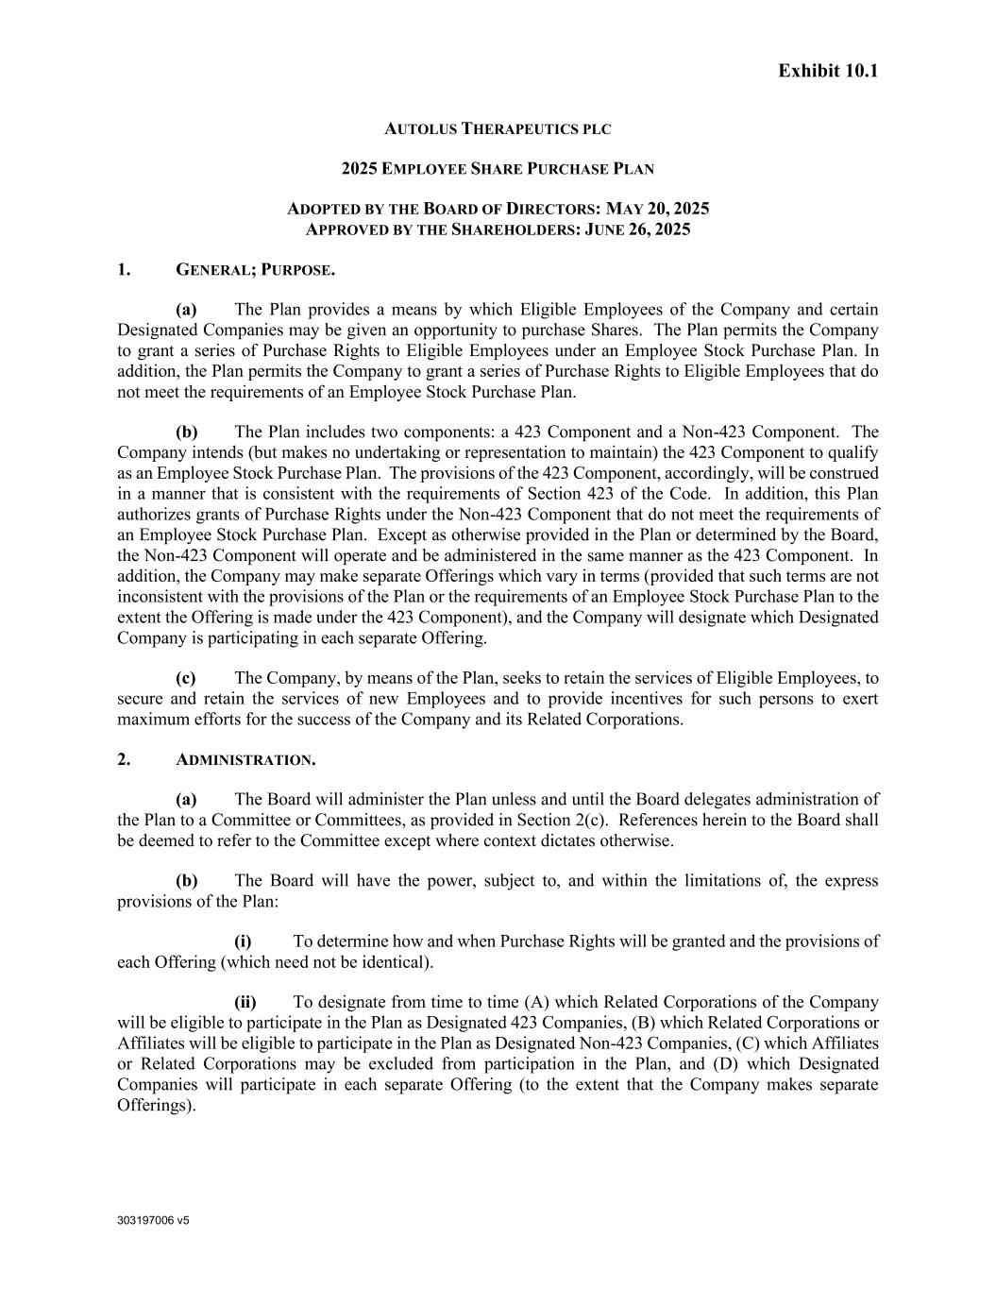
53
303197006 v5 Exhibit 10.1 AUTOLUS THERAPEUTICS PLC 2025 EMPLOYEE SHARE PURCHASE PLAN ADOPTED BY THE BOARD OF DIRECTORS: MAY 20, 2025 APPROVED BY THE SHAREHOLDERS: JUNE 26, 2025 1. GENERAL; PURPOSE. (a) The Plan provides a means by which Eligible Employees of the Company and certain Designated Companies may be given an opportunity to purchase Shares. The Plan permits the Company to grant a series of Purchase Rights to Eligible Employees under an Employee Stock Purchase Plan. In addition, the Plan permits the Company to grant a series of Purchase Rights to Eligible Employees that do not meet the requirements of an Employee Stock Purchase Plan. (b) The Plan includes two components: a 423 Component and a Non-423 Component. The Company intends (but makes no undertaking or representation to maintain) the 423 Component to qualify as an Employee Stock Purchase Plan. The provisions of the 423 Component, accordingly, will be construed in a manner that is consistent with the requirements of Section 423 of the Code. In addition, this Plan authorizes grants of Purchase Rights under the Non-423 Component that do not meet the requirements of an Employee Stock Purchase Plan. Except as otherwise provided in the Plan or determined by the Board, the Non-423 Component will operate and be administered in the same manner as the 423 Component. In addition, the Company may make separate Offerings which vary in terms (provided that such terms are not inconsistent with the provisions of the Plan or the requirements of an Employee Stock Purchase Plan to the extent the Offering is made under the 423 Component), and the Company will designate which Designated Company is participating in each separate Offering. (c) The Company, by means of the Plan, seeks to retain the services of Eligible Employees, to secure and retain the services of new Employees and to provide incentives for such persons to exert maximum efforts for the success of the Company and its Related Corporations. 2. ADMINISTRATION. (a) The Board will administer the Plan unless and until the Board delegates administration of the Plan to a Committee or Committees, as provided in Section 2(c). References herein to the Board shall be deemed to refer to the Committee except where context dictates otherwise. (b) The Board will have the power, subject to, and within the limitations of, the express provisions of the Plan: (i) To determine how and when Purchase Rights will be granted and the provisions of each Offering (which need not be identical). (ii) To designate from time to time (A) which Related Corporations of the Company will be eligible to participate in the Plan as Designated 423 Companies, (B) which Related Corporations or Affiliates will be eligible to participate in the Plan as Designated Non-423 Companies, (C) which Affiliates or Related Corporations may be excluded from participation in the Plan, and (D) which Designated Companies will participate in each separate Offering (to the extent that the Company makes separate Offerings).

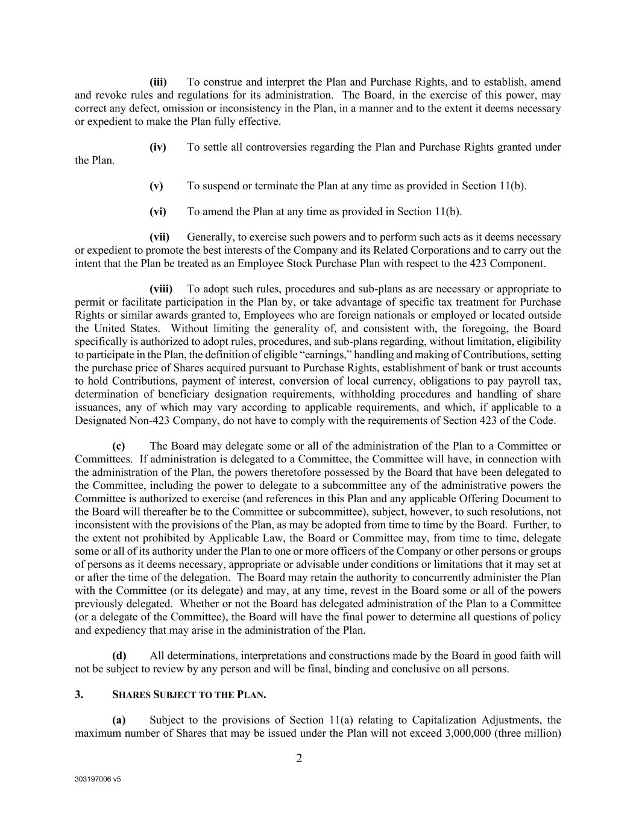
303197006 v5 2 (iii) To construe and interpret the Plan and Purchase Rights, and to establish, amend and revoke rules and regulations for its administration. The Board, in the exercise of this power, may correct any defect, omission or inconsistency in the Plan, in a manner and to the extent it deems necessary or expedient to make the Plan fully effective. (iv) To settle all controversies regarding the Plan and Purchase Rights granted under the Plan. (v) To suspend or terminate the Plan at any time as provided in Section 11(b). (vi) To amend the Plan at any time as provided in Section 11(b). (vii) Generally, to exercise such powers and to perform such acts as it deems necessary or expedient to promote the best interests of the Company and its Related Corporations and to carry out the intent that the Plan be treated as an Employee Stock Purchase Plan with respect to the 423 Component. (viii) To adopt such rules, procedures and sub-plans as are necessary or appropriate to permit or facilitate participation in the Plan by, or take advantage of specific tax treatment for Purchase Rights or similar awards granted to, Employees who are foreign nationals or employed or located outside the United States. Without limiting the generality of, and consistent with, the foregoing, the Board specifically is authorized to adopt rules, procedures, and sub-plans regarding, without limitation, eligibility to participate in the Plan, the definition of eligible “earnings,” handling and making of Contributions, setting the purchase price of Shares acquired pursuant to Purchase Rights, establishment of bank or trust accounts to hold Contributions, payment of interest, conversion of local currency, obligations to pay payroll tax, determination of beneficiary designation requirements, withholding procedures and handling of share issuances, any of which may vary according to applicable requirements, and which, if applicable to a Designated Non-423 Company, do not have to comply with the requirements of Section 423 of the Code. (c) The Board may delegate some or all of the administration of the Plan to a Committee or Committees. If administration is delegated to a Committee, the Committee will have, in connection with the administration of the Plan, the powers theretofore possessed by the Board that have been delegated to the Committee, including the power to delegate to a subcommittee any of the administrative powers the Committee is authorized to exercise (and references in this Plan and any applicable Offering Document to the Board will thereafter be to the Committee or subcommittee), subject, however, to such resolutions, not inconsistent with the provisions of the Plan, as may be adopted from time to time by the Board. Further, to the extent not prohibited by Applicable Law, the Board or Committee may, from time to time, delegate some or all of its authority under the Plan to one or more officers of the Company or other persons or groups of persons as it deems necessary, appropriate or advisable under conditions or limitations that it may set at or after the time of the delegation. The Board may retain the authority to concurrently administer the Plan with the Committee (or its delegate) and may, at any time, revest in the Board some or all of the powers previously delegated. Whether or not the Board has delegated administration of the Plan to a Committee (or a delegate of the Committee), the Board will have the final power to determine all questions of policy and expediency that may arise in the administration of the Plan. (d) All determinations, interpretations and constructions made by the Board in good faith will not be subject to review by any person and will be final, binding and conclusive on all persons. 3. SHARES SUBJECT TO THE PLAN. (a) Subject to the provisions of Section 11(a) relating to Capitalization Adjustments, the maximum number of Shares that may be issued under the Plan will not exceed 3,000,000 (three million)

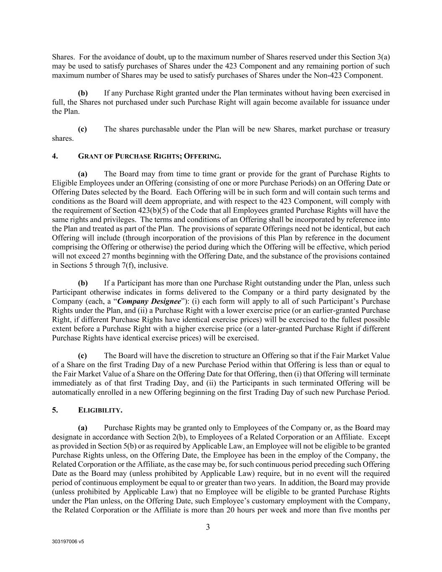
303197006 v5 3 Shares. For the avoidance of doubt, up to the maximum number of Shares reserved under this Section 3(a) may be used to satisfy purchases of Shares under the 423 Component and any remaining portion of such maximum number of Shares may be used to satisfy purchases of Shares under the Non-423 Component. (b) If any Purchase Right granted under the Plan terminates without having been exercised in full, the Shares not purchased under such Purchase Right will again become available for issuance under the Plan. (c) The shares purchasable under the Plan will be new Shares, market purchase or treasury shares. 4. GRANT OF PURCHASE RIGHTS; OFFERING. (a) The Board may from time to time grant or provide for the grant of Purchase Rights to Eligible Employees under an Offering (consisting of one or more Purchase Periods) on an Offering Date or Offering Dates selected by the Board. Each Offering will be in such form and will contain such terms and conditions as the Board will deem appropriate, and with respect to the 423 Component, will comply with the requirement of Section 423(b)(5) of the Code that all Employees granted Purchase Rights will have the same rights and privileges. The terms and conditions of an Offering shall be incorporated by reference into the Plan and treated as part of the Plan. The provisions of separate Offerings need not be identical, but each Offering will include (through incorporation of the provisions of this Plan by reference in the document comprising the Offering or otherwise) the period during which the Offering will be effective, which period will not exceed 27 months beginning with the Offering Date, and the substance of the provisions contained in Sections 5 through 7(f), inclusive. (b) If a Participant has more than one Purchase Right outstanding under the Plan, unless such Participant otherwise indicates in forms delivered to the Company or a third party designated by the Company (each, a “Company Designee”): (i) each form will apply to all of such Participant’s Purchase Rights under the Plan, and (ii) a Purchase Right with a lower exercise price (or an earlier-granted Purchase Right, if different Purchase Rights have identical exercise prices) will be exercised to the fullest possible extent before a Purchase Right with a higher exercise price (or a later-granted Purchase Right if different Purchase Rights have identical exercise prices) will be exercised. (c) The Board will have the discretion to structure an Offering so that if the Fair Market Value of a Share on the first Trading Day of a new Purchase Period within that Offering is less than or equal to the Fair Market Value of a Share on the Offering Date for that Offering, then (i) that Offering will terminate immediately as of that first Trading Day, and (ii) the Participants in such terminated Offering will be automatically enrolled in a new Offering beginning on the first Trading Day of such new Purchase Period. 5. ELIGIBILITY. (a) Purchase Rights may be granted only to Employees of the Company or, as the Board may designate in accordance with Section 2(b), to Employees of a Related Corporation or an Affiliate. Except as provided in Section 5(b) or as required by Applicable Law, an Employee will not be eligible to be granted Purchase Rights unless, on the Offering Date, the Employee has been in the employ of the Company, the Related Corporation or the Affiliate, as the case may be, for such continuous period preceding such Offering Date as the Board may (unless prohibited by Applicable Law) require, but in no event will the required period of continuous employment be equal to or greater than two years. In addition, the Board may provide (unless prohibited by Applicable Law) that no Employee will be eligible to be granted Purchase Rights under the Plan unless, on the Offering Date, such Employee’s customary employment with the Company, the Related Corporation or the Affiliate is more than 20 hours per week and more than five months per

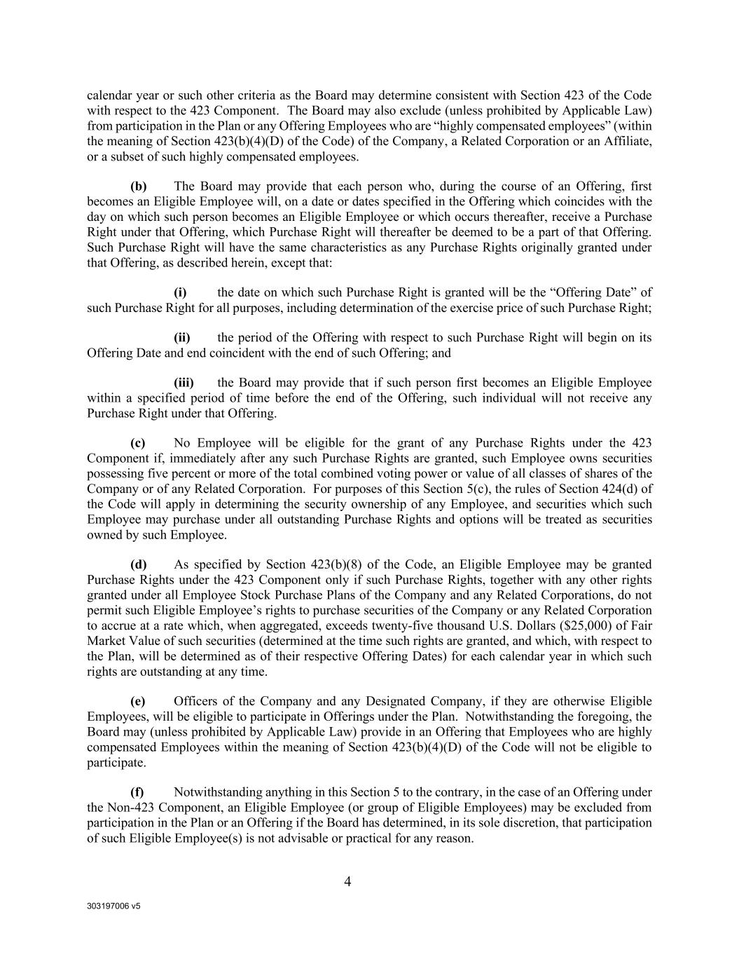
303197006 v5 4 calendar year or such other criteria as the Board may determine consistent with Section 423 of the Code with respect to the 423 Component. The Board may also exclude (unless prohibited by Applicable Law) from participation in the Plan or any Offering Employees who are “highly compensated employees” (within the meaning of Section 423(b)(4)(D) of the Code) of the Company, a Related Corporation or an Affiliate, or a subset of such highly compensated employees. (b) The Board may provide that each person who, during the course of an Offering, first becomes an Eligible Employee will, on a date or dates specified in the Offering which coincides with the day on which such person becomes an Eligible Employee or which occurs thereafter, receive a Purchase Right under that Offering, which Purchase Right will thereafter be deemed to be a part of that Offering. Such Purchase Right will have the same characteristics as any Purchase Rights originally granted under that Offering, as described herein, except that: (i) the date on which such Purchase Right is granted will be the “Offering Date” of such Purchase Right for all purposes, including determination of the exercise price of such Purchase Right; (ii) the period of the Offering with respect to such Purchase Right will begin on its Offering Date and end coincident with the end of such Offering; and (iii) the Board may provide that if such person first becomes an Eligible Employee within a specified period of time before the end of the Offering, such individual will not receive any Purchase Right under that Offering. (c) No Employee will be eligible for the grant of any Purchase Rights under the 423 Component if, immediately after any such Purchase Rights are granted, such Employee owns securities possessing five percent or more of the total combined voting power or value of all classes of shares of the Company or of any Related Corporation. For purposes of this Section 5(c), the rules of Section 424(d) of the Code will apply in determining the security ownership of any Employee, and securities which such Employee may purchase under all outstanding Purchase Rights and options will be treated as securities owned by such Employee. (d) As specified by Section 423(b)(8) of the Code, an Eligible Employee may be granted Purchase Rights under the 423 Component only if such Purchase Rights, together with any other rights granted under all Employee Stock Purchase Plans of the Company and any Related Corporations, do not permit such Eligible Employee’s rights to purchase securities of the Company or any Related Corporation to accrue at a rate which, when aggregated, exceeds twenty-five thousand U.S. Dollars ($25,000) of Fair Market Value of such securities (determined at the time such rights are granted, and which, with respect to the Plan, will be determined as of their respective Offering Dates) for each calendar year in which such rights are outstanding at any time. (e) Officers of the Company and any Designated Company, if they are otherwise Eligible Employees, will be eligible to participate in Offerings under the Plan. Notwithstanding the foregoing, the Board may (unless prohibited by Applicable Law) provide in an Offering that Employees who are highly compensated Employees within the meaning of Section 423(b)(4)(D) of the Code will not be eligible to participate. (f) Notwithstanding anything in this Section 5 to the contrary, in the case of an Offering under the Non-423 Component, an Eligible Employee (or group of Eligible Employees) may be excluded from participation in the Plan or an Offering if the Board has determined, in its sole discretion, that participation of such Eligible Employee(s) is not advisable or practical for any reason.

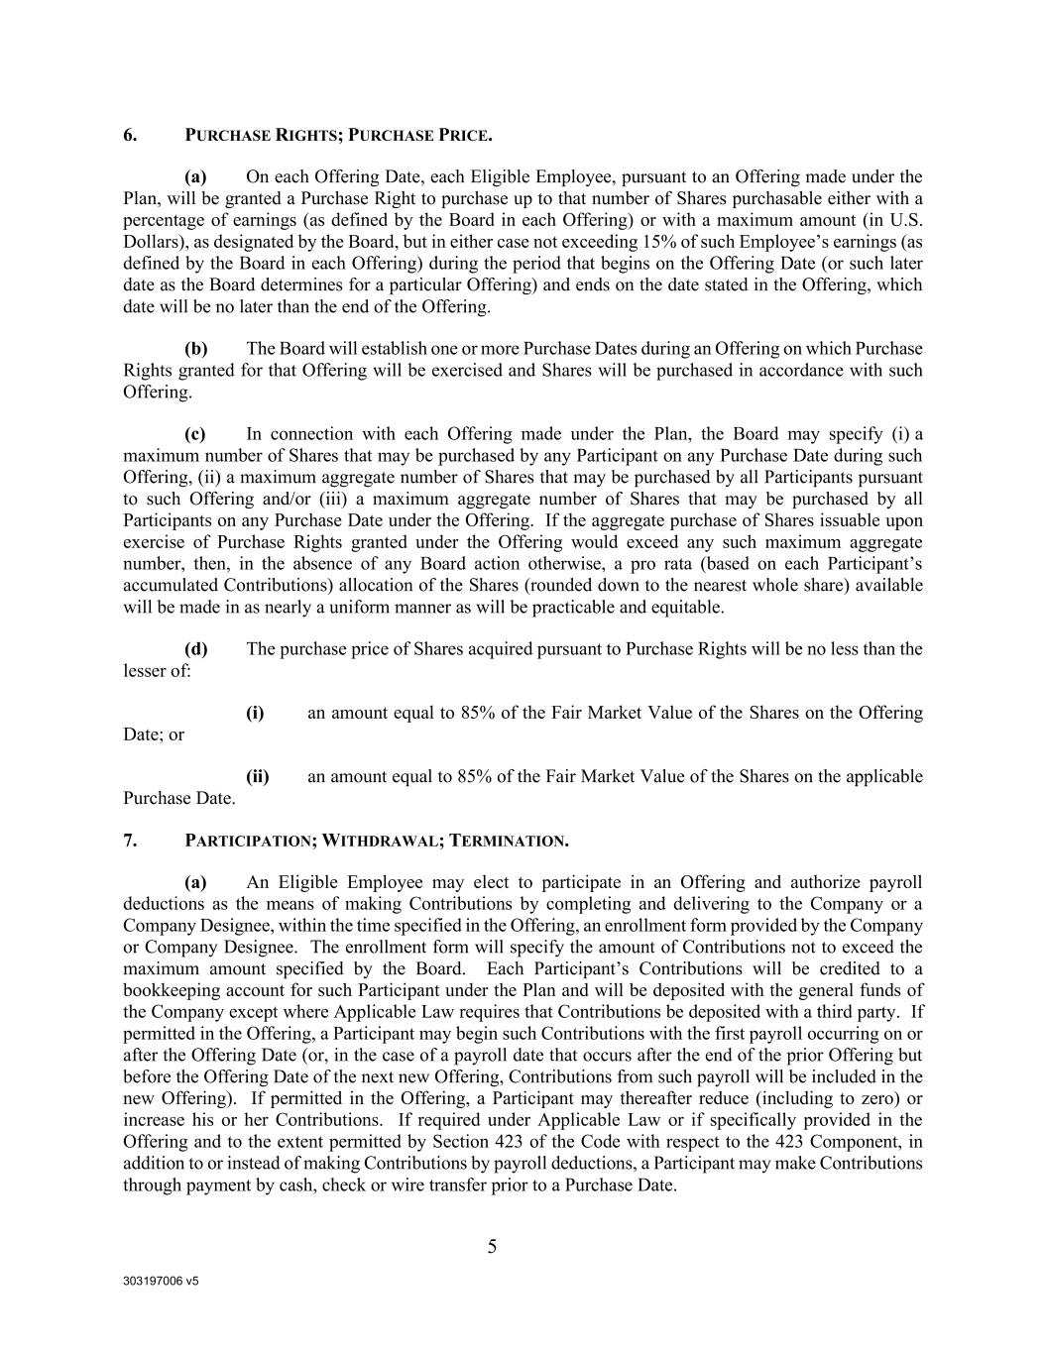
303197006 v5 5 6. PURCHASE RIGHTS; PURCHASE PRICE. (a) On each Offering Date, each Eligible Employee, pursuant to an Offering made under the Plan, will be granted a Purchase Right to purchase up to that number of Shares purchasable either with a percentage of earnings (as defined by the Board in each Offering) or with a maximum amount (in U.S. Dollars), as designated by the Board, but in either case not exceeding 15% of such Employee’s earnings (as defined by the Board in each Offering) during the period that begins on the Offering Date (or such later date as the Board determines for a particular Offering) and ends on the date stated in the Offering, which date will be no later than the end of the Offering. (b) The Board will establish one or more Purchase Dates during an Offering on which Purchase Rights granted for that Offering will be exercised and Shares will be purchased in accordance with such Offering. (c) In connection with each Offering made under the Plan, the Board may specify (i) a maximum number of Shares that may be purchased by any Participant on any Purchase Date during such Offering, (ii) a maximum aggregate number of Shares that may be purchased by all Participants pursuant to such Offering and/or (iii) a maximum aggregate number of Shares that may be purchased by all Participants on any Purchase Date under the Offering. If the aggregate purchase of Shares issuable upon exercise of Purchase Rights granted under the Offering would exceed any such maximum aggregate number, then, in the absence of any Board action otherwise, a pro rata (based on each Participant’s accumulated Contributions) allocation of the Shares (rounded down to the nearest whole share) available will be made in as nearly a uniform manner as will be practicable and equitable. (d) The purchase price of Shares acquired pursuant to Purchase Rights will be no less than the lesser of: (i) an amount equal to 85% of the Fair Market Value of the Shares on the Offering Date; or (ii) an amount equal to 85% of the Fair Market Value of the Shares on the applicable Purchase Date. 7. PARTICIPATION; WITHDRAWAL; TERMINATION. (a) An Eligible Employee may elect to participate in an Offering and authorize payroll deductions as the means of making Contributions by completing and delivering to the Company or a Company Designee, within the time specified in the Offering, an enrollment form provided by the Company or Company Designee. The enrollment form will specify the amount of Contributions not to exceed the maximum amount specified by the Board. Each Participant’s Contributions will be credited to a bookkeeping account for such Participant under the Plan and will be deposited with the general funds of the Company except where Applicable Law requires that Contributions be deposited with a third party. If permitted in the Offering, a Participant may begin such Contributions with the first payroll occurring on or after the Offering Date (or, in the case of a payroll date that occurs after the end of the prior Offering but before the Offering Date of the next new Offering, Contributions from such payroll will be included in the new Offering). If permitted in the Offering, a Participant may thereafter reduce (including to zero) or increase his or her Contributions. If required under Applicable Law or if specifically provided in the Offering and to the extent permitted by Section 423 of the Code with respect to the 423 Component, in addition to or instead of making Contributions by payroll deductions, a Participant may make Contributions through payment by cash, check or wire transfer prior to a Purchase Date.

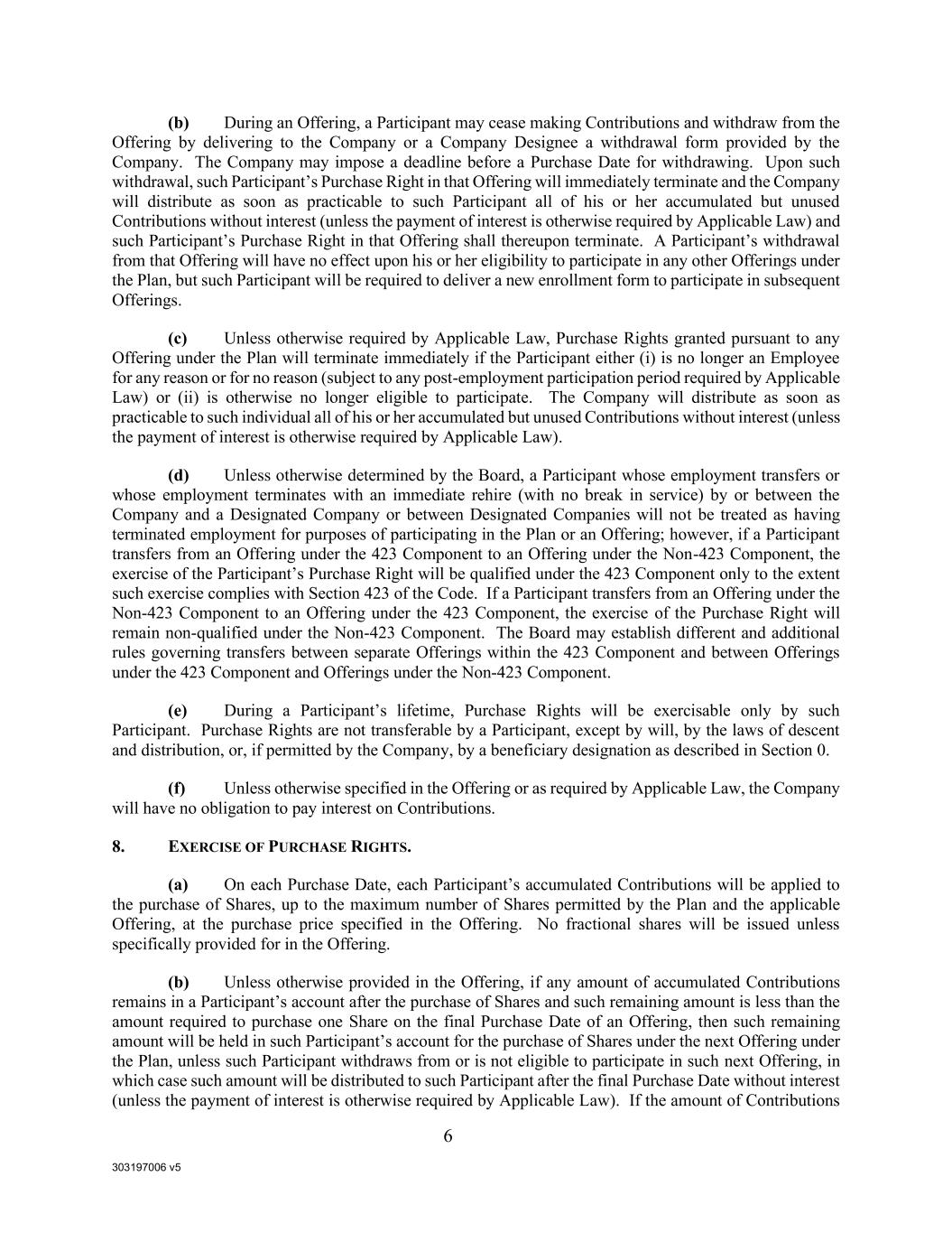
303197006 v5 6 (b) During an Offering, a Participant may cease making Contributions and withdraw from the Offering by delivering to the Company or a Company Designee a withdrawal form provided by the Company. The Company may impose a deadline before a Purchase Date for withdrawing. Upon such withdrawal, such Participant’s Purchase Right in that Offering will immediately terminate and the Company will distribute as soon as practicable to such Participant all of his or her accumulated but unused Contributions without interest (unless the payment of interest is otherwise required by Applicable Law) and such Participant’s Purchase Right in that Offering shall thereupon terminate. A Participant’s withdrawal from that Offering will have no effect upon his or her eligibility to participate in any other Offerings under the Plan, but such Participant will be required to deliver a new enrollment form to participate in subsequent Offerings. (c) Unless otherwise required by Applicable Law, Purchase Rights granted pursuant to any Offering under the Plan will terminate immediately if the Participant either (i) is no longer an Employee for any reason or for no reason (subject to any post-employment participation period required by Applicable Law) or (ii) is otherwise no longer eligible to participate. The Company will distribute as soon as practicable to such individual all of his or her accumulated but unused Contributions without interest (unless the payment of interest is otherwise required by Applicable Law). (d) Unless otherwise determined by the Board, a Participant whose employment transfers or whose employment terminates with an immediate rehire (with no break in service) by or between the Company and a Designated Company or between Designated Companies will not be treated as having terminated employment for purposes of participating in the Plan or an Offering; however, if a Participant transfers from an Offering under the 423 Component to an Offering under the Non-423 Component, the exercise of the Participant’s Purchase Right will be qualified under the 423 Component only to the extent such exercise complies with Section 423 of the Code. If a Participant transfers from an Offering under the Non-423 Component to an Offering under the 423 Component, the exercise of the Purchase Right will remain non-qualified under the Non-423 Component. The Board may establish different and additional rules governing transfers between separate Offerings within the 423 Component and between Offerings under the 423 Component and Offerings under the Non-423 Component. (e) During a Participant’s lifetime, Purchase Rights will be exercisable only by such Participant. Purchase Rights are not transferable by a Participant, except by will, by the laws of descent and distribution, or, if permitted by the Company, by a beneficiary designation as described in Section 0. (f) Unless otherwise specified in the Offering or as required by Applicable Law, the Company will have no obligation to pay interest on Contributions. 8. EXERCISE OF PURCHASE RIGHTS. (a) On each Purchase Date, each Participant’s accumulated Contributions will be applied to the purchase of Shares, up to the maximum number of Shares permitted by the Plan and the applicable Offering, at the purchase price specified in the Offering. No fractional shares will be issued unless specifically provided for in the Offering. (b) Unless otherwise provided in the Offering, if any amount of accumulated Contributions remains in a Participant’s account after the purchase of Shares and such remaining amount is less than the amount required to purchase one Share on the final Purchase Date of an Offering, then such remaining amount will be held in such Participant’s account for the purchase of Shares under the next Offering under the Plan, unless such Participant withdraws from or is not eligible to participate in such next Offering, in which case such amount will be distributed to such Participant after the final Purchase Date without interest (unless the payment of interest is otherwise required by Applicable Law). If the amount of Contributions

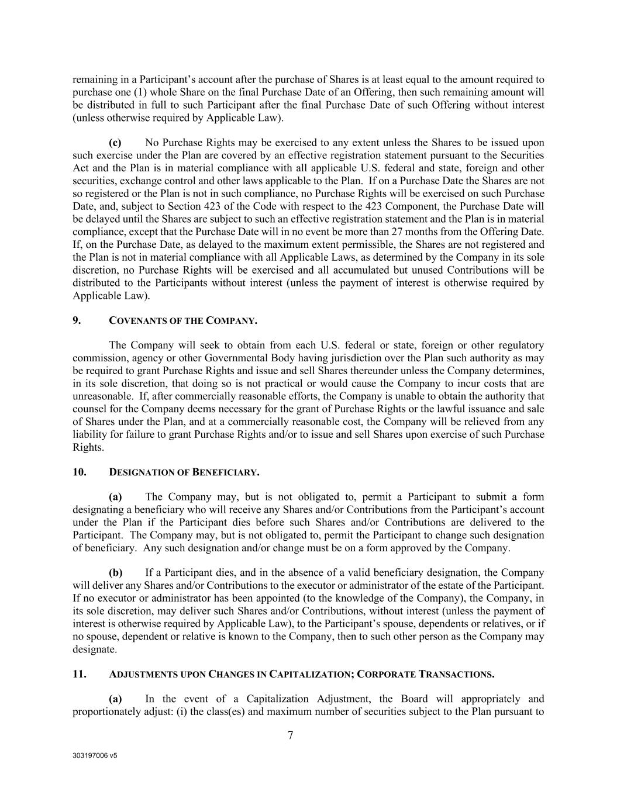
303197006 v5 7 remaining in a Participant’s account after the purchase of Shares is at least equal to the amount required to purchase one (1) whole Share on the final Purchase Date of an Offering, then such remaining amount will be distributed in full to such Participant after the final Purchase Date of such Offering without interest (unless otherwise required by Applicable Law). (c) No Purchase Rights may be exercised to any extent unless the Shares to be issued upon such exercise under the Plan are covered by an effective registration statement pursuant to the Securities Act and the Plan is in material compliance with all applicable U.S. federal and state, foreign and other securities, exchange control and other laws applicable to the Plan. If on a Purchase Date the Shares are not so registered or the Plan is not in such compliance, no Purchase Rights will be exercised on such Purchase Date, and, subject to Section 423 of the Code with respect to the 423 Component, the Purchase Date will be delayed until the Shares are subject to such an effective registration statement and the Plan is in material compliance, except that the Purchase Date will in no event be more than 27 months from the Offering Date. If, on the Purchase Date, as delayed to the maximum extent permissible, the Shares are not registered and the Plan is not in material compliance with all Applicable Laws, as determined by the Company in its sole discretion, no Purchase Rights will be exercised and all accumulated but unused Contributions will be distributed to the Participants without interest (unless the payment of interest is otherwise required by Applicable Law). 9. COVENANTS OF THE COMPANY. The Company will seek to obtain from each U.S. federal or state, foreign or other regulatory commission, agency or other Governmental Body having jurisdiction over the Plan such authority as may be required to grant Purchase Rights and issue and sell Shares thereunder unless the Company determines, in its sole discretion, that doing so is not practical or would cause the Company to incur costs that are unreasonable. If, after commercially reasonable efforts, the Company is unable to obtain the authority that counsel for the Company deems necessary for the grant of Purchase Rights or the lawful issuance and sale of Shares under the Plan, and at a commercially reasonable cost, the Company will be relieved from any liability for failure to grant Purchase Rights and/or to issue and sell Shares upon exercise of such Purchase Rights. 10. DESIGNATION OF BENEFICIARY. (a) The Company may, but is not obligated to, permit a Participant to submit a form designating a beneficiary who will receive any Shares and/or Contributions from the Participant’s account under the Plan if the Participant dies before such Shares and/or Contributions are delivered to the Participant. The Company may, but is not obligated to, permit the Participant to change such designation of beneficiary. Any such designation and/or change must be on a form approved by the Company. (b) If a Participant dies, and in the absence of a valid beneficiary designation, the Company will deliver any Shares and/or Contributions to the executor or administrator of the estate of the Participant. If no executor or administrator has been appointed (to the knowledge of the Company), the Company, in its sole discretion, may deliver such Shares and/or Contributions, without interest (unless the payment of interest is otherwise required by Applicable Law), to the Participant’s spouse, dependents or relatives, or if no spouse, dependent or relative is known to the Company, then to such other person as the Company may designate. 11. ADJUSTMENTS UPON CHANGES IN CAPITALIZATION; CORPORATE TRANSACTIONS. (a) In the event of a Capitalization Adjustment, the Board will appropriately and proportionately adjust: (i) the class(es) and maximum number of securities subject to the Plan pursuant to

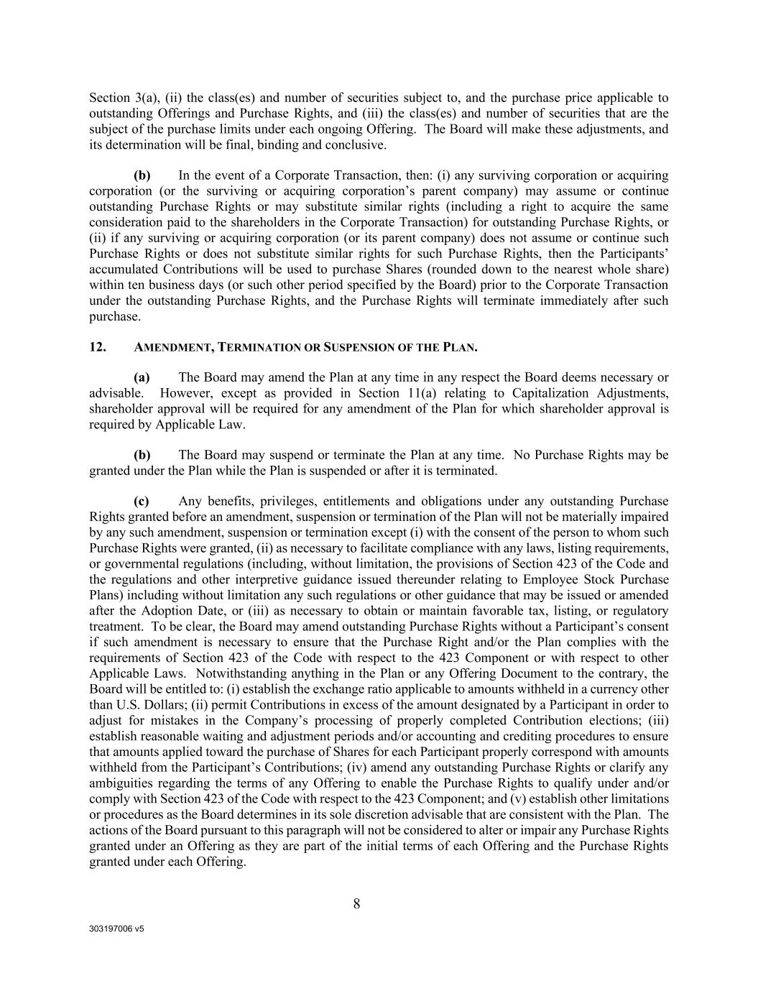
303197006 v5 8 Section 3(a), (ii) the class(es) and number of securities subject to, and the purchase price applicable to outstanding Offerings and Purchase Rights, and (iii) the class(es) and number of securities that are the subject of the purchase limits under each ongoing Offering. The Board will make these adjustments, and its determination will be final, binding and conclusive. (b) In the event of a Corporate Transaction, then: (i) any surviving corporation or acquiring corporation (or the surviving or acquiring corporation’s parent company) may assume or continue outstanding Purchase Rights or may substitute similar rights (including a right to acquire the same consideration paid to the shareholders in the Corporate Transaction) for outstanding Purchase Rights, or (ii) if any surviving or acquiring corporation (or its parent company) does not assume or continue such Purchase Rights or does not substitute similar rights for such Purchase Rights, then the Participants’ accumulated Contributions will be used to purchase Shares (rounded down to the nearest whole share) within ten business days (or such other period specified by the Board) prior to the Corporate Transaction under the outstanding Purchase Rights, and the Purchase Rights will terminate immediately after such purchase. 12. AMENDMENT, TERMINATION OR SUSPENSION OF THE PLAN. (a) The Board may amend the Plan at any time in any respect the Board deems necessary or advisable. However, except as provided in Section 11(a) relating to Capitalization Adjustments, shareholder approval will be required for any amendment of the Plan for which shareholder approval is required by Applicable Law. (b) The Board may suspend or terminate the Plan at any time. No Purchase Rights may be granted under the Plan while the Plan is suspended or after it is terminated. (c) Any benefits, privileges, entitlements and obligations under any outstanding Purchase Rights granted before an amendment, suspension or termination of the Plan will not be materially impaired by any such amendment, suspension or termination except (i) with the consent of the person to whom such Purchase Rights were granted, (ii) as necessary to facilitate compliance with any laws, listing requirements, or governmental regulations (including, without limitation, the provisions of Section 423 of the Code and the regulations and other interpretive guidance issued thereunder relating to Employee Stock Purchase Plans) including without limitation any such regulations or other guidance that may be issued or amended after the Adoption Date, or (iii) as necessary to obtain or maintain favorable tax, listing, or regulatory treatment. To be clear, the Board may amend outstanding Purchase Rights without a Participant’s consent if such amendment is necessary to ensure that the Purchase Right and/or the Plan complies with the requirements of Section 423 of the Code with respect to the 423 Component or with respect to other Applicable Laws. Notwithstanding anything in the Plan or any Offering Document to the contrary, the Board will be entitled to: (i) establish the exchange ratio applicable to amounts withheld in a currency other than U.S. Dollars; (ii) permit Contributions in excess of the amount designated by a Participant in order to adjust for mistakes in the Company’s processing of properly completed Contribution elections; (iii) establish reasonable waiting and adjustment periods and/or accounting and crediting procedures to ensure that amounts applied toward the purchase of Shares for each Participant properly correspond with amounts withheld from the Participant’s Contributions; (iv) amend any outstanding Purchase Rights or clarify any ambiguities regarding the terms of any Offering to enable the Purchase Rights to qualify under and/or comply with Section 423 of the Code with respect to the 423 Component; and (v) establish other limitations or procedures as the Board determines in its sole discretion advisable that are consistent with the Plan. The actions of the Board pursuant to this paragraph will not be considered to alter or impair any Purchase Rights granted under an Offering as they are part of the initial terms of each Offering and the Purchase Rights granted under each Offering.

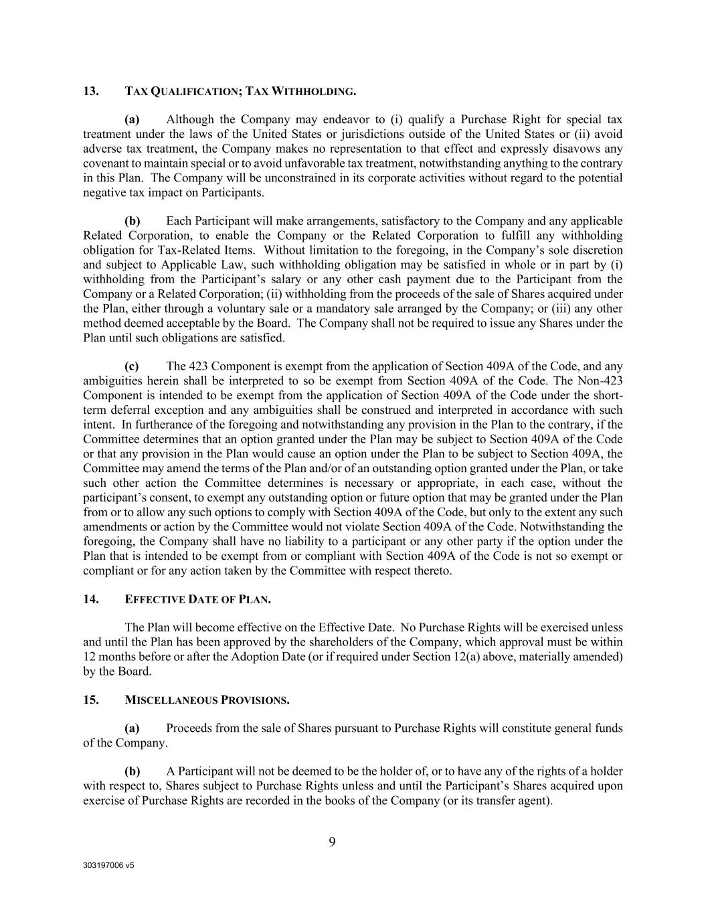
303197006 v5 9 13. TAX QUALIFICATION; TAX WITHHOLDING. (a) Although the Company may endeavor to (i) qualify a Purchase Right for special tax treatment under the laws of the United States or jurisdictions outside of the United States or (ii) avoid adverse tax treatment, the Company makes no representation to that effect and expressly disavows any covenant to maintain special or to avoid unfavorable tax treatment, notwithstanding anything to the contrary in this Plan. The Company will be unconstrained in its corporate activities without regard to the potential negative tax impact on Participants. (b) Each Participant will make arrangements, satisfactory to the Company and any applicable Related Corporation, to enable the Company or the Related Corporation to fulfill any withholding obligation for Tax-Related Items. Without limitation to the foregoing, in the Company’s sole discretion and subject to Applicable Law, such withholding obligation may be satisfied in whole or in part by (i) withholding from the Participant’s salary or any other cash payment due to the Participant from the Company or a Related Corporation; (ii) withholding from the proceeds of the sale of Shares acquired under the Plan, either through a voluntary sale or a mandatory sale arranged by the Company; or (iii) any other method deemed acceptable by the Board. The Company shall not be required to issue any Shares under the Plan until such obligations are satisfied. (c) The 423 Component is exempt from the application of Section 409A of the Code, and any ambiguities herein shall be interpreted to so be exempt from Section 409A of the Code. The Non-423 Component is intended to be exempt from the application of Section 409A of the Code under the short- term deferral exception and any ambiguities shall be construed and interpreted in accordance with such intent. In furtherance of the foregoing and notwithstanding any provision in the Plan to the contrary, if the Committee determines that an option granted under the Plan may be subject to Section 409A of the Code or that any provision in the Plan would cause an option under the Plan to be subject to Section 409A, the Committee may amend the terms of the Plan and/or of an outstanding option granted under the Plan, or take such other action the Committee determines is necessary or appropriate, in each case, without the participant’s consent, to exempt any outstanding option or future option that may be granted under the Plan from or to allow any such options to comply with Section 409A of the Code, but only to the extent any such amendments or action by the Committee would not violate Section 409A of the Code. Notwithstanding the foregoing, the Company shall have no liability to a participant or any other party if the option under the Plan that is intended to be exempt from or compliant with Section 409A of the Code is not so exempt or compliant or for any action taken by the Committee with respect thereto. 14. EFFECTIVE DATE OF PLAN. The Plan will become effective on the Effective Date. No Purchase Rights will be exercised unless and until the Plan has been approved by the shareholders of the Company, which approval must be within 12 months before or after the Adoption Date (or if required under Section 12(a) above, materially amended) by the Board. 15. MISCELLANEOUS PROVISIONS. (a) Proceeds from the sale of Shares pursuant to Purchase Rights will constitute general funds of the Company. (b) A Participant will not be deemed to be the holder of, or to have any of the rights of a holder with respect to, Shares subject to Purchase Rights unless and until the Participant’s Shares acquired upon exercise of Purchase Rights are recorded in the books of the Company (or its transfer agent).

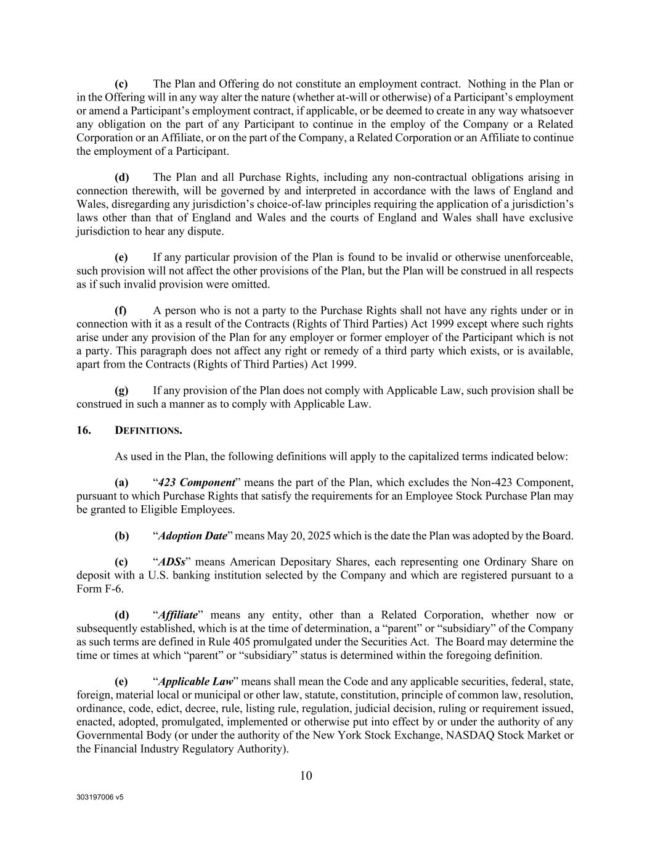
303197006 v5 10 (c) The Plan and Offering do not constitute an employment contract. Nothing in the Plan or in the Offering will in any way alter the nature (whether at-will or otherwise) of a Participant’s employment or amend a Participant’s employment contract, if applicable, or be deemed to create in any way whatsoever any obligation on the part of any Participant to continue in the employ of the Company or a Related Corporation or an Affiliate, or on the part of the Company, a Related Corporation or an Affiliate to continue the employment of a Participant. (d) The Plan and all Purchase Rights, including any non-contractual obligations arising in connection therewith, will be governed by and interpreted in accordance with the laws of England and Wales, disregarding any jurisdiction’s choice-of-law principles requiring the application of a jurisdiction’s laws other than that of England and Wales and the courts of England and Wales shall have exclusive jurisdiction to hear any dispute. (e) If any particular provision of the Plan is found to be invalid or otherwise unenforceable, such provision will not affect the other provisions of the Plan, but the Plan will be construed in all respects as if such invalid provision were omitted. (f) A person who is not a party to the Purchase Rights shall not have any rights under or in connection with it as a result of the Contracts (Rights of Third Parties) Act 1999 except where such rights arise under any provision of the Plan for any employer or former employer of the Participant which is not a party. This paragraph does not affect any right or remedy of a third party which exists, or is available, apart from the Contracts (Rights of Third Parties) Act 1999. (g) If any provision of the Plan does not comply with Applicable Law, such provision shall be construed in such a manner as to comply with Applicable Law. 16. DEFINITIONS. As used in the Plan, the following definitions will apply to the capitalized terms indicated below: (a) “423 Component” means the part of the Plan, which excludes the Non-423 Component, pursuant to which Purchase Rights that satisfy the requirements for an Employee Stock Purchase Plan may be granted to Eligible Employees. (b) “Adoption Date” means May 20, 2025 which is the date the Plan was adopted by the Board. (c) “ADSs” means American Depositary Shares, each representing one Ordinary Share on deposit with a U.S. banking institution selected by the Company and which are registered pursuant to a Form F-6. (d) “Affiliate” means any entity, other than a Related Corporation, whether now or subsequently established, which is at the time of determination, a “parent” or “subsidiary” of the Company as such terms are defined in Rule 405 promulgated under the Securities Act. The Board may determine the time or times at which “parent” or “subsidiary” status is determined within the foregoing definition. (e) “Applicable Law” means shall mean the Code and any applicable securities, federal, state, foreign, material local or municipal or other law, statute, constitution, principle of common law, resolution, ordinance, code, edict, decree, rule, listing rule, regulation, judicial decision, ruling or requirement issued, enacted, adopted, promulgated, implemented or otherwise put into effect by or under the authority of any Governmental Body (or under the authority of the New York Stock Exchange, NASDAQ Stock Market or the Financial Industry Regulatory Authority).

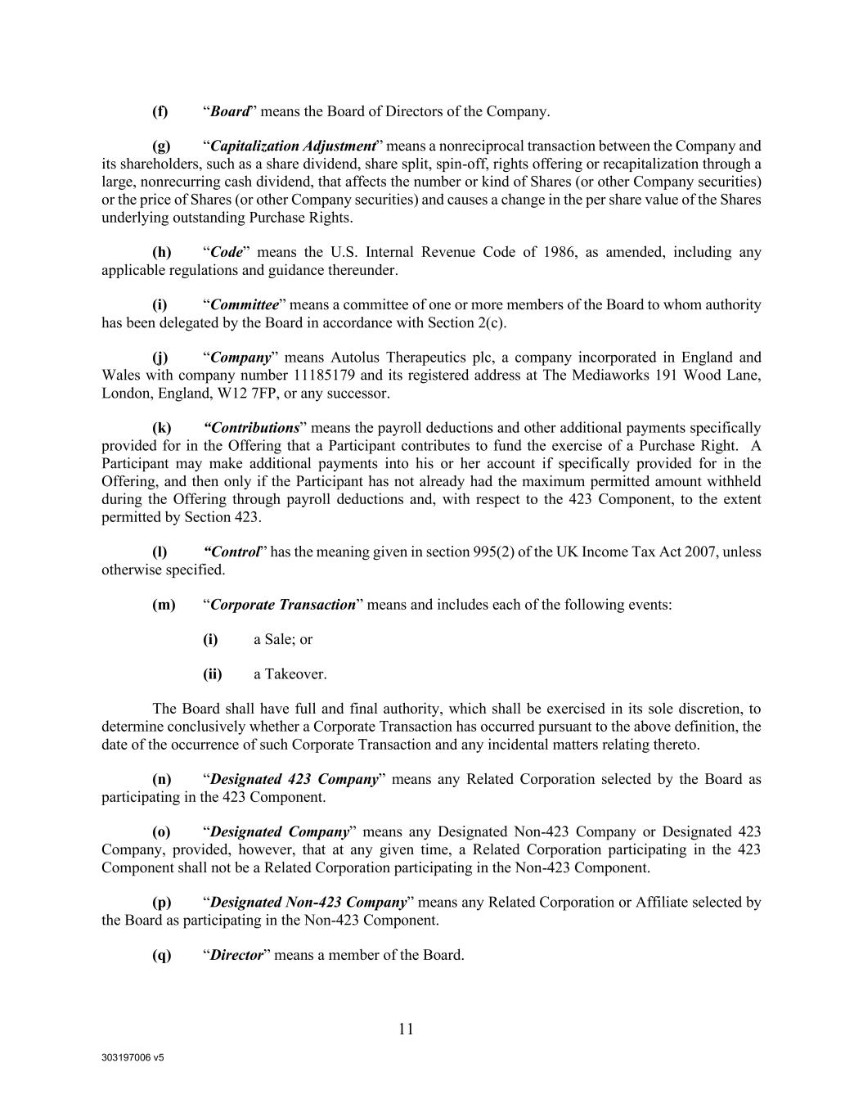
303197006 v5 11 (f) “Board” means the Board of Directors of the Company. (g) “Capitalization Adjustment” means a nonreciprocal transaction between the Company and its shareholders, such as a share dividend, share split, spin-off, rights offering or recapitalization through a large, nonrecurring cash dividend, that affects the number or kind of Shares (or other Company securities) or the price of Shares (or other Company securities) and causes a change in the per share value of the Shares underlying outstanding Purchase Rights. (h) “Code” means the U.S. Internal Revenue Code of 1986, as amended, including any applicable regulations and guidance thereunder. (i) “Committee” means a committee of one or more members of the Board to whom authority has been delegated by the Board in accordance with Section 2(c). (j) “Company” means Autolus Therapeutics plc, a company incorporated in England and Wales with company number 11185179 and its registered address at The Mediaworks 191 Wood Lane, London, England, W12 7FP, or any successor. (k) “Contributions” means the payroll deductions and other additional payments specifically provided for in the Offering that a Participant contributes to fund the exercise of a Purchase Right. A Participant may make additional payments into his or her account if specifically provided for in the Offering, and then only if the Participant has not already had the maximum permitted amount withheld during the Offering through payroll deductions and, with respect to the 423 Component, to the extent permitted by Section 423. (l) “Control” has the meaning given in section 995(2) of the UK Income Tax Act 2007, unless otherwise specified. (m) “Corporate Transaction” means and includes each of the following events: (i) a Sale; or (ii) a Takeover. The Board shall have full and final authority, which shall be exercised in its sole discretion, to determine conclusively whether a Corporate Transaction has occurred pursuant to the above definition, the date of the occurrence of such Corporate Transaction and any incidental matters relating thereto. (n) “Designated 423 Company” means any Related Corporation selected by the Board as participating in the 423 Component. (o) “Designated Company” means any Designated Non-423 Company or Designated 423 Company, provided, however, that at any given time, a Related Corporation participating in the 423 Component shall not be a Related Corporation participating in the Non-423 Component. (p) “Designated Non-423 Company” means any Related Corporation or Affiliate selected by the Board as participating in the Non-423 Component. (q) “Director” means a member of the Board.

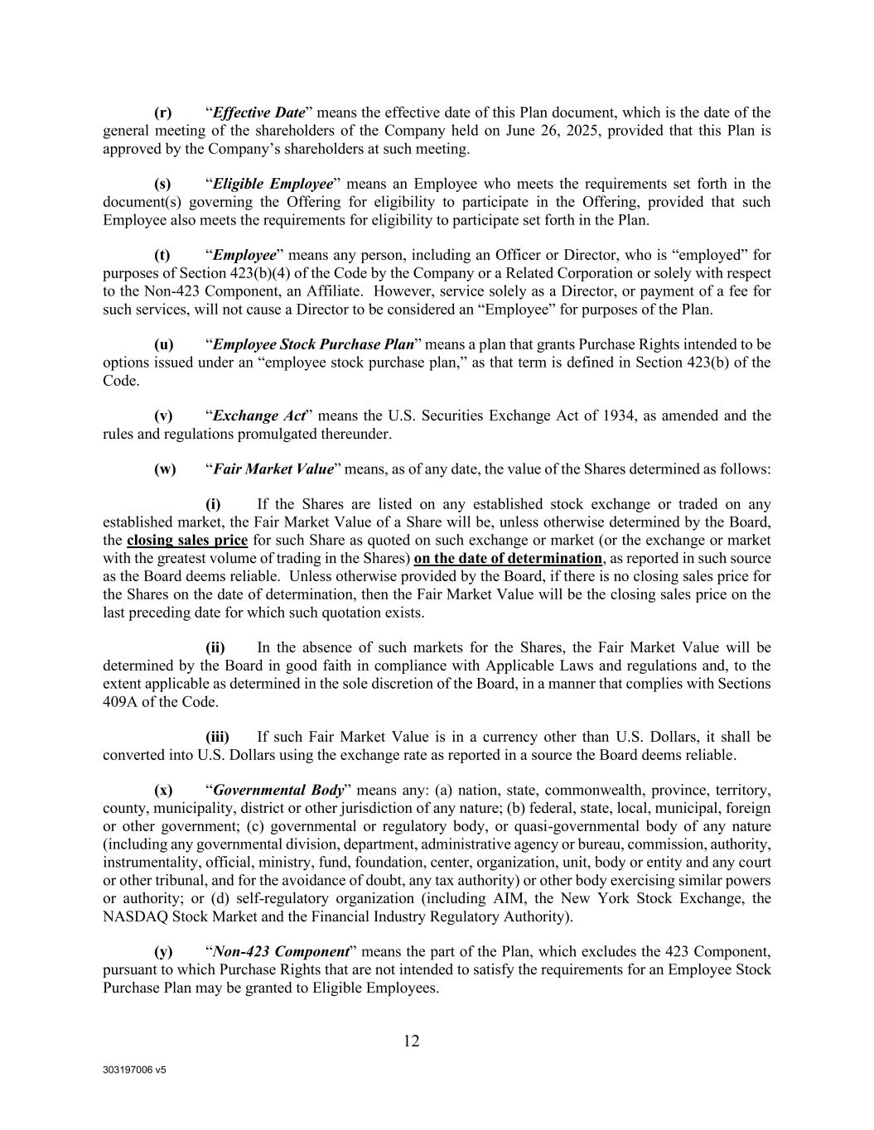
303197006 v5 12 (r) “Effective Date” means the effective date of this Plan document, which is the date of the general meeting of the shareholders of the Company held on June 26, 2025, provided that this Plan is approved by the Company’s shareholders at such meeting. (s) “Eligible Employee” means an Employee who meets the requirements set forth in the document(s) governing the Offering for eligibility to participate in the Offering, provided that such Employee also meets the requirements for eligibility to participate set forth in the Plan. (t) “Employee” means any person, including an Officer or Director, who is “employed” for purposes of Section 423(b)(4) of the Code by the Company or a Related Corporation or solely with respect to the Non-423 Component, an Affiliate. However, service solely as a Director, or payment of a fee for such services, will not cause a Director to be considered an “Employee” for purposes of the Plan. (u) “Employee Stock Purchase Plan” means a plan that grants Purchase Rights intended to be options issued under an “employee stock purchase plan,” as that term is defined in Section 423(b) of the Code. (v) “Exchange Act” means the U.S. Securities Exchange Act of 1934, as amended and the rules and regulations promulgated thereunder. (w) “Fair Market Value” means, as of any date, the value of the Shares determined as follows: (i) If the Shares are listed on any established stock exchange or traded on any established market, the Fair Market Value of a Share will be, unless otherwise determined by the Board, the closing sales price for such Share as quoted on such exchange or market (or the exchange or market with the greatest volume of trading in the Shares) on the date of determination, as reported in such source as the Board deems reliable. Unless otherwise provided by the Board, if there is no closing sales price for the Shares on the date of determination, then the Fair Market Value will be the closing sales price on the last preceding date for which such quotation exists. (ii) In the absence of such markets for the Shares, the Fair Market Value will be determined by the Board in good faith in compliance with Applicable Laws and regulations and, to the extent applicable as determined in the sole discretion of the Board, in a manner that complies with Sections 409A of the Code. (iii) If such Fair Market Value is in a currency other than U.S. Dollars, it shall be converted into U.S. Dollars using the exchange rate as reported in a source the Board deems reliable. (x) “Governmental Body” means any: (a) nation, state, commonwealth, province, territory, county, municipality, district or other jurisdiction of any nature; (b) federal, state, local, municipal, foreign or other government; (c) governmental or regulatory body, or quasi-governmental body of any nature (including any governmental division, department, administrative agency or bureau, commission, authority, instrumentality, official, ministry, fund, foundation, center, organization, unit, body or entity and any court or other tribunal, and for the avoidance of doubt, any tax authority) or other body exercising similar powers or authority; or (d) self-regulatory organization (including AIM, the New York Stock Exchange, the NASDAQ Stock Market and the Financial Industry Regulatory Authority). (y) “Non-423 Component” means the part of the Plan, which excludes the 423 Component, pursuant to which Purchase Rights that are not intended to satisfy the requirements for an Employee Stock Purchase Plan may be granted to Eligible Employees.

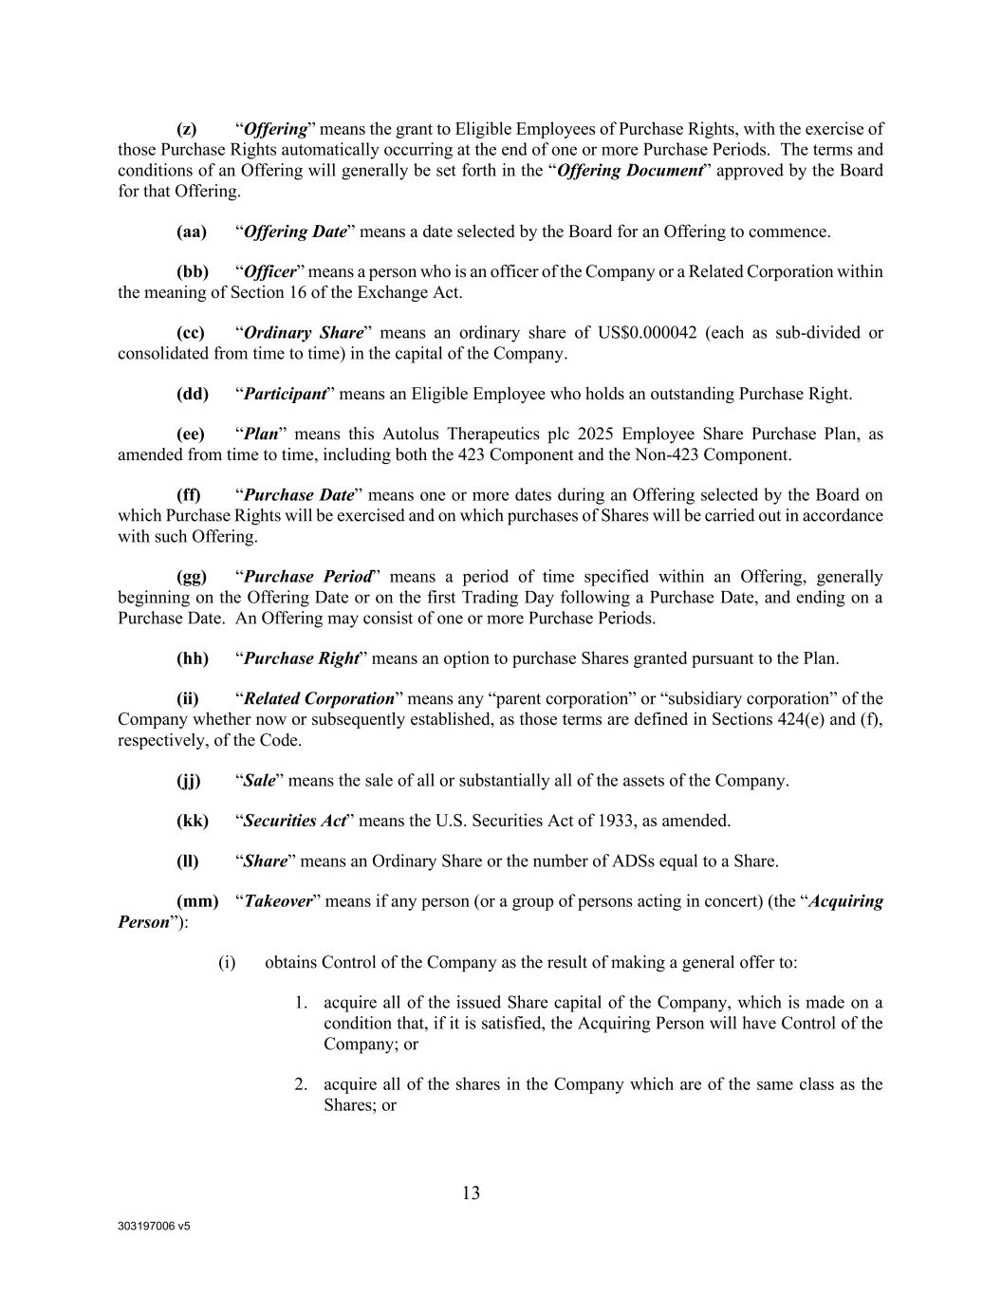
303197006 v5 13 (z) “Offering” means the grant to Eligible Employees of Purchase Rights, with the exercise of those Purchase Rights automatically occurring at the end of one or more Purchase Periods. The terms and conditions of an Offering will generally be set forth in the “Offering Document” approved by the Board for that Offering. (aa) “Offering Date” means a date selected by the Board for an Offering to commence. (bb) “Officer” means a person who is an officer of the Company or a Related Corporation within the meaning of Section 16 of the Exchange Act. (cc) “Ordinary Share” means an ordinary share of US$0.000042 (each as sub-divided or consolidated from time to time) in the capital of the Company. (dd) “Participant” means an Eligible Employee who holds an outstanding Purchase Right. (ee) “Plan” means this Autolus Therapeutics plc 2025 Employee Share Purchase Plan, as amended from time to time, including both the 423 Component and the Non-423 Component. (ff) “Purchase Date” means one or more dates during an Offering selected by the Board on which Purchase Rights will be exercised and on which purchases of Shares will be carried out in accordance with such Offering. (gg) “Purchase Period” means a period of time specified within an Offering, generally beginning on the Offering Date or on the first Trading Day following a Purchase Date, and ending on a Purchase Date. An Offering may consist of one or more Purchase Periods. (hh) “Purchase Right” means an option to purchase Shares granted pursuant to the Plan. (ii) “Related Corporation” means any “parent corporation” or “subsidiary corporation” of the Company whether now or subsequently established, as those terms are defined in Sections 424(e) and (f), respectively, of the Code. (jj) “Sale” means the sale of all or substantially all of the assets of the Company. (kk) “Securities Act” means the U.S. Securities Act of 1933, as amended. (ll) “Share” means an Ordinary Share or the number of ADSs equal to a Share. (mm) “Takeover” means if any person (or a group of persons acting in concert) (the “Acquiring Person”): (i) obtains Control of the Company as the result of making a general offer to: 1. acquire all of the issued Share capital of the Company, which is made on a condition that, if it is satisfied, the Acquiring Person will have Control of the Company; or 2. acquire all of the shares in the Company which are of the same class as the Shares; or

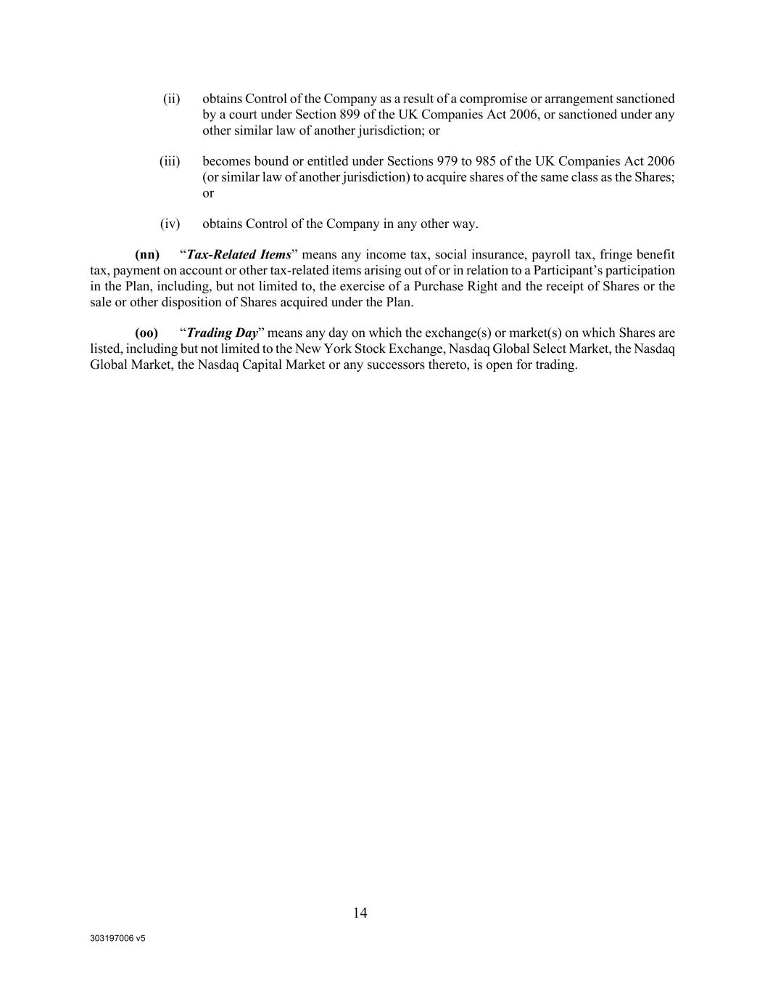
303197006 v5 14 (ii) obtains Control of the Company as a result of a compromise or arrangement sanctioned by a court under Section 899 of the UK Companies Act 2006, or sanctioned under any other similar law of another jurisdiction; or (iii) becomes bound or entitled under Sections 979 to 985 of the UK Companies Act 2006 (or similar law of another jurisdiction) to acquire shares of the same class as the Shares; or (iv) obtains Control of the Company in any other way. (nn) “Tax-Related Items” means any income tax, social insurance, payroll tax, fringe benefit tax, payment on account or other tax-related items arising out of or in relation to a Participant’s participation in the Plan, including, but not limited to, the exercise of a Purchase Right and the receipt of Shares or the sale or other disposition of Shares acquired under the Plan. (oo) “Trading Day” means any day on which the exchange(s) or market(s) on which Shares are listed, including but not limited to the New York Stock Exchange, Nasdaq Global Select Market, the Nasdaq Global Market, the Nasdaq Capital Market or any successors thereto, is open for trading.

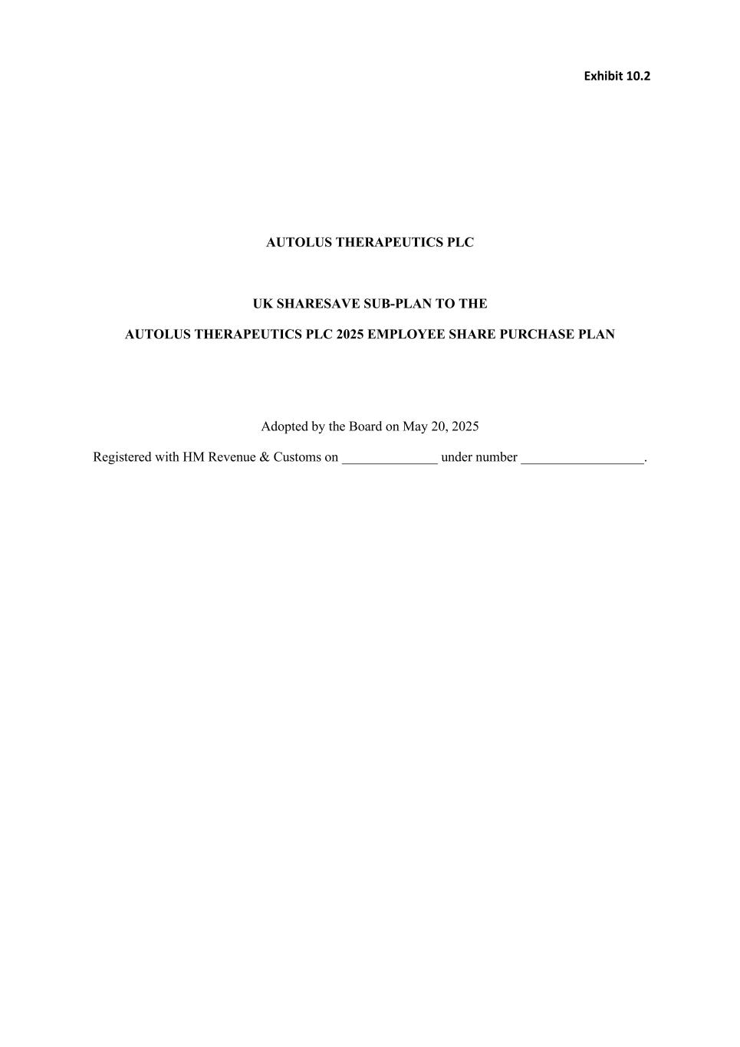
Exhibit 10.2 AUTOLUS THERAPEUTICS PLC UK SHARESAVE SUB-PLAN TO THE AUTOLUS THERAPEUTICS PLC 2025 EMPLOYEE SHARE PURCHASE PLAN Adopted by the Board on May 20, 2025 Registered with HM Revenue & Customs on ______________ under number __________________.

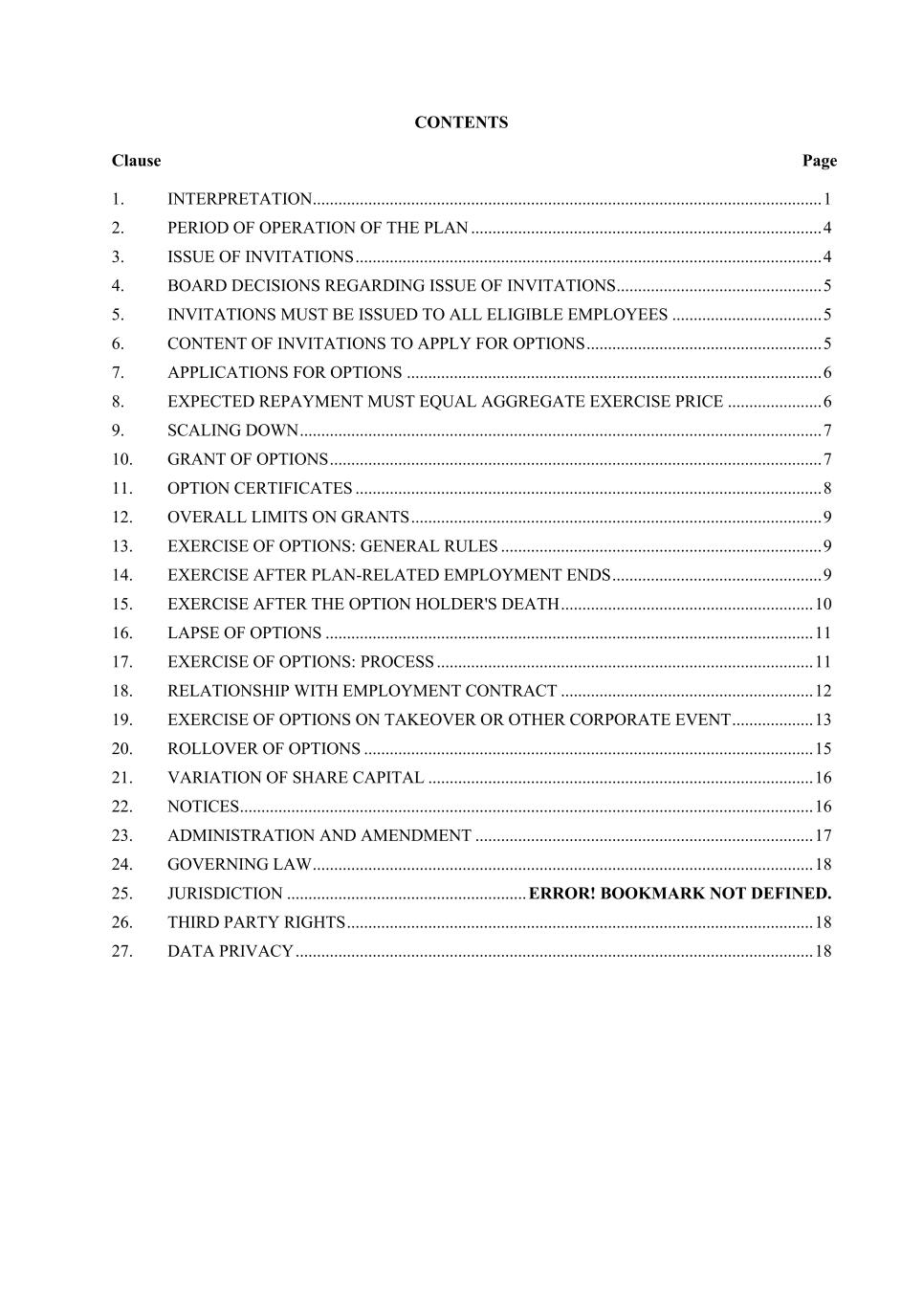
CONTENTS Clause Page 1. INTERPRETATION....................................................................................................................... 1 2. PERIOD OF OPERATION OF THE PLAN .................................................................................. 4 3. ISSUE OF INVITATIONS ............................................................................................................. 4 4. BOARD DECISIONS REGARDING ISSUE OF INVITATIONS................................................ 5 5. INVITATIONS MUST BE ISSUED TO ALL ELIGIBLE EMPLOYEES ................................... 5 6. CONTENT OF INVITATIONS TO APPLY FOR OPTIONS ....................................................... 5 7. APPLICATIONS FOR OPTIONS ................................................................................................. 6 8. EXPECTED REPAYMENT MUST EQUAL AGGREGATE EXERCISE PRICE ...................... 6 9. SCALING DOWN .......................................................................................................................... 7 10. GRANT OF OPTIONS ................................................................................................................... 7 11. OPTION CERTIFICATES ............................................................................................................. 8 12. OVERALL LIMITS ON GRANTS ................................................................................................ 9 13. EXERCISE OF OPTIONS: GENERAL RULES ........................................................................... 9 14. EXERCISE AFTER PLAN-RELATED EMPLOYMENT ENDS ................................................. 9 15. EXERCISE AFTER THE OPTION HOLDER'S DEATH ........................................................... 10 16. LAPSE OF OPTIONS .................................................................................................................. 11 17. EXERCISE OF OPTIONS: PROCESS ........................................................................................ 11 18. RELATIONSHIP WITH EMPLOYMENT CONTRACT ........................................................... 12 19. EXERCISE OF OPTIONS ON TAKEOVER OR OTHER CORPORATE EVENT ................... 13 20. ROLLOVER OF OPTIONS ......................................................................................................... 15 21. VARIATION OF SHARE CAPITAL .......................................................................................... 16 22. NOTICES ...................................................................................................................................... 16 23. ADMINISTRATION AND AMENDMENT ............................................................................... 17 24. GOVERNING LAW ..................................................................................................................... 18 25. JURISDICTION ........................................................ ERROR! BOOKMARK NOT DEFINED. 26. THIRD PARTY RIGHTS ............................................................................................................. 18 27. DATA PRIVACY ......................................................................................................................... 18

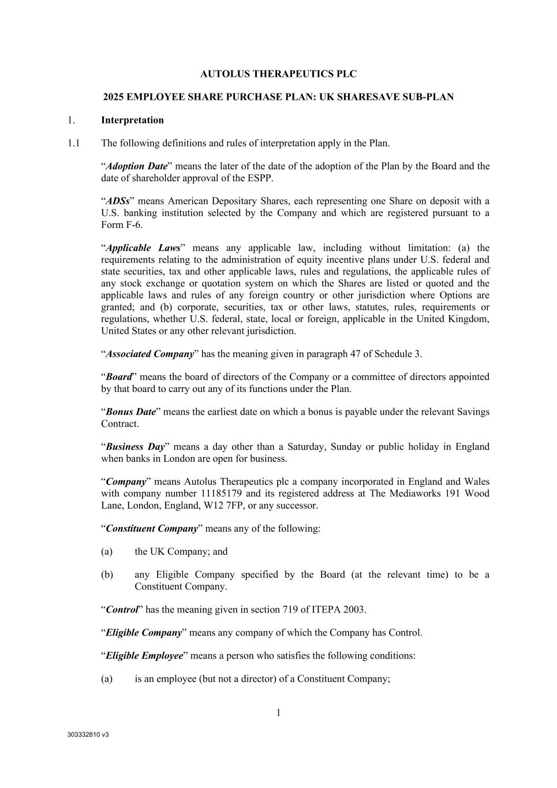
303332810 v3 1 AUTOLUS THERAPEUTICS PLC 2025 EMPLOYEE SHARE PURCHASE PLAN: UK SHARESAVE SUB-PLAN 1. Interpretation 1.1 The following definitions and rules of interpretation apply in the Plan. “Adoption Date” means the later of the date of the adoption of the Plan by the Board and the date of shareholder approval of the ESPP. “ADSs” means American Depositary Shares, each representing one Share on deposit with a U.S. banking institution selected by the Company and which are registered pursuant to a Form F-6. “Applicable Laws” means any applicable law, including without limitation: (a) the requirements relating to the administration of equity incentive plans under U.S. federal and state securities, tax and other applicable laws, rules and regulations, the applicable rules of any stock exchange or quotation system on which the Shares are listed or quoted and the applicable laws and rules of any foreign country or other jurisdiction where Options are granted; and (b) corporate, securities, tax or other laws, statutes, rules, requirements or regulations, whether U.S. federal, state, local or foreign, applicable in the United Kingdom, United States or any other relevant jurisdiction. “Associated Company” has the meaning given in paragraph 47 of Schedule 3. “Board” means the board of directors of the Company or a committee of directors appointed by that board to carry out any of its functions under the Plan. “Bonus Date” means the earliest date on which a bonus is payable under the relevant Savings Contract. “Business Day” means a day other than a Saturday, Sunday or public holiday in England when banks in London are open for business. “Company” means Autolus Therapeutics plc a company incorporated in England and Wales with company number 11185179 and its registered address at The Mediaworks 191 Wood Lane, London, England, W12 7FP, or any successor. “Constituent Company” means any of the following: (a) the UK Company; and (b) any Eligible Company specified by the Board (at the relevant time) to be a Constituent Company. “Control” has the meaning given in section 719 of ITEPA 2003. “Eligible Company” means any company of which the Company has Control. “Eligible Employee” means a person who satisfies the following conditions: (a) is an employee (but not a director) of a Constituent Company;

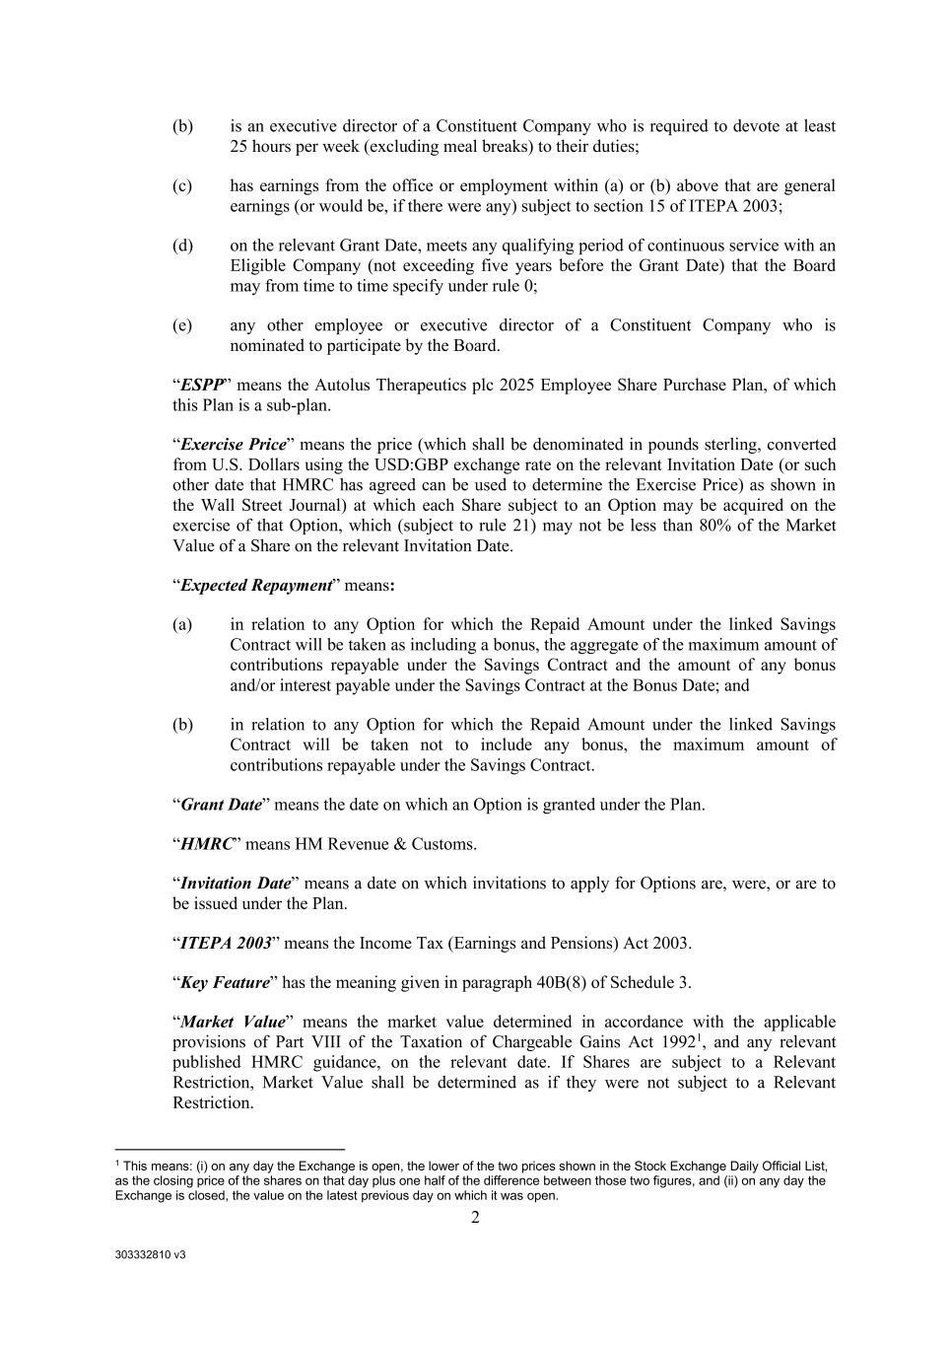
303332810 v3 2 (b) is an executive director of a Constituent Company who is required to devote at least 25 hours per week (excluding meal breaks) to their duties; (c) has earnings from the office or employment within (a) or (b) above that are general earnings (or would be, if there were any) subject to section 15 of ITEPA 2003; (d) on the relevant Grant Date, meets any qualifying period of continuous service with an Eligible Company (not exceeding five years before the Grant Date) that the Board may from time to time specify under rule 0; (e) any other employee or executive director of a Constituent Company who is nominated to participate by the Board. “ESPP” means the Autolus Therapeutics plc 2025 Employee Share Purchase Plan, of which this Plan is a sub-plan. “Exercise Price” means the price (which shall be denominated in pounds sterling, converted from U.S. Dollars using the USD:GBP exchange rate on the relevant Invitation Date (or such other date that HMRC has agreed can be used to determine the Exercise Price) as shown in the Wall Street Journal) at which each Share subject to an Option may be acquired on the exercise of that Option, which (subject to rule 21) may not be less than 80% of the Market Value of a Share on the relevant Invitation Date. “Expected Repayment” means: (a) in relation to any Option for which the Repaid Amount under the linked Savings Contract will be taken as including a bonus, the aggregate of the maximum amount of contributions repayable under the Savings Contract and the amount of any bonus and/or interest payable under the Savings Contract at the Bonus Date; and (b) in relation to any Option for which the Repaid Amount under the linked Savings Contract will be taken not to include any bonus, the maximum amount of contributions repayable under the Savings Contract. “Grant Date” means the date on which an Option is granted under the Plan. “HMRC” means HM Revenue & Customs. “Invitation Date” means a date on which invitations to apply for Options are, were, or are to be issued under the Plan. “ITEPA 2003” means the Income Tax (Earnings and Pensions) Act 2003. “Key Feature” has the meaning given in paragraph 40B(8) of Schedule 3. “Market Value” means the market value determined in accordance with the applicable provisions of Part VIII of the Taxation of Chargeable Gains Act 19921, and any relevant published HMRC guidance, on the relevant date. If Shares are subject to a Relevant Restriction, Market Value shall be determined as if they were not subject to a Relevant Restriction. 1 This means: (i) on any day the Exchange is open, the lower of the two prices shown in the Stock Exchange Daily Official List, as the closing price of the shares on that day plus one half of the difference between those two figures, and (ii) on any day the Exchange is closed, the value on the latest previous day on which it was open.

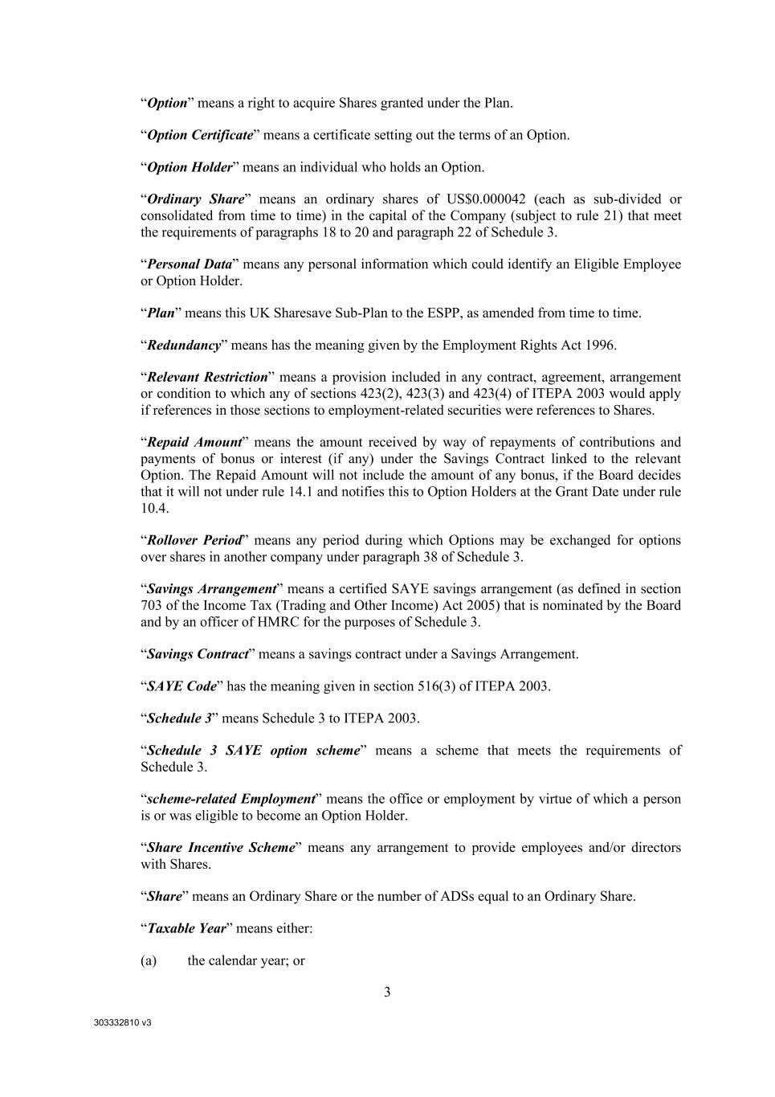
303332810 v3 3 “Option” means a right to acquire Shares granted under the Plan. “Option Certificate” means a certificate setting out the terms of an Option. “Option Holder” means an individual who holds an Option. “Ordinary Share” means an ordinary shares of US$0.000042 (each as sub-divided or consolidated from time to time) in the capital of the Company (subject to rule 21) that meet the requirements of paragraphs 18 to 20 and paragraph 22 of Schedule 3. “Personal Data” means any personal information which could identify an Eligible Employee or Option Holder. “Plan” means this UK Sharesave Sub-Plan to the ESPP, as amended from time to time. “Redundancy” means has the meaning given by the Employment Rights Act 1996. “Relevant Restriction” means a provision included in any contract, agreement, arrangement or condition to which any of sections 423(2), 423(3) and 423(4) of ITEPA 2003 would apply if references in those sections to employment-related securities were references to Shares. “Repaid Amount” means the amount received by way of repayments of contributions and payments of bonus or interest (if any) under the Savings Contract linked to the relevant Option. The Repaid Amount will not include the amount of any bonus, if the Board decides that it will not under rule 14.1 and notifies this to Option Holders at the Grant Date under rule 10.4. “Rollover Period” means any period during which Options may be exchanged for options over shares in another company under paragraph 38 of Schedule 3. “Savings Arrangement” means a certified SAYE savings arrangement (as defined in section 703 of the Income Tax (Trading and Other Income) Act 2005) that is nominated by the Board and by an officer of HMRC for the purposes of Schedule 3. “Savings Contract” means a savings contract under a Savings Arrangement. “SAYE Code” has the meaning given in section 516(3) of ITEPA 2003. “Schedule 3” means Schedule 3 to ITEPA 2003. “Schedule 3 SAYE option scheme” means a scheme that meets the requirements of Schedule 3. “scheme-related Employment” means the office or employment by virtue of which a person is or was eligible to become an Option Holder. “Share Incentive Scheme” means any arrangement to provide employees and/or directors with Shares. “Share” means an Ordinary Share or the number of ADSs equal to an Ordinary Share. “Taxable Year” means either: (a) the calendar year; or

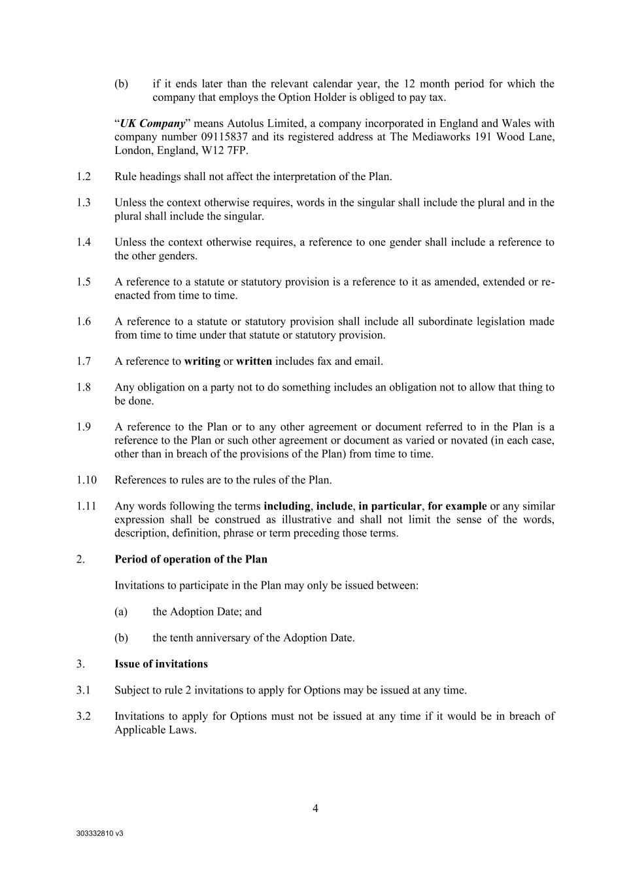
303332810 v3 4 (b) if it ends later than the relevant calendar year, the 12 month period for which the company that employs the Option Holder is obliged to pay tax. “UK Company” means Autolus Limited, a company incorporated in England and Wales with company number 09115837 and its registered address at The Mediaworks 191 Wood Lane, London, England, W12 7FP. 1.2 Rule headings shall not affect the interpretation of the Plan. 1.3 Unless the context otherwise requires, words in the singular shall include the plural and in the plural shall include the singular. 1.4 Unless the context otherwise requires, a reference to one gender shall include a reference to the other genders. 1.5 A reference to a statute or statutory provision is a reference to it as amended, extended or re- enacted from time to time. 1.6 A reference to a statute or statutory provision shall include all subordinate legislation made from time to time under that statute or statutory provision. 1.7 A reference to writing or written includes fax and email. 1.8 Any obligation on a party not to do something includes an obligation not to allow that thing to be done. 1.9 A reference to the Plan or to any other agreement or document referred to in the Plan is a reference to the Plan or such other agreement or document as varied or novated (in each case, other than in breach of the provisions of the Plan) from time to time. 1.10 References to rules are to the rules of the Plan. 1.11 Any words following the terms including, include, in particular, for example or any similar expression shall be construed as illustrative and shall not limit the sense of the words, description, definition, phrase or term preceding those terms. 2. Period of operation of the Plan Invitations to participate in the Plan may only be issued between: (a) the Adoption Date; and (b) the tenth anniversary of the Adoption Date. 3. Issue of invitations 3.1 Subject to rule 2 invitations to apply for Options may be issued at any time. 3.2 Invitations to apply for Options must not be issued at any time if it would be in breach of Applicable Laws.

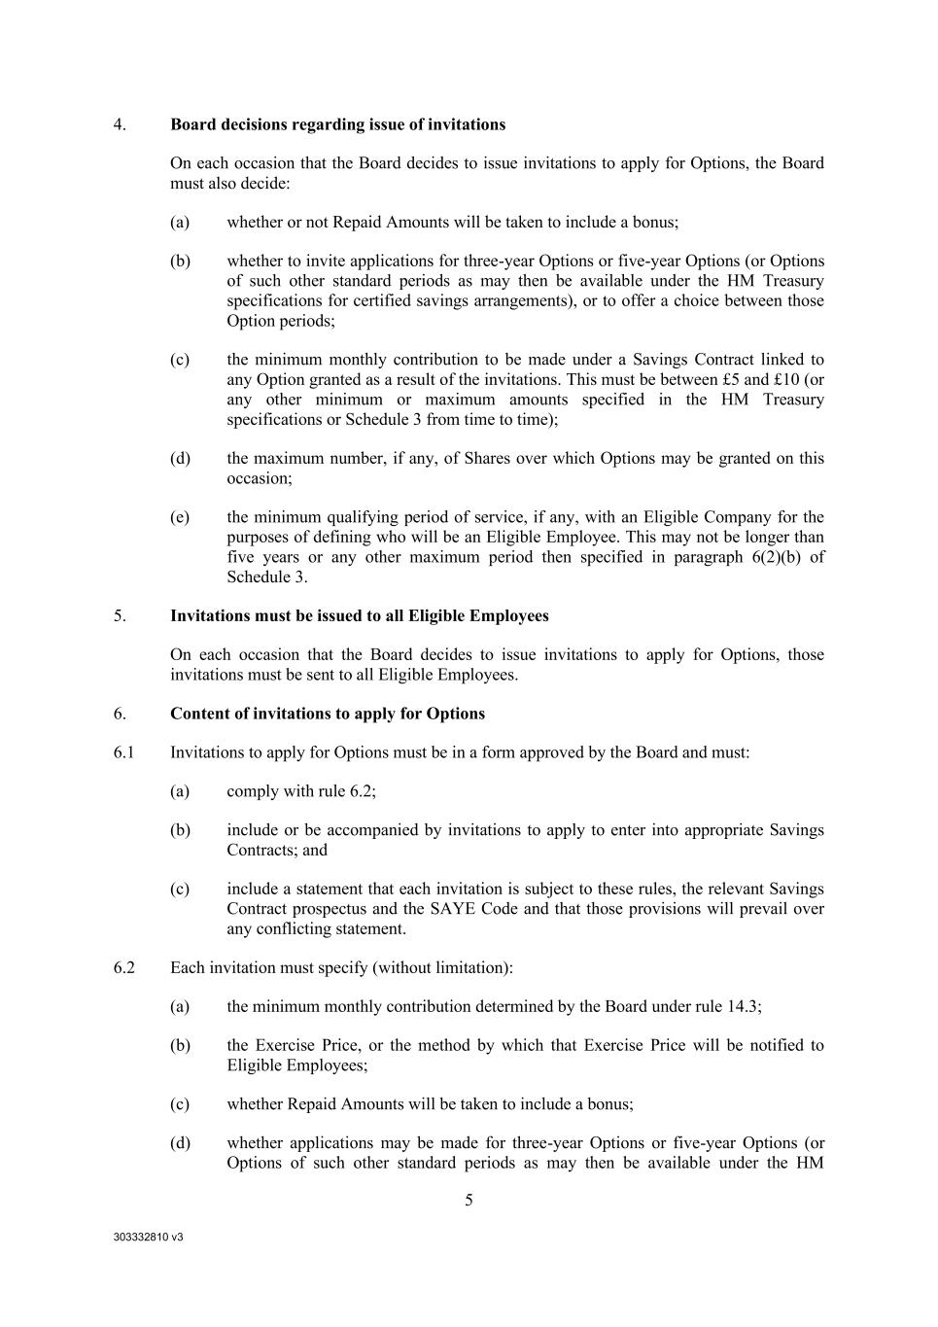
303332810 v3 5 4. Board decisions regarding issue of invitations On each occasion that the Board decides to issue invitations to apply for Options, the Board must also decide: (a) whether or not Repaid Amounts will be taken to include a bonus; (b) whether to invite applications for three-year Options or five-year Options (or Options of such other standard periods as may then be available under the HM Treasury specifications for certified savings arrangements), or to offer a choice between those Option periods; (c) the minimum monthly contribution to be made under a Savings Contract linked to any Option granted as a result of the invitations. This must be between £5 and £10 (or any other minimum or maximum amounts specified in the HM Treasury specifications or Schedule 3 from time to time); (d) the maximum number, if any, of Shares over which Options may be granted on this occasion; (e) the minimum qualifying period of service, if any, with an Eligible Company for the purposes of defining who will be an Eligible Employee. This may not be longer than five years or any other maximum period then specified in paragraph 6(2)(b) of Schedule 3. 5. Invitations must be issued to all Eligible Employees On each occasion that the Board decides to issue invitations to apply for Options, those invitations must be sent to all Eligible Employees. 6. Content of invitations to apply for Options 6.1 Invitations to apply for Options must be in a form approved by the Board and must: (a) comply with rule 6.2; (b) include or be accompanied by invitations to apply to enter into appropriate Savings Contracts; and (c) include a statement that each invitation is subject to these rules, the relevant Savings Contract prospectus and the SAYE Code and that those provisions will prevail over any conflicting statement. 6.2 Each invitation must specify (without limitation): (a) the minimum monthly contribution determined by the Board under rule 14.3; (b) the Exercise Price, or the method by which that Exercise Price will be notified to Eligible Employees; (c) whether Repaid Amounts will be taken to include a bonus; (d) whether applications may be made for three-year Options or five-year Options (or Options of such other standard periods as may then be available under the HM

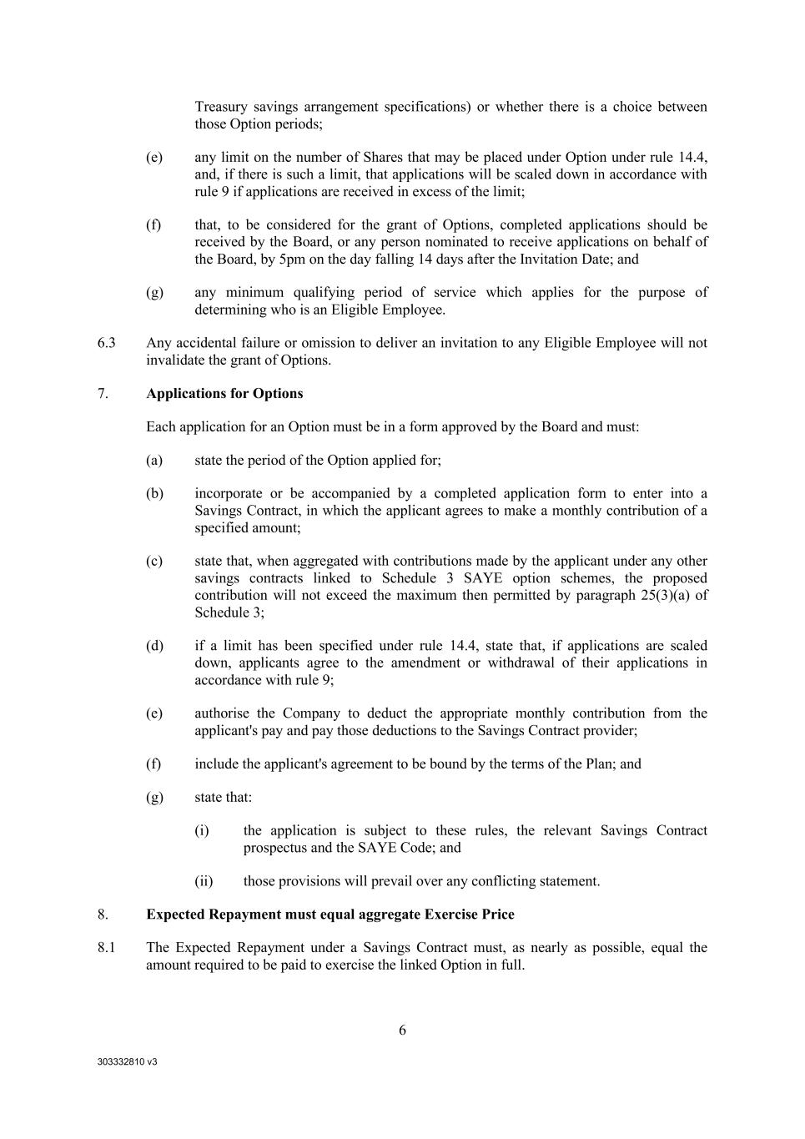
303332810 v3 6 Treasury savings arrangement specifications) or whether there is a choice between those Option periods; (e) any limit on the number of Shares that may be placed under Option under rule 14.4, and, if there is such a limit, that applications will be scaled down in accordance with rule 9 if applications are received in excess of the limit; (f) that, to be considered for the grant of Options, completed applications should be received by the Board, or any person nominated to receive applications on behalf of the Board, by 5pm on the day falling 14 days after the Invitation Date; and (g) any minimum qualifying period of service which applies for the purpose of determining who is an Eligible Employee. 6.3 Any accidental failure or omission to deliver an invitation to any Eligible Employee will not invalidate the grant of Options. 7. Applications for Options Each application for an Option must be in a form approved by the Board and must: (a) state the period of the Option applied for; (b) incorporate or be accompanied by a completed application form to enter into a Savings Contract, in which the applicant agrees to make a monthly contribution of a specified amount; (c) state that, when aggregated with contributions made by the applicant under any other savings contracts linked to Schedule 3 SAYE option schemes, the proposed contribution will not exceed the maximum then permitted by paragraph 25(3)(a) of Schedule 3; (d) if a limit has been specified under rule 14.4, state that, if applications are scaled down, applicants agree to the amendment or withdrawal of their applications in accordance with rule 9; (e) authorise the Company to deduct the appropriate monthly contribution from the applicant's pay and pay those deductions to the Savings Contract provider; (f) include the applicant's agreement to be bound by the terms of the Plan; and (g) state that: (i) the application is subject to these rules, the relevant Savings Contract prospectus and the SAYE Code; and (ii) those provisions will prevail over any conflicting statement. 8. Expected Repayment must equal aggregate Exercise Price 8.1 The Expected Repayment under a Savings Contract must, as nearly as possible, equal the amount required to be paid to exercise the linked Option in full.

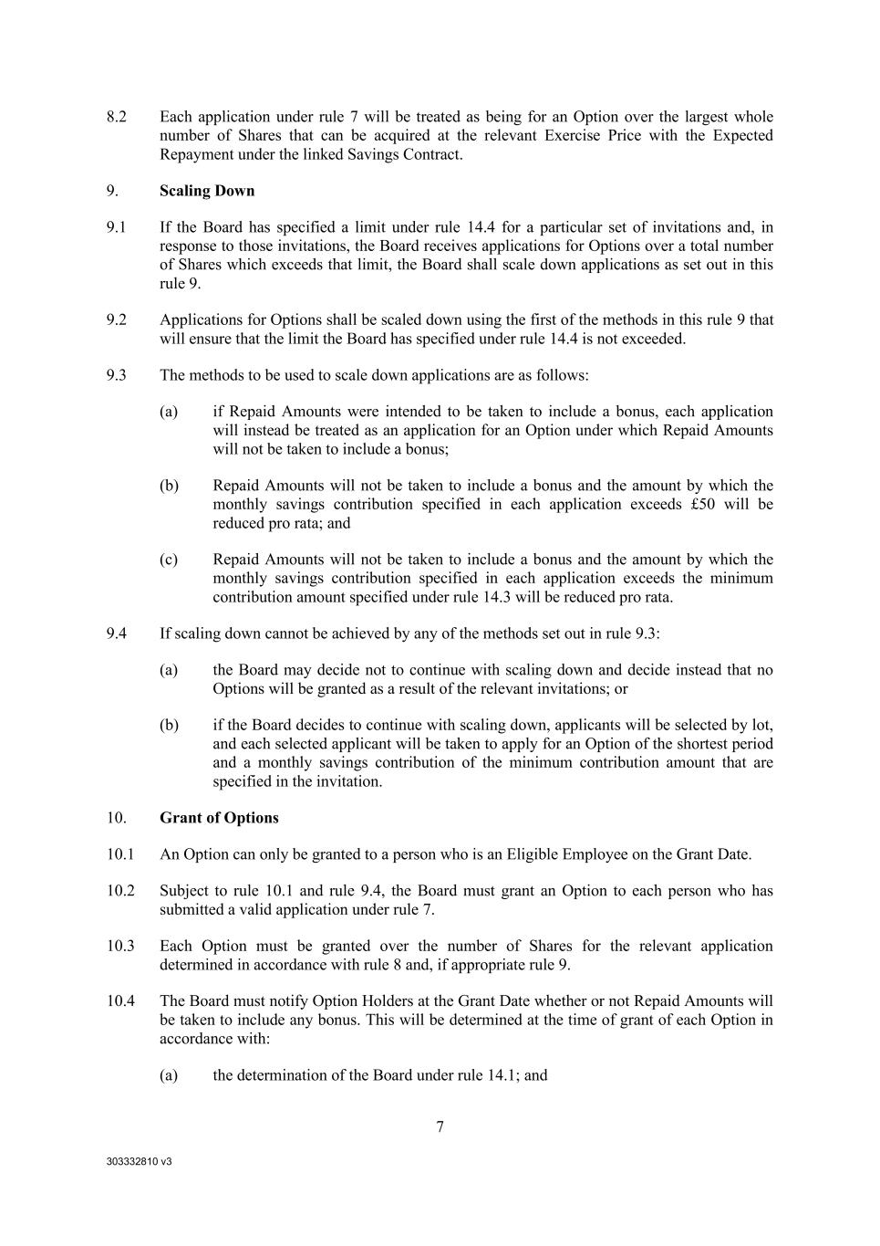
303332810 v3 7 8.2 Each application under rule 7 will be treated as being for an Option over the largest whole number of Shares that can be acquired at the relevant Exercise Price with the Expected Repayment under the linked Savings Contract. 9. Scaling Down 9.1 If the Board has specified a limit under rule 14.4 for a particular set of invitations and, in response to those invitations, the Board receives applications for Options over a total number of Shares which exceeds that limit, the Board shall scale down applications as set out in this rule 9. 9.2 Applications for Options shall be scaled down using the first of the methods in this rule 9 that will ensure that the limit the Board has specified under rule 14.4 is not exceeded. 9.3 The methods to be used to scale down applications are as follows: (a) if Repaid Amounts were intended to be taken to include a bonus, each application will instead be treated as an application for an Option under which Repaid Amounts will not be taken to include a bonus; (b) Repaid Amounts will not be taken to include a bonus and the amount by which the monthly savings contribution specified in each application exceeds £50 will be reduced pro rata; and (c) Repaid Amounts will not be taken to include a bonus and the amount by which the monthly savings contribution specified in each application exceeds the minimum contribution amount specified under rule 14.3 will be reduced pro rata. 9.4 If scaling down cannot be achieved by any of the methods set out in rule 9.3: (a) the Board may decide not to continue with scaling down and decide instead that no Options will be granted as a result of the relevant invitations; or (b) if the Board decides to continue with scaling down, applicants will be selected by lot, and each selected applicant will be taken to apply for an Option of the shortest period and a monthly savings contribution of the minimum contribution amount that are specified in the invitation. 10. Grant of Options 10.1 An Option can only be granted to a person who is an Eligible Employee on the Grant Date. 10.2 Subject to rule 10.1 and rule 9.4, the Board must grant an Option to each person who has submitted a valid application under rule 7. 10.3 Each Option must be granted over the number of Shares for the relevant application determined in accordance with rule 8 and, if appropriate rule 9. 10.4 The Board must notify Option Holders at the Grant Date whether or not Repaid Amounts will be taken to include any bonus. This will be determined at the time of grant of each Option in accordance with: (a) the determination of the Board under rule 14.1; and

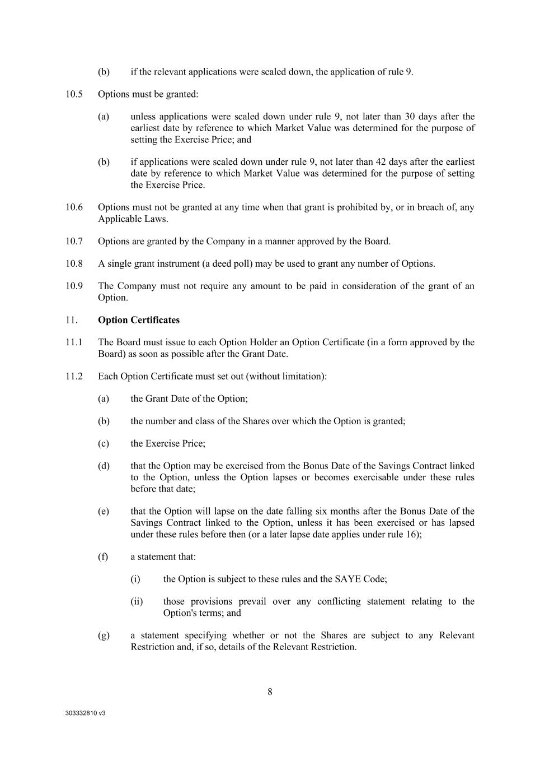
303332810 v3 8 (b) if the relevant applications were scaled down, the application of rule 9. 10.5 Options must be granted: (a) unless applications were scaled down under rule 9, not later than 30 days after the earliest date by reference to which Market Value was determined for the purpose of setting the Exercise Price; and (b) if applications were scaled down under rule 9, not later than 42 days after the earliest date by reference to which Market Value was determined for the purpose of setting the Exercise Price. 10.6 Options must not be granted at any time when that grant is prohibited by, or in breach of, any Applicable Laws. 10.7 Options are granted by the Company in a manner approved by the Board. 10.8 A single grant instrument (a deed poll) may be used to grant any number of Options. 10.9 The Company must not require any amount to be paid in consideration of the grant of an Option. 11. Option Certificates 11.1 The Board must issue to each Option Holder an Option Certificate (in a form approved by the Board) as soon as possible after the Grant Date. 11.2 Each Option Certificate must set out (without limitation): (a) the Grant Date of the Option; (b) the number and class of the Shares over which the Option is granted; (c) the Exercise Price; (d) that the Option may be exercised from the Bonus Date of the Savings Contract linked to the Option, unless the Option lapses or becomes exercisable under these rules before that date; (e) that the Option will lapse on the date falling six months after the Bonus Date of the Savings Contract linked to the Option, unless it has been exercised or has lapsed under these rules before then (or a later lapse date applies under rule 16); (f) a statement that: (i) the Option is subject to these rules and the SAYE Code; (ii) those provisions prevail over any conflicting statement relating to the Option's terms; and (g) a statement specifying whether or not the Shares are subject to any Relevant Restriction and, if so, details of the Relevant Restriction.

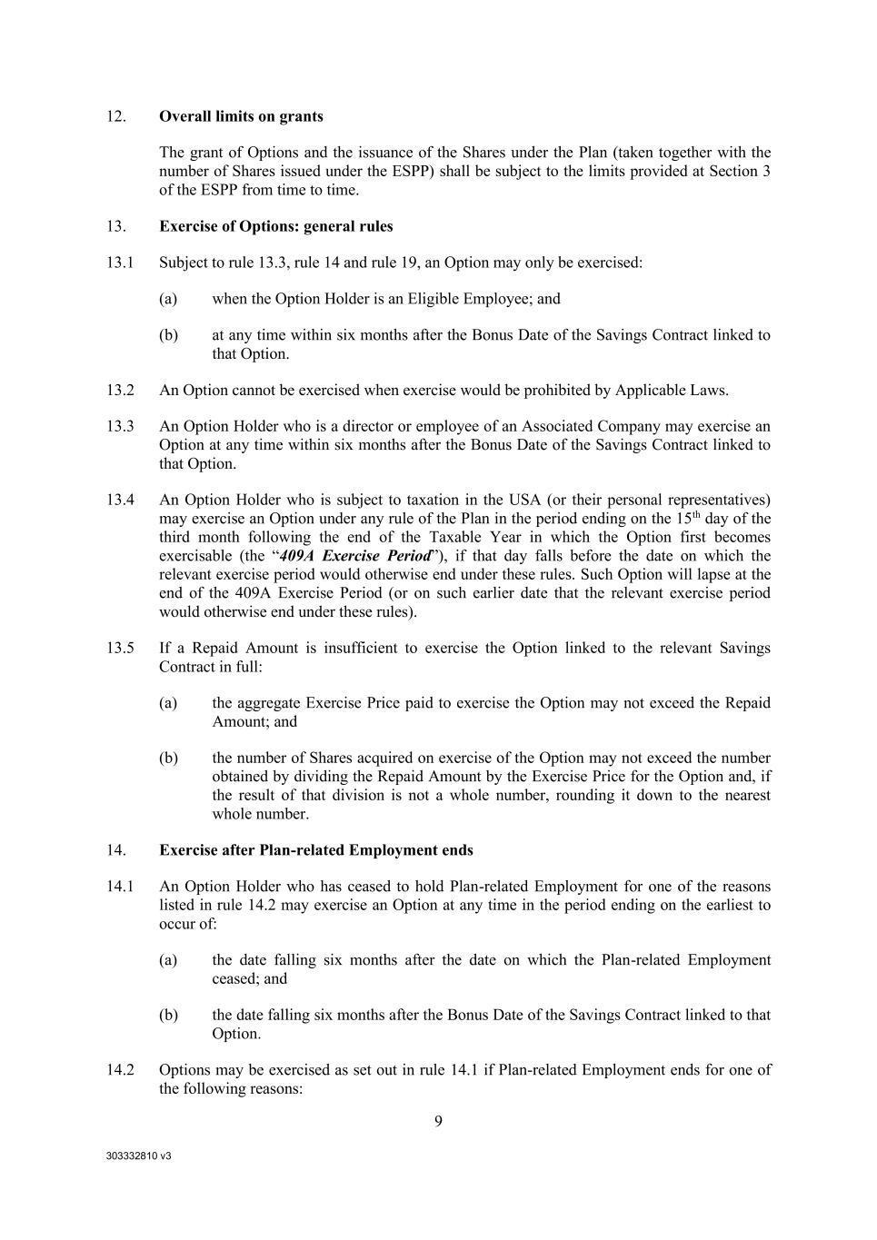
303332810 v3 9 12. Overall limits on grants The grant of Options and the issuance of the Shares under the Plan (taken together with the number of Shares issued under the ESPP) shall be subject to the limits provided at Section 3 of the ESPP from time to time. 13. Exercise of Options: general rules 13.1 Subject to rule 13.3, rule 14 and rule 19, an Option may only be exercised: (a) when the Option Holder is an Eligible Employee; and (b) at any time within six months after the Bonus Date of the Savings Contract linked to that Option. 13.2 An Option cannot be exercised when exercise would be prohibited by Applicable Laws. 13.3 An Option Holder who is a director or employee of an Associated Company may exercise an Option at any time within six months after the Bonus Date of the Savings Contract linked to that Option. 13.4 An Option Holder who is subject to taxation in the USA (or their personal representatives) may exercise an Option under any rule of the Plan in the period ending on the 15th day of the third month following the end of the Taxable Year in which the Option first becomes exercisable (the “409A Exercise Period”), if that day falls before the date on which the relevant exercise period would otherwise end under these rules. Such Option will lapse at the end of the 409A Exercise Period (or on such earlier date that the relevant exercise period would otherwise end under these rules). 13.5 If a Repaid Amount is insufficient to exercise the Option linked to the relevant Savings Contract in full: (a) the aggregate Exercise Price paid to exercise the Option may not exceed the Repaid Amount; and (b) the number of Shares acquired on exercise of the Option may not exceed the number obtained by dividing the Repaid Amount by the Exercise Price for the Option and, if the result of that division is not a whole number, rounding it down to the nearest whole number. 14. Exercise after Plan-related Employment ends 14.1 An Option Holder who has ceased to hold Plan-related Employment for one of the reasons listed in rule 14.2 may exercise an Option at any time in the period ending on the earliest to occur of: (a) the date falling six months after the date on which the Plan-related Employment ceased; and (b) the date falling six months after the Bonus Date of the Savings Contract linked to that Option. 14.2 Options may be exercised as set out in rule 14.1 if Plan-related Employment ends for one of the following reasons:

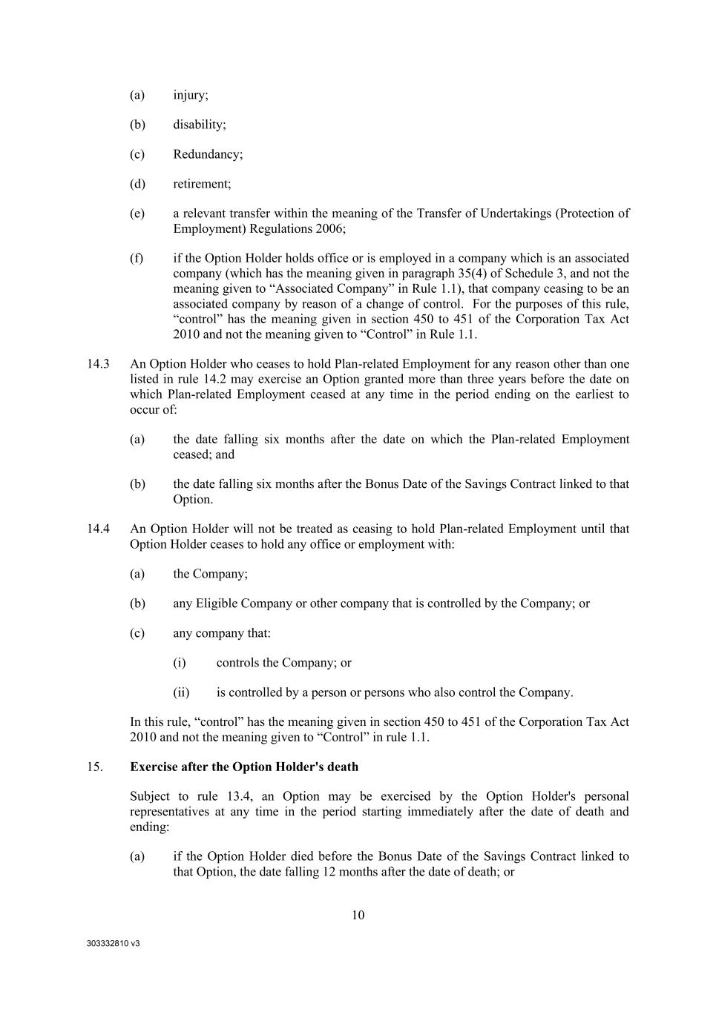
303332810 v3 10 (a) injury; (b) disability; (c) Redundancy; (d) retirement; (e) a relevant transfer within the meaning of the Transfer of Undertakings (Protection of Employment) Regulations 2006; (f) if the Option Holder holds office or is employed in a company which is an associated company (which has the meaning given in paragraph 35(4) of Schedule 3, and not the meaning given to “Associated Company” in Rule 1.1), that company ceasing to be an associated company by reason of a change of control. For the purposes of this rule, “control” has the meaning given in section 450 to 451 of the Corporation Tax Act 2010 and not the meaning given to “Control” in Rule 1.1. 14.3 An Option Holder who ceases to hold Plan-related Employment for any reason other than one listed in rule 14.2 may exercise an Option granted more than three years before the date on which Plan-related Employment ceased at any time in the period ending on the earliest to occur of: (a) the date falling six months after the date on which the Plan-related Employment ceased; and (b) the date falling six months after the Bonus Date of the Savings Contract linked to that Option. 14.4 An Option Holder will not be treated as ceasing to hold Plan-related Employment until that Option Holder ceases to hold any office or employment with: (a) the Company; (b) any Eligible Company or other company that is controlled by the Company; or (c) any company that: (i) controls the Company; or (ii) is controlled by a person or persons who also control the Company. In this rule, “control” has the meaning given in section 450 to 451 of the Corporation Tax Act 2010 and not the meaning given to “Control” in rule 1.1. 15. Exercise after the Option Holder's death Subject to rule 13.4, an Option may be exercised by the Option Holder's personal representatives at any time in the period starting immediately after the date of death and ending: (a) if the Option Holder died before the Bonus Date of the Savings Contract linked to that Option, the date falling 12 months after the date of death; or

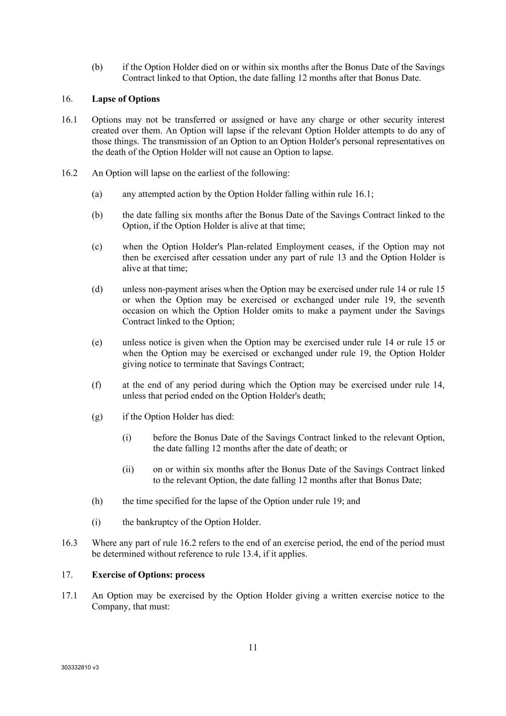
303332810 v3 11 (b) if the Option Holder died on or within six months after the Bonus Date of the Savings Contract linked to that Option, the date falling 12 months after that Bonus Date. 16. Lapse of Options 16.1 Options may not be transferred or assigned or have any charge or other security interest created over them. An Option will lapse if the relevant Option Holder attempts to do any of those things. The transmission of an Option to an Option Holder's personal representatives on the death of the Option Holder will not cause an Option to lapse. 16.2 An Option will lapse on the earliest of the following: (a) any attempted action by the Option Holder falling within rule 16.1; (b) the date falling six months after the Bonus Date of the Savings Contract linked to the Option, if the Option Holder is alive at that time; (c) when the Option Holder's Plan-related Employment ceases, if the Option may not then be exercised after cessation under any part of rule 13 and the Option Holder is alive at that time; (d) unless non-payment arises when the Option may be exercised under rule 14 or rule 15 or when the Option may be exercised or exchanged under rule 19, the seventh occasion on which the Option Holder omits to make a payment under the Savings Contract linked to the Option; (e) unless notice is given when the Option may be exercised under rule 14 or rule 15 or when the Option may be exercised or exchanged under rule 19, the Option Holder giving notice to terminate that Savings Contract; (f) at the end of any period during which the Option may be exercised under rule 14, unless that period ended on the Option Holder's death; (g) if the Option Holder has died: (i) before the Bonus Date of the Savings Contract linked to the relevant Option, the date falling 12 months after the date of death; or (ii) on or within six months after the Bonus Date of the Savings Contract linked to the relevant Option, the date falling 12 months after that Bonus Date; (h) the time specified for the lapse of the Option under rule 19; and (i) the bankruptcy of the Option Holder. 16.3 Where any part of rule 16.2 refers to the end of an exercise period, the end of the period must be determined without reference to rule 13.4, if it applies. 17. Exercise of Options: process 17.1 An Option may be exercised by the Option Holder giving a written exercise notice to the Company, that must:

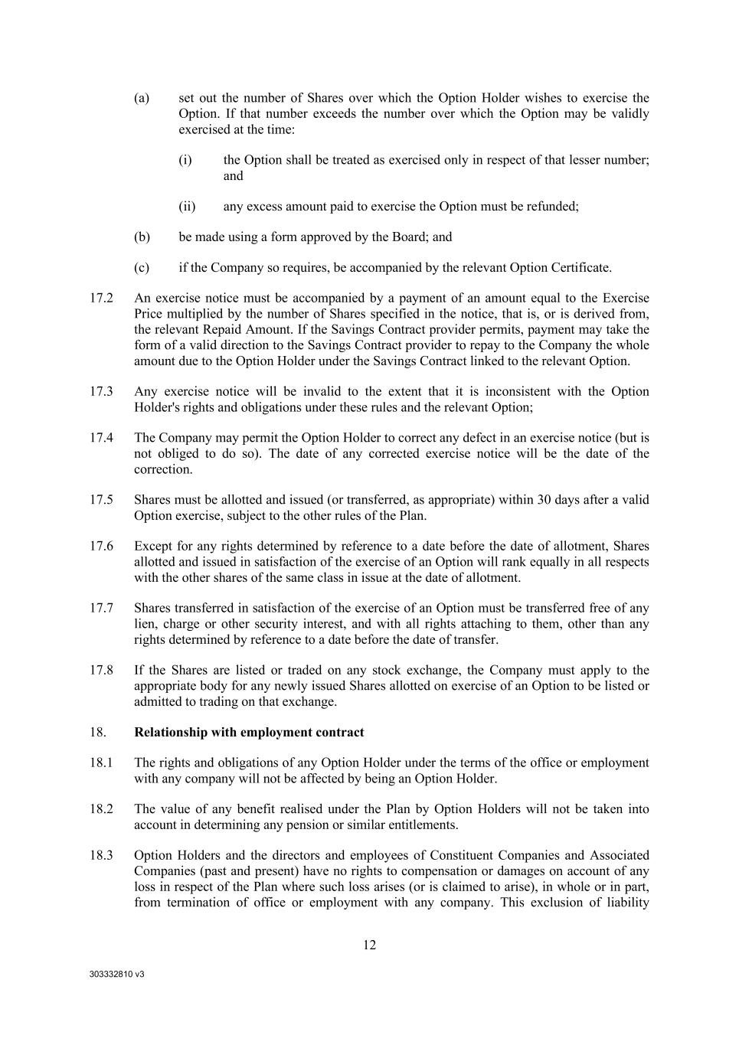
303332810 v3 12 (a) set out the number of Shares over which the Option Holder wishes to exercise the Option. If that number exceeds the number over which the Option may be validly exercised at the time: (i) the Option shall be treated as exercised only in respect of that lesser number; and (ii) any excess amount paid to exercise the Option must be refunded; (b) be made using a form approved by the Board; and (c) if the Company so requires, be accompanied by the relevant Option Certificate. 17.2 An exercise notice must be accompanied by a payment of an amount equal to the Exercise Price multiplied by the number of Shares specified in the notice, that is, or is derived from, the relevant Repaid Amount. If the Savings Contract provider permits, payment may take the form of a valid direction to the Savings Contract provider to repay to the Company the whole amount due to the Option Holder under the Savings Contract linked to the relevant Option. 17.3 Any exercise notice will be invalid to the extent that it is inconsistent with the Option Holder's rights and obligations under these rules and the relevant Option; 17.4 The Company may permit the Option Holder to correct any defect in an exercise notice (but is not obliged to do so). The date of any corrected exercise notice will be the date of the correction. 17.5 Shares must be allotted and issued (or transferred, as appropriate) within 30 days after a valid Option exercise, subject to the other rules of the Plan. 17.6 Except for any rights determined by reference to a date before the date of allotment, Shares allotted and issued in satisfaction of the exercise of an Option will rank equally in all respects with the other shares of the same class in issue at the date of allotment. 17.7 Shares transferred in satisfaction of the exercise of an Option must be transferred free of any lien, charge or other security interest, and with all rights attaching to them, other than any rights determined by reference to a date before the date of transfer. 17.8 If the Shares are listed or traded on any stock exchange, the Company must apply to the appropriate body for any newly issued Shares allotted on exercise of an Option to be listed or admitted to trading on that exchange. 18. Relationship with employment contract 18.1 The rights and obligations of any Option Holder under the terms of the office or employment with any company will not be affected by being an Option Holder. 18.2 The value of any benefit realised under the Plan by Option Holders will not be taken into account in determining any pension or similar entitlements. 18.3 Option Holders and the directors and employees of Constituent Companies and Associated Companies (past and present) have no rights to compensation or damages on account of any loss in respect of the Plan where such loss arises (or is claimed to arise), in whole or in part, from termination of office or employment with any company. This exclusion of liability

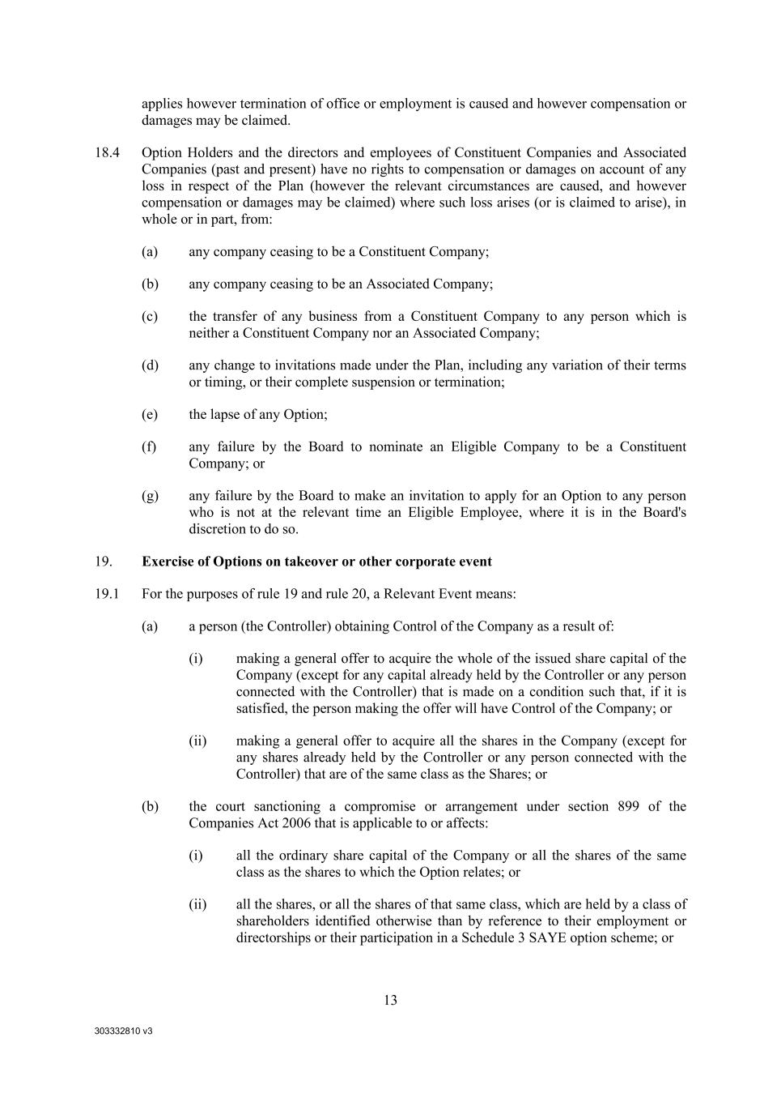
303332810 v3 13 applies however termination of office or employment is caused and however compensation or damages may be claimed. 18.4 Option Holders and the directors and employees of Constituent Companies and Associated Companies (past and present) have no rights to compensation or damages on account of any loss in respect of the Plan (however the relevant circumstances are caused, and however compensation or damages may be claimed) where such loss arises (or is claimed to arise), in whole or in part, from: (a) any company ceasing to be a Constituent Company; (b) any company ceasing to be an Associated Company; (c) the transfer of any business from a Constituent Company to any person which is neither a Constituent Company nor an Associated Company; (d) any change to invitations made under the Plan, including any variation of their terms or timing, or their complete suspension or termination; (e) the lapse of any Option; (f) any failure by the Board to nominate an Eligible Company to be a Constituent Company; or (g) any failure by the Board to make an invitation to apply for an Option to any person who is not at the relevant time an Eligible Employee, where it is in the Board's discretion to do so. 19. Exercise of Options on takeover or other corporate event 19.1 For the purposes of rule 19 and rule 20, a Relevant Event means: (a) a person (the Controller) obtaining Control of the Company as a result of: (i) making a general offer to acquire the whole of the issued share capital of the Company (except for any capital already held by the Controller or any person connected with the Controller) that is made on a condition such that, if it is satisfied, the person making the offer will have Control of the Company; or (ii) making a general offer to acquire all the shares in the Company (except for any shares already held by the Controller or any person connected with the Controller) that are of the same class as the Shares; or (b) the court sanctioning a compromise or arrangement under section 899 of the Companies Act 2006 that is applicable to or affects: (i) all the ordinary share capital of the Company or all the shares of the same class as the shares to which the Option relates; or (ii) all the shares, or all the shares of that same class, which are held by a class of shareholders identified otherwise than by reference to their employment or directorships or their participation in a Schedule 3 SAYE option scheme; or

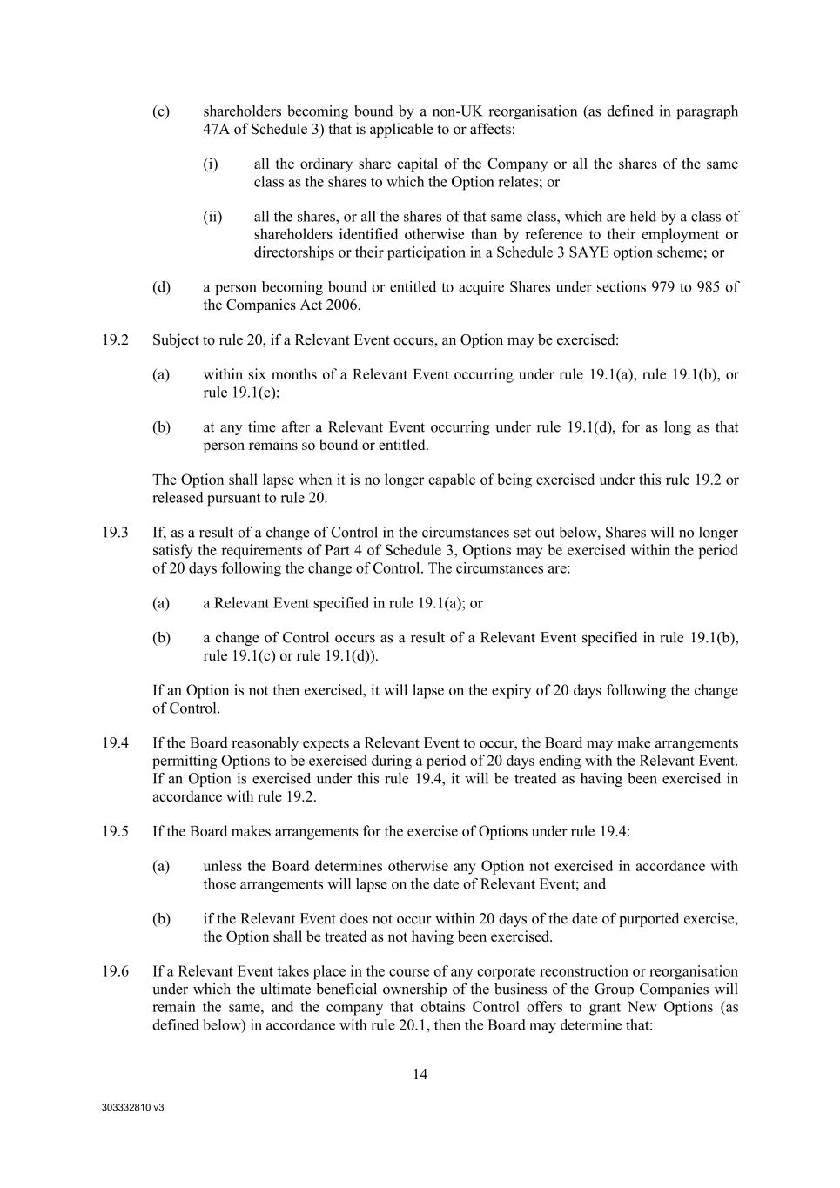
303332810 v3 14 (c) shareholders becoming bound by a non-UK reorganisation (as defined in paragraph 47A of Schedule 3) that is applicable to or affects: (i) all the ordinary share capital of the Company or all the shares of the same class as the shares to which the Option relates; or (ii) all the shares, or all the shares of that same class, which are held by a class of shareholders identified otherwise than by reference to their employment or directorships or their participation in a Schedule 3 SAYE option scheme; or (d) a person becoming bound or entitled to acquire Shares under sections 979 to 985 of the Companies Act 2006. 19.2 Subject to rule 20, if a Relevant Event occurs, an Option may be exercised: (a) within six months of a Relevant Event occurring under rule 19.1(a), rule 19.1(b), or rule 19.1(c); (b) at any time after a Relevant Event occurring under rule 19.1(d), for as long as that person remains so bound or entitled. The Option shall lapse when it is no longer capable of being exercised under this rule 19.2 or released pursuant to rule 20. 19.3 If, as a result of a change of Control in the circumstances set out below, Shares will no longer satisfy the requirements of Part 4 of Schedule 3, Options may be exercised within the period of 20 days following the change of Control. The circumstances are: (a) a Relevant Event specified in rule 19.1(a); or (b) a change of Control occurs as a result of a Relevant Event specified in rule 19.1(b), rule 19.1(c) or rule 19.1(d)). If an Option is not then exercised, it will lapse on the expiry of 20 days following the change of Control. 19.4 If the Board reasonably expects a Relevant Event to occur, the Board may make arrangements permitting Options to be exercised during a period of 20 days ending with the Relevant Event. If an Option is exercised under this rule 19.4, it will be treated as having been exercised in accordance with rule 19.2. 19.5 If the Board makes arrangements for the exercise of Options under rule 19.4: (a) unless the Board determines otherwise any Option not exercised in accordance with those arrangements will lapse on the date of Relevant Event; and (b) if the Relevant Event does not occur within 20 days of the date of purported exercise, the Option shall be treated as not having been exercised. 19.6 If a Relevant Event takes place in the course of any corporate reconstruction or reorganisation under which the ultimate beneficial ownership of the business of the Group Companies will remain the same, and the company that obtains Control offers to grant New Options (as defined below) in accordance with rule 20.1, then the Board may determine that:

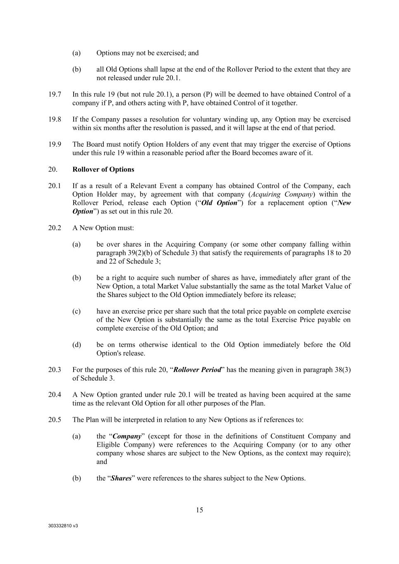
303332810 v3 15 (a) Options may not be exercised; and (b) all Old Options shall lapse at the end of the Rollover Period to the extent that they are not released under rule 20.1. 19.7 In this rule 19 (but not rule 20.1), a person (P) will be deemed to have obtained Control of a company if P, and others acting with P, have obtained Control of it together. 19.8 If the Company passes a resolution for voluntary winding up, any Option may be exercised within six months after the resolution is passed, and it will lapse at the end of that period. 19.9 The Board must notify Option Holders of any event that may trigger the exercise of Options under this rule 19 within a reasonable period after the Board becomes aware of it. 20. Rollover of Options 20.1 If as a result of a Relevant Event a company has obtained Control of the Company, each Option Holder may, by agreement with that company (Acquiring Company) within the Rollover Period, release each Option (“Old Option”) for a replacement option (“New Option”) as set out in this rule 20. 20.2 A New Option must: (a) be over shares in the Acquiring Company (or some other company falling within paragraph 39(2)(b) of Schedule 3) that satisfy the requirements of paragraphs 18 to 20 and 22 of Schedule 3; (b) be a right to acquire such number of shares as have, immediately after grant of the New Option, a total Market Value substantially the same as the total Market Value of the Shares subject to the Old Option immediately before its release; (c) have an exercise price per share such that the total price payable on complete exercise of the New Option is substantially the same as the total Exercise Price payable on complete exercise of the Old Option; and (d) be on terms otherwise identical to the Old Option immediately before the Old Option's release. 20.3 For the purposes of this rule 20, “Rollover Period” has the meaning given in paragraph 38(3) of Schedule 3. 20.4 A New Option granted under rule 20.1 will be treated as having been acquired at the same time as the relevant Old Option for all other purposes of the Plan. 20.5 The Plan will be interpreted in relation to any New Options as if references to: (a) the “Company” (except for those in the definitions of Constituent Company and Eligible Company) were references to the Acquiring Company (or to any other company whose shares are subject to the New Options, as the context may require); and (b) the “Shares” were references to the shares subject to the New Options.

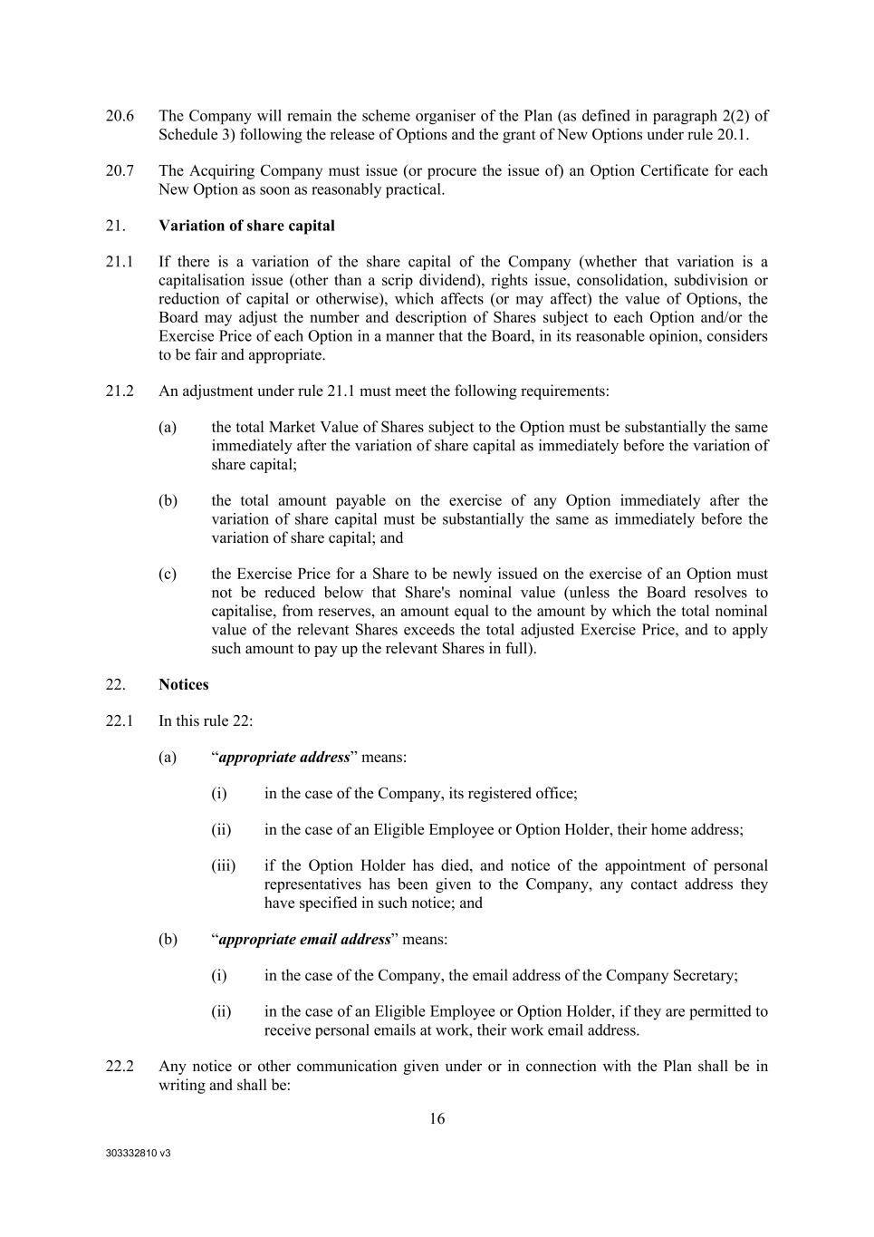
303332810 v3 16 20.6 The Company will remain the scheme organiser of the Plan (as defined in paragraph 2(2) of Schedule 3) following the release of Options and the grant of New Options under rule 20.1. 20.7 The Acquiring Company must issue (or procure the issue of) an Option Certificate for each New Option as soon as reasonably practical. 21. Variation of share capital 21.1 If there is a variation of the share capital of the Company (whether that variation is a capitalisation issue (other than a scrip dividend), rights issue, consolidation, subdivision or reduction of capital or otherwise), which affects (or may affect) the value of Options, the Board may adjust the number and description of Shares subject to each Option and/or the Exercise Price of each Option in a manner that the Board, in its reasonable opinion, considers to be fair and appropriate. 21.2 An adjustment under rule 21.1 must meet the following requirements: (a) the total Market Value of Shares subject to the Option must be substantially the same immediately after the variation of share capital as immediately before the variation of share capital; (b) the total amount payable on the exercise of any Option immediately after the variation of share capital must be substantially the same as immediately before the variation of share capital; and (c) the Exercise Price for a Share to be newly issued on the exercise of an Option must not be reduced below that Share's nominal value (unless the Board resolves to capitalise, from reserves, an amount equal to the amount by which the total nominal value of the relevant Shares exceeds the total adjusted Exercise Price, and to apply such amount to pay up the relevant Shares in full). 22. Notices 22.1 In this rule 22: (a) “appropriate address” means: (i) in the case of the Company, its registered office; (ii) in the case of an Eligible Employee or Option Holder, their home address; (iii) if the Option Holder has died, and notice of the appointment of personal representatives has been given to the Company, any contact address they have specified in such notice; and (b) “appropriate email address” means: (i) in the case of the Company, the email address of the Company Secretary; (ii) in the case of an Eligible Employee or Option Holder, if they are permitted to receive personal emails at work, their work email address. 22.2 Any notice or other communication given under or in connection with the Plan shall be in writing and shall be:

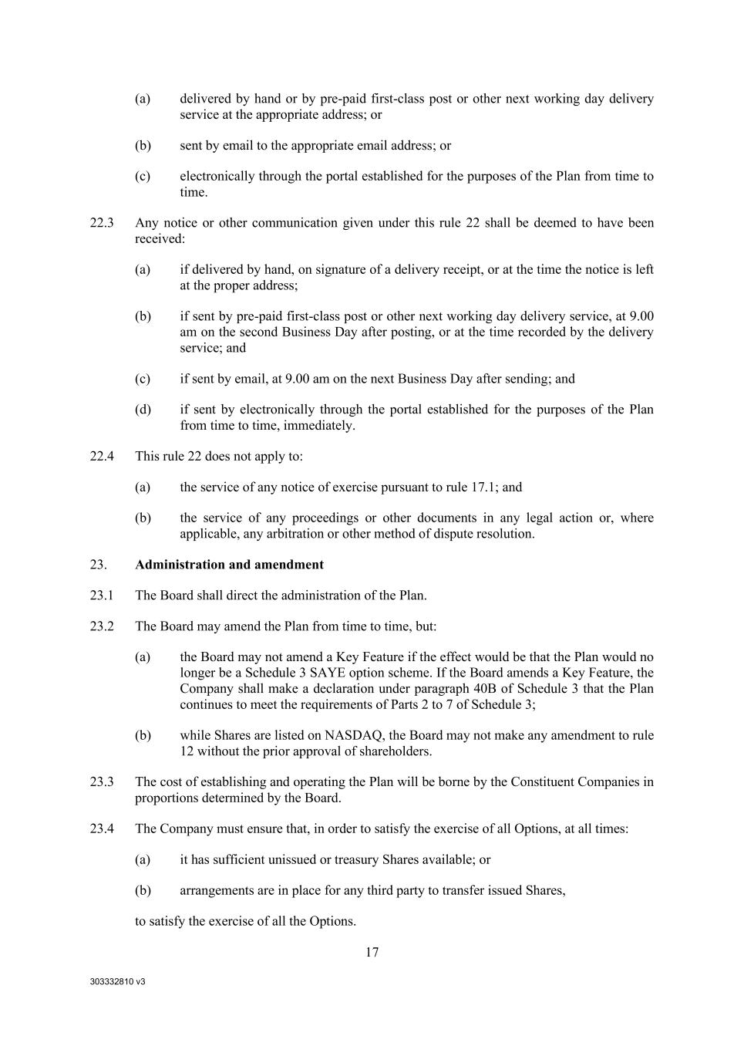
303332810 v3 17 (a) delivered by hand or by pre-paid first-class post or other next working day delivery service at the appropriate address; or (b) sent by email to the appropriate email address; or (c) electronically through the portal established for the purposes of the Plan from time to time. 22.3 Any notice or other communication given under this rule 22 shall be deemed to have been received: (a) if delivered by hand, on signature of a delivery receipt, or at the time the notice is left at the proper address; (b) if sent by pre-paid first-class post or other next working day delivery service, at 9.00 am on the second Business Day after posting, or at the time recorded by the delivery service; and (c) if sent by email, at 9.00 am on the next Business Day after sending; and (d) if sent by electronically through the portal established for the purposes of the Plan from time to time, immediately. 22.4 This rule 22 does not apply to: (a) the service of any notice of exercise pursuant to rule 17.1; and (b) the service of any proceedings or other documents in any legal action or, where applicable, any arbitration or other method of dispute resolution. 23. Administration and amendment 23.1 The Board shall direct the administration of the Plan. 23.2 The Board may amend the Plan from time to time, but: (a) the Board may not amend a Key Feature if the effect would be that the Plan would no longer be a Schedule 3 SAYE option scheme. If the Board amends a Key Feature, the Company shall make a declaration under paragraph 40B of Schedule 3 that the Plan continues to meet the requirements of Parts 2 to 7 of Schedule 3; (b) while Shares are listed on NASDAQ, the Board may not make any amendment to rule 12 without the prior approval of shareholders. 23.3 The cost of establishing and operating the Plan will be borne by the Constituent Companies in proportions determined by the Board. 23.4 The Company must ensure that, in order to satisfy the exercise of all Options, at all times: (a) it has sufficient unissued or treasury Shares available; or (b) arrangements are in place for any third party to transfer issued Shares, to satisfy the exercise of all the Options.

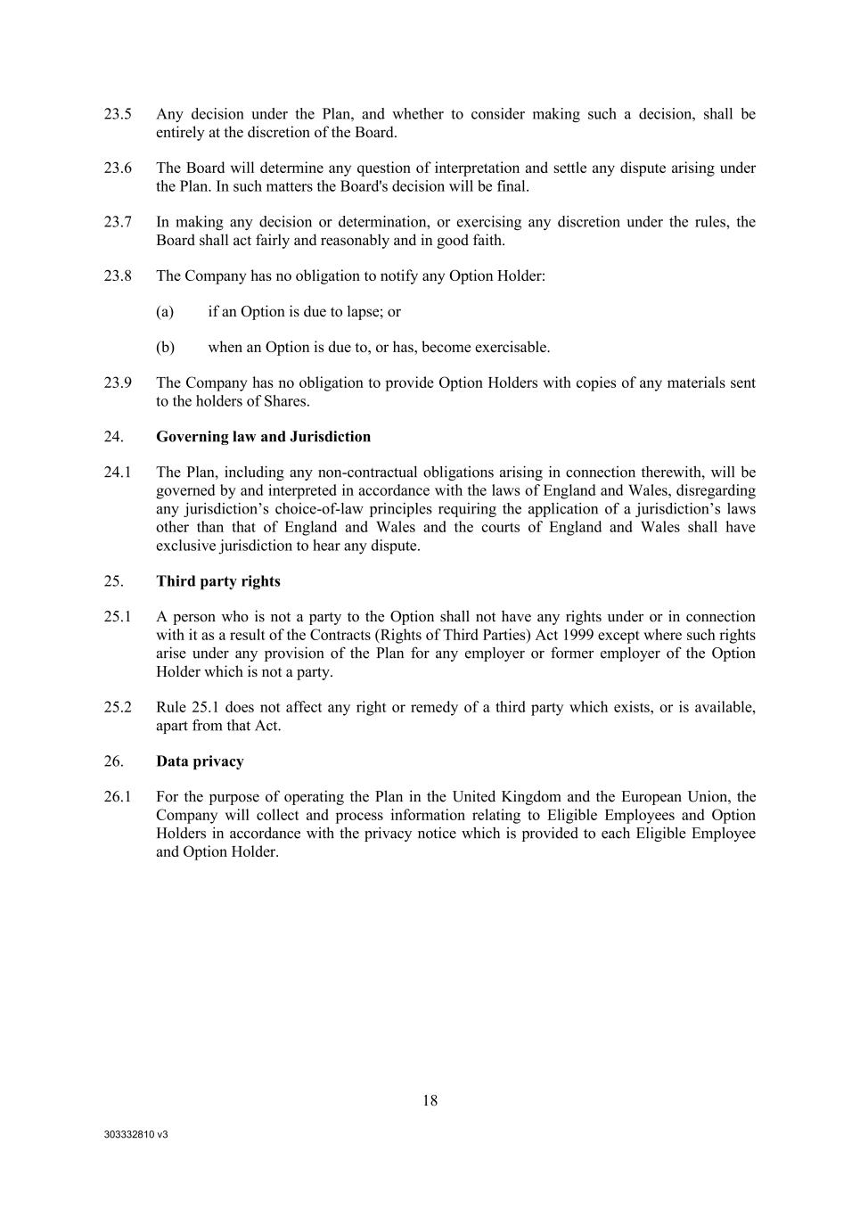
303332810 v3 18 23.5 Any decision under the Plan, and whether to consider making such a decision, shall be entirely at the discretion of the Board. 23.6 The Board will determine any question of interpretation and settle any dispute arising under the Plan. In such matters the Board's decision will be final. 23.7 In making any decision or determination, or exercising any discretion under the rules, the Board shall act fairly and reasonably and in good faith. 23.8 The Company has no obligation to notify any Option Holder: (a) if an Option is due to lapse; or (b) when an Option is due to, or has, become exercisable. 23.9 The Company has no obligation to provide Option Holders with copies of any materials sent to the holders of Shares. 24. Governing law and Jurisdiction 24.1 The Plan, including any non-contractual obligations arising in connection therewith, will be governed by and interpreted in accordance with the laws of England and Wales, disregarding any jurisdiction’s choice-of-law principles requiring the application of a jurisdiction’s laws other than that of England and Wales and the courts of England and Wales shall have exclusive jurisdiction to hear any dispute. 25. Third party rights 25.1 A person who is not a party to the Option shall not have any rights under or in connection with it as a result of the Contracts (Rights of Third Parties) Act 1999 except where such rights arise under any provision of the Plan for any employer or former employer of the Option Holder which is not a party. 25.2 Rule 25.1 does not affect any right or remedy of a third party which exists, or is available, apart from that Act. 26. Data privacy 26.1 For the purpose of operating the Plan in the United Kingdom and the European Union, the Company will collect and process information relating to Eligible Employees and Option Holders in accordance with the privacy notice which is provided to each Eligible Employee and Option Holder.

Exhibit 31.1
Certification by the Principal Executive Officer pursuant to
Securities Exchange Act Rules 13a-14(a) and 15d-14(a)
as adopted pursuant to Section 302 of the Sarbanes-Oxley Act of 2002

I, Christian Itin, certify that:
1. |  |  | I have reviewed this Quarterly Report on Form 10-Q of Autolus Therapeutics plc;
2. |  |  | Based on my knowledge, this report does not contain any untrue statement of a material fact or omit to state a material fact necessary to make the statements made, in light of the circumstances under which such statements were made, not misleading with respect to the period covered by this report;
3. |  |  | Based on my knowledge, the financial statements, and other financial information included in this report, fairly present in all material respects the financial condition, results of operations and cash flows of the registrant as of, and for, the periods presented in this report;
4. |  |  | The registrant’s other certifying officer and I are responsible for establishing and maintaining disclosure controls and procedures (as defined in Exchange Act Rules 13a-15(e) and 15d-15(e)) and internal control over financial reporting (as defined in Exchange Act Rules 13a-15(f) and 15d-15(f)) for the registrant and have:
 |  |  | (a) |  |  | Designed such disclosure controls and procedures, or caused such disclosure controls and procedures to be designed under our supervision, to ensure that material information relating to the registrant, including its consolidated subsidiaries, is made known to us by others within those entities, particularly during the period in which this report is being prepared;
 |  |  | (b) |  |  | Designed such internal control over financial reporting, or caused such internal control over financial reporting to be designed under our supervision, to provide reasonable assurance regarding the reliability of financial reporting and the preparation of financial statements for external purposes in accordance with generally accepted accounting principles;
 |  |  | (c) |  |  | Evaluated the effectiveness of the registrant’s disclosure controls and procedures and presented in this report our conclusions about the effectiveness of the disclosure controls and procedures, as of the end of the period covered by this report based on such evaluation; and
 |  |  | (d) |  |  | Disclosed in this report any change in the registrant’s internal control over financial reporting that occurred during the registrant’s most recent fiscal quarter (the registrant’s fourth fiscal quarter in the case of an annual report) that has materially affected, or is reasonably likely to materially affect, the registrant’s internal control over financial reporting; and
5. |  |  |  |  |  | The registrant’s other certifying officer and I have disclosed, based on our most recent evaluation of internal control over financial reporting, to the registrant’s auditors and the audit committee of the registrant’s board of directors (or persons performing the equivalent functions):
 |  |  | (a) |  |  | All significant deficiencies and material weaknesses in the design or operation of internal control over financial reporting which are reasonably likely to adversely affect the registrant’s ability to record, process, summarize and report financial information; and
 |  |  | (b) |  |  | Any fraud, whether or not material, that involves management or other employees who have a significant role in the registrant’s internal control over financial reporting.

Date: August 12, 2025 |  |  | /s/ Christian Itin, Ph.D.
 |  |  | Name: Christian Itin, Ph.D.
 |  |  | Title: Chief Executive Officer
 |  |  | (Principal Executive Officer)

Exhibit 31.2
Certification by the Principal Financial Officer pursuant to
Securities Exchange Act Rules 13a-14(a) and 15d-14(a)
as adopted pursuant to Section 302 of the Sarbanes-Oxley Act of 2002

I, Robert Dolski, certify that:
1. |  |  | I have reviewed this Quarterly Report on Form 10-Q of Autolus Therapeutics plc;
2. |  |  | Based on my knowledge, this report does not contain any untrue statement of a material fact or omit to state a material fact necessary to make the statements made, in light of the circumstances under which such statements were made, not misleading with respect to the period covered by this report;
3. |  |  | Based on my knowledge, the financial statements, and other financial information included in this report, fairly present in all material respects the financial condition, results of operations and cash flows of the registrant as of, and for, the periods presented in this report;
4. |  |  | The registrant’s other certifying officer and I are responsible for establishing and maintaining disclosure controls and procedures (as defined in Exchange Act Rules 13a-15(e) and 15d-15(e)) and internal control over financial reporting (as defined in Exchange Act Rules 13a-15(f) and 15d-15(f)) for the registrant and have:
 |  |  | (a) |  |  | Designed such disclosure controls and procedures, or caused such disclosure controls and procedures to be designed under our supervision, to ensure that material information relating to the registrant, including its consolidated subsidiaries, is made known to us by others within those entities, particularly during the period in which this report is being prepared;
 |  |  | (b) |  |  | Designed such internal control over financial reporting, or caused such internal control over financial reporting to be designed under our supervision, to provide reasonable assurance regarding the reliability of financial reporting and the preparation of financial statements for external purposes in accordance with generally accepted accounting principles;
 |  |  | (c) |  |  | Evaluated the effectiveness of the registrant’s disclosure controls and procedures and presented in this report our conclusions about the effectiveness of the disclosure controls and procedures, as of the end of the period covered by this report based on such evaluation; and
 |  |  | (d) |  |  | Disclosed in this report any change in the registrant’s internal control over financial reporting that occurred during the registrant’s most recent fiscal quarter (the registrant’s fourth fiscal quarter in the case of an annual report) that has materially affected, or is reasonably likely to materially affect, the registrant’s internal control over financial reporting; and
5. |  |  |  |  |  | The registrant’s other certifying officer and I have disclosed, based on our most recent evaluation of internal control over financial reporting, to the registrant’s auditors and the audit committee of the registrant’s board of directors (or persons performing the equivalent functions):
 |  |  | (a) |  |  | All significant deficiencies and material weaknesses in the design or operation of internal control over financial reporting which are reasonably likely to adversely affect the registrant’s ability to record, process, summarize and report financial information; and
 |  |  | (b) |  |  | Any fraud, whether or not material, that involves management or other employees who have a significant role in the registrant’s internal control over financial reporting.

Date: August 12, 2025 |  |  | /s/ Robert Dolski
 |  |  | Name: Robert Dolski
 |  |  | Title: Chief Financial Officer
 |  |  | (Principal Financial Officer)

Exhibit 32.1
Certification pursuant to
18 U.S.C. Section 1350, as adopted pursuant to
Section 906 of the Sarbanes-Oxley Act of 2002

Pursuant to the requirement set forth in Rule 13a-14(b) of the Securities Exchange Act of 1934, as amended, (the “Exchange Act”) and Section 1350 of Chapter 63 of Title 18 of the United States Code (18 U.S.C. §1350), Christian Itin, Chief Executive Officer of Autolus Therapeutics plc (the “Company”), and Robert Dolski, Chief Financial Officer of the Company, each hereby certifies that, to the best of his or her knowledge:
(1) |  |  | The Company’s Quarterly Report on Form 10-Q for the quarter ended March 31, 2025, to which this Certification is attached as Exhibit 32.1 (the “Periodic Report”) fully complies with the requirements of Section 13(a) or 15(d) of the Securities Exchange Act of 1934, as amended; and
(2) |  |  | The information contained in the Quarterly Report fairly presents, in all material respects, the financial condition and results of operations of the Company.

Date: August 12, 2025

/s/ Christian Itin, Ph.D. |  |  |  |  |  | /s/ Robert Dolski.
Name: Christian Itin, Ph.D. |  |  |  |  |  | Name: Robert Dolski
Title: Chief Executive Officer |  |  |  |  |  | Title: Chief Financial Officer
(Principal Executive Officer) |  |  |  |  |  | (Principal Financial Officer)

This certification accompanies the Form 10-Q to which it relates, is not deemed filed with the Securities and Exchange Commission and is not to be incorporated by reference into any filing of Autolus Therapeutics plc under the Securities Act of 1933, as amended, or the Securities Exchange Act of 1934, as amended (whether made before or after the date of the Form 10-Q), irrespective of any general incorporation language contained in such filing.

