UNITED STATES
SECURITIES AND EXCHANGE COMMISSION
WASHINGTON, D.C. 20549

FORM 8-K

CURRENT REPORT
Pursuant to Section 13 or 15(d)
of the Securities Exchange Act of 1934

Date of Report (Date of earliest event reported): August 3, 2026
Autolus Therapeutics plc
(Exact name of registrant as specified in its Charter)

England and Wales |  |  | 001-38547 |  |  |  |  |  | Not applicable
(State or other jurisdiction of incorporation or organization) |  |  | (Commission File Number) |  |  |  |  |  | (I.R.S. Employer Identification No.)
The Mediaworks
191 Wood Lane
London |  |  |  |  |  | W12 7FP
United Kingdom
(Address of principal executive offices)(Zip Code)
(44) 20 |  |  |  |  |  | 3829 6230
(Registrant's telephone number, including area code)
Not Applicable
(Former name or former address, if changed since last report)

Check the appropriate box below if the Form 8-K filing is intended to simultaneously satisfy the filing obligation of the registrant under any of the following provisions (see General Instruction A.2. below):
☐ |  |  | Written communications pursuant to Rule 425 under the Securities Act (17 CFR 230.425)
☐ |  |  | Soliciting material pursuant to Rule 14a-12 under the Exchange Act (17 CFR 240.14a-12)
☐ |  |  | Pre-commencement communications pursuant to Rule 14d-2(b) under the Exchange Act (17 CFR 240.14d-2(b))
☐ |  |  | Pre-commencement communications pursuant to Rule 13e-4(c) under the Exchange Act (17 CFR 240.13e-4(c))

Securities registered pursuant to Section 12(b) of the Act:
Title of each class |  |  | Trading Symbol(s) |  |  | Name of each exchange on which registered
American Depositary Shares, each representing one ordinary share, nominal value $0.000042 per share |  |  | AUTL |  |  | The Nasdaq Global Select Market
Ordinary shares, nominal value $0.000042 per share* |  |  | * |  |  | The Nasdaq Stock Market LLC*
* |  |  |  |  |  | Not for trading, but only in connection with the listing of the American Depositary Shares on The Nasdaq Global Select Market. The American Depositary Shares represent the right to receive ordinary shares and are being registered under the Securities Act of 1933, as amended, pursuant to a separate Registration Statement on Form F-6. Accordingly, the American Depositary Shares are exempt from the operation of Section 12(a) of the Securities Exchange Act of 1934, as amended, pursuant to Rule 12a-8 thereunder.
Indicate by check mark whether the registrant is an emerging growth company as defined in Rule 405 of the Securities Act of 1933 (§230.405 of this chapter) or Rule 12b-2 of the Securities Exchange Act of 1934 (§240.12b-2 of this chapter).
Emerging growth company ☐

If an emerging growth company, indicate by check mark if the registrant has elected not to use the extended transition period for complying with any new or revised financial accounting standards provided pursuant to Section 13(a) of the Exchange Act. ☐

Item 2.02 Results of Operations and Financial Condition.
On August 3, 2026, Autolus Therapeutics plc (the “Company”) issued a press release announcing updates to its 2026 net product revenue guidance on AUCATZYL® (obe-cel), its anticipated Q2 2026 net product revenue from AUCATZYL, its anticipated gross margin percentage on AUCATZYL sales during the first half of 2026, a new credit facility and its cash runway position. The press release is being furnished as Exhibit 99.1 to this Current Report on Form 8-K and is incorporated by reference herein.
The information contained in this Item 2.02, including Exhibit 99.1, shall not be deemed “filed” for purposes of Section 18 of the Securities Exchange Act of 1934, as amended (the “Exchange Act”), or otherwise subject to the liability of that section, nor shall it be deemed incorporated by reference in any filing under the Securities Act of 1933, as amended, or the Exchange Act, except as shall be expressly set forth by reference in such a filing.

Item 8.01 Other Events.
On August 3, 2026, the Company announced an increase in full year 2026 guidance for AUCATZYL® net product revenue to $140 million to $150 million, from between $120 million to $135 million. Based on current operating plans, including anticipated AUCATZYL net product revenues and proceeds from the credit facility described in the press release, the Company expects that its current and projected cash, cash equivalents and marketable securities will be sufficient to fund the Company’s operations into the second quarter of 2028.

Forward-Looking Statements
This Current Report contains forward-looking statements within the meaning of the "safe harbor" provisions of the Private Securities Litigation Reform Act of 1995. Forward-looking statements are statements that are not historical facts, and in some cases can be identified by terms such as "may," "will," "could," "expects," "plans," "anticipates," and "believes." These statements include, but are not limited to, statements regarding the Company’s future expectations, plans and prospects, including the anticipated level of full year 2026 AUCATZYL net product revenue; the Company’s anticipated cash runway; the therapeutic potential and expected clinical benefits of AUCATZYL (obe-cel; obecabtagene autoleucel) for adult patients with r/r B-ALL and obe-cel in additional indications including lupus nephritis and progressive multiple sclerosis; the Company’s ability to generate revenues from AUCATZYL; the Company’s ability to obtain and maintain regulatory approval for obe-cel for adult r/r B-ALL in additional territories and the timing thereof; expectations regarding the commercialization, marketing and manufacturing of AUCATZYL for adult r/r B-ALL, including expanding into additional territories and the related timing of reaching patients in such territories; the development of obe-cel in autoimmune indications and of additional product candidates, including statements regarding the initiation, timing, progress and the results of clinical studies or trials and related preparatory work; the period during which the results of clinical studies or trials will become available; the Company’s plans to expand, develop and enhance its manufacturing activities; and the Company’s pursuit of expanded market access across Europe. Any forward-looking statements are based on management's current views and assumptions and involve risks and uncertainties that could cause actual results, performance, or events to differ materially from those expressed or implied in such statements. These risks and uncertainties include, but are not limited to, the risks identified in the section titled "Risk Factors" in the Company’s Annual Report on Form 10-K filed with the Securities and Exchange Commission, or the SEC, on March 27, 2026 as well as discussions of potential risks, uncertainties, and other important factors in the Company’s subsequent Quarterly Reports on Form 10-Q and other filings with the Securities and Exchange Commission. All information in this Current Report is as of the date of this Current Report, and the Company undertakes no obligation to publicly update any forward-looking statement, whether as a result of new information, future events, or otherwise, except as required by law. You should, therefore, not rely on these forward-looking statements as representing the Company’s views as of any date subsequent to the date of this Current Report.

Item 9.01 Exhibits
d) Exhibits
Exhibit No. |  |  |  |  |  | Description of Exhibit
99.1 |  |  |  |  |  | Press release dated August 3, 2026
104 |  |  |  |  |  | Cover Page Interactive Date File (embedded within the Inline XBRL document)

SIGNATURES
Pursuant to the requirements of the Securities Exchange Act of 1934, as amended, the registrant has duly caused this report to be signed on its behalf by the undersigned hereunto duly authorized.
 |  |  |  |  |  | AUTOLUS THERAPEUTICS PLC
Dated: August 3, 2026 |  |  | By: |  |  | /s/Christian Itin, Ph.D.
 |  |  |  |  |  | Name: Christian Itin, Ph.D.
 |  |  |  |  |  | Title: Chief Executive Officer

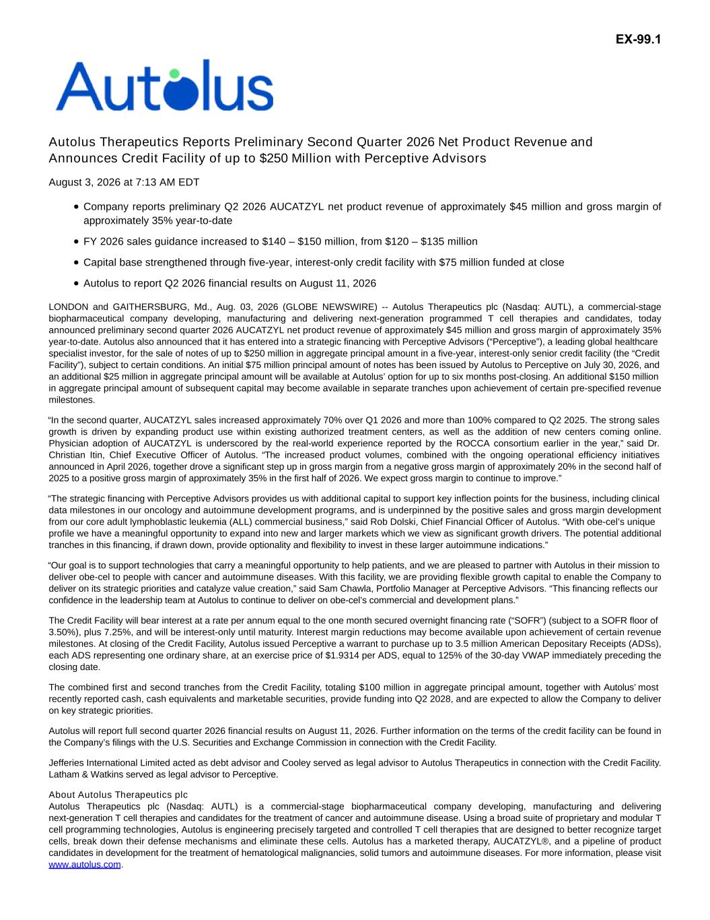

Autolus Therapeutics Reports Preliminary Second Quarter 2026 Net Product Revenue and Announces Credit Facility of up to $250 Million with Perceptive Advisors August 3, 2026 at 7:13 AM EDT Company reports preliminary Q2 2026 AUCATZYL net product revenue of approximately $45 million and gross margin of approximately 35% year-to-date FY 2026 sales guidance increased to $140 – $150 million, from $120 – $135 million Capital base strengthened through five-year, interest-only credit facility with $75 million funded at close Autolus to report Q2 2026 financial results on August 11, 2026 LONDON and GAITHERSBURG, Md., Aug. 03, 2026 (GLOBE NEWSWIRE) -- Autolus Therapeutics plc (Nasdaq: AUTL), a commercial-stage biopharmaceutical company developing, manufacturing and delivering next-generation programmed T cell therapies and candidates, today announced preliminary second quarter 2026 AUCATZYL net product revenue of approximately $45 million and gross margin of approximately 35% year-to-date. Autolus also announced that it has entered into a strategic financing with Perceptive Advisors (“Perceptive”), a leading global healthcare specialist investor, for the sale of notes of up to $250 million in aggregate principal amount in a five-year, interest-only senior credit facility (the “Credit Facility”), subject to certain conditions. An initial $75 million principal amount of notes has been issued by Autolus to Perceptive on July 30, 2026, and an additional $25 million in aggregate principal amount will be available at Autolus’ option for up to six months post-closing. An additional $150 million in aggregate principal amount of subsequent capital may become available in separate tranches upon achievement of certain pre-specified revenue milestones. “In the second quarter, AUCATZYL sales increased approximately 70% over Q1 2026 and more than 100% compared to Q2 2025. The strong sales growth is driven by expanding product use within existing authorized treatment centers, as well as the addition of new centers coming online. Physician adoption of AUCATZYL is underscored by the real-world experience reported by the ROCCA consortium earlier in the year,” said Dr. Christian Itin, Chief Executive Officer of Autolus. “The increased product volumes, combined with the ongoing operational efficiency initiatives announced in April 2026, together drove a significant step up in gross margin from a negative gross margin of approximately 20% in the second half of 2025 to a positive gross margin of approximately 35% in the first half of 2026. We expect gross margin to continue to improve.” “The strategic financing with Perceptive Advisors provides us with additional capital to support key inflection points for the business, including clinical data milestones in our oncology and autoimmune development programs, and is underpinned by the positive sales and gross margin development from our core adult lymphoblastic leukemia (ALL) commercial business,” said Rob Dolski, Chief Financial Officer of Autolus. “With obe-cel’s unique profile we have a meaningful opportunity to expand into new and larger markets which we view as significant growth drivers. The potential additional tranches in this financing, if drawn down, provide optionality and flexibility to invest in these larger autoimmune indications.” “Our goal is to support technologies that carry a meaningful opportunity to help patients, and we are pleased to partner with Autolus in their mission to deliver obe-cel to people with cancer and autoimmune diseases. With this facility, we are providing flexible growth capital to enable the Company to deliver on its strategic priorities and catalyze value creation,” said Sam Chawla, Portfolio Manager at Perceptive Advisors. “This financing reflects our confidence in the leadership team at Autolus to continue to deliver on obe-cel’s commercial and development plans.” The Credit Facility will bear interest at a rate per annum equal to the one month secured overnight financing rate (“SOFR”) (subject to a SOFR floor of 3.50%), plus 7.25%, and will be interest-only until maturity. Interest margin reductions may become available upon achievement of certain revenue milestones. At closing of the Credit Facility, Autolus issued Perceptive a warrant to purchase up to 3.5 million American Depositary Receipts (ADSs), each ADS representing one ordinary share, at an exercise price of $1.9314 per ADS, equal to 125% of the 30-day VWAP immediately preceding the closing date. The combined first and second tranches from the Credit Facility, totaling $100 million in aggregate principal amount, together with Autolus’ most recently reported cash, cash equivalents and marketable securities, provide funding into Q2 2028, and are expected to allow the Company to deliver on key strategic priorities. Autolus will report full second quarter 2026 financial results on August 11, 2026. Further information on the terms of the credit facility can be found in the Company’s filings with the U.S. Securities and Exchange Commission in connection with the Credit Facility. Jefferies International Limited acted as debt advisor and Cooley served as legal advisor to Autolus Therapeutics in connection with the Credit Facility. Latham & Watkins served as legal advisor to Perceptive. About Autolus Therapeutics plc Autolus Therapeutics plc (Nasdaq: AUTL) is a commercial-stage biopharmaceutical company developing, manufacturing and delivering next-generation T cell therapies and candidates for the treatment of cancer and autoimmune disease. Using a broad suite of proprietary and modular T cell programming technologies, Autolus is engineering precisely targeted and controlled T cell therapies that are designed to better recognize target cells, break down their defense mechanisms and eliminate these cells. Autolus has a marketed therapy, AUCATZYL®, and a pipeline of product candidates in development for the treatment of hematological malignancies, solid tumors and autoimmune diseases. For more information, please visit www.autolus.com. EX-99.1

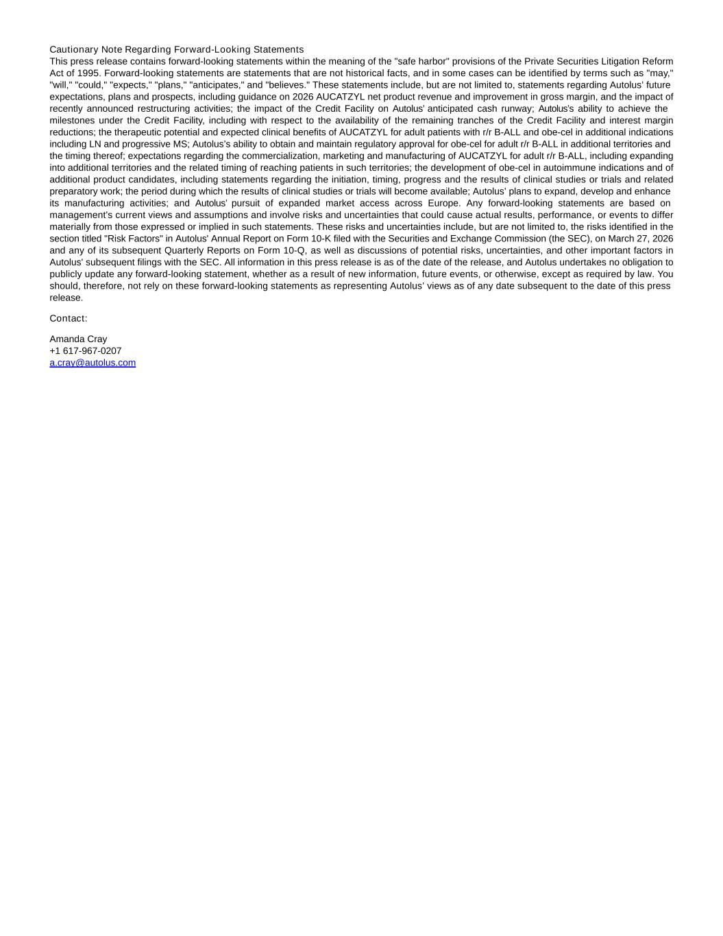
Cautionary Note Regarding Forward-Looking Statements This press release contains forward-looking statements within the meaning of the "safe harbor" provisions of the Private Securities Litigation Reform Act of 1995. Forward-looking statements are statements that are not historical facts, and in some cases can be identified by terms such as "may," "will," "could," "expects," "plans," "anticipates," and "believes." These statements include, but are not limited to, statements regarding Autolus’ future expectations, plans and prospects, including guidance on 2026 AUCATZYL net product revenue and improvement in gross margin, and the impact of recently announced restructuring activities; the impact of the Credit Facility on Autolus’ anticipated cash runway; Autolus’s ability to achieve the milestones under the Credit Facility, including with respect to the availability of the remaining tranches of the Credit Facility and interest margin reductions; the therapeutic potential and expected clinical benefits of AUCATZYL for adult patients with r/r B-ALL and obe-cel in additional indications including LN and progressive MS; Autolus’s ability to obtain and maintain regulatory approval for obe-cel for adult r/r B-ALL in additional territories and the timing thereof; expectations regarding the commercialization, marketing and manufacturing of AUCATZYL for adult r/r B-ALL, including expanding into additional territories and the related timing of reaching patients in such territories; the development of obe-cel in autoimmune indications and of additional product candidates, including statements regarding the initiation, timing, progress and the results of clinical studies or trials and related preparatory work; the period during which the results of clinical studies or trials will become available; Autolus’ plans to expand, develop and enhance its manufacturing activities; and Autolus’ pursuit of expanded market access across Europe. Any forward-looking statements are based on management's current views and assumptions and involve risks and uncertainties that could cause actual results, performance, or events to differ materially from those expressed or implied in such statements. These risks and uncertainties include, but are not limited to, the risks identified in the section titled "Risk Factors" in Autolus' Annual Report on Form 10-K filed with the Securities and Exchange Commission (the SEC), on March 27, 2026 and any of its subsequent Quarterly Reports on Form 10-Q, as well as discussions of potential risks, uncertainties, and other important factors in Autolus' subsequent filings with the SEC. All information in this press release is as of the date of the release, and Autolus undertakes no obligation to publicly update any forward-looking statement, whether as a result of new information, future events, or otherwise, except as required by law. You should, therefore, not rely on these forward-looking statements as representing Autolus’ views as of any date subsequent to the date of this press release. Contact: Amanda Cray +1 617-967-0207 a.cray@autolus.com

