Table of contents

UNITED STATES
SECURITIES AND EXCHANGE COMMISSION
Washington, D.C. 20549
FORM 10-Q
(Mark One)
☒ |  |  | QUARTERLY REPORT PURSUANT TO SECTION 13 OR 15(d) OF THE SECURITIES EXCHANGE ACT OF 1934

For the quarterly period ended March 31, 2026

OR
☐ |  |  | TRANSITION REPORT PURSUANT TO SECTION 13 OR 15(d) OF THE SECURITIES EXCHANGE ACT OF 1934
For the transition period from __________ to __________

Commission File Number 001-38547

AUTOLUS THERAPEUTICS PLC
(Exact name of registrant as specified in its charter)
England and Wales |  |  |  |  |  |  |  |  | Not applicable
(State or other jurisdiction of incorporation or organization) |  |  |  |  |  |  |  |  | (I.R.S. Employer Identification No.)
The Mediaworks
191 Wood Lane
London |  |  | W12 7FP |  |  |  |  |  | United Kingdom
(Address of principal executive offices)
(44) 20 |  |  |  |  |  | 3829 6230
(Registrant's telephone number, including area code)

Securities registered pursuant to Section 12(b) of the Act:
Title of each class |  |  | Trading Symbol(s) |  |  | Name of each exchange on which registered
American Depositary Shares, each representing one ordinary share, par value $0.000042 per share |  |  | AUTL |  |  | The Nasdaq Global Select Market
Ordinary shares, nominal value $0.000042 per share* |  |  | * |  |  | The Nasdaq Stock Market LLC*
* |  |  |  |  |  | Not for trading, but only in connection with the listing of the American Depositary Shares on The Nasdaq Stock Market LLC.
Indicate by check mark whether the registrant (1) has filed all reports required to be filed by Section 13 or 15(d) of the Securities Exchange Act of 1934 during the preceding 12 months (or for such shorter period that the registrant was required to file such reports), and (2) has been subject to such filing requirements for the past 90 days.
Yes ☒ No ☐
1
Table of contents
Indicate by check mark whether the registrant has submitted electronically, every Interactive Data File required to be submitted pursuant to Rule 405 of Regulation S-T (§232.405 of this chapter) during the preceding 12 months (or for such shorter period that the registrant was required to submit such files). Yes ☒ No ☐

Indicate by check mark whether the registrant is a large accelerated filer, an accelerated filer, a non-accelerated filer, a smaller reporting company or an emerging growth company. See the definitions of “large accelerated filer,” “accelerated filer,” “smaller reporting company” and “an emerging growth company” in Rule 12b-2 of the Exchange Act:
Large accelerated filer |  |  | ☐ |  |  | Accelerated filer |  |  | ☐
Non-accelerated filer |  |  | ☒ |  |  | Smaller reporting company |  |  | ☒
 |  |  |  |  |  | Emerging growth company |  |  | ☐

If an emerging growth company, indicate by check mark if the registrant has elected not to use the extended transition period for complying with any new or revised financial accounting standards provided pursuant to Section 13(a) of the Exchange Act.
Yes ☐ No ☐

Indicate by check mark whether the registrant is a shell company (as defined in Rule 12b-2 of the Act). Yes ☐ No ☒

As of May 13, 2026, the registrant had 266,155,786 ordinary shares (including shares in form of American Depositary Shares (“ADSs”)), par value $0.000042 per share, outstanding.

2
Table of contents
EXPLANATORY NOTE

Autolus Therapeutics plc (the “Company”) qualifies as a “Foreign Private Issuer,” as defined in Rule 3b-4 under the Securities Exchange Act of 1934 (the “Exchange Act”) and is exempt from filing quarterly reports on Form 10-Q by virtue of Rules 13a-13 and 15d-13 under the Exchange Act. The Company has voluntarily elected to file this Quarterly Report on Form 10-Q for the quarter ended March 31, 2026. Accordingly, as a foreign private issuer, the Company remains exempt from the U.S. federal proxy rules pursuant to Section 14 of the Exchange Act and Regulations 14A and 14C thereunder, Regulation FD, and its officers, directors, and principal shareholders are not subject to the short-swing profit disclosure and recovery provisions contained in Section 16 of the Exchange Act.

TABLE OF CONTENTS
Part I – Financial Information |  |  | 6
Item 1. Financial Statements (Unaudited) |  |  | 6
Condensed Consolidated Balance Sheets as of March 31, 2026 and December 31, 2025 |  |  | 6
Condensed Consolidated Statements of Operations and Comprehensive Loss for the Three Months Ended March 31, 2026 and 2025 |  |  | 7
Condensed Consolidated Statements of Changes in Shareholders’ Equity for the Three Months Ended March 31, 2026 and 2025 |  |  | 8
Condensed Consolidated Statements of Cash Flows for the Three Months Ended March 31, 2026 and 2025 |  |  | 9
Notes to the Condensed Consolidated Interim Financial Statements |  |  | 11
Item 2. Management’s Discussion and Analysis of Financial Condition and Results of Operations |  |  | 30
Item 3. Quantitative and Qualitative Disclosures About Market Risk |  |  | 40
Item 4. Controls and Procedures |  |  | 40
Part II – Other Information |  |  | 40
Item 1. Legal Proceedings |  |  | 40
Item 1A. Risk Factors |  |  | 40
Item 2. Unregistered Sales of Equity Securities and Use of Proceeds |  |  | 41
Item 3. Defaults Upon Senior Securities |  |  | 41
Item 4. Mine Safety Disclosures |  |  | 41
Item 5. Other Information |  |  | 41
Item 6. Exhibits |  |  | 41
Signatures |  |  | 42

GENERAL INFORMATION
Unless context otherwise requires, all references in this Quarterly Report on Form 10-Q to “Autolus,” the “Group,” the “company,” “we,” “us” and “our” refer to Autolus Therapeutics plc and its consolidated subsidiaries, except where the context otherwise requires.
Autolus, AUCATZYL® and our other trademarks or service marks appearing in this Quarterly Report on Form 10-Q are our property. Solely for convenience, the trademarks and trade names in this Quarterly Report on Form 10-Q are referred to without the ® and TM symbols, but such references should not be construed as any indicator that their respective owners will not assert, to the fullest extent under applicable law, their rights thereto. Products or service names of other companies mentioned in this Quarterly Report on Form 10-Q may be trademarks, trade names or service marks of their respective owners.

3
Table of contents
CAUTIONARY NOTE REGARDING FORWARD-LOOKING STATEMENTS
This Quarterly Report on Form 10-Q contains forward-looking statements about us and our industry that involve substantial risks and uncertainties. All statements other than statements of historical facts contained in this Quarterly Report on Form 10-Q, including statements regarding our strategy, future financial condition, future operations, research and development costs, plans and objectives of management, are forward-looking statements. In some cases, you can identify forward-looking statements by terminology such as “aim,” “anticipate,” “assume,” “believe,” “contemplate,” “continue,” “could,” “design,” “due,” “estimate,” “expect,” “goal,” “intend,” “may,” “objective,” “plan,” “predict,” “positioned,” “potential,” “seek,” “should,” “target,” “will,” “would” and other similar expressions that are predictions of or indicate future events and future trends, or the negative of these terms or other comparable terminology. Although we believe that we have a reasonable basis for each forward-looking statement contained in this Quarterly Report on Form 10-Q, we caution you that these statements are based on a combination of facts and factors currently known by us and our expectations of the future, about which we cannot be certain.
The forward-looking statements in this Quarterly Report on Form 10-Q include, among other things, statements about:
•the therapeutic potential and expected clinical benefits of AUCATZYL/obe-cel (obecabtagene autoleucel) for adult patients with relapsed or refractory B-cell precursor acute lymphoblastic leukemia (“r/r B-ALL”);
•our ability to generate revenues from AUCATZYL, which is dependent upon maintaining significant market acceptance among physicians, patients and healthcare payors;
•our ability to maintain regulatory approval of AUCATZYL in the US, European Union (“EU”) and United Kingdom (“U.K.”), to obtain and maintain regulatory approval for obe-cel for adult r/r B-ALL in additional territories and the timing thereof, and to obtain and maintain regulatory approval of our other product candidates in the indications for which we plan to develop them, and any related restrictions, limitations or warnings in the label of an approved drug or therapy;
•our expectations regarding the commercialization and marketing of AUCATZYL for adult r/r B-ALL, including expanding into additional territories and the related timing of reaching patients in such territories;
•the development of our commercial product and product candidates, including statements regarding the initiation, timing, progress and the results of clinical studies or trials and related preparatory work, the period during which the results of the trials will become available and our research and development programs;
•our estimates regarding expenses, future revenue, capital requirements and needs for additional financing;
•our commercialization, marketing and manufacturing capabilities and strategy for AUCATZYL, including our ability to successfully recruit and retain sales and marketing personnel and to successfully build the market for AUCATZYL;
•our expectations about the willingness of healthcare providers to recommend AUCATZYL to people with adult r/r B-ALL;
•the impacts of public health crises and their effects on our operations and business, including interruption of key clinical trial activities, such as clinical trial site monitoring, access to capital, and potential disruption in the operations and business of third-party manufacturers, clinical sites, contract research organizations (“CROs”), other service providers and collaborators with whom we conduct business;
•our expectations regarding our ability to obtain and maintain intellectual property protection and our ability to license additional intellectual property relating to our product candidates from third parties and to comply with our existing license agreements;
•our plans to research, develop, manufacture and commercialize our product candidates;
•the potential benefits of our commercial product and product candidates;
•the timing or likelihood of regulatory filings and approvals for our product candidates, along with regulatory developments in the US, EU, U.K. and other foreign countries;
•the size and growth potential of the markets for our commercial product and product candidates, if approved, and the rate and degree of market acceptance of our commercial product and product candidates, including reimbursement that may be received from payors;
•our need for and ability to obtain additional funding, on favorable terms or at all;
•our plans to collaborate, or statements regarding our current collaborations with BioNTech SE (“BioNTech”) and others;
•our license and option agreement with BioNTech (the “BioNTech License and Option Agreement”), including our potential to receive milestone payments and royalties under the agreement;
•our ability to attract collaborators with development, regulatory and commercialization expertise;
•our ability to identify, recruit and retain qualified employees and key personnel;
•our ability to contract with third-party suppliers and manufacturers and their ability to perform adequately;
•the scalability and commercial viability of our manufacturing methods and processes;
•the success of competing therapies that are or may become available;
•whether we are classified as a Passive Foreign Investment Company (“PFIC”), for current and future periods;
4
Table of contents
•additional costs and expenses related to our decision to voluntarily comply with certain U.S. domestic issuer reporting obligations before we are required to do so; and
•any other factors which may impact our financial results or future trading prices of our ADSs, and the impact of securities analysts’ reports on these prices.
Although we believe that the expectations reflected in these forward-looking statements are reasonable, these statements relate to our strategy, future operations, future financial position, future revenue, projected costs, prospects, plans, objectives of management and expected market growth, and involve known and unknown risks, uncertainties and other factors including, without limitation, risks, uncertainties and assumptions regarding the impact of macroeconomic events, including inflation, changes in interest rates, tariffs, changes in trade policies, political changes, general market conditions and the impacts of the war in Ukraine, conflicts in the Middle East and Europe, and global geopolitical tensions, on our business, operations, strategy, goals and anticipated timelines, our ongoing and planned preclinical activities, our ability to initiate, enroll, conduct or complete ongoing and planned clinical trials, our timelines for regulatory submissions and our financial position that may cause our actual results, levels of activity, performance or achievements to be materially different from any future results, levels of activity, performance or achievements expressed or implied by these forward-looking statements. You are urged to carefully review the disclosures we make concerning these risks and other factors that may affect our business and operating results in this Quarterly Report on Form 10-Q. You are cautioned not to place undue reliance on these forward-looking statements, which speak only as of the date of this document. Except as required by law, we do not intend, and undertake no obligation, to update any forward-looking information to reflect events or circumstances.

5
Table of contents
PART I - FINANCIAL INFORMATION

Item 1. Financial Statements (Unaudited)

AUTOLUS THERAPEUTICS PLC
Condensed Consolidated Balance Sheets
(In thousands, except share and per share amounts)
 |  |  |  |  |  | Note |  |  |  |  |  | March 31,  2026 |  |  |  |  |  | December 31,  2025
Assets
Current assets:
Cash and cash equivalents |  |  |  |  |  |  |  |  |  |  |  | $ | 130,925 |  |  |  |  | $ | 104,132
Marketable securities - Available-for-sale debt securities |  |  |  |  |  | 7 |  |  |  |  |  | 98,509 |  |  |  |  |  | 196,578
Restricted cash |  |  |  |  |  |  |  |  |  |  |  | 1,493 |  |  |  |  |  | 1,503
Accounts receivable, net |  |  |  |  |  | 3 |  |  |  |  |  | 27,663 |  |  |  |  |  | 24,024
Inventories, net |  |  |  |  |  | 8 |  |  |  |  |  | 33,233 |  |  |  |  |  | 33,209
Prepaid expenses and other current assets |  |  |  |  |  | 9 |  |  |  |  |  | 77,012 |  |  |  |  |  | 76,469
Total current assets |  |  |  |  |  |  |  |  |  |  |  | 368,835 |  |  |  |  |  | 435,915
Non-current assets:
Property and equipment, net |  |  |  |  |  | 10 |  |  |  |  |  | 61,908 |  |  |  |  |  | 63,563
Intangible assets, net |  |  |  |  |  | 11 |  |  |  |  |  | 18,976 |  |  |  |  |  | 19,809
Prepaid expenses and other non-current assets |  |  |  |  |  |  |  |  |  |  |  | 194 |  |  |  |  |  | 249
Operating lease right-of-use assets, net |  |  |  |  |  |  |  |  |  |  |  | 72,563 |  |  |  |  |  | 64,940
Long-term deposits |  |  |  |  |  |  |  |  |  |  |  | 1,014 |  |  |  |  |  | 1,032
Deferred tax asset |  |  |  |  |  |  |  |  |  |  |  | 3,575 |  |  |  |  |  | 3,560
Total assets |  |  |  |  |  |  |  |  |  |  |  | $ | 527,065 |  |  |  |  | $ | 589,068
Liabilities and shareholders’ equity
Current liabilities:
Accounts payable |  |  |  |  |  |  |  |  |  |  |  | $ | 1,872 |  |  |  |  | $ | 3,083
Accrued expenses and other liabilities |  |  |  |  |  | 12 |  |  |  |  |  | 46,766 |  |  |  |  |  | 55,792
Operating lease liabilities, current |  |  |  |  |  | 16 |  |  |  |  |  | 3,061 |  |  |  |  |  | 4,565
Liabilities related to future royalties and milestones, net - current |  |  |  |  |  | 15 |  |  |  |  |  | 11,900 |  |  |  |  |  | 10,000
Total current liabilities |  |  |  |  |  |  |  |  |  |  |  | 63,599 |  |  |  |  |  | 73,440
Non-current liabilities:
Operating lease liabilities, non-current |  |  |  |  |  | 16 |  |  |  |  |  | 76,895 |  |  |  |  |  | 66,822
Liabilities related to future royalties and milestones, net - non-current |  |  |  |  |  | 15 |  |  |  |  |  | 277,268 |  |  |  |  |  | 270,200
Other long-term payables |  |  |  |  |  |  |  |  |  |  |  | 477 |  |  |  |  |  | 477
Total liabilities |  |  |  |  |  |  |  |  |  |  |  | 418,239 |  |  |  |  |  | 410,939
Commitments and contingencies |  |  |  |  |  | 17
Shareholders’ equity:
Ordinary shares, $0.000042 par value; 490,909,783 and 490,909,783 shares authorized as of March 31, 2026 and as of December 31, 2025, respectively; 266,143,286 and 266,143,286, shares issued at March 31, 2026 and December 31, 2025, respectively; 266,155,786 and 266,143,286, shares outstanding at March 31, 2026 and December 31, 2025, respectively |  |  |  |  |  |  |  |  |  |  |  | 12 |  |  |  |  |  | 12
Deferred shares, £0.00001 par value; 34,425 shares authorized, issued and outstanding at March 31, 2026 and December 31, 2025 |  |  |  |  |  |  |  |  |  |  |  | — |  |  |  |  |  | —
Deferred B shares, £0.00099 par value; 88,893,548 shares authorized, issued and outstanding at March 31, 2026 and December 31, 2025 |  |  |  |  |  |  |  |  |  |  |  | 118 |  |  |  |  |  | 118
Deferred C shares, £0.000008 par value; 1 share authorized, issued and outstanding at March 31, 2026 and December 31, 2025 |  |  |  |  |  |  |  |  |  |  |  | — |  |  |  |  |  | —
Additional paid-in capital |  |  |  |  |  |  |  |  |  |  |  | 1,573,673 |  |  |  |  |  | 1,570,107
Accumulated other comprehensive loss |  |  |  |  |  |  |  |  |  |  |  | (6,627) |  |  |  |  |  | (5,356)
Accumulated deficit |  |  |  |  |  |  |  |  |  |  |  | (1,458,350) |  |  |  |  |  | (1,386,752)
Total shareholders’ equity |  |  |  |  |  |  |  |  |  |  |  | 108,826 |  |  |  |  |  | 178,129
Total liabilities and shareholders’ equity |  |  |  |  |  |  |  |  |  |  |  | $ | 527,065 |  |  |  |  | $ | 589,068
The accompanying notes are an integral part of these unaudited condensed consolidated interim financial statements.

6
Table of contents
AUTOLUS THERAPEUTICS PLC
Condensed Consolidated Statements of Operations and Comprehensive Loss
(Unaudited, in thousands, except share and per share amounts)

 |  |  |  |  |  |  |  |  |  |  |  | Three Months Ended March 31,
 |  |  |  |  |  | Note |  |  |  |  |  | 2026 |  |  |  |  |  | 2025
Revenue:
Product revenue, net |  |  |  |  |  | 3 |  |  |  |  |  | $ | 26,218 |  |  |  |  | $ | 8,982
Total revenue, net |  |  |  |  |  |  |  |  |  |  |  | 26,218 |  |  |  |  |  | 8,982
Cost and operating expenses:
Cost of sales |  |  |  |  |  |  |  |  |  |  |  | (24,568) |  |  |  |  |  | (17,951)
Research and development expenses, net |  |  |  |  |  |  |  |  |  |  |  | (21,210) |  |  |  |  |  | (26,734)
Selling, general and administrative expenses |  |  |  |  |  |  |  |  |  |  |  | (39,953) |  |  |  |  |  | (29,537)
Loss from operations |  |  |  |  |  |  |  |  |  |  |  | (59,513) |  |  |  |  |  | (65,240)
Other income (expense):
Other income, net |  |  |  |  |  |  |  |  |  |  |  | 100 |  |  |  |  |  | 129
Foreign exchange (losses) gains, net |  |  |  |  |  |  |  |  |  |  |  | (2,667) |  |  |  |  |  | 1,181
Interest income |  |  |  |  |  |  |  |  |  |  |  | 2,469 |  |  |  |  |  | 6,137
Interest expense, net |  |  |  |  |  | 4 |  |  |  |  |  | (11,124) |  |  |  |  |  | (10,143)
Total other (expenses) income, net |  |  |  |  |  |  |  |  |  |  |  | (11,222) |  |  |  |  |  | (2,696)
Net loss before income tax |  |  |  |  |  |  |  |  |  |  |  | (70,735) |  |  |  |  |  | (67,936)
Income tax expense |  |  |  |  |  |  |  |  |  |  |  | (863) |  |  |  |  |  | (2,225)
Net loss |  |  |  |  |  |  |  |  |  |  |  | (71,598) |  |  |  |  |  | (70,161)
Other comprehensive (loss) income:
Foreign currency exchange translation adjustment |  |  |  |  |  |  |  |  |  |  |  | (1,130) |  |  |  |  |  | 10,668
Unrealized holding (losses) gains on available-for-sale debt securities, net of tax of $0 and $0, respectively |  |  |  |  |  |  |  |  |  |  |  | (141) |  |  |  |  |  | 400
Total other comprehensive (loss) income, net of tax |  |  |  |  |  |  |  |  |  |  |  | (1,271) |  |  |  |  |  | 11,068
Total comprehensive loss |  |  |  |  |  |  |  |  |  |  |  | $ | (72,869) |  |  |  |  | $ | (59,093)
Basic and diluted net loss per ordinary share |  |  |  |  |  | 5 |  |  |  |  |  | $ | (0.27) |  |  |  |  | $ | (0.26)
Weighted-average basic and diluted ordinary shares |  |  |  |  |  | 5 |  |  |  |  |  | 266,143,425 |  |  |  |  |  | 266,126,548
The accompanying notes are an integral part of these unaudited condensed consolidated interim financial statements.

7
Table of contents
AUTOLUS THERAPEUTICS PLC
Condensed Consolidated Statements of Changes in Shareholders’ Equity
(Unaudited, in thousands, except share amounts)
 |  |  | Ordinary Shares |  |  |  |  |  |  |  |  |  |  |  | Deferred Shares |  |  |  |  |  |  |  |  |  |  |  | Deferred B Shares |  |  |  |  |  |  |  |  |  |  |  | Deferred C Shares |  |  |  |  |  |  |  |  |  |  |  | Additional Paid in Capital |  |  |  |  |  | Accumulated other comprehensive loss |  |  |  |  |  | Accumulated deficit |  |  |  |  |  | Total Shareholders' Equity
 |  |  | Shares |  |  |  |  |  | Amount |  |  |  |  |  | Shares |  |  |  |  |  | Amount |  |  |  |  |  | Shares |  |  |  |  |  | Amount |  |  |  |  |  | Shares |  |  |  |  |  | Amount
Balance at December 31, 2025 |  |  | 266,143,286 |  |  |  |  |  | $ | 12 |  |  |  |  | 34,425 |  |  |  |  |  | $ | — |  |  |  |  | 88,893,548 |  |  |  |  |  | $ | 118 |  |  |  |  | 1 |  |  |  |  |  | $ | — |  |  |  |  | $ | 1,570,107 |  |  |  |  | $ | (5,356) |  |  |  |  | $ | (1,386,752) |  |  |  |  | $ | 178,129
Share-based compensation expense |  |  | — |  |  |  |  |  | — |  |  |  |  |  | — |  |  |  |  |  | — |  |  |  |  |  | — |  |  |  |  |  | — |  |  |  |  |  | — |  |  |  |  |  | — |  |  |  |  |  | 3,566 |  |  |  |  |  | — |  |  |  |  |  | — |  |  |  |  |  | 3,566
Other comprehensive loss |  |  | — |  |  |  |  |  | — |  |  |  |  |  | — |  |  |  |  |  | — |  |  |  |  |  | — |  |  |  |  |  | — |  |  |  |  |  | — |  |  |  |  |  | — |  |  |  |  |  | — |  |  |  |  |  | (1,271) |  |  |  |  |  | — |  |  |  |  |  | (1,271)
Net loss |  |  | — |  |  |  |  |  | — |  |  |  |  |  | — |  |  |  |  |  | — |  |  |  |  |  | — |  |  |  |  |  | — |  |  |  |  |  | — |  |  |  |  |  | — |  |  |  |  |  | — |  |  |  |  |  | — |  |  |  |  |  | (71,598) |  |  |  |  |  | (71,598)
Balance at March 31, 2026 |  |  | 266,143,286 |  |  |  |  |  | $ | 12 |  |  |  |  | 34,425 |  |  |  |  |  | $ | — |  |  |  |  | 88,893,548 |  |  |  |  |  | $ | 118 |  |  |  |  | 1 |  |  |  |  |  | $ | — |  |  |  |  | $ | 1,573,673 |  |  |  |  | $ | (6,627) |  |  |  |  | $ | (1,458,350) |  |  |  |  | $ | 108,826

 |  |  | Ordinary Shares |  |  |  |  |  |  |  |  |  |  |  | Deferred Shares |  |  |  |  |  |  |  |  |  |  |  | Deferred B Shares |  |  |  |  |  |  |  |  |  |  |  | Deferred C Shares |  |  |  |  |  |  |  |  |  |  |  | Additional Paid in Capital |  |  |  |  |  | Accumulated other comprehensive loss |  |  |  |  |  | Accumulated deficit |  |  |  |  |  | Total Shareholders' Equity
 |  |  | Shares |  |  |  |  |  | Amount |  |  |  |  |  | Shares |  |  |  |  |  | Amount |  |  |  |  |  | Shares |  |  |  |  |  | Amount |  |  |  |  |  | Shares |  |  |  |  |  | Amount
Balance at December 31, 2024 |  |  | 266,121,689 |  |  |  |  |  | $ | 12 |  |  |  |  | 34,425 |  |  |  |  |  | $ | — |  |  |  |  | 88,893,548 |  |  |  |  |  | $ | 118 |  |  |  |  | 1 |  |  |  |  |  | $ | — |  |  |  |  | $ | 1,555,593 |  |  |  |  | $ | (29,174) |  |  |  |  | $ | (1,099,224) |  |  |  |  | $ | 427,325
Share-based compensation expense |  |  | — |  |  |  |  |  | — |  |  |  |  |  | — |  |  |  |  |  | — |  |  |  |  |  | — |  |  |  |  |  | — |  |  |  |  |  | — |  |  |  |  |  | — |  |  |  |  |  | 2,876 |  |  |  |  |  | — |  |  |  |  |  | — |  |  |  |  |  | 2,876
Vesting of restricted stock unit awards net of shares withheld to cover tax withholding |  |  | 3,648 |  |  |  |  |  | — |  |  |  |  |  | — |  |  |  |  |  | — |  |  |  |  |  | — |  |  |  |  |  | — |  |  |  |  |  | — |  |  |  |  |  | — |  |  |  |  |  | — |  |  |  |  |  | — |  |  |  |  |  | — |  |  |  |  |  | —
Other comprehensive income |  |  | — |  |  |  |  |  | — |  |  |  |  |  | — |  |  |  |  |  | — |  |  |  |  |  | — |  |  |  |  |  | — |  |  |  |  |  | — |  |  |  |  |  | — |  |  |  |  |  | — |  |  |  |  |  | 11,068 |  |  |  |  |  | — |  |  |  |  |  | 11,068
Net loss |  |  | — |  |  |  |  |  | — |  |  |  |  |  | — |  |  |  |  |  | — |  |  |  |  |  | — |  |  |  |  |  | — |  |  |  |  |  | — |  |  |  |  |  | — |  |  |  |  |  | — |  |  |  |  |  | — |  |  |  |  |  | (70,161) |  |  |  |  |  | (70,161)
Balance at March 31, 2025 |  |  | 266,125,337 |  |  |  |  |  | $ | 12 |  |  |  |  | 34,425 |  |  |  |  |  | $ | — |  |  |  |  | 88,893,548 |  |  |  |  |  | $ | 118 |  |  |  |  | 1 |  |  |  |  |  | $ | — |  |  |  |  | $ | 1,558,469 |  |  |  |  | $ | (18,106) |  |  |  |  | $ | (1,169,385) |  |  |  |  | $ | 371,108

The accompanying notes are an integral part of these unaudited condensed consolidated interim financial statements.

8
Table of contents
AUTOLUS THERAPEUTICS PLC
Condensed Consolidated Statements of Cash Flows
(Unaudited, in thousands)
 |  |  | Three Months Ended March 31,
 |  |  | 2026 |  |  |  |  |  | 2025
Cash flows from operating activities:
Net loss |  |  | $ | (71,598) |  |  |  |  | $ | (70,161)
Adjustments to reconcile net loss to net cash used in operating activities:
Depreciation on property and equipment |  |  | 2,209 |  |  |  |  |  | 1,992
Amortization of intangible assets |  |  | 490 |  |  |  |  |  | 285
Inventory reserves and write-offs |  |  | 2,046 |  |  |  |  |  | —
Loss on disposal of property and equipment |  |  | 2 |  |  |  |  |  | 3
Share-based compensation net of amounts capitalized |  |  | 3,565 |  |  |  |  |  | 2,867
Interest expense accrued on liabilities related to future royalties and milestones, net |  |  | 11,030 |  |  |  |  |  | 10,137
Accretion of available-for-sale securities |  |  | (935) |  |  |  |  |  | (2,639)
Foreign exchange differences |  |  | 3,511 |  |  |  |  |  | (1,896)
Non-cash operating lease expense |  |  | 883 |  |  |  |  |  | 1,059
Deferred income tax |  |  | (16) |  |  |  |  |  | 487
Changes in operating assets and liabilities:
(Increase) decrease in prepaid expenses and other current assets |  |  | (1,894) |  |  |  |  |  | 610
Decrease in prepaid expenses and other non-current assets |  |  | 52 |  |  |  |  |  | 116
Increase in inventories, net |  |  | (2,541) |  |  |  |  |  | (10,099)
Increase in accounts receivable, net |  |  | (3,632) |  |  |  |  |  | (14,335)
(Decrease) increase in accounts payable |  |  | (1,173) |  |  |  |  |  | 1,862
Increase in deferred revenue |  |  | — |  |  |  |  |  | 4,725
(Decrease) increase in accrued expenses and other liabilities |  |  | (7,510) |  |  |  |  |  | 3,248
Increase (decrease) in operating lease liability |  |  | 194 |  |  |  |  |  | (3,826)
Net cash used in operating activities |  |  | (65,317) |  |  |  |  |  | (75,565)
Cash flows from investing activities:
Acquisition of property and equipment |  |  | (2,688) |  |  |  |  |  | (8,243)
Purchases of marketable securities: available-for-sale debt securities |  |  | (14,721) |  |  |  |  |  | (71,304)
Proceeds from maturities and redemptions of marketable securities: available-for-sale debt securities |  |  | 113,560 |  |  |  |  |  | 20,000
Net cash provided by (used in) investing activities |  |  | 96,151 |  |  |  |  |  | (59,547)
Cash flows from financing activities:
Payments of liabilities related to future royalties and milestones, net |  |  | (2,062) |  |  |  |  |  | —
Net cash (used in) provided by financing activities |  |  | (2,062) |  |  |  |  |  | —
Effect of exchange rate changes on cash, cash equivalents and restricted cash |  |  | (1,989) |  |  |  |  |  | 3,558
Net increase (decrease) in cash, cash equivalents and restricted cash |  |  | 26,783 |  |  |  |  |  | (131,554)
Cash, cash equivalents and restricted cash, beginning of period |  |  | 105,635 |  |  |  |  |  | 228,805
Cash, cash equivalents and restricted cash, end of period |  |  | $ | 132,418 |  |  |  |  | $ | 97,251

9
Table of contents
AUTOLUS THERAPEUTICS PLC
Condensed Consolidated Statements of Cash Flows
(Unaudited, in thousands)
 |  |  | Three Months Ended March 31,
 |  |  | 2026 |  |  |  |  |  | 2025
Unaudited supplemental cash flow information
Cash paid for income taxes |  |  | $ | 209 |  |  |  |  | $ | 9
Unaudited supplemental non-cash flow information
Property and equipment purchases included in accounts payable or accrued expenses |  |  | $ | 145 |  |  |  |  | $ | 2,279
Leased assets obtained in exchange for operating lease liabilities |  |  | $ | 9,123 |  |  |  |  | $ | 71
Capitalized share-based compensation, net of forfeitures |  |  | $ | 1 |  |  |  |  | $ | 9
Capitalized implementation costs included in accounts payable and accrued expenses |  |  | $ | 137 |  |  |  |  | $ | 289
Reconciliation of cash, cash equivalents and restricted cash reported within the consolidated balance sheets:
Cash and cash equivalents |  |  | $ | 130,925 |  |  |  |  | $ | 95,799
Restricted cash |  |  | 1,493 |  |  |  |  |  | 1,452
Total cash, cash equivalents and restricted cash |  |  | $ | 132,418 |  |  |  |  | $ | 97,251

The accompanying notes are an integral part of these unaudited condensed consolidated interim financial statements.

10
Table of contents

AUTOLUS THERAPEUTICS PLC
Notes to the Unaudited Condensed Consolidated Interim Financial Statements
(Unaudited)

Note 1. Nature of the Business
Autolus Therapeutics plc (with its subsidiaries, collectively, “Autolus” or the “Company”) is a commercial-stage biopharmaceutical company developing next-generation programmed T cell therapies for the treatment of cancer and autoimmune diseases. Using its broad suite of proprietary and modular T cell programming technologies, the Company is engineering precisely targeted, controlled and highly active T cell therapies that are designed to better recognize target cells, break down their defense mechanisms and attack and kill these cells. The Company believes its programmed T cell therapies have the potential to be best-in- class and to offer patients substantial benefits over the existing standard of care, including the potential for cure in some patients.
On November 8, 2024 Autolus was notified by the United States Food and Drug Administration (the “FDA”) that its biologics license application (“BLA”) was approved, allowing for the marketing of AUCATZYL (obecabtagene autoleucel, also known as obe-cel) in the United States for the treatment of adult patients (18 years and older) with r/r B-ALL. The first sale of AUCATZYL in the United States occurred in January 2025.
The United Kingdom Medicines and Healthcare products Regulatory Agency granted AUCATZYL conditional marketing authorization in April 2025. In November 2025, the National Institute for Health and Care Excellence recommended AUCATZYL for use in the National Health Service (“NHS”) in England and Wales as a treatment option for adult patients (age 26 and older) with r/r B-ALL. We launched AUCATZYL in the United Kingdom in January 2026, and it is available through routine commissioning by the NHS.
In July 2025, the European Commission granted marketing authorization for AUCATZYL in adult patients (age 26 and older) with r/r B-ALL. Evaluation of potential pricing and feasibility of market entry opportunities in certain EU countries is ongoing. At this time, the EU launch, including launch in Germany, is on hold. The Company did not generate any EU product revenue of AUCATZYL in 2025 and does not anticipate any EU product revenue in 2026.
Autolus is registered in England and Wales. Its registered office is The MediaWorks, 191 Wood Lane, London, W12 7FP, United Kingdom.
The Company is subject to risks and uncertainties common to companies in the biotechnology industry, including, but not limited to, development by competitors of new technological innovations, dependence on key personnel, protection of proprietary technology, compliance with government regulations and the ability to secure additional capital to fund operations. The Company’s product candidates currently under development will require significant additional research and development efforts, including preclinical and clinical testing and regulatory approval, prior to commercialization. The Company also expects to incur significant additional costs as it expands its commercialization efforts for AUCATZYL. These efforts will require significant amounts of capital, as well as additional personnel, infrastructure, and compliance capabilities. Even if the Company’s product development efforts for obe-cel and its other product candidates are successful, it is uncertain when, if ever, the Company will become profitable.
The Company is a public limited company incorporated under the laws of England and Wales, and qualifies as a “foreign private issuer,” as such term is defined in Rule 405 under the Securities Act of 1933, as amended (the “Securities Act”), and Rule 3b-4 under the Exchange Act, and, therefore, is not subject to the same requirements that are imposed upon United States domestic issuers by the Securities and Exchange Commission (the “SEC”). The Company has decided to voluntarily file periodic reports, such as annual reports on Form 10-K, quarterly reports on Form 10-Q, and current reports on Form 8-K on United States domestic issuer forms, which are more detailed and extensive in certain respects, and which must be filed more promptly than the forms currently required for foreign private issuers. Although the Company has voluntarily chosen to file periodic reports and current reports on United States domestic issuer forms, the Company has maintained its status as a foreign private issuer and is not subject to certain other requirements imposed on United States domestic issuers.

11
Table of contents
AUTOLUS THERAPEUTICS PLC
Notes to the Unaudited Condensed Consolidated Interim Financial Statements - Continued

Note 2. Summary of Significant Accounting Policies
Basis of Presentation
The accompanying unaudited condensed consolidated interim financial statements of the Company have been prepared in accordance with generally accepted accounting principles in the United States (“U.S. GAAP”) for interim financial information and with the instructions to Form 10-Q and Article 10 of Regulation S-X, and are presented in US dollars. Accordingly, they do not include all of the information and footnotes required by generally accepted accounting principles for complete financial statements.
The condensed consolidated balance sheet at December 31, 2025, has been derived from the audited consolidated financial statements at that date but does not include all of the information and footnotes required by generally accepted accounting principles for complete financial statements.
The significant accounting policies used in the preparation of these unaudited condensed consolidated interim financial statements are consistent with those discussed in Note 2, “Summary of Significant Accounting Policies” in the Company’s Annual Report on Form 10-K for the year ended December 31, 2025, as filed with the SEC on March 27, 2026 (the “Annual Report”). The information included in these unaudited condensed consolidated interim financial statements should be read in conjunction with the audited consolidated financial statements and the related notes thereto as of and for the year ended December 31, 2025, included in the Annual Report.
These unaudited condensed consolidated interim financial statements include all adjustments, consisting of normal recurring adjustments, which, in the opinion of management, are necessary to fairly state the Company’s financial position as of March 31, 2026, and the results of its operation for the three-month period ended March 31, 2026, and cash flows for the three-month period ended March 31, 2026. The interim results and cash flows are not necessarily indicative of results and cash flows that may be expected for the year ending December 31, 2026.
Going Concern
In accordance with the Financial Accounting Standards Board’s (“FASB”) Accounting Standards Codification (“ASC”) Topic 205-40, Going Concern, the Company has evaluated whether there are conditions or events, considered in the aggregate, that raise substantial doubt about the Company’s ability to continue as a going concern within one year after the date that the condensed consolidated financial statements are issued.
The Company has incurred recurring losses since its inception, including net losses of $71.6 million and $70.2 million for the three months ended March 31, 2026 and 2025, respectively. The Company had an accumulated deficit of $1,458.4 million and $1,386.8 million as of March 31, 2026 and December 31, 2025, respectively.
Notwithstanding these conditions, based on its cash and cash equivalents and marketable securities of $130.9 million and $98.5 million, respectively, as of March 31, 2026, together with its forecasted operating plan, the Company expects that its existing financial resources will be sufficient to fund its operations for at least one year from the date these condensed consolidated financial statements are issued. Accordingly, management has concluded that there are no conditions or events, considered in the aggregate, that raise substantial doubt about the Company’s ability to continue as a going concern within one year after the date that these condensed consolidated financial statements are issued.
In performing this assessment, the Company prepared cash flow forecasts for the one-year period from the date of issuance, which reflect management’s current operating plan and expectations. These forecasts include assumptions regarding increases in product revenues and gross margin, cost reductions resulting from the restructuring actions announced in April 2026, and expected timing of cash inflows from R&D tax credits, including the R&D tax credit claimed by the Company in its corporate tax return for the accounting period to December 2023 that is subject to ongoing discussions with the United Kingdom tax authority. These assumptions are subject to uncertainty due to numerous factors, including the Company’s limited sales history following its recent product launches in the U.S. and U.K., it’s ability to obtain cost reductions, and other factors outside the Company’s control. While management believes these assumptions are reasonable, actual results may differ, and the Company may use its cash resources sooner than currently expected.
The Company has historically funded its operations primarily through the issuance of equity securities, licensing and collaboration arrangements, and other strategic financing transactions. The Company expects to continue to incur losses for the foreseeable future as it advances the development, approval, and commercialization of its product candidates. While the Company may require additional capital to support its operating plans and achieve profitability, such funding is not expected to be required to meet its obligations as they become due within one year from the date these condensed consolidated financial statements are issued.

12
Table of contents
AUTOLUS THERAPEUTICS PLC
Notes to the Unaudited Condensed Consolidated Interim Financial Statements - Continued

Use of Estimates
The preparation of condensed consolidated interim financial statements in conformity with U.S. GAAP requires management to make estimates and assumptions that affect the reported amounts of assets and liabilities, the disclosure of contingent assets and liabilities at the date of the consolidated financial statements and the reported amounts of income and expenses during the reporting periods. Significant estimates and assumptions reflected in these condensed consolidated interim financial statements include, but are not limited to, the accrual for research and development expenses, income taxes and present value of liabilities related to future royalties and milestones, net including the related interest expense and cumulative catch-up adjustment, incremental borrowing rates related to the Company’s leased properties, and the estimated expected rebate and chargeback percentage for revenue deductions related to product revenue, net. Estimates are periodically reviewed in light of changes in circumstances, facts and experience. Actual results could differ from those estimates.
Segment Information
The Company’s Executive Committee, which includes its Chief Executive Officer, is its chief operating decision maker (the “CODM”). The CODM manages the Company’s operations on an integrated basis for the purpose of appropriately allocating resources. When evaluating the Company’s financial performance, the CODM reviews total revenue, total expenses and expenses by function and makes decisions using this information on a global basis. The Company and the CODM view the Company’s operations and manage its business as a single operating and reportable segment, which is the business of developing and commercializing CAR T therapies.
Product revenue, net
Product revenue
During the three-month period ended March 31, 2025, the Company’s product revenue, net was solely comprised of sales of AUCATZYL in the U.S. The Company uses Cardinal Health 105, LLC (“Cardinal Health”) as an agent to deliver the Company’s product, AUCATZYL, to Authorized Treatment Centers (“ATC”). The ATCs are responsible for the treatment of the patient including infusion of the product which occurs in two separate doses. Cardinal Health is obligated to pay the Company for the product upon the delivery and acceptance of the product at the ATC within standard payment terms. The ATC is obligated to pay Cardinal Health for the product upon receipt and acceptance of the product and is entitled to a credit in certain circumstances, including when the patient is not administered one or both doses.
During the three-months ended March 31, 2026, the Company launched AUCATZYL in the U.K. Consequently, the Company's product revenue, net now includes sales of AUCATZYL in the U.S. and U.K. AUCATZYL is available through the National Health Service (“NHS”) and private treatment centers.
The Company accounts for product revenues pursuant to the provisions of ASC Topic 606, Revenue from Contracts with Customers (“ASC 606”). Under ASC 606, the Company recognizes revenue when the customer obtains control of promised goods or services, in an amount that reflects the consideration that the entity expects to receive in exchange for those goods or services. To determine revenue recognition for arrangements that the Company determines are within the scope of ASC 606, the Company performs the following five steps: (i) identify the contract(s) with a customer; (ii) identify the performance obligations in the contract; (iii) determine the transaction price, including variable consideration, if any; (iv) allocate the transaction price to the performance obligations in the contract; and (v) recognize revenue when (or as) the entity satisfies a performance obligation. The Company only applies the five-step model to contracts when it is probable that the entity will collect the consideration to which it is entitled in exchange for the goods or services it transfers to the customer.
The Company has determined that the patient is the customer in the arrangement pursuant to ASC 606. The Company has identified a single performance obligation, which is satisfied when the patient has received its second (final) dose of the product, and it records an accounts receivable on the balance sheet when product sales are invoiced and the final dose of the product has been administered to the patient.
Gross-to-net deductions
Product revenue, net of gross-to-net deductions, is recognized only to the extent that a significant reversal in the amount of cumulative revenue recognized is not probable of occurring when the uncertainty associated with gross-to-net deductions is subsequently resolved. In the United States, product revenue is recognized net of estimated rebates and chargebacks, patient travel assistance and patient co-pay assistance deductions. These deductions to product revenue are referred to as gross-to-net deductions and are estimated and recorded in the period in which the related product revenue occurs. Currently there are no such deductions for sales outside of the United States.

13
Table of contents
AUTOLUS THERAPEUTICS PLC
Notes to the Unaudited Condensed Consolidated Interim Financial Statements - Continued

Rebates and chargebacks
Rebates and chargebacks are based on contractual arrangements or statutory requirements and include amounts due to payors and healthcare providers under various programs. These amounts may vary by payor and individual plans. Providers qualified under certain programs can purchase the Company’s products through the Company’s third-party logistics partner at a discount. The Company’s third-party logistics partner then charge the discount back to the Company.
In the United States, rebates and chargebacks are estimated primarily based on product sales, including pricing, historical and estimated payor mix, setting of care and discount rates, among other inputs, which require significant estimates and judgment. The Company assesses and updates its estimates each reporting period to reflect actual claims and other current information.
In the United States, the chargebacks the Company participates in for covered entities under the 340B Program, the Department of Defense (DoD), and the Department of Veteran Affairs (VA), whereby pricing on products is extended below list price to participating entities. These entities purchase products at the lower program price then charge the Company the difference between their acquisition cost and the lower program price. The price differential is accrued for as part of the gross to net liabilities and will be reflected as a reduction to accounts receivable, net when actual chargeback is processed and applied. Currently there are no such chargebacks for sales outside of the United States.
In the United States, the rebates the Company participates in are state government Medicaid programs and the TriCare program. All discounts and rebates provided through these programs are included in the Company’s Medicaid and TriCare rebate accrual. The estimated amount of unpaid or unbilled rebates are recognized and presented as a liability. Currently there are no such rebates for sales outside of the United States.
Patient Co-Pay Assistance
The Company may provide co-pay or other financial assistance to patients, such as travel and lodging reimbursement, which are treated as consideration payable to a customer and recorded as a reduction to product sales based on an estimate of the amounts to be paid at the time revenue is recognized.
Foreign Currency Translation
The reporting currency of the Company is in U.S. dollars. The Company has determined that its functional currency of the ultimate parent company, Autolus Therapeutics plc, is British Pound Sterling. The functional currency of each subsidiary’s operations is the applicable local currency. Monetary assets and liabilities denominated in currencies other than the Company’s functional currency are translated into the functional currency at rates of exchange prevailing at the balance sheet dates. Non-monetary assets and liabilities denominated in foreign currencies are translated into the functional currency at the exchange rates prevailing at the date of the transaction. Translation adjustments are not included in determining net income (loss) but are included in foreign currency translation to other comprehensive loss, a component of shareholders’ equity.
The Company recorded foreign exchange losses of $2.7 million and foreign exchange gains of $1.2 million for the three months ended March 31, 2026 and 2025, respectively, which are included in foreign exchange (losses) gains, net in the unaudited condensed consolidated statements of operations and comprehensive loss.
Recently Issued Accounting Pronouncements
In November 2024, the FASB issued ASU 2024-03—Income Statement—Reporting Comprehensive Income—Expense Disaggregation Disclosures (Subtopic 220-40): Disaggregation of Income Statement Expenses, to improve the disclosures about entity’s expenses. The amendments apply to all public business entities. The ASU is effective for annual reporting periods beginning after December 15, 2026, and interim reporting periods beginning after December 15, 2027 with early adoption permitted. The Company is currently evaluating the impact this new accounting will have on its consolidated financial statements and disclosures
In January 2025, the FASB issued ASU 2025-01—Income Statement—Reporting Comprehensive Income—Expense Disaggregation Disclosures (Subtopic 220-40): Clarifying the Effective Date, to clarify the effective date of ASU No. 2024-03, Income Statement—Reporting Comprehensive Income—Expense Disaggregation Disclosures (Subtopic 220-40): Disaggregation of Income Statement Expenses. FASB clarified that all public business entities should initially adopt the disclosure requirements in the ASU 2024-03 in the first annual reporting period beginning after December 15, 2026, and interim reporting periods within annual reporting periods beginning after December 15, 2027. The Company is currently assessing the effect of this ASU on its consolidated financial statements and related disclosures.

14
Table of contents
AUTOLUS THERAPEUTICS PLC
Notes to the Unaudited Condensed Consolidated Interim Financial Statements - Continued

In July 2025, the FASB issued ASU 2025-05—Financial Instruments—Credit Losses (Topic 326): Measurement of Credit Losses for Accounts Receivable and Contract Assets to provide all entities with a practical expedient and entities other than public business entities with an accounting policy election when estimating expected credit losses for current accounts receivable and current contract assets arising from transactions accounted for under Topic 606. The ASU is effective for annual reporting periods beginning after December 15, 2025, and interim reporting periods within those annual reporting periods. Early adoption is permitted in both interim and annual reporting periods in which financial statements have not yet been issued or made available for issuance. The adoption of ASU 2025-05 in the current period has not had a material effect on the Company’s consolidated financial statements and related disclosures.
In September 2025, the FASB issued ASU 2025-06—Intangibles—Goodwill and Other—Internal-Use Software (Subtopic 350-40): Targeted Improvements to the Accounting for Internal-Use Software to remove all references to prescriptive and sequential software development stages (referred to as “project stages”) throughout Subtopic 350-40. The ASU is effective for all entities for annual reporting periods beginning after December 15, 2027, and interim reporting periods within those annual reporting periods. Early adoption is permitted as of the beginning of an annual reporting period. The Company is currently evaluating the impact this new accounting will have on its consolidated financial statements and disclosures
In December 2025, the Financial Accounting Standards Board (the “FASB”) issued the Accounting Standards Update (“ASU”) 2025-12, Codification Improvements that represent changes to the Codification that (1) clarify, (2) correct errors, or (3) make minor improvements. The amendments make the Codification easier to understand and apply. The ASU is effective for all entities for annual reporting periods beginning after December 15, 2026, and interim reporting periods within those annual reporting periods. This ASU is not expected to have a material effect on the Company’s consolidated financial statements and related disclosures.
In December 2025, the FASB issued ASU 2025-11, Interim Reporting (Topic 270): Narrow-Scope Improvements to clarify interim disclosure requirements and the applicability of Topic 270, Interim Reporting. The ASU is effective for interim reporting periods within annual reporting periods beginning after December 15, 2027, for public business entities and for interim reporting periods within annual reporting periods beginning after December 15, 2028, for entities other than public business entities. The Company is currently evaluating the impact this new accounting will have on its consolidated financial statements and disclosures
In January 2025, the FASB issued ASU 2025-01—Income Statement—Reporting Comprehensive Income—Expense Disaggregation Disclosures (Subtopic 220-40): Clarifying the Effective Date, to clarify the effective date of ASU No. 2024-03, Income Statement—Reporting Comprehensive Income—Expense Disaggregation Disclosures (Subtopic 220-40): Disaggregation of Income Statement Expenses. FASB clarified that all public business entities should initially adopt the disclosure requirements in the ASU 2024-03 in the first annual reporting period beginning after December 15, 2026, and interim reporting periods within annual reporting periods beginning after December 15, 2027. The Company is currently assessing the effect of this ASU on its consolidated financial statements and related disclosures.

Note 3. Revenue
Product revenue, net
On November 8, 2024, the Company was notified by the FDA that the Company’s BLA was approved, allowing for the marketing of AUCATZYL in the United States for the treatment of adult patients with r/r B-ALL. The first sale of AUCATZYL in the United States occurred in January 2025. In November 2025, the NICE recommended AUCATZYL for use in the NHS in England and Wales as a treatment option for adult patients (age 26 and older) with r/r B-ALL. The first sale of AUCATZYL in the United Kingdom occurred in January 2026.
Product revenue, net recognized after estimated deductions for rebates and chargebacks for the three months ended March 31, 2026, and 2025 (in thousands):
 |  |  |  |  |  | Three Months Ended March 31,
 |  |  |  |  |  | 2026 |  |  |  |  |  | 2025
Product revenue, net |  |  |  |  |  | $ | 26,218 |  |  |  |  | $ | 8,982
Accounts receivable from contracts with customers
Accounts receivable, net as of March 31, 2026 and December 31, 2025 was $27.7 million and $24.0 million, respectively. An allowance for lifetime expected credit losses on accounts receivable is measured using historical credit loss experience, conditions at the end of each reporting period, and reasonable and supportable forecasts that affect collectability. Expected credit losses as of March 31, 2026 and December 31, 2025, based on the Company's third-party agreements are immaterial.

15
Table of contents
AUTOLUS THERAPEUTICS PLC
Notes to the Unaudited Condensed Consolidated Interim Financial Statements - Continued
Accruals for rebates and chargebacks
Current accruals for rebates and chargebacks as of March 31, 2026 were as follows (in thousands):
 |  |  |  |  |  | Rebates |  |  |  |  |  | Chargebacks |  |  |  |  |  | Total
As of December 31, 2025 |  |  |  |  |  | $ | 3,656 |  |  |  |  | $ | 1,335 |  |  |  |  | $ | 4,991
Rebate and chargeback accruals related to product revenue recognized in the period |  |  |  |  |  | 2,461 |  |  |  |  |  | 1,049 |  |  |  |  |  | 3,510
Payments and credits made |  |  |  |  |  | (547) |  |  |  |  |  | (1,213) |  |  |  |  |  | (1,760)
Adjustments related to prior period sales |  |  |  |  |  | — |  |  |  |  |  | (11) |  |  |  |  |  | (11)
As of March 31, 2026 |  |  |  |  |  | $ | 5,570 |  |  |  |  | $ | 1,160 |  |  |  |  | $ | 6,730

Note 4. Interest Expense, Net
Interest expense, net consisted of the following (in thousands):
 |  |  |  |  |  | Three Months Ended March 31,
 |  |  |  |  |  | 2026 |  |  |  |  |  | 2025
Interest expense accrued on liabilities related to future royalties and milestones, net |  |  |  |  |  | $ | 11,030 |  |  |  |  | $ | 10,138
Other interest expense |  |  |  |  |  | 94 |  |  |  |  |  | 5
Total interest expense |  |  |  |  |  | $ | 11,124 |  |  |  |  | $ | 10,143

Note 5. Net Loss Per Share
Basic and diluted net loss per share was calculated as follows (in thousands, except share and per share amounts):
 |  |  | Three Months Ended March 31,
 |  |  | 2026 |  |  |  |  |  | 2025
Numerator
Net loss |  |  | $ | (71,598) |  |  |  |  | $ | (70,161)
Net loss |  |  | $ | (71,598) |  |  |  |  | $ | (70,161)
Denominator
Weighted-average number of ordinary shares used in net loss per share - basic and diluted |  |  | 266,143,425 |  |  |  |  |  | 266,126,548
Basic and diluted net loss per ordinary share |  |  | $ | (0.27) |  |  |  |  | $ | (0.26)
For all periods presented, outstanding but unvested RSUs, share options and warrants have been excluded from the calculation as their effects would be anti-dilutive. Therefore, the weighted average number of ordinary shares used to calculate both basic and diluted loss per share are the same for all periods presented.
The following potentially dilutive securities have been excluded from the calculation of diluted net loss per share due to their anti-dilutive effect:
 |  |  | Three Months Ended March 31,
 |  |  | 2026 |  |  |  |  |  | 2025
Unvested restricted stock units |  |  | 4,041,786 |  |  |  |  |  | 16,250
Outstanding share options |  |  | 37,697,453 |  |  |  |  |  | 30,478,805
Warrants |  |  | 3,265,306 |  |  |  |  |  | 3,265,306
Total |  |  | 45,004,545 |  |  |  |  |  | 33,760,361

16
Table of contents
AUTOLUS THERAPEUTICS PLC
Notes to the Unaudited Condensed Consolidated Interim Financial Statements - Continued
Note 6. Fair Value Measurements
The Company uses valuation approaches that maximize the use of observable inputs and minimize the use of unobservable inputs to the extent possible. The Company determines fair value based on assumptions that market participants would use in pricing an asset or liability in the principal or most advantageous market. When considering market participant assumptions in fair value measurements, the following fair value hierarchy distinguishes between observable and unobservable inputs, which are categorized in the following levels:
• Level 1 — Quoted prices in active markets for identical assets or liabilities.
• Level 2 — Inputs other than quoted prices included within Level 1 that are observable for the asset or liability, either directly or indirectly.
• Level 3 — Unobservable inputs that reflect the Company’s own assumptions about the assumptions market participants would use in pricing the asset or liability.
The carrying amounts reported in the balance sheet for cash and cash equivalents, restricted cash, prepaid expenses and other assets, accounts payable and accrued expenses and other liabilities approximate their fair value because of the short-term nature of these instruments.
The following tables present information about the Company’s financial assets measured at fair value on a recurring basis and indicate the level of the fair value hierarchy utilized to determine such fair values (in thousands):
 |  |  | March 31, 2026
 |  |  | Aggregate estimated fair value |  |  |  |  |  | Quoted Prices in Active Markets for Identical Assets (Level 1) |  |  |  |  |  | Significant Other Observable Inputs (Level 2) |  |  |  |  |  | Significant Unobservable Inputs (Level 3)
Assets classified as cash equivalents:
Money market funds |  |  | $ | 89,392 |  |  |  |  | $ | 89,392 |  |  |  |  | $ | — |  |  |  |  | $ | —
Commercial paper |  |  | 6,736 |  |  |  |  |  | 6,736 |  |  |  |  |  | — |  |  |  |  |  | —
 |  |  | $ | 96,128 |  |  |  |  | $ | 96,128 |  |  |  |  | $ | — |  |  |  |  | $ | —
Assets classified as marketable securities: available-for-sale debt securities
Commercial paper |  |  | $ | 29,814 |  |  |  |  | $ | — |  |  |  |  | $ | 29,814 |  |  |  |  | $ | —
Corporate debt securities |  |  | 30,916 |  |  |  |  |  | — |  |  |  |  |  | 30,916 |  |  |  |  |  | —
United Kingdom Government Securities |  |  | 17,763 |  |  |  |  |  | — |  |  |  |  |  | 17,763 |  |  |  |  |  | —
United States Treasury Bills |  |  | 20,016 |  |  |  |  |  | 20,016 |  |  |  |  |  | — |  |  |  |  |  | —
 |  |  | $ | 98,509 |  |  |  |  | $ | 20,016 |  |  |  |  | $ | 78,493 |  |  |  |  | $ | —
 |  |  | $ | 194,637 |  |  |  |  | $ | 116,144 |  |  |  |  | $ | 78,493 |  |  |  |  | $ | —
17
Table of contents
AUTOLUS THERAPEUTICS PLC
Notes to the Unaudited Condensed Consolidated Interim Financial Statements - Continued

 |  |  | December 31, 2025
 |  |  | Aggregate estimated fair value |  |  |  |  |  | Quoted Prices in Active Markets for Identical Assets (Level 1) |  |  |  |  |  | Significant Other Observable Inputs (Level 2) |  |  |  |  |  | Significant Unobservable Inputs (Level 3)
Assets classified as cash equivalents:
Money market funds |  |  | $ | 71,191 |  |  |  |  | $ | 71,191 |  |  |  |  | $ | — |  |  |  |  | $ | —
United Kingdom Government Securities |  |  | 301 |  |  |  |  |  | — |  |  |  |  |  | 301 |  |  |  |  |  | —
United States Treasury Bills |  |  | 1,753 |  |  |  |  |  | — |  |  |  |  |  | 1,753 |  |  |  |  |  | —
 |  |  | $ | 73,245 |  |  |  |  | $ | 71,191 |  |  |  |  | $ | 2,054 |  |  |  |  | $ | —
Assets classified as marketable securities: available-for-sale debt securities
Commercial paper |  |  | $ | 52,589 |  |  |  |  | $ | — |  |  |  |  | $ | 52,589 |  |  |  |  | $ | —
Corporate debt securities |  |  | 58,299 |  |  |  |  |  | — |  |  |  |  |  | 58,299 |  |  |  |  |  | —
United Kingdom Government Securities |  |  | 66,175 |  |  |  |  |  | — |  |  |  |  |  | 66,175 |  |  |  |  |  | —
United States Treasury Bills |  |  | 19,515 |  |  |  |  |  | 19,515 |  |  |  |  |  | — |  |  |  |  |  | —
 |  |  | $ | 196,578 |  |  |  |  | $ | 19,515 |  |  |  |  | $ | 177,063 |  |  |  |  | $ | —
 |  |  | $ | 269,823 |  |  |  |  | $ | 90,706 |  |  |  |  | $ | 179,117 |  |  |  |  | $ | —
The Company estimates the fair value of available-for-sale debt securities using actual trade and indicative prices sourced from third-party providers on a daily basis to estimate the fair value. If observable market prices are not available (such as for securities with short maturities and limited second market activity), the securities are priced using a valuation model that maximizes the use of observable inputs, such as market interest rates.
As of March 31, 2026 and December 31, 2025, the Company did not have non-financial assets measured at fair value on a recurring basis. During the three months ended March 31, 2026 and the year ended December 31, 2025, there were no transfers between fair value levels.

Note 7. Marketable Securities: Available-For-Sale Debt Securities
As of March 31, 2026 and December 31, 2025, the Company has the following investments in available-for-sale debt securities, which are categorized as marketable securities: available-for-sale debt securities on the balance sheet depending on their maturity at acquisition (in thousands):
 |  |  |  |  |  | March 31, 2026
 |  |  |  |  |  | Remaining contractual maturity |  |  |  |  |  | Amortized cost |  |  |  |  |  | Gross unrealized gains |  |  |  |  |  | Gross unrealized losses |  |  |  |  |  | Aggregate estimated fair value
Marketable securities: available-for-sale debt securities:
Commercial paper |  |  |  |  |  | within 1 year |  |  |  |  |  | $ | 29,820 |  |  |  |  | $ | 1 |  |  |  |  | $ | (7) |  |  |  |  | $ | 29,814
Corporate debt securities |  |  |  |  |  | within 1 year |  |  |  |  |  | 30,906 |  |  |  |  |  | 12 |  |  |  |  |  | (2) |  |  |  |  |  | 30,916
United Kingdom Government Securities |  |  |  |  |  | within 1 year |  |  |  |  |  | 17,764 |  |  |  |  |  | — |  |  |  |  |  | (1) |  |  |  |  |  | 17,763
United States Treasury Bills |  |  |  |  |  | within 1 year |  |  |  |  |  | 20,005 |  |  |  |  |  | 13 |  |  |  |  |  | (2) |  |  |  |  |  | 20,016
Total |  |  |  |  |  |  |  |  |  |  |  | $ | 98,495 |  |  |  |  | $ | 26 |  |  |  |  | $ | (12) |  |  |  |  | $ | 98,509

18
Table of contents
AUTOLUS THERAPEUTICS PLC
Notes to the Unaudited Condensed Consolidated Interim Financial Statements - Continued

 |  |  |  |  |  | December 31, 2025
 |  |  |  |  |  | Remaining contractual maturity |  |  |  |  |  | Amortized cost |  |  |  |  |  | Gross unrealized gains |  |  |  |  |  | Gross unrealized losses |  |  |  |  |  | Aggregate estimated fair value
Marketable securities: available-for-sale debt securities:
Commercial paper |  |  |  |  |  | within 1 year |  |  |  |  |  | $ | 52,569 |  |  |  |  | $ | 21 |  |  |  |  | $ | (1) |  |  |  |  | $ | 52,589
Corporate debt securities |  |  |  |  |  | within 1 year |  |  |  |  |  | 58,226 |  |  |  |  |  | 74 |  |  |  |  |  | (1) |  |  |  |  |  | 58,299
United Kingdom Government Securities |  |  |  |  |  | within 1 year |  |  |  |  |  | 66,162 |  |  |  |  |  | 12 |  |  |  |  |  | — |  |  |  |  |  | 66,174
United States Treasury Bills |  |  |  |  |  | within 1 year |  |  |  |  |  | 19,466 |  |  |  |  |  | 50 |  |  |  |  |  | — |  |  |  |  |  | 19,516
Total |  |  |  |  |  |  |  |  |  |  |  | $ | 196,423 |  |  |  |  | $ | 157 |  |  |  |  | $ | (2) |  |  |  |  | $ | 196,578
The number of securities held by the Company and aggregate fair value (in thousands) and in an unrealized loss position as of March 31, 2026 and December 31, 2025 are as follows (in thousands):
 |  |  |  |  |  | March 31, 2026
 |  |  |  |  |  | Number of securities held |  |  |  |  |  | Gross unrealized losses |  |  |  |  |  | Fair market value of investments in an unrealized loss position
Marketable securities: available-for-sale debt securities in a continuous loss position for less than 12 months:
Commercial paper |  |  |  |  |  | 8 |  |  |  |  |  | $ | (7) |  |  |  |  | $ | 16,611
Corporate debt securities |  |  |  |  |  | 4 |  |  |  |  |  | (2) |  |  |  |  |  | 8,478
United Kingdom Government Securities |  |  |  |  |  | 1 |  |  |  |  |  | (1) |  |  |  |  |  | 17,763
United States Treasury Bills |  |  |  |  |  | 1 |  |  |  |  |  | (2) |  |  |  |  |  | 5,011
Total |  |  |  |  |  | 14 |  |  |  |  |  | $ | (12) |  |  |  |  | $ | 47,863

 |  |  |  |  |  | December 31, 2025
 |  |  |  |  |  | Number of securities held |  |  |  |  |  | Gross unrealized losses |  |  |  |  |  | Fair market value of investments in an unrealized loss position
Marketable securities: available-for-sale debt securities in a continuous loss position for less than 12 months:
Commercial paper |  |  |  |  |  | 2 |  |  |  |  |  | $ | (1) |  |  |  |  | $ | 2,454
Corporate debt securities |  |  |  |  |  | 2 |  |  |  |  |  | (1) |  |  |  |  |  | 7,000
Total |  |  |  |  |  | 4 |  |  |  |  |  | $ | (2) |  |  |  |  | $ | 9,454
The aggregated net unrealized loss on available-for-sale debt securities in the amount of $0.1 million has been recognized in accumulated other comprehensive loss in the Company’s condensed consolidated balance sheet as of March 31, 2026.
At March 31, 2026, the Company held 14 marketable securities: available-for-sale debt securities out of its total investment portfolio that were in a continuous unrealized loss position. As of March 31, 2026, no allowance for expected credit losses has been recognized in relation to securities in an unrealized loss position. The related unrealized losses are not severe, have been for a short duration and are due to normal market, exchange rate fluctuations and all securities have an investment-grade credit rating. The Company neither intends to sell these investments nor has concluded that it will more-likely-than-not have to sell them before recovery of their carrying values. The Company also believes that it will be able to collect both principal and interest amounts due to the Company at maturity.
There were no amounts reclassified out of other comprehensive income (loss), net of tax during the three months ended March 31, 2026 and during the year ended December 31, 2025.

19
Table of contents
AUTOLUS THERAPEUTICS PLC
Notes to the Unaudited Condensed Consolidated Interim Financial Statements - Continued

Note 8. Inventories, Net
Inventories, net consisted of the following (in thousands):
 |  |  |  |  |  | March 31, |  |  |  |  |  | December 31,
 |  |  |  |  |  | 2026 |  |  |  |  |  | 2025
Raw materials |  |  |  |  |  | $ | 12,590 |  |  |  |  | $ | 16,160
Consumables |  |  |  |  |  | 6,843 |  |  |  |  |  | 8,021
Work in progress |  |  |  |  |  | 6,255 |  |  |  |  |  | 3,633
Finished goods |  |  |  |  |  | 7,545 |  |  |  |  |  | 5,395
Total inventories, net |  |  |  |  |  | $ | 33,233 |  |  |  |  | $ | 33,209
Inventory write-downs as a result of excess, obsolescence, scrap or other reasons are recorded in cost of sales in the Company’s consolidated statements of operations. For the three months ended March 31, 2026 and 2025, inventory write-downs were $2.0 million and nil, respectively. Inventory write-downs were mainly related to inventory in excess of expected demand and shelf-life expiration. Inventory amounts above are net of the associated inventory write-downs.

Note 9. Prepaid Expenses and Other Current Assets
Prepaid expenses and other current assets consisted of the following (in thousands):
 |  |  | March 31, |  |  |  |  |  | December 31,
 |  |  | 2026 |  |  |  |  |  | 2025
Research and development claims receivable |  |  | $ | 46,922 |  |  |  |  | $ | 45,870
Prepayments |  |  | 15,798 |  |  |  |  |  | 21,275
Other receivables |  |  | 6,969 |  |  |  |  |  | 915
VAT receivable |  |  | 3,443 |  |  |  |  |  | 3,577
Deferred cost |  |  | 2,621 |  |  |  |  |  | 3,429
Accrued interest income |  |  | 740 |  |  |  |  |  | 874
Lease and lease deposit receivable |  |  | 519 |  |  |  |  |  | 529
Total prepaid expenses and other current assets |  |  | $ | 77,012 |  |  |  |  | $ | 76,469

Note 10. Property and Equipment, Net
Property and equipment, net consisted of the following (in thousands):
 |  |  | March 31, |  |  |  |  |  | December 31,
 |  |  | 2026 |  |  |  |  |  | 2025
Lab equipment |  |  | $ | 54,747 |  |  |  |  | $ | 55,586
Office equipment |  |  | 6,831 |  |  |  |  |  | 6,883
Furniture and fixtures |  |  | 2,614 |  |  |  |  |  | 2,651
Leasehold improvements |  |  | 15,482 |  |  |  |  |  | 15,762
Assets under construction |  |  | 28,008 |  |  |  |  |  | 27,075
Less: accumulated depreciation |  |  | (45,774) |  |  |  |  |  | (44,394)
Total property and equipment, net |  |  | $ | 61,908 |  |  |  |  | $ | 63,563
Depreciation expense for the three months ended March 31, 2026 and 2025 was $2.2 million and $1.9 million, respectively.

20
Table of contents
AUTOLUS THERAPEUTICS PLC
Notes to the Unaudited Condensed Consolidated Interim Financial Statements - Continued

Note 11. Intangible Assets, Net
The following table summarizes the carrying amount of the Company's intangible assets, net of accumulated amortization (in thousands):
 |  |  |  |  |  | March 31, |  |  |  |  |  | December 31,
 |  |  |  |  |  | 2026 |  |  |  |  |  | 2025
Licensed IP rights |  |  |  |  |  | $ | 21,145 |  |  |  |  | $ | 21,528
Less: accumulated amortization |  |  |  |  |  | (2,169) |  |  |  |  |  | (1,719)
Total intangibles assets, net |  |  |  |  |  | $ | 18,976 |  |  |  |  | $ | 19,809
Amortization expense for the three months ended March 31, 2026 and 2025 was $0.5 million and $0.3 million, respectively. The estimated annual amortization expense related to this asset is $1.9 million for each of the five years ending in 2031.
On July 18, 2025, the Company was notified by the European Commission that the Company has been granted marketing approval for AUCATZYL (obecabtagene autoleucel) for the treatment of adult patients (26 years and older) with r/r B-ALL, which triggered a £6.0 million regulatory milestone payment that was paid by the Company to UCL Business Ltd (“UCLB”) in the third quarter of 2025, pursuant to a certain exclusive license agreement, as amended (the “UCLB License Agreement”). This milestone payment was capitalized as an intangible assets and amortized over the remaining useful life of the patent.

Note 12. Accrued Expenses and Other Liabilities
Accrued expenses and other liabilities consisted of the following (in thousands):
 |  |  | March 31, |  |  |  |  |  | December 31,
 |  |  | 2026 |  |  |  |  |  | 2025
Compensation and benefits |  |  | $ | 18,718 |  |  |  |  | $ | 26,224
Manufacturing accruals |  |  | 7,544 |  |  |  |  |  | 6,861
Rebates, chargebacks and returns |  |  | 6,730 |  |  |  |  |  | 4,991
Professional fees |  |  | 5,655 |  |  |  |  |  | 7,679
Research and development costs |  |  | 5,506 |  |  |  |  |  | 8,009
Other liabilities |  |  | 2,613 |  |  |  |  |  | 2,028
Total accrued expenses and other liabilities |  |  | $ | 46,766 |  |  |  |  | $ | 55,792

Note 13. Shareholders’ Equity
Ordinary Shares
Each holder of ordinary shares is entitled to one vote per ordinary share and to receive dividends when and if such dividends are recommended by the Company’s board of directors and declared by the shareholders. As of March 31, 2026, the Company has not declared any dividends.
Restricted Stock Units
At March 31, 2026, restricted stock unit awards for 12,500 ordinary shares had vested but the underlying shares had not been issued. However, these vested restricted stock unit awards have been included in the calculation of the Company’s outstanding shares at March 31, 2026 as they are considered issuable for little or no cash consideration. Subsequent to March 31, 2026, 12,500 of the underlying ordinary shares will be issued.

21
Table of contents
AUTOLUS THERAPEUTICS PLC
Notes to the Unaudited Condensed Consolidated Interim Financial Statements - Continued

Note 14. Share-Based Compensation
2025 Employee Share Purchase Plan
In May 2025, the Company’s board of directors adopted the 2025 Employee Share Purchase Plan (the “Purchase Plan” or “ESPP”), which became effective upon approval by the Company’s shareholders in June 2025. The following description of the Purchase Plan is a summary only and is qualified in its entirety by reference to the complete text of the Purchase Plan. Subject to adjustment for certain changes in the Company’s capitalization, the maximum number of Shares (as defined therein) that may be issued under the Purchase Plan is 3,000,000. The Purchase Plan includes both (i) a 423 Component (as defined therein), which is intended to be used to grant rights to purchase Shares which qualify as options issued under an “employee stock purchase plan” as that term is defined in Section 423(b) of the U.S. Internal Revenue Code of 1986, as amended (the “Code”), and (ii) a Non-423 Component (as defined therein), which is intended to be used to grant rights to purchase Shares which do not qualify for such treatment under the Code. The UK Sharesave Sub-Plan has been adopted as a sub-plan to the Purchase Plan. The Sharesave is a UK “all employee” share option plan, which is intended to satisfy the requirements of Schedule 3 of ITEPA for tax qualifying save-as-you-earn share options plans. The Purchase Plan, including any sub-plans, is administered by the Company’s board of directors, which may delegate such administration to a committee comprised of one or more members of the board. The plan administrator has the power, subject to the provisions of the Purchase Plan, to determine when and how rights to purchase the Company’s shares will be granted, the provisions of each offering of such rights (which need not be identical), and whether employees of any of Autolus parent or subsidiary companies will be eligible to participate in the Purchase Plan. The Company has not yet initiated any purchase periods or granted shares under the ESPP as of March 31, 2026.
2025 Inducement Plan
The Company’s 2025 Inducement Plan (the “2025 Inducement Plan”) became effective on March 27, 2025 and, in accordance with Nasdaq listing rules and the SEC requirements, provides for issuance of inducement equity awards to qualifying individuals in connection with their entering into employment with the Company or its affiliates. Awards granted under the 2025 Inducement Plan will not exceed 3,000,000 ADSs, representing an equal number of ordinary shares. Equity awards granted under the 2025 Inducement Plan generally vest in the same manner as other Company share option awards, with 25% of the share option awards vesting one year after the vesting commencement date and the remainder of the awards vesting in equal monthly installments over three additional years. Restricted share unit awards under the 2025 Inducement Plan generally vest in four equal annual installments.
The following table summarizes the total share-based compensation expense included in the unaudited condensed consolidated statements of operations and comprehensive loss (in thousands):
 |  |  | Three Months Ended March 31,
 |  |  | 2026 |  |  |  |  |  | 2025
Research and development expenses, net |  |  | $ | 941 |  |  |  |  | $ | 998
Selling, general and administrative expenses |  |  | 2,361 |  |  |  |  |  | 1,732
Cost of sales |  |  | 264 |  |  |  |  |  | 146
Capitalized to prepaid expenses and other non-current assets |  |  | (1) |  |  |  |  |  | (9)
Total share-based compensation expense |  |  | $ | 3,565 |  |  |  |  | $ | 2,867

22
Table of contents
AUTOLUS THERAPEUTICS PLC
Notes to the Unaudited Condensed Consolidated Interim Financial Statements - Continued

Share Options
The table below summarizes Company’s share option activity during the three months ended March 31, 2026:
 |  |  |  |  |  | Number of  Options |  |  |  |  |  | Weighted-  Average  Exercise  Price per share |  |  |  |  |  | Weighted-  Average  Remaining  Contractual  Term  (Years) |  |  |  |  |  | Aggregate  Intrinsic  Value (1)  (in thousands)
Outstanding as of December 31, 2025 |  |  |  |  |  | 31,130,935 |  |  |  |  |  | $ | 4.11 |  |  |  |  | 7.75 |  |  |  |  |  | $ | 1,977
Granted |  |  |  |  |  | 7,196,365 |  |  |  |  |  | 1.53 |  |  |  |  |  |  |  |  |  |  |  | —
Forfeited |  |  |  |  |  | (436,042) |  |  |  |  |  | 2.33 |  |  |  |  |  |  |  |  |  |  |  | —
Expired |  |  |  |  |  | (193,805) |  |  |  |  |  | 2.71 |  |  |  |  |  |  |  |  |  |  |  | —
Outstanding as of March 31, 2026 |  |  |  |  |  | 37,697,453 |  |  |  |  |  | $ | 3.65 |  |  |  |  | 7.95 |  |  |  |  |  | $ | 66
Exercisable as of March 31, 2026 |  |  |  |  |  | 17,861,459 |  |  |  |  |  | $ | 5.49 |  |  |  |  | 6.67 |  |  |  |  |  | $ | 66
Vested and expected to vest as of March 31, 2026 |  |  |  |  |  | 37,697,453 |  |  |  |  |  | $ | 3.65 |  |  |  |  | 7.95 |  |  |  |  |  | $ | 66
(1) Aggregate intrinsic value is calculated as the difference between the exercise price of the underlying options and the fair value of ordinary shares for those options in the money as of March 31, 2026.
The weighted average grant-date fair value of share options granted was $1.09 per share option for the three months ended March 31, 2026. The weighted average grant-date fair value of share options granted was $1.34 per share option for the three months ended March 31, 2025.
The total intrinsic value of share options exercised was nil for the three months ended March 31, 2026 and 2025, respectively.
As of March 31, 2026, the total unrecognized compensation expense related to unvested share options was $16.0 million, which the Company expects to recognize over a weighted average vesting period of 3.22 years.
Restricted Stock Units
The table below summarizes Company’s restricted stock unit (“RSU”) awards activity during the three months ended March 31, 2026:
 |  |  |  |  |  | Number of  restricted  units |  |  |  |  |  | Weighted average  grant date  fair value
Unvested and outstanding at December 31, 2025 |  |  |  |  |  | 92,500 |  |  |  |  |  | $ | 1.87
Granted |  |  |  |  |  | 3,963,256 |  |  |  |  |  | 1.59
Vested |  |  |  |  |  | (12,500) |  |  |  |  |  | 4.23
Forfeited |  |  |  |  |  | (1,470) |  |  |  |  |  | 1.62
Unvested and outstanding at March 31, 2026 |  |  |  |  |  | 4,041,786 |  |  |  |  |  | $ | 1.58
As of March 31, 2026, there was $6.1 million of unrecognized share-based compensation expense related to unvested RSUs which is expected to be recognized over a weighted average period of 3.90 years.

Note 15. Liabilities Related to Future Royalties and Milestones, Net
The following table summarizes the carrying amount of the Company’s liabilities related to future royalties and milestones, net (in thousands):
Balance at December 31, 2025 |  |  |  |  |  | $ | 280,200
Interest expense accrued on liabilities related to future royalties and milestones, net |  |  |  |  |  | 11,030
Revenue share payments |  |  |  |  |  | (2,062)
Balance at March 31, 2026 |  |  |  |  |  | $ | 289,168
During the three months ended March 31, 2026 and 2025, interest expense on liabilities related to future royalties and milestones, net amounted to $11.0 million and $10.1 million, respectively.
23
Table of contents
AUTOLUS THERAPEUTICS PLC
Notes to the Unaudited Condensed Consolidated Interim Financial Statements - Continued

There were no cumulative catch-up adjustments for the three months ended March 31, 2026 and 2025, respectively.
Blackstone Collaboration Agreement
On November 6, 2021, the Company concurrently entered into the following agreements with BXLS V - Autobahn L.P, (“Blackstone”): (i) Strategic Collaboration Agreement (the “Blackstone Collaboration Agreement”), (ii) Securities Purchase Agreement (the “Blackstone Securities Purchase Agreement”), (iii) Warrant Agreement (the “Blackstone Warrant”) and (iv) Registration Rights Agreement (the “Blackstone Registration Rights Agreement”). The Blackstone Collaboration Agreement, the Blackstone Securities Purchase Agreement, the Blackstone Warrant and the Blackstone Registration Rights Agreement are collectively referred to as the “Blackstone Agreements”. The Blackstone Agreements were entered into in contemplation of one another and, accordingly, the Company assessed the accounting for the Blackstone Agreements in the aggregate.
For further details on the terms and accounting treatment considerations for these contracts, please refer to following notes to the Company’s consolidated financial statements contained in the Company’s Annual Report:
•Note 12, “Liabilities related to future royalties and milestones, net”
•Note 13, “Warrants”
•Note 14, “Shareholders’ equity”
In November 2021, the upfront payment of $50.0 million was paid by Blackstone upon execution of the Blackstone Collaboration Agreement. In December 2022, two Blackstone Development Payments were paid by Blackstone of $35.0 million each as a result of (i) the joint steering committee’s review of the Company’s interim analysis of pivotal FELIX Phase 2 clinical trial of obe-cel in r/r B-ALL and (ii) achievement of a pre-agreed manufacturing milestone as a result of completion of planned activities demonstrating the performance and qualification of the Company’s obe-cel’s manufacturing process. On November 8, 2024, the Company was notified by the FDA that the Company has been granted marketing approval for AUCATZYL for the treatment of adult patients (18 years and older) with r/r B-ALL. The remaining $30.0 million of Blackstone Development Payments due upon such approval were paid to the Company in December 2024.

BioNTech Agreements
On February 6, 2024, the Company concurrently entered into the BioNTech Agreements. The BioNTech Agreements were entered into in contemplation of one another and, accordingly, the Company assessed the accounting for these agreements in the aggregate. The following descriptions of the BioNTech Agreements do not purport to be complete and are qualified in their entirety by reference to the full texts of such agreements.
For further details on the terms and accounting treatment considerations for these contracts, please refer to following notes to the Company’s consolidated financial statements contained in the Company’s Annual Report:
•Note 2, “Summary of significant accounting policies”
•Note 3, “Revenue”
•Note 12, “Liabilities related to future royalties and milestones, net”
•Note 14, “Shareholders’ equity”
•Note 20, “Commitments and contingencies”
Obe-cel Product Revenue Interest
Under the BioNTech License and Option Agreement, BioNTech has agreed to financially support the expansion of the clinical development program for, and planned commercialization of obe-cel. In exchange for the grant of rights to future revenues from the sales of obe-cel products, BioNTech made an upfront payment to the Company of $40.0 million. The Company will pay BioNTech a low single-digit percentage of annual net sales of obe-cel products, which may be increased up to a mid-single digit percentage in exchange for milestone payments of up to $100.0 million in the aggregate on achievement of certain regulatory events for specific new indications upon BioNTech’s election. The Company has accounted for the Obe-cel Product Revenue Interest as a liability primarily due to the Company’s significant continuing involvement in generating the royalty stream. In February 2024, the Company initially recognized the BioNTech Liability at $38.3 million being the face value less debt issuance costs.

24
Table of contents
AUTOLUS THERAPEUTICS PLC
Notes to the Unaudited Condensed Consolidated Interim Financial Statements - Continued

The carrying amount of the Blackstone Collaboration Liability and BioNTech Liability is based on the Company’s estimate of the future royalties to be paid to Blackstone and BioNTech over the life of the arrangement as discounted using an effective interest rate. The excess or deficit of estimated present value of future royalties over the initial carrying amount, is recognized using the cumulative catch-up method within interest expense using the initial effective interest rate. The imputed rate of interest on the unamortized portion of the Blackstone Collaboration Liability and BioNTech Liability was approximately 15.80% and 28.70% as of March 31, 2026 and 2025, respectively.
On a quarterly basis, the Company assesses the amount and timing of expected royalty payments using a combination of internal projections and forecasts from external sources. To the extent the present value of such payments is greater or less than its initial estimates or the timing of such payments is materially different than its original estimates, the Company will adjust the amortization of the BioNTech Liability using the cumulative catch-up method.

Note 16. Leases
Operating leases - Lessee
The Company leases certain office space, laboratory space, and equipment. At the inception of an arrangement, the Company determines whether the arrangement is or contains a lease based on the unique facts and circumstances present.
The Company’s costs as a lessee for the three months ended March 31, 2026 and 2025 were as follows (in thousands):
 |  |  |  |  |  | Three Months Ended March 31,
 |  |  |  |  |  | 2026 |  |  |  |  |  | 2025
Operating lease costs |  |  |  |  |  | $ | 2,610 |  |  |  |  | $ | 2,172
Variable costs |  |  |  |  |  | 420 |  |  |  |  |  | 496
Short term lease costs |  |  |  |  |  | — |  |  |  |  |  | 15
Total lease costs |  |  |  |  |  | $ | 3,030 |  |  |  |  | $ | 2,683
Supplemental cash flow information for the three months ended March 31, 2026 and 2025 were as follows (in thousands):
 |  |  |  |  |  |  |  |  |  |  |  | Three Months Ended March 31,
Other information |  |  |  |  |  |  |  |  |  |  |  | 2026 |  |  |  |  |  | 2025
Cash paid for amounts included in the measurement of lease liabilities:
Operating cash (inflows) outflows from operating leases(1) |  |  |  |  |  |  |  |  |  |  |  | $ | 1,558 |  |  |  |  | $ | (2,163)
(1) Includes lease incentives received during the three months ended March 31, 2025 relating to the Company’s Nucleus facility lease.
The weighted average remaining lease term and weighted average discount rate of operating leases as of March 31, 2026 and 2025 were as follows:
 |  |  |  |  |  |  |  |  |  |  |  | Three Months Ended March 31,
 |  |  |  |  |  |  |  |  |  |  |  | 2026 |  |  |  |  |  | 2025
Weighted-average remaining lease term - operating leases |  |  |  |  |  |  |  |  |  |  |  | 15.5 years |  |  |  |  |  | 16.1 years
Weighted-average discount rate - operating leases |  |  |  |  |  |  |  |  |  |  |  | 7.97 |  | % |  |  |  | 8.16 |  | %
25
Table of contents
AUTOLUS THERAPEUTICS PLC
Notes to the Unaudited Condensed Consolidated Interim Financial Statements - Continued

The maturities of operating lease liabilities as of March 31, 2026 were as follows (in thousands):
2026 |  |  |  |  |  |  |  |  |  |  |  | $ | 6,763
2027 |  |  |  |  |  |  |  |  |  |  |  | 9,538
2028 |  |  |  |  |  |  |  |  |  |  |  | 8,606
2029 |  |  |  |  |  |  |  |  |  |  |  | 9,447
2030 |  |  |  |  |  |  |  |  |  |  |  | 9,447
Thereafter |  |  |  |  |  |  |  |  |  |  |  | 97,505
Total lease payments |  |  |  |  |  |  |  |  |  |  |  | 141,306
Less: imputed interest |  |  |  |  |  |  |  |  |  |  |  | (61,350)
Present value of lease liabilities |  |  |  |  |  |  |  |  |  |  |  | $ | 79,956

Note 17. Commitments and Contingencies
License Agreements
In September 2014, the Company entered into the UCLB License Agreement. In connection with the UCLB License Agreement, the Company is required to make annual license payments and may be required to make payments to UCLB upon the achievement of specified milestones, including upon regulatory approval for obe-cel. During the three months ended March 31, 2026, $0.8 million was paid or payable to UCLB by the Company, relating to the income allocable to the value of the sublicensed intellectual property rights and royalties.
On July 18, 2025, the Company was notified by the European Commission that the Company has been granted marketing approval for AUCATZYL (obecabtagene autoleucel) for the treatment of adult patients (26 years and older) with r/r B-ALL which triggered a £6.0 million regulatory milestone payment that was paid by the Company in accordance with the UCLB License Agreement n the third quarter of 2025.
Contractual obligations
In previous periods, the Company has entered into agreements with certain advisory firms. The Company is obligated to make specified payments upon the achievement of certain strategic transactions involving the Company. There were no fees paid or payable to strategic advisory firms during the three months ended March 31, 2026 and 2025, respectively.
The Company has estimated the probability of the Company achieving each potential milestone in relation to the agreements with UCLB and its agreements with certain advisory firms in accordance with ASC 450. The Company considers regulatory approval, commercial milestones and execution of collaboration agreements probable when actually achieved. Furthermore, the Company recognizes expenses for clinical milestones when their achievement is deemed probable. The Company concluded that as of March 31, 2026, there were no other milestones for which the likelihood of achievement was currently probable.

Capital Commitments
As of March 31, 2026, the Company’s unconditional purchase obligations for capital expenditures totaled $1.3 million and included signed orders for capital equipment and capital expenditures for construction and related expenditures relating to its properties in the United Kingdom and the United States. The Company expects to incur the full amount of these obligations within one year.
Master Supply Commitments
As of March 31, 2026, the Company’s unconditional purchase obligations with Miltenyi Biotec GmbH for reagents and consumables totaled $1.1 million, which the Company expects to incur within one year.
On January 21, 2026, the Company, entered into a Master Service Agreement with AGC Biologics S.p.A (“AGC”) for the manufacture and supply of lentiviral vector (the “AGC Agreement”), a raw material which is used in Company’s manufacture of CAR-T products for clinical and commercial use. The AGC Agreement replaces and supersedes the prior arrangement between the Company and AGC, pursuant to which AGC has provided similar products and services.

26
Table of contents
AUTOLUS THERAPEUTICS PLC
Notes to the Unaudited Condensed Consolidated Interim Financial Statements - Continued

The Agreement sets forth the general terms and conditions applicable to AGC’s provision of products and services to the Company; specific projects will be set forth in individual work orders executed separately by the parties. The AGC Agreement contains customary provisions regarding order placement and fulfillment, governance, regulatory support, change management, risk allocation, intellectual property, and confidentiality. The AGC Agreement runs for a fixed term of ten years, and may be terminated by either party for default, or by the Company upon written notice (subject, in the latter case, to the payment of certain fees by the Company). The AGC Agreement is non-exclusive with respect to each party. However, under the Agreement and the initial statement of work thereunder, the Company has committed to purchase a minimum of 14 batches of lentiviral vector during the first two calendar years of the term, and to purchase a minimum value of EUR 25 million of products and services during the subsequent five-year period. The AGC Agreement also provides AGC with the first right to negotiate with the Company regarding the provision of new manufacturing activities in relation to obe-cel.
BioNTech Agreements
BioNTech License and Option Agreement - Product Options gain contingency
As the Product Options within the BioNTech License and Option Agreement were an embedded feature within a freestanding financial instrument, the Company assessed if the Product Options should be accounted for as a derivative under ASC 815. However, the Company determined the Product Options met the scope exception for derivative accounting under ASC 815 and therefore should be accounted for a gain contingency under the scope of ASC 450. As of March 31, 2026 and December 31, 2025, the Product Options were not exercised and, therefore, no amounts were recognized. Refer to Note 15, “Liabilities related to future royalties and milestones, net” for further details about the BioNTech Agreements.
Legal Proceedings
From time to time, the Company may be a party to litigation or subject to claims incident to the ordinary course of business. Regardless of the outcome, litigation can have an adverse impact on the Company due to defense and settlement costs, diversion of management resources and other factors. The Company was not a party to any litigation and did not have contingency reserves established for any liabilities as of March 31, 2026 and December 31, 2025.
Indemnification Agreements
In the normal course of business, the Company enters into contracts and agreements that contain a variety of representations and warranties and provide for general indemnification. The Company’s exposure under these agreements is unknown because they involve claims that may be made against the Company in the future. To date, the Company has not paid any claims or been required to defend any action related to its indemnification obligations. However, the Company may record charges in the future as a result of these indemnification obligations.
In accordance with the indemnification agreements entered into with relevant individuals in accordance with the Company’s Articles of Association, the Company has indemnification obligations to its directors, officers and members of senior management for certain events or occurrences, subject to certain limits, while they are serving at the Company’s request in such capacity. There have been no claims to date under these indemnification agreements, and the Company has director and officer insurance that may enable it to recover a portion of any amounts paid for future potential claims.
SME Research and Development (R&D) tax credit
In the accounting period to December 2023, based on the relevant tax legislation, the Company met the conditions of the research and development (“R&D”) intensive scheme, and therefore submitted its corporate tax return on this basis. This is subject to agreement by the United Kingdom tax authority. The tax authority’s non-statutory guidance includes some expenditure in the calculation of whether a company meets the R&D intensive scheme, which is in conflict with the criteria in the tax legislation. The position is uncertain and the legislation is currently untested in the United Kingdom courts. The Company is engaged in ongoing discussions with the United Kingdom tax authority regarding the R&D tax credit claimed by the Company in its corporate tax return for the accounting period to December 2023. If the Company’s claim under the R&D intensive scheme is unsuccessful, there will be a material reduction in the value of the tax credit obtained (18.6% as opposed to 26.97% net benefit), and certain amounts claimed by the Company may be disallowed. However, in that instance, the Company expects that normal U.K. small and medium enterprise (“SME”) relief will be available. The Company recorded a research and development claims receivable of $17.0 million within prepaid expenses and other current assets utilizing the net benefit of 18.6%. These funds have not yet been received. Should the uncertainty be resolved in the Company’s favor, this would result in a gain and would be accounted for as a gain contingency under the scope of ASC 450. This uncertainty only applies to one accounting period.

27
Table of contents
AUTOLUS THERAPEUTICS PLC
Notes to the Unaudited Condensed Consolidated Interim Financial Statements - Continued

Note 18. Segment Reporting
Segment loss
The table below is a summary of the segment loss, including significant segment expenses (in thousands):
 |  |  | Three Months Ended March 31,
 |  |  | 2026 |  |  |  |  |  | 2025
Product Revenue, net |  |  | $ | 26,218 |  |  |  |  | $ | 8,982
Less:
Cost of sales |  |  | (24,568) |  |  |  |  |  | (17,951)
Research and clinical development |  |  | (10,956) |  |  |  |  |  | (13,119)
Product delivery |  |  | (7,737) |  |  |  |  |  | (1,795)
Commercial and Medical affairs |  |  | (18,419) |  |  |  |  |  | (19,144)
Support functions |  |  | (20,230) |  |  |  |  |  | (17,025)
Other segment income (expenses), net (1) |  |  | (3,821) |  |  |  |  |  | (5,187)
Total operating expenses |  |  | (85,731) |  |  |  |  |  | (74,222)
Operating loss |  |  | (59,513) |  |  |  |  |  | (65,240)
Other income, net |  |  | 100 |  |  |  |  |  | 129
Foreign exchange (losses) gains, net |  |  | (2,667) |  |  |  |  |  | 1,181
Interest income |  |  | 2,469 |  |  |  |  |  | 6,137
Interest expense, net |  |  | (11,124) |  |  |  |  |  | (10,143)
Income tax expenses |  |  | (863) |  |  |  |  |  | (2,225)
Segment and consolidated net loss |  |  | $ | (71,598) |  |  |  |  | $ | (70,161)
(1) Other segment income (expenses), net include United Kingdom research and development tax credits, depreciation, amortization and share-based compensation expenses.

Note 19. Related Party Transactions
Blackstone Agreements
In November 2021, the Company concurrently entered into the Blackstone Agreements. As of the execution of the Blackstone Agreements, Blackstone became a related party of the Company, as Blackstone became the owner of more than 10% of the Company’s outstanding voting securities. In addition, Blackstone received and exercised its right to nominate one director to the board of directors of the Company and is therefore considered to be one of the principal owners of the Company. As of March 31, 2026, Blackstone holds more than 5% of the Company’s outstanding voting securities.
As of March 31, 2026, the carrying amount of the Blackstone Collaboration Agreement Liability was $243.7 million. For the three months ended March 31, 2026, the aggregated cumulative accrued interest expense and cumulative catch-up adjustment amounted to $8.3 million and the revenue share payments amounted to $1.3 million. As of December 31, 2025, the carrying amount of the Blackstone Collaboration Agreement Liability was $236.7 million which included aggregated cumulative accrued interest expense and cumulative catch-up adjustment of $27.9 million and $10.7 million, respectively. Refer to Note 15, “Liabilities related to future royalties and milestones, net” for further details.
BioNTech Agreements
In February 2024, the Company concurrently entered into the BioNTech Agreements. Upon the execution of the BioNTech Agreements, BioNTech became a related party of the Company. BioNTech owns more than 10% of the Company’s outstanding voting securities and is therefore one of the principal owners of the Company. In addition, BioNTech has the right to nominate one director to the board of directors of the Company, which BioNTech has not yet exercised.
As of March 31, 2026, the carrying amount of the BioNTech Liability was $45.5 million. For the three months ended March 31, 2026, the aggregated cumulative accrued interest expense and cumulative catch-up adjustment amounted to $2.7 million and the revenue share payments amounted to $0.7 million. As of December 31, 2025, the carrying amount of the BioNTech Liability was $43.5 million which included aggregated cumulative accrued interest expense and cumulative catch-up adjustment of $8.5 million and $1.8 million, respectively. Refer to Note 15, “Liabilities related to future royalties and milestones, net” for further details.

28
Table of contents
AUTOLUS THERAPEUTICS PLC
Notes to the Unaudited Condensed Consolidated Interim Financial Statements - Continued
Note 20. Subsequent Events
The Company evaluated subsequent events through May 14, 2026, the date on which these unaudited condensed consolidated financial statements were issued.
Reduction in force
On April 29, 2026, Autolus Therapeutics plc (the “Company”) announced its Board of Directors approved a plan to improve operational efficiency and reduce operating expenses. This plan will implement a reduction in force whereby the Company will eliminate approximately 13% of the Company’s workforce, inclusive of employee-related actions that began in the second half of 2025.
The Company anticipates that it will complete the implementation of the plan by the third quarter of 2026. Affected employees will be offered separation benefits, including severance payments and, where applicable, temporary healthcare coverage assistance. The Company estimates that it will incur total expenses relating to the realignment of approximately $8 million, consisting of severance and termination-related costs. The Company expects to record a significant portion of these charges in the first half of 2026. During the year ended December 31, 2025 and the three months ended March 31, 2026, the Company recognized $2.4 million and $1.2 millon, respectively, in severance and other termination-related costs. The cumulative severance and other termination related costs recognized as of March 31, 2026, are included within the expected total costs of $8 million.
The estimate of costs that the Company expects to incur related to the workforce reduction and the timing thereof are subject to a number of assumptions and actual results may differ. The Company may also incur additional costs not currently contemplated due to events that may occur as a result of, or that are associated with, the actions described above.

29
Table of contents
Item 2. Management's Discussion and Analysis of Financial Condition and Results of Operations
The following discussion and analysis of our financial condition and results of operations should be read together with the unaudited condensed consolidated interim financial statements and the related notes to those statements included in this Quarterly Report on Form 10-Q. We also recommend that you read our discussion and analysis of financial condition and results of operations together with our audited financial statements and the notes thereto, which appear in our Annual Report on the Form 10-K for the year ended December 31, 2025 as filed with the Securities and Exchange Commission, or the SEC on March 27, 2026, or the Annual Report.
We maintain our books and records in pounds sterling, our results are subsequently converted to U.S. dollars, and we prepare our consolidated financial statements in accordance with U.S. GAAP, as issued by the FASB. All references in this Quarterly Report on Form 10-Q to “$” are to U.S. dollars and all references to “£” are to pounds sterling. Our unaudited condensed consolidated statements of operations and comprehensive loss and unaudited condensed consolidated statements of cash flows for the three months ended March 31, 2026 and 2025 have been translated from pounds sterling into U.S. dollars at the rate of £1.00 to $1.3477 and £1.00 to $1.2588, respectively. Our unaudited condensed consolidated balance sheet as of March 31, 2026 and audited consolidated balance sheet as of December 31, 2025 have been translated from pounds sterling into U.S. dollars at the rate of £1.00 to $1.3216 and £1.00 to $1.2935, respectively. These translations should not be considered representations that any such amounts have been, could have been or could be converted into U.S. dollars at those or any other exchange rate as of those or any other dates.
The statements in this discussion and analysis of our financial condition and results of operations regarding our expectations regarding our future performance, liquidity and capital resources and other non-historical statements are forward-looking statements. Forward-looking statements involve known and unknown risks, uncertainties and other factors that may cause our actual results, performance or achievements to be materially different from any future results, performance or achievements expressed or implied by the forward-looking statements. These risks and uncertainties include, but are not limited to, the risks and uncertainties set forth in the “Risk Factors” section of our Annual Report, this Quarterly Report and any subsequent reports that we file with the SEC.
Autolus, AUCATZYL and our other trademarks or service marks appearing in this report are our property. Solely for convenience, the trademarks and trade names in this report are referred to without the ® and TM symbols, but such references should not be construed as any indicator that their respective owners will not assert, to the fullest extent under applicable law, their rights thereto. Products or service names of other companies mentioned in this report may be trademarks, trade names or service marks of their respective owners.

Overview
We are a commercial-stage biopharmaceutical company developing next-generation programmed T cell therapies for the treatment of cancer and autoimmune diseases. Using our broad suite of proprietary and modular T cell programming technologies, we are engineering precisely targeted, controlled and highly active T cell therapies that are designed to better recognize target cells, break down their defense mechanisms and attack and kill these cells. We believe our programmed T cell therapies have the potential to be best-in-class and to offer patients substantial benefits over the existing standard of care, including the potential for cure in some patients.
Since our inception, we have incurred significant operating losses. For the three months ended March 31, 2026 and 2025, we incurred net losses of $71.6 million and $70.2 million, respectively, and had an accumulated deficit of $1,458.4 million and $1,386.8 million as of March 31, 2026 and December 31, 2025, respectively.
As of March 31, 2026, we had cash and cash equivalents of $130.9 million and marketable securities of $98.5 million. Based on our current clinical development and commercialization plans, we believe our existing cash, cash equivalents and marketable securities will be sufficient to fund our current and planned operating expenses and capital expenditure requirements through at least the next twelve months from the date of issuance of our unaudited condensed consolidated financial statements included in this Quarterly Report. This forecast of cash resources is forward-looking information that involves risks and uncertainties, and the actual amount of our revenues and expenses, which we have based on assumptions that may prove to be wrong and could prove to be significantly higher than we currently anticipate, could vary materially and adversely as a result of a number of factors. Management does not know whether additional financing will be on terms favorable or acceptable to us when needed, if at all. If adequate additional funds are not available when required, or if we are unsuccessful in entering into partnership agreements for further development of our product candidates, management may need to curtail its development efforts and planned operations.

30
Table of contents
Recent Developments
AUCATZYL launch:
•We reported net product revenue, net of $26.2 million for three months ended March 31, 2026, compared to $9.0 milion for the three months ended March 31, 2025.
•We launched AUCATZYL in the U.K. in January 2026 and it is now available under routine commissioning.
•Data from the Real-World Outcomes Collaborative for CAR T in Adult ALL (“ROCCA”) consortium database evaluating patient characteristics, toxicity and response after real-world administration of AUCATZYL was presented at the TANDEM meeting in February 2026. Real-world data show consistency in both safety and efficacy compared to the FELIX clinical trial that was the basis for regulatory approvals. The ROCCA Consortium registry covered approximately 60% of U.S. commercial patients at a data cutoff of January 2026.
Obe-cel clinical updates:
Obe-cel data in pediatric r/r B-ALL
•The Phase 2 portion of the ongoing CATULUS Phase 1 trial of obe-cel in pediatric relapsed or refractory (r/r) B-ALL patients is underway and we expect to report data at the end of 2027. The U.S. Food and Drug Administration (“FDA”) has granted regenerative medicine advanced therapy (“RMAT”) designation to obe-cel for the treatment of pediatric patients with r/r B-ALL.
Obe-cel in lupus nephritis (“LN”)
•Data from the Phase 1 CARLYSLE trial in patients with severe refractory systemic lupus erythematosus (“srSLE”) supported progression of obe-cel as a treatment for LN and selection of the recommended Phase 2 dose of 50 million cells. Following alignment with the FDA on a potential registrational path to approval, the pivotal LUMINA Phase 2 trial is enrolling, and we expect to report data in 2028.
Obe-cel in progressive multiple sclerosis (“MS”)
•We have advanced obe-cel into initial clinical development to explore treatment in progressive MS. The Phase 1 BOBCAT trial, expected to include up to 18 adult patients, is enrolling and will determine the safety, tolerability, and preliminary efficacy of obe-cel in participants with refractory progressive forms of MS. We expect to report initial data from the trial at the end of 2026 and full data in 2027.
AUTO8 in AL-Amyloidosis
▪The first patient was dosed in the ongoing Phase 1 ALARIC trial evaluating AUTO8 in light-chain amyloidosis, and initial data is expected to be reported at the end of 2026.
Early-stage pipeline programs and collaborations:
•Our translational programs with University College London (“UCL”) continue to fuel our early-stage pipeline, providing a cost-efficient path to development.
•In November 2025, Moderna announced that the first patient has been dosed in a Phase 1/2 study of mRNA-2808, an investigational mRNA-based T-cell engager for participants with relapsed or refractory multiple myeloma. mRNA-2808 utilizes our proprietary binder that was licensed to Moderna in 2022.
Reduction in force:
•In April 2026, we announced a strategic initiative and plan to improve operational efficiency and reduce operating expenses. As part of this plan, we are implementing a reduction in force affecting approximately 13% of its existing overall workforce, impacting all areas of the business. The actions are expected to reduce operating expenses by approximately $15 million on an annualized basis beginning in 2027. As a result of the reorganization, which includes employee-related actions taken beginning in the second half of 2025, we expect to incur total restructuring charges of approximately $8 million, consisting primarily of employee severance and related costs, the majority of which will be recognized in the first half of 2026. The implementation of the workforce reduction plan is expected to be complete by the third quarter of 2026.

31
Table of contents
Components of Our Results of Operations
Product Revenue, Net
During the three-month period ended March 31, 2025, our product revenue comprised of sales of AUCATZYL in the U.S. In the U.S., we use Cardinal Health as an agent to deliver our product, AUCATZYL, to ATCs. The ATCs are responsible for the treatment of the patient including administration of the product which occurs in two separate doses. Cardinal Health is obligated to pay us for the product upon the delivery and acceptance of the product at the ATC within standard payment terms. The ATC is obligated to pay Cardinal Health for the product upon receipt and acceptance of the product and is entitled to a credit, in certain circumstances, including when the patient is not administered one or both doses. In November 2025, the NICE recommended AUCATZYL for use in the NHS in England and Wales as a treatment option for adult patients (age 26 and older) with r/r B-ALL. The first sale of AUCATZYL in the United Kingdom occurred in January 2026.
During the three-months ended March 31, 2026, we launched AUCATZYL in the U.K. Consequently, our product revenue, net comprised of sales of AUCATZYL in the U.S. and U.K. AUCATZYL is available in the U.K. through the NHS and private treatment centers.
In July 2025, the European Commission granted marketing authorization for AUCATZYL in adult patients (age 26 and older) with r/r B-ALL. Evaluation of potential pricing and the feasibility of market entry opportunities in certain EU countries is ongoing; consequently, the commercial launch in Germany is currently on hold. We did not generate any EU product revenue from AUCATZYL in 2025 and do not anticipate any EU product revenue in 2026.
We have determined that the patient is the customer pursuant to ASC 606 in the arrangement. We have identified a single performance obligation which is satisfied when the patient has received its final dose of the product. We record an accounts receivable on the balance sheet when product sales are invoiced and the final dose of the product has been administered to the patient.
Product revenue, net of gross-to-net deductions, is recognized only to the extent that a significant reversal in the amount of cumulative revenue recognized is not probable of occurring when the uncertainty associated with gross-to-net deductions is subsequently resolved. Product revenue is recognized net of estimated rebates and chargebacks, patient travel assistance and patient co-pay assistance deductions. These deductions to product revenue are referred to as gross-to-net deductions and are estimated and recorded in the period in which the related product revenue occurs. Refer to Note 2, “Summary of Significant Accounting Policies,” for further details on our product revenue, net accounting policy.
Cost of Sales
Cost of sales represents production costs including raw materials, employee-related expenses, including salaries, related benefits, travel and share-based compensation expense for employees engaged in commercial manufacturing functions, external manufacturing costs including outsourced professional expenses services, allocated facilities costs, depreciation and other expenses, royalties payable to third-parties and other costs incurred in bringing inventories to their location and condition prior to sale. Cost of sales also includes the cost of all commercial product which is recognized as cost of goods sold upon final administration to the patient, any cancelled orders, and product related to the patient access program. Cost of sales may also include costs related to excess or obsolete inventory adjustment charges and amortization expense of intangible assets.
Cost of sales for a newly launched product does not include the full cost of manufacturing until the initial pre-launch raw materials inventory is depleted. Thus, the cost of sales as a percentage of net sales of AUCATZYL for the three months ended March 31, 2026 was affected by use of the initial pre-launch raw materials inventory, which was previously expensed as research and development expense, and is referred to as zero cost inventories. We estimate cost of sales as a percentage of net product revenue and will continue to be positively impacted as we sell products which includes some raw material inventory that was previously expensed prior to the FDA approval.
Research and Development Expenses, Net
Research and development expenses, net (“R&D”) consist of costs incurred in connection with the research and development of our product candidates, which are partially offset by research and development tax credits, including tax credits arising from the U.K. small and medium enterprise (“SME”) regime and research and development expenditure credit (“RDEC”) regime provided by His Majesty's Revenue and Customs (“HMRC”). We expense research and development costs as incurred. These expenses include:
•expenses incurred under agreements with CROs, as well as investigative sites and consultants that conduct our clinical trials, preclinical studies and other scientific development services;
•manufacturing scale-up expenses and the cost of acquiring and manufacturing preclinical and clinical trial materials;
•employee-related expenses, including salaries, related benefits, travel and share-based compensation expense for employees engaged in research and development functions;
•expenses incurred for outsourced professional scientific development services;
•costs for laboratory materials and supplies used to support our research activities;
32
Table of contents
•allocated facilities costs, depreciation and other expenses, which include rent and utilities; and
•upfront, milestone and management fees for maintaining licenses under our third-party licensing agreements.
We recognize external development costs based on an evaluation of the progress to completion of specific tasks using information provided to us by our service providers.
Our direct research and development expenses are tracked on a program-by-program basis for our product candidates and consist primarily of external costs, such as fees paid to outside consultants and CROs in connection with our preclinical development, manufacturing and clinical development activities. Our direct research and development expenses by program also include fees incurred under license agreements. We do not allocate employee costs or facility expenses, including depreciation or other indirect costs, to specific programs because these costs are deployed across multiple programs and, as such, are not separately classified. We use internal resources primarily to oversee research and development as well as for managing our preclinical development, process development, manufacturing and clinical development activities.
Research and development activities are central to our business model. Product candidates in later stages of clinical development generally have higher development costs than those in earlier stages of clinical development, primarily due to the increased size and duration of later-stage clinical trials. As a result, we expect that our research and development expenses will increase substantially over the next few years as we initiate and conduct additional clinical trials and prepare regulatory filings related to our product candidates. We also expect to incur additional expenses related to milestone, royalty payments and maintenance fees payable to third parties with whom we have entered into license agreements to acquire the rights related to our product candidates.
The successful development and commercialization of our product candidates is highly uncertain. At this time, we cannot reasonably estimate or know the nature, timing and costs of the efforts that will be necessary to complete the clinical development of any of our product candidates or when, if ever, material net cash inflows may commence from sales of any of our product candidates. This uncertainty is due to the numerous risks and uncertainties associated with development and commercialization activities, including the uncertainty of:
•the scope, progress, outcome and costs of our clinical trials and other research and development activities, including establishing an appropriate safety profile with IND-directed studies;
•successful patient enrollment in, and the initiation and completion of, clinical trials;
•the timing, receipt and terms of any marketing approvals from applicable regulatory authorities;
•establishing commercial manufacturing capabilities or making arrangements with third-party manufacturers;
•development and timely delivery of commercial-grade drug formulations that can be used in our clinical trials and for commercial manufacturing;
•obtaining, maintaining, defending and enforcing patent claims and other intellectual property rights;
•significant and changing government regulation;
•launching commercial sales of our product candidates, if and when approved, whether alone or in collaboration with others;
•maintaining a continued acceptable safety profile of the product candidates following approval; and
•significant competition and rapidly changing technologies within the biopharmaceutical industry.
We may never succeed in achieving regulatory approval for any of our product candidates other than AUCATZYL. We may obtain unexpected results from our clinical trials. We may elect to discontinue, delay or modify clinical trials of some product candidates or focus on others. Any changes in the outcome of any of these variables with respect to the development of our product candidates in clinical development could mean a significant change in the costs and timing associated with the development of these product candidates. For example, if the European Medicines Agency (“EMA”), the FDA, or another regulatory authority were to delay our planned start of clinical trials or require us to conduct clinical trials or other testing beyond those that we currently expect or if we experience significant delays in enrollment in any of our planned clinical trials, we could be required to expend significant additional financial resources and time on the completion of clinical development of that product candidate. Commercialization of our product candidates will take several years and millions of dollars in development costs.
U.K. Research and Development Tax Credits
Research and development expenditure is presented net of reimbursements from reimbursable tax and expenditure credits from the United Kingdom government. As a company that carries out extensive research and development activities, we benefit from the Research and Development tax incentives provided by United Kingdom tax legislation. The specific tax incentives available for us to claim vary year to year and are dependent on the criteria met.
The benefits from United Kingdom research and development tax credits are recognized in the statements of operations and comprehensive loss as a reduction of research and development expenses and represents the sum of the research and development tax credits recoverable in the United Kingdom.

33
Table of contents
The SME program has been particularly beneficial to us as under such program the tax losses that arise from our qualifying R&D activities can be surrendered for a cash rebate of up to 33.35% of qualifying expenditure incurred prior to April 1, 2023 and decreased to 18.6% after April 1, 2023. The United Kingdom government enacted changes to the SME regime effective from April 1, 2023 which included the introduction of a new rate for R&D intensive companies of 27%. Qualifying expenditures largely comprise of employment costs for research staff, consumables, outsourced contract research organization costs and utilities costs incurred as part of research projects for which we do not receive income. A large proportion of costs relate to our pipeline research, clinical trials management and manufacturing development activities, all of which are being carried out by our subsidiary Autolus Limited, are eligible for inclusion within these tax credit cash rebate claims.
Under the RDEC program, the headline rate for qualifying R&D expenditure is 20% and can generate cash rebates of up to 15% on qualifying R&D expenditure.
Amendments to the current SME and RDEC programs contained in the Finance Act 2024 (unless limited exceptions apply) introduce (i) restrictions on the tax relief that can be claimed for expenditure incurred on sub-contracted R&D activities or externally provided workers, where such activities are not carried out in the United Kingdom or such workers are not subject to United Kingdom payroll taxes, and (ii) merge the SME and RDEC programs into a single scheme which would generate net cash benefit of up to 15% of the qualifying expenditure for profit making companies and up to 16.2% for loss making companies. These changes apply to periods commencing after April 1, 2024.
In the accounting period ended March 31, 2026, we may make a claim under the merged RDEC regime, as detailed above.
Selling, General and Administrative Expenses
Selling, general and administrative expenses consist primarily of salaries, related benefits, travel and share-based compensation expense for personnel in executive, finance, legal and other administrative functions. Selling, general and administrative expenses also include allocated facility-related costs, patent filing and prosecution costs and professional fees for marketing, insurance, legal, consulting, accounting, termination benefits and related charges, audit services, gains and losses on disposal of property and equipment and impairment of operating lease right of use assets and related property and equipment. Included in selling, general and administrative expenses is historical irrecoverable input VAT previously claimed on selling, general and administrative expenses and subsequently reversed.
We anticipate that our selling, general and administrative expenses will increase in the future as we maintain the headcount necessary to support the commercialization of AUCATZYL and the planned development of our product candidates. We anticipate an increase in salaries and related benefits as a result of our commercial operations, especially as they relate to the sales and marketing of AUCATZYL and our other product candidates. In addition, we anticipate an increase in termination benefits and related charges arising from the reduction in force approved and announced in April 2026, with a significant portion of these termination benefits and related charges expected to be recognized in the first half of 2026.
We have experienced, and expect to continue to experience, increased expense with being a public company, including increased accounting, audit, legal, regulatory and compliance costs associated with maintaining compliance with Nasdaq listing rules and the SEC requirements, director and officer insurance premiums, as well as higher investor and public relations costs. Additionally, should we fail to maintain our status as a foreign private issuer, we would expect to incur increased expenses to remain compliant with the applicable SEC and Nasdaq requirements.
Other income, net
Other income, net consists primarily of sublease income.
Foreign Exchange (Losses) Gains, Net
Foreign exchange (losses) gains, net consist of foreign currency transaction gains and losses arising from transactions denominated in foreign currencies.
Interest Income
Interest income primarily relates to interest on cash, cash equivalents and available-for-sale debt securities and is presented net of amortization or accretion of the premium or discount on purchase and sales of the debt securities.

34
Table of contents
Interest Expense, Net
Interest expense, net consists primarily of interest expense arising from amortization of the liabilities related to future royalties and milestones, pursuant to our collaboration agreements with BXLS V - Autobahn L.P, (“Blackstone”) and BioNTech SE (“BioNTech”), using the effective interest rate method. On a quarterly basis, we assess the expected present value of the future Blackstone and BioNTech payments under the Blackstone Collaboration Agreement and BioNTech Agreements which may be received by us and future royalties and sales milestone payments to Blackstone and BioNTech which may be paid by us. To the extent the amount or timing of such receipts or payments is materially different than our previous estimates we record a cumulative catch-up adjustment to the liabilities related to future royalties and milestones. Adjustments to increase or decrease the carrying amount are recognized as an adjustment to interest expense, net in the period in which the change in estimate occurred.
Income Tax Expense
We are subject to corporate taxation in the United Kingdom, United States, Germany and Switzerland. Due to the nature of our business, we have generated losses since inception. Our income tax (expense) benefit recognized represents the sum of income tax payable or receivable in the United Kingdom and in the United States.
Un-surrendered U.K. losses may be carried forward indefinitely to be offset against future taxable profits, subject to numerous utilization criteria and restrictions. The amount that can be offset each year is limited to £5.0 million plus an incremental 50% of United Kingdom taxable profits. After accounting for tax credits receivable, we had accumulated tax losses for carry forward in the United Kingdom of $953.6 million at December 31, 2025. No deferred tax assets are recognized on our U.K. losses and tax credit carryforwards because there is currently no indication that we will make sufficient taxable profits to utilize these tax losses and tax credit carryforwards. We carry a $3.6 million deferred tax asset balance related to the U.S. entity at March 31, 2026 for which a valuation allowance of $2.4 million was applied. We have recorded a valuation allowance against the net deferred tax asset where the recoverability due to future taxable profits is unknown. On April 1, 2023 the main rate of the U.K. corporation tax was increased to 25% for companies with profits in excess of £250,000, or the small profits rate of 19% for companies with profits of £50,000 or less (with marginal relief from the main rate available to companies with profits between £50,000 and £250,000).
In the event we generate profits in the future, we may benefit from the U.K. “patent box” regime that allows profits attributable to revenues from patents or patented products to be taxed at an effective rate of 10%.

Results of Operations

Comparison of Three Months Ended March 31, 2026 and 2025
The following table summarizes our results of operations for the three months ended March 31, 2026, and 2025 (in thousands):
 |  |  | Three Months Ended March 31, |  |  |  |  |  |  |  |  |  |  |  | Change |  |  |  |  |  | Change
 |  |  | 2026 |  |  |  |  |  | 2025 |  |  |  |  |  | (in thousands) |  |  |  |  |  | (in percentage)
Revenue:
Product revenue, net |  |  | $ | 26,218 |  |  |  |  | $ | 8,982 |  |  |  |  | $ | 17,236 |  |  |  |  | 192 |  | %
Total revenue, net |  |  | 26,218 |  |  |  |  |  | 8,982 |  |  |  |  |  | 17,236 |  |  |  |  |  | 192 |  | %
Cost and operating expenses:
Cost of sales |  |  | (24,568) |  |  |  |  |  | (17,951) |  |  |  |  |  | (6,617) |  |  |  |  |  | 37 |  | %
Research and development expenses, net |  |  | (21,210) |  |  |  |  |  | (26,734) |  |  |  |  |  | 5,524 |  |  |  |  |  | (21) |  | %
Selling, general and administrative expenses |  |  | (39,953) |  |  |  |  |  | (29,537) |  |  |  |  |  | (10,416) |  |  |  |  |  | 35 |  | %
Loss from operations |  |  | (59,513) |  |  |  |  |  | (65,240) |  |  |  |  |  | 5,727 |  |  |  |  |  | (9) |  | %
Other income (expense):
Other income, net |  |  | 100 |  |  |  |  |  | 129 |  |  |  |  |  | (29) |  |  |  |  |  | (22) |  | %
Foreign exchange (losses) gains, net |  |  | (2,667) |  |  |  |  |  | 1,181 |  |  |  |  |  | (3,848) |  |  |  |  |  | (326) |  | %
Interest income |  |  | 2,469 |  |  |  |  |  | 6,137 |  |  |  |  |  | (3,668) |  |  |  |  |  | (60) |  | %
Interest expense, net |  |  | (11,124) |  |  |  |  |  | (10,143) |  |  |  |  |  | (981) |  |  |  |  |  | 10 |  | %
Total other expenses, net |  |  | (11,222) |  |  |  |  |  | (2,696) |  |  |  |  |  | (8,526) |  |  |  |  |  | 316 |  | %
Net loss before income tax |  |  | (70,735) |  |  |  |  |  | (67,936) |  |  |  |  |  | (2,799) |  |  |  |  |  | 4 |  | %
Income tax expenses |  |  | (863) |  |  |  |  |  | (2,225) |  |  |  |  |  | 1,362 |  |  |  |  |  | (61) |  | %
Net loss |  |  | $ | (71,598) |  |  |  |  | $ | (70,161) |  |  |  |  | $ | (1,437) |  |  |  |  | 2 |  | %
35
Table of contents
Product Revenue, Net
We began recognizing product revenue, net arising from the commercial sales of AUCATZYL in the United States and United Kingdom in January 2025 and January 2026, respectively. Product revenue, net increased by $17.2 million to $26.2 million for the three months ended March 31, 2026 from $9.0 million for the three months ended March 31, 2025. The increase is primarily due to an increase in the number of AUCATZYL doses administered in the territories where we commercialize AUCATZYL.
Cost of Sales
Cost of sales increased by $6.6 million to $24.6 million for the three months ended March 31, 2026 from $18.0 million for the three months ended March 31, 2025 primarily due to:
•an increase of $6.7 million in the consumption of raw materials and consumables relating to the manufacturing of AUCATZYL; and
•a net increase of $0.7 million in information technology infrastructure and support for information systems, facility costs and lease expenses relating to the manufacturing and production of AUCATZYL; offset by
•a decrease of $0.5 million in salaries and other employment related costs including share-based compensation expenses; and
•a decrease of $0.3 million in legal and professional fees related to manufacturing activities.
Certain manufacturing expenses incurred prior to AUCATZYL receiving the FDA approval were classified as research and development expenses, resulting in zero cost inventory. If cost of sales included previously expensed inventories, the total cost of sales with these manufacturing costs included would have increased by approximately $0.7 million and $2.4 million for the three months ended March 31, 2026 and 2025 respectively.
Research and Development Expenses, Net
The following tables provide additional detail on our research and development expenses, net (in thousands):
 |  |  | Three Months Ended March 31, |  |  |  |  |  |  |  |  |  |  |  | Change  (in thousands) |  |  |  |  |  | Change  (in percentage)
 |  |  | 2026 |  |  |  |  |  | 2025
Direct research and development expenses
B cell malignancies (Obe-cel & AUTO1/22) |  |  | $ | 5,964 |  |  |  |  | $ | 10,643 |  |  |  |  | $ | (4,679) |  |  |  |  | (44) |  | %
Other projects (AUTO4, AUTO5, AUTO6, AUTO7 & AUTO8) |  |  | 459 |  |  |  |  |  | 168 |  |  |  |  |  | 291 |  |  |  |  |  | 173 |  | %
Total direct research and development expense |  |  | $ | 6,423 |  |  |  |  | $ | 10,811 |  |  |  |  | $ | (4,388) |  |  |  |  | (41) |  | %
Indirect research and development expenses and unallocated costs:
Personnel related (including share-based compensation) |  |  | $ | 12,722 |  |  |  |  | $ | 13,396 |  |  |  |  | (674) |  |  |  |  |  | (5) |  | %
Indirect research and development expense* |  |  | 2,065 |  |  |  |  |  | 2,527 |  |  |  |  |  | (462) |  |  |  |  |  | (18) |  | %
Total research and development expenses, net |  |  | $ | 21,210 |  |  |  |  | $ | 26,734 |  |  |  |  | $ | (5,524) |  |  |  |  | (21) |  | %
* Indirect research and development expense is net of United Kingdom research and development tax credits
Research and development expenses, net decreased by $5.5 million to $21.2 million for the three months ended March 31, 2026 from $26.7 million for the three months ended March 31, 2025 primarily due to:
•a decrease of $5.2 million in clinical trial costs, clinical manufacturing supply costs and related support costs; and
•a decrease of $0.7 million in salaries and other employment related costs including share-based compensation expense relating to research and development activities; offset by:
•a decrease of $0.4 million in United Kingdom R&D tax credits (resulting in an increase in R&D expense) due to no longer being eligible for the SME scheme and moving to the merged RDEC from January 1, 2025, as well as lower qualifying spend.

36
Table of contents
Selling, General and Administrative Expenses
Selling, general and administrative expenses increased by $10.4 million to $39.9 million for the three months ended March 31, 2026 from $29.5 million for the three months ended March 31, 2025 primarily due to:
•an increase of $7.3 million in salaries and other employment related costs including share-based compensation expenses, which was mainly driven by an increase in the number of employees engaged in selling, general and administrative activities;
•an increase of $1.6 million in professional fees primarily related to commercialization activities in the U.S. and U.K.; and
•an increase of $1.5 million in information technology infrastructure and support for information systems and facility costs relating to the conduct of corporate and commercial operations, including increase in space utilized for these activities.
Foreign Exchange (Losses) Gains, Net
Foreign exchange (losses) gains, net decreased to a loss of $2.7 million for the three months ended March 31, 2026 as compared to a gain of $1.2 million for the three months ended March 31, 2025 primarily due to gains and losses on a variety of items, including on U.S. dollar monetary assets and liabilities held by our main operating subsidiary in the United Kingdom, as well as our cash and cash equivalents and liabilities related to future royalties and milestones.
Interest Income
Interest income decreased to $2.5 million for the three months ended March 31, 2026, as compared to $6.1 million for the three months ended March 31, 2025. The decrease in interest income of $3.6 million was primarily driven by lower aggregate balances and yield associated with our cash, cash equivalents and marketable securities during the three months ended March 31, 2026 as compared to the three months ended March 31, 2025.
Interest Expense, Net
Interest expense, net increased to $11.1 million for the three months ended March 31, 2026 as compared to $10.1 million for the three months ended March 31, 2025. Interest expense, net increased by $1.0 million primarily due to higher liabilities related to future royalties and milestone, net balances as of March 31, 2026 compared to March 31, 2025 in relation to the Collaboration Agreement with Blackstone and the BioNTech License and Option Agreement.
Income Tax Expense
Income tax expense decreased to $0.9 million for the three months ended March 31, 2026 as compared to $2.3 million for the three months ended March 31, 2025. Income tax expenses decreased by $1.4 million primarily due to a decrease in Autolus Inc.'s taxable income due to the recognition of product revenue, net offset by related intra-group recharges during the three months ended March 31, 2026 compared to the three months ended March 31, 2025.

Liquidity and Capital Resources
Since our inception, we have incurred operating losses and negative cash flows from our operations. We expect to incur significant expenses and operating losses for the foreseeable future as we market AUCATZYL and advance our other product candidates through preclinical and clinical development and seek regulatory approval and pursue commercialization of any additional approved products. As a result, we will need significant additional capital to fund our operations until such time as we can generate significant revenue from sales of AUCATZYL or other products.
We have one product approved for commercial sale in the United States and United Kingdom, AUCATZYL, of which the first commercial sale of AUCATZYL in the United States and United Kingdom was made during January 2025 and January 2026, respectively. We have funded our operations to date primarily with proceeds from government grants, sales of our equity securities including ADSs, through public offerings and pursuant to our at-the-market equity facility, through U.K. research and development tax credits and receipts from the SME and RDEC schemes, out-licensing arrangements, strategic collaboration agreements and sale of our commercial product. We have an accumulated deficit of $1,458.4 million as of March 31, 2026.
We expect to incur significant expenses and operating losses for the foreseeable future as we market and continue commercialization of AUCATZYL and advance our other product candidates through preclinical and clinical development and seek regulatory approval and pursue commercialization of any additional approved products. As a result, we will need significant additional capital to fund our operations until such time as we can generate significant revenue from sales of AUCATZYL or other products for which we may obtain regulatory approval.

37
Table of contents
We have funded our operations to date primarily with proceeds from product revenue, government grants, sales of our equity securities, through public offerings and pursuant to our at-the-market equity facility, United Kingdom research and development tax credits and receipts from the SME and RDEC schemes, out-licensing arrangements and strategic collaboration and financing agreements. From our inception in 2014 through March 31, 2026, we have generated an aggregate of $1.8 billion from these capital sources.
As of March 31, 2026, we had cash and cash equivalents of $130.9 million and available-for-sale debt securities of $98.5 million.
Cash Flows
The following table summarizes our cash flows for each of the periods presented (in thousands):
 |  |  | Three Months Ended March 31,
 |  |  | 2026 |  |  |  |  |  | 2025
Net cash used in operating activities |  |  | $ | (65,317) |  |  |  |  | $ | (75,565)
Net cash provided by (used in) investing activities |  |  | 96,151 |  |  |  |  |  | (59,547)
Net cash (used in) provided by financing activities |  |  | (2,062) |  |  |  |  |  | —
Effect of exchange rate changes on cash, cash equivalents and restricted cash |  |  | (1,989) |  |  |  |  |  | 3,558
Net increase (decrease) in cash, cash equivalents and restricted cash |  |  | $ | 26,783 |  |  |  |  | $ | (131,554)
Net Cash Used in Operating Activities
Net cash used in our operating activities was $65.3 million for the three months ended March 31, 2026, compared to net cash used in operating activities of $75.6 million for the three months ended March 31, 2025. The decrease of $10.3 million in net cash used in our operating activities was primarily driven by increases in accounts receivable, inventories net, operating lease liability and prepaid expenses working capital movements, reflecting the timing of payments, partially offset by accounts payable and accrued expenses working capital movements.
Net Cash Provided by (Used in) Investing Activities
During the three months ended March 31, 2026 and 2025, net cash provided by investing activities amounted to $96.2 million and net cash used in investing activities amounted to $59.5 million, respectively. Net cash provided by investing activities during the three months ended March 31, 2026 primarily reflected by $113.6 million in proceeds from maturity and redemption of marketable securities, offset by purchases of marketable securities totaling $14.7 million, and purchases of property and equipment totaling $2.7 million. Net cash used in investing activities during the three months ended March 31, 2025 consisted of $71.3 million of investment in marketable securities and of $8.2 million related to purchases of property and equipment offset by $20.0 million of maturity and redemption of marketable securities.
Net Cash (Used in) Provided by Financing Activities
During the three months ended March 31, 2026, net cash used in financing activities totaled $2.1 million, primarily due to revenue share payments to Blackstone and BioNTech. During the three months ended March 31, 2025, there was no cash used or provided by financing activities.
Funding Requirements
We expect to continue incurring significant expenses in connection with our ongoing activities, particularly as we continue to market and sell AUCATZYL, operate our commercial manufacturing facility and advance the preclinical activities and clinical trials of our other product candidates. Our expenses may increase as we:
•maintain our sales, marketing and distribution infrastructure in connection with commercializing AUCATZYL and other product candidates for which we may obtain marketing approval and intend to commercialize on our own or jointly;
•initiate new preclinical activities and clinical trials for our product candidates;
•seek regulatory approvals for any product candidates that successfully complete preclinical and clinical trials;
•retain our manufacturing, clinical, medical and development personnel;
•expand our infrastructure and facilities to accommodate our employee base; and
•maintain, expand and protect our intellectual property portfolio.
38
Table of contents
Our primary uses of capital are compensation and related expenses, clinical costs, external research and development services, laboratory and related supplies, legal and other regulatory expenses, manufacturing and selling AUCATZYL, and administrative and overhead costs. Our future funding requirements will be heavily determined by the resources needed to support the development of our product candidates and commercialization of AUCATZYL. We also expect to incur significant commercialization expenses related to product manufacturing, sales, marketing and distribution, depending on where we choose to commercialize. We may also require additional capital to pursue in-licenses or acquisitions of other product candidates.
Based on our current clinical development and commercialization plans, we believe our existing cash and cash equivalents of $130.9 million, marketable securities of $98.5 million as of March 31, 2026 and the expected proceeds from the sale of AUCATZYL , will enable us to fund our current and planned operating expenses and capital expenditure requirements for at least twelve months from the date of issuance of this Quarterly Report. We have based these estimates on assumptions that may prove to be wrong, and we could utilize our available capital resources sooner than we expect. If we receive regulatory approval for our other product candidates, we expect to incur significant commercialization expenses related to product manufacturing, sales, marketing and distribution, depending on where we choose to commercialize. We may also require additional capital to pursue in-licenses or acquisitions of other product candidates.
Because of the numerous risks and uncertainties associated with research, development and commercialization of pharmaceutical product candidates, we are unable to estimate the exact amount of our working capital requirements. Our future funding requirements will depend on and could increase significantly as a result of many factors, including:
•our ability to continue to execute our commercialization strategies for AUCATZYL and, if approved, any of our other product candidates for which we may receive regulatory approval;
•the scope, progress, outcome and costs of our clinical trials and other research and development activities;
•the costs, timing, receipt and terms of any marketing approvals from applicable regulatory authorities;
•the costs of future activities, including product sales, medical affairs, marketing, manufacturing and distribution, for AUCATZYL or any of our product candidates for which we receive marketing approval;
•the revenue, if any, received from commercial sale of AUCATZYL or our other product candidates, should any receive marketing approval;
•the costs and timing of hiring new employees to support our continued growth;
•the costs of preparing, filing and prosecuting patent applications, maintaining and enforcing our intellectual property rights and defending intellectual property-related claims; and
•the extent to which we in-license or acquire additional product candidates or technologies.
Until such time, if ever, that we can generate product revenue sufficient to achieve profitability, we expect to finance our cash needs through a combination of public or private equity and debt offerings, reimbursable United Kingdom research and development tax credits and receipts from the SME and RDEC schemes, out-licensing agreements, or strategic collaboration agreements. To the extent that we raise additional capital through the sale of equity, the ownership interest of existing shareholders will be diluted. If we raise additional funds through other third-party funding, collaborations agreements, strategic alliances, out-licensing agreements or marketing and distribution arrangements, we may have to relinquish valuable rights to our technologies, future revenue streams, research programs or product candidates or grant licenses on terms that may not be favorable to us. If we are unable to raise additional funds when needed, we may be required to delay, limit, reduce or terminate our product development or future commercialization efforts or grant rights to develop and market products or product candidates that we would otherwise prefer to develop and market ourselves.

Critical Accounting Policies and Significant Judgments and Estimates
Our management’s discussion and analysis of our financial condition and results of operations is based on our unaudited condensed consolidated interim financial statements, which we have prepared in accordance with U.S. GAAP. The preparation of our unaudited condensed consolidated financial statements and related disclosures requires us to make estimates and judgments that affect the reported amounts of assets, liabilities, costs and expenses, and the disclosure of contingent assets and liabilities in our unaudited condensed consolidated interim financial statements. We base our estimates on historical experience, known trends and events and various other factors that we believe are reasonable under the circumstances, the results of which form the basis for making judgments about the carrying values of assets and liabilities that are not readily apparent from other sources. We evaluate our estimates and assumptions on an ongoing basis. Our actual results may differ from these estimates under different assumptions or conditions.
There have been no material changes to our critical accounting estimates and significant judgments during the three months ended March 31, 2026.

39
Table of contents
Contractual Obligations
As of March 31, 2026, other than disclosed in Notes 15 to 17 to our unaudited condensed consolidated interim financial statements included in this Quarterly Report, there have been no material changes to our contractual obligations and commitments from those described under “Management’s Discussion and Analysis of Financial Condition and Results of Operations” included in our Annual Report.

Recent Accounting Pronouncements Not Yet Adopted
A description of recently issued accounting pronouncements that may potentially impact our financial position and results of operations is disclosed in Note 2, “Summary of Significant Accounting Policies,” to our unaudited condensed consolidated interim financial statements included in this Quarterly Report.

Item 3. Quantitative and Qualitative Disclosures about Market Risk
Under SEC rules and regulations, we are not required to provide the information required by this item in this Quarterly Report on Form 10-Q, as we are considered to be a “smaller reporting company”.

Item 4. Controls and Procedures
Evaluation of Disclosure Controls and Procedures
We maintain “disclosure controls and procedures,” as defined in Rule 13a-15(e) and Rule 15d-15(e) under the Securities Exchange Act of 1934, as amended, or the Exchange Act, that are designed to ensure that information required to be disclosed by a company in the reports that it files or submits under the Exchange Act is recorded, processed, summarized and reported, within the time periods specified in the SEC’s rules and forms. Disclosure controls and procedures include, without limitation, controls and procedures designed to ensure that information required to be disclosed by a company in the reports that it files or submits under the Exchange Act is accumulated and communicated to our management, including our principal executive and principal financial officers, as appropriate to allow timely decisions regarding required disclosure.
Our management, with the participation of our Chief Executive Officer and Chief Financial Officer, has evaluated the effectiveness of our disclosure controls and procedures (as defined in Rules 13a-15(e) and 15d-15(e)) under the Exchange Act as of March 31, 2026.
Based on such evaluation, our Chief Executive Officer and our Chief Financial Officer have concluded that our disclosure controls and procedures were effective at March 31, 2026.
Changes in Internal Control over Financial Reporting
No changes in our internal control over financial reporting (as defined in Rules 13a-15(e) and 15d – 15(e)) under the Exchange Act) occurred during the quarter ended March 31, 2026 that have materially affected, or are reasonably likely to materially affect, our internal control over financial reporting.

PART II - OTHER INFORMATION

Item 1. Legal Proceedings.
From time to time, we may become involved in legal proceedings arising in the ordinary course of our business. We are not currently a party to any material legal proceedings, and we are not aware of any pending or threatened legal proceeding against us that we believe could have an adverse effect on our business, operating results or financial condition.

Item 1A. Risk Factors.
Our business is subject to numerous risks. You should carefully consider and the information in this Quarterly Report on Form 10-Q, including our financial statements, and related notes, and the risk factors discussed in our most recent Annual Report on Form 10-K, in evaluating our business and prospects. If any of these risks actually occur, our business and financial results could be harmed. In that case, the trading price our ADSs could decline. You should also consider the more detailed description of our business contained in our Annual Report.
There were no material changes during the period covered in this Quarterly Report on Form 10-Q to the Risk Factors previously disclosed in our most recent Annual Report on Form 10-K.

40
Table of contents
Item 2. Unregistered Sales of Equity Securities and Use of Proceeds.
None.

Item 3. Defaults Upon Senior Securities.
None.

Item 4. Mine Safety Disclosures.
Not applicable.

Item 5. Other Information.
Insider Trading Arrangements
During the three months ended March 31, 2026, none of our directors or officers (as defined in Rule 16a-1(f) under the Exchange Act) adopted or terminated a “Rule 10b5-1 trading arrangement” or “non-Rule 10b5-1 trading arrangement,” as those terms are defined in Item 408(a) of Regulation S-K.

Resignation of John Berriman as Director
On May 13, 2026, Mr. John Berriman, a member of the board of directors of the Company since 2014, notified the Company of his intention not to stand for re-election at the Company’s 2026 Annual General Meeting of Shareholders. Mr. Berriman has indicated that this decision was not the result of any disagreement with the Company’s management or Board. The Company thanks Mr. Berriman for his dedicated service to the Company and wishes him well in his future endeavors.

Item 6. Exhibits.
The following exhibits are either provided with this Quarterly Report on Form 10-Q or are incorporated herein by reference:
Exhibit number |  |  |  |  |  | Description
3.1 |  |  |  |  |  | Articles of Association of Autolus Therapeutics plc (incorporated by reference to Exhibit 3.1 to our Registration Statement on Form F-1 (file no: 333-224720))
10.1* |  |  |  |  |  | Master Supply Agreement and Statement of Work 1, dated January 21, 2026 and March 17, 2026, respectively, between Autolus Limited and AGC Biologics S.p.A.
31.1* |  |  |  |  |  | Certification of Principal Executive Officer Pursuant to Rules 13a-14(a) and 15d-14(a) under the Securities Exchange Act of 1934, as Adopted Pursuant to Section 302 of the Sarbanes-Oxley Act of 2002.
31.2* |  |  |  |  |  | Certification of Principal Financial Officer Pursuant to Rules 13a-14(a) and 15d-14(a) under the Securities Exchange Act of 1934, as Adopted Pursuant to Section 302 of the Sarbanes-Oxley Act of 2002.
32.1** |  |  |  |  |  | Certification of Principal Executive Officer and Principal Financial Officer Pursuant to 18 U.S.C. Section 1350, as Adopted Pursuant to Section 906 of the Sarbanes-Oxley Act of 2002.
101.INS* |  |  |  |  |  | Inline XBRL Instance Document
101.SCH* |  |  |  |  |  | Inline XBRL Taxonomy Extension Schema With Embedded Linkbase Documents
104 |  |  |  |  |  | Cover Page Interactive Data File (embedded within the Inline XBRL document)
* |  |  | Filed herewith
** |  |  | This certification is being furnished solely to accompany this Quarterly Report on Form 10-Q pursuant to 18 U.S.C. Section 1350, and is not being filed for purposes of Section 18 of the Securities Exchange Act of 1934, as amended, or otherwise subject to the liability of that section, nor shall it be deemed incorporated by reference into any filing of the registrant under the Securities Act of 1933, as amended, or the Securities Exchange Act of 1934, as amended, whether made before or after the date hereof, regardless of any general incorporation language in such filing.

41
Table of contents
SIGNATURES
Pursuant to the requirements of the Securities Exchange Act of 1934, the registrant has duly caused this report to be signed on its behalf by the undersigned, thereunto duly authorized.

 |  |  |  |  |  | Autolus Therapeutics plc
Date: |  |  | May 14, 2026 |  |  | By: |  |  | /s/ Christian Itin, Ph.D.
 |  |  |  |  |  |  |  |  | Name |  |  | Christian Itin, Ph.D.
 |  |  |  |  |  |  |  |  | Title: |  |  | Chief Executive Officer
 |  |  |  |  |  |  |  |  |  |  |  | (On Behalf of the Registrant and as Principal Executive Officer)
Date: |  |  | May 14, 2026 |  |  | By: |  |  | /s/ Robert Dolski
 |  |  |  |  |  |  |  |  | Name |  |  | Robert Dolski
 |  |  |  |  |  |  |  |  | Title: |  |  | Chief Financial Officer
 |  |  |  |  |  |  |  |  |  |  |  | (Principal Financial Officer)
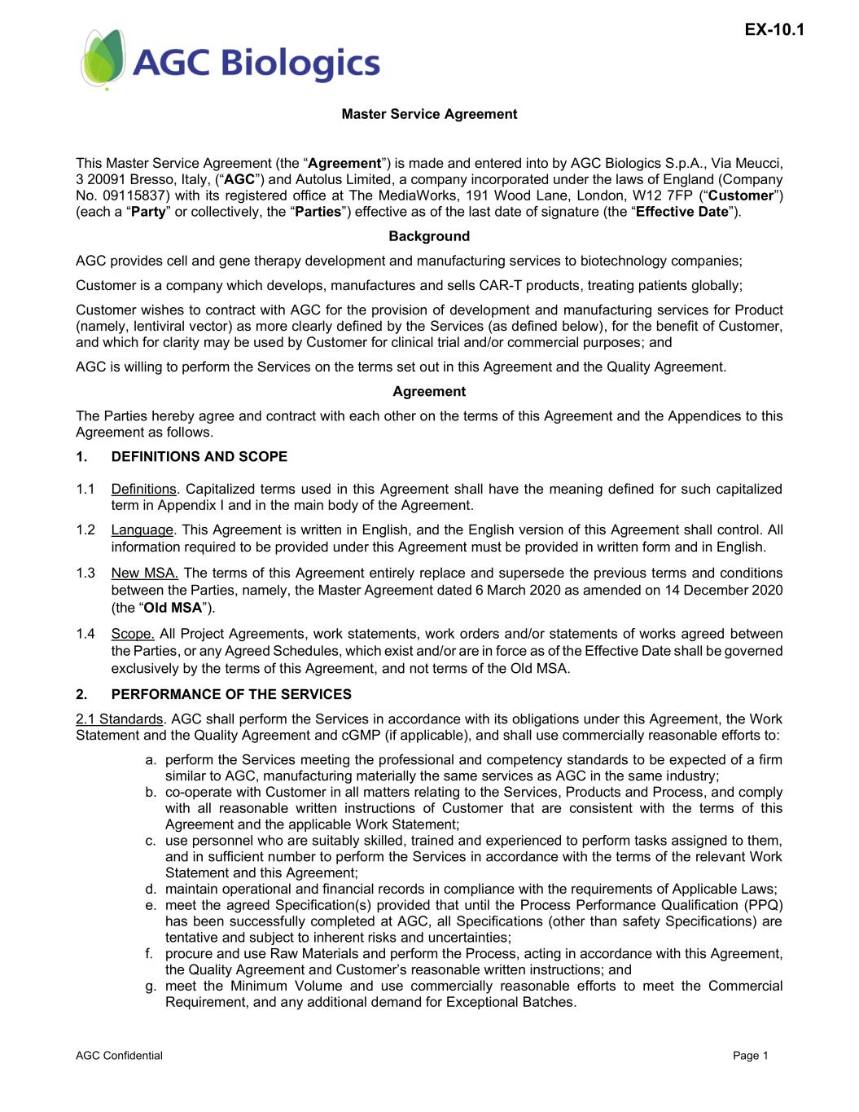
42
AGC Confidential Page 1 Master Service Agreement This Master Service Agreement (the “Agreement”) is made and entered into by AGC Biologics S.p.A., Via Meucci, 3 20091 Bresso, Italy, (“AGC”) and Autolus Limited, a company incorporated under the laws of England (Company No. 09115837) with its registered office at The MediaWorks, 191 Wood Lane, London, W12 7FP (“Customer”) (each a “Party” or collectively, the “Parties”) effective as of the last date of signature (the “Effective Date”). Background AGC provides cell and gene therapy development and manufacturing services to biotechnology companies; Customer is a company which develops, manufactures and sells CAR-T products, treating patients globally; Customer wishes to contract with AGC for the provision of development and manufacturing services for Product (namely, lentiviral vector) as more clearly defined by the Services (as defined below), for the benefit of Customer, and which for clarity may be used by Customer for clinical trial and/or commercial purposes; and AGC is willing to perform the Services on the terms set out in this Agreement and the Quality Agreement. Agreement The Parties hereby agree and contract with each other on the terms of this Agreement and the Appendices to this Agreement as follows. 1. DEFINITIONS AND SCOPE 1.1 Definitions. Capitalized terms used in this Agreement shall have the meaning defined for such capitalized term in Appendix I and in the main body of the Agreement. 1.2 Language. This Agreement is written in English, and the English version of this Agreement shall control. All information required to be provided under this Agreement must be provided in written form and in English. 1.3 New MSA. The terms of this Agreement entirely replace and supersede the previous terms and conditions between the Parties, namely, the Master Agreement dated 6 March 2020 as amended on 14 December 2020 (the “Old MSA”). 1.4 Scope. All Project Agreements, work statements, work orders and/or statements of works agreed between the Parties, or any Agreed Schedules, which exist and/or are in force as of the Effective Date shall be governed exclusively by the terms of this Agreement, and not terms of the Old MSA. 2. PERFORMANCE OF THE SERVICES 2.1 Standards. AGC shall perform the Services in accordance with its obligations under this Agreement, the Work Statement and the Quality Agreement and cGMP (if applicable), and shall use commercially reasonable efforts to: a. perform the Services meeting the professional and competency standards to be expected of a firm similar to AGC, manufacturing materially the same services as AGC in the same industry; b. co-operate with Customer in all matters relating to the Services, Products and Process, and comply with all reasonable written instructions of Customer that are consistent with the terms of this Agreement and the applicable Work Statement; c. use personnel who are suitably skilled, trained and experienced to perform tasks assigned to them, and in sufficient number to perform the Services in accordance with the terms of the relevant Work Statement and this Agreement; d. maintain operational and financial records in compliance with the requirements of Applicable Laws; e. meet the agreed Specification(s) provided that until the Process Performance Qualification (PPQ) has been successfully completed at AGC, all Specifications (other than safety Specifications) are tentative and subject to inherent risks and uncertainties; f. procure and use Raw Materials and perform the Process, acting in accordance with this Agreement, the Quality Agreement and Customer’s reasonable written instructions; and g. meet the Minimum Volume and use commercially reasonable efforts to meet the Commercial Requirement, and any additional demand for Exceptional Batches. EX-10.1

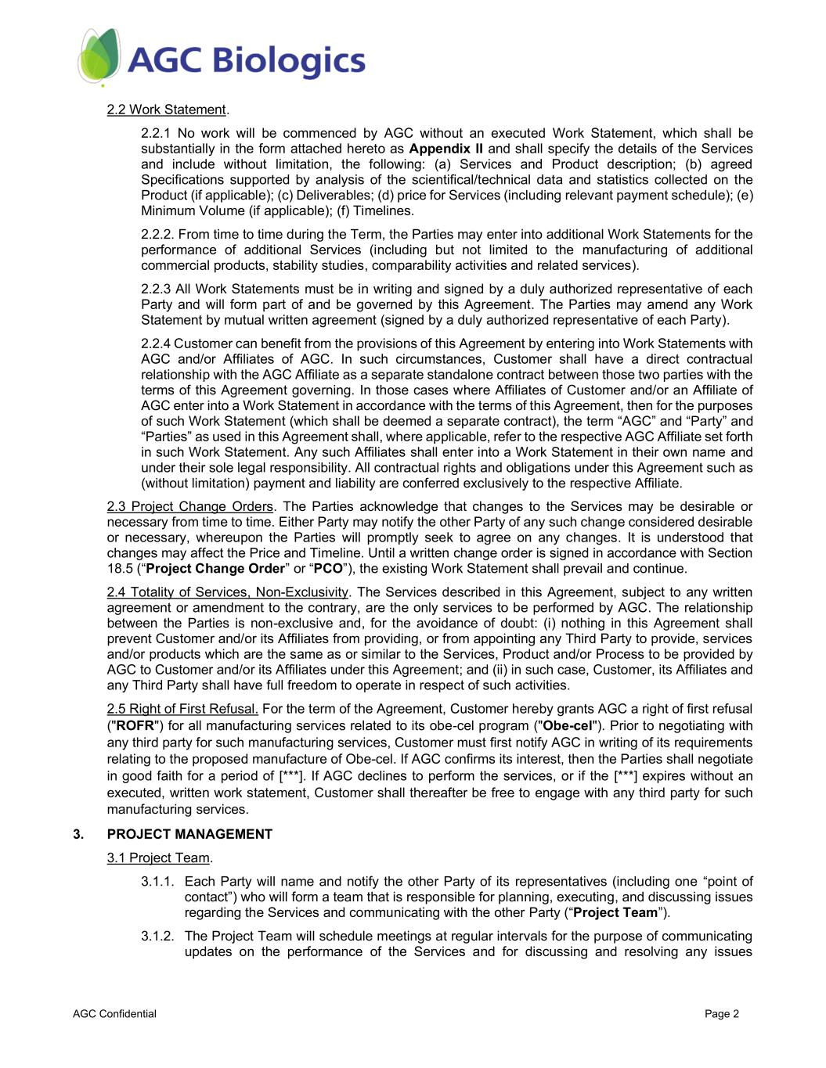
AGC Confidential Page 2 2.2 Work Statement. 2.2.1 No work will be commenced by AGC without an executed Work Statement, which shall be substantially in the form attached hereto as Appendix II and shall specify the details of the Services and include without limitation, the following: (a) Services and Product description; (b) agreed Specifications supported by analysis of the scientifical/technical data and statistics collected on the Product (if applicable); (c) Deliverables; (d) price for Services (including relevant payment schedule); (e) Minimum Volume (if applicable); (f) Timelines. 2.2.2. From time to time during the Term, the Parties may enter into additional Work Statements for the performance of additional Services (including but not limited to the manufacturing of additional commercial products, stability studies, comparability activities and related services). 2.2.3 All Work Statements must be in writing and signed by a duly authorized representative of each Party and will form part of and be governed by this Agreement. The Parties may amend any Work Statement by mutual written agreement (signed by a duly authorized representative of each Party). 2.2.4 Customer can benefit from the provisions of this Agreement by entering into Work Statements with AGC and/or Affiliates of AGC. In such circumstances, Customer shall have a direct contractual relationship with the AGC Affiliate as a separate standalone contract between those two parties with the terms of this Agreement governing. In those cases where Affiliates of Customer and/or an Affiliate of AGC enter into a Work Statement in accordance with the terms of this Agreement, then for the purposes of such Work Statement (which shall be deemed a separate contract), the term “AGC” and “Party” and “Parties” as used in this Agreement shall, where applicable, refer to the respective AGC Affiliate set forth in such Work Statement. Any such Affiliates shall enter into a Work Statement in their own name and under their sole legal responsibility. All contractual rights and obligations under this Agreement such as (without limitation) payment and liability are conferred exclusively to the respective Affiliate. 2.3 Project Change Orders. The Parties acknowledge that changes to the Services may be desirable or necessary from time to time. Either Party may notify the other Party of any such change considered desirable or necessary, whereupon the Parties will promptly seek to agree on any changes. It is understood that changes may affect the Price and Timeline. Until a written change order is signed in accordance with Section 18.5 (“Project Change Order” or “PCO”), the existing Work Statement shall prevail and continue. 2.4 Totality of Services, Non-Exclusivity. The Services described in this Agreement, subject to any written agreement or amendment to the contrary, are the only services to be performed by AGC. The relationship between the Parties is non-exclusive and, for the avoidance of doubt: (i) nothing in this Agreement shall prevent Customer and/or its Affiliates from providing, or from appointing any Third Party to provide, services and/or products which are the same as or similar to the Services, Product and/or Process to be provided by AGC to Customer and/or its Affiliates under this Agreement; and (ii) in such case, Customer, its Affiliates and any Third Party shall have full freedom to operate in respect of such activities. 2.5 Right of First Refusal. For the term of the Agreement, Customer hereby grants AGC a right of first refusal ("ROFR") for all manufacturing services related to its obe-cel program ("Obe-cel"). Prior to negotiating with any third party for such manufacturing services, Customer must first notify AGC in writing of its requirements relating to the proposed manufacture of Obe-cel. If AGC confirms its interest, then the Parties shall negotiate in good faith for a period of [***]. If AGC declines to perform the services, or if the [***] expires without an executed, written work statement, Customer shall thereafter be free to engage with any third party for such manufacturing services. 3. PROJECT MANAGEMENT 3.1 Project Team. 3.1.1. Each Party will name and notify the other Party of its representatives (including one “point of contact”) who will form a team that is responsible for planning, executing, and discussing issues regarding the Services and communicating with the other Party (“Project Team”). 3.1.2. The Project Team will schedule meetings at regular intervals for the purpose of communicating updates on the performance of the Services and for discussing and resolving any issues

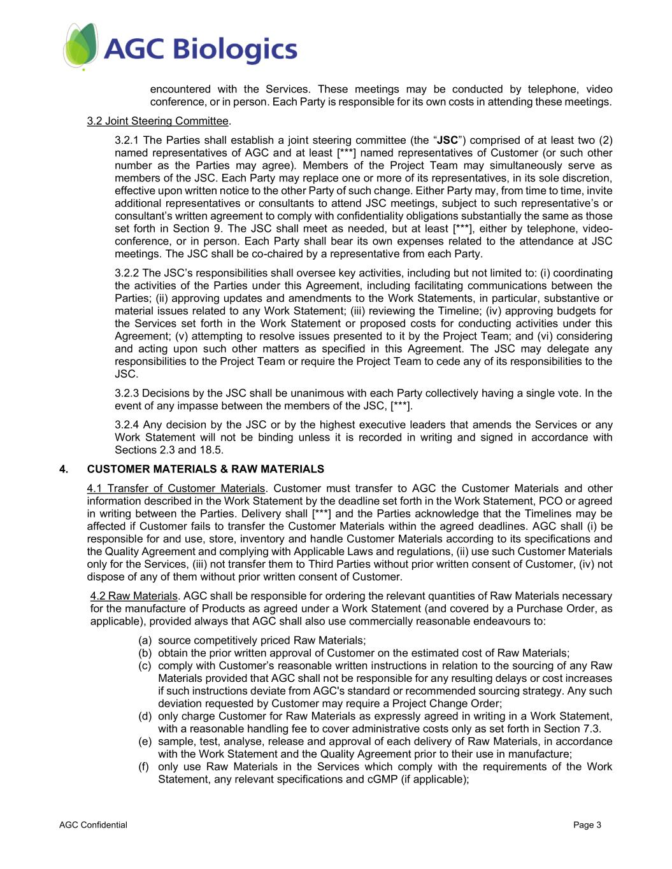
AGC Confidential Page 3 encountered with the Services. These meetings may be conducted by telephone, video conference, or in person. Each Party is responsible for its own costs in attending these meetings. 3.2 Joint Steering Committee. 3.2.1 The Parties shall establish a joint steering committee (the “JSC”) comprised of at least two (2) named representatives of AGC and at least [***] named representatives of Customer (or such other number as the Parties may agree). Members of the Project Team may simultaneously serve as members of the JSC. Each Party may replace one or more of its representatives, in its sole discretion, effective upon written notice to the other Party of such change. Either Party may, from time to time, invite additional representatives or consultants to attend JSC meetings, subject to such representative’s or consultant’s written agreement to comply with confidentiality obligations substantially the same as those set forth in Section 9. The JSC shall meet as needed, but at least [***], either by telephone, video- conference, or in person. Each Party shall bear its own expenses related to the attendance at JSC meetings. The JSC shall be co-chaired by a representative from each Party. 3.2.2 The JSC’s responsibilities shall oversee key activities, including but not limited to: (i) coordinating the activities of the Parties under this Agreement, including facilitating communications between the Parties; (ii) approving updates and amendments to the Work Statements, in particular, substantive or material issues related to any Work Statement; (iii) reviewing the Timeline; (iv) approving budgets for the Services set forth in the Work Statement or proposed costs for conducting activities under this Agreement; (v) attempting to resolve issues presented to it by the Project Team; and (vi) considering and acting upon such other matters as specified in this Agreement. The JSC may delegate any responsibilities to the Project Team or require the Project Team to cede any of its responsibilities to the JSC. 3.2.3 Decisions by the JSC shall be unanimous with each Party collectively having a single vote. In the event of any impasse between the members of the JSC, [***]. 3.2.4 Any decision by the JSC or by the highest executive leaders that amends the Services or any Work Statement will not be binding unless it is recorded in writing and signed in accordance with Sections 2.3 and 18.5. 4. CUSTOMER MATERIALS & RAW MATERIALS 4.1 Transfer of Customer Materials. Customer must transfer to AGC the Customer Materials and other information described in the Work Statement by the deadline set forth in the Work Statement, PCO or agreed in writing between the Parties. Delivery shall [***] and the Parties acknowledge that the Timelines may be affected if Customer fails to transfer the Customer Materials within the agreed deadlines. AGC shall (i) be responsible for and use, store, inventory and handle Customer Materials according to its specifications and the Quality Agreement and complying with Applicable Laws and regulations, (ii) use such Customer Materials only for the Services, (iii) not transfer them to Third Parties without prior written consent of Customer, (iv) not dispose of any of them without prior written consent of Customer. 4.2 Raw Materials. AGC shall be responsible for ordering the relevant quantities of Raw Materials necessary for the manufacture of Products as agreed under a Work Statement (and covered by a Purchase Order, as applicable), provided always that AGC shall also use commercially reasonable endeavours to: (a) source competitively priced Raw Materials; (b) obtain the prior written approval of Customer on the estimated cost of Raw Materials; (c) comply with Customer’s reasonable written instructions in relation to the sourcing of any Raw Materials provided that AGC shall not be responsible for any resulting delays or cost increases if such instructions deviate from AGC's standard or recommended sourcing strategy. Any such deviation requested by Customer may require a Project Change Order; (d) only charge Customer for Raw Materials as expressly agreed in writing in a Work Statement, with a reasonable handling fee to cover administrative costs only as set forth in Section 7.3. (e) sample, test, analyse, release and approval of each delivery of Raw Materials, in accordance with the Work Statement and the Quality Agreement prior to their use in manufacture; (f) only use Raw Materials in the Services which comply with the requirements of the Work Statement, any relevant specifications and cGMP (if applicable);

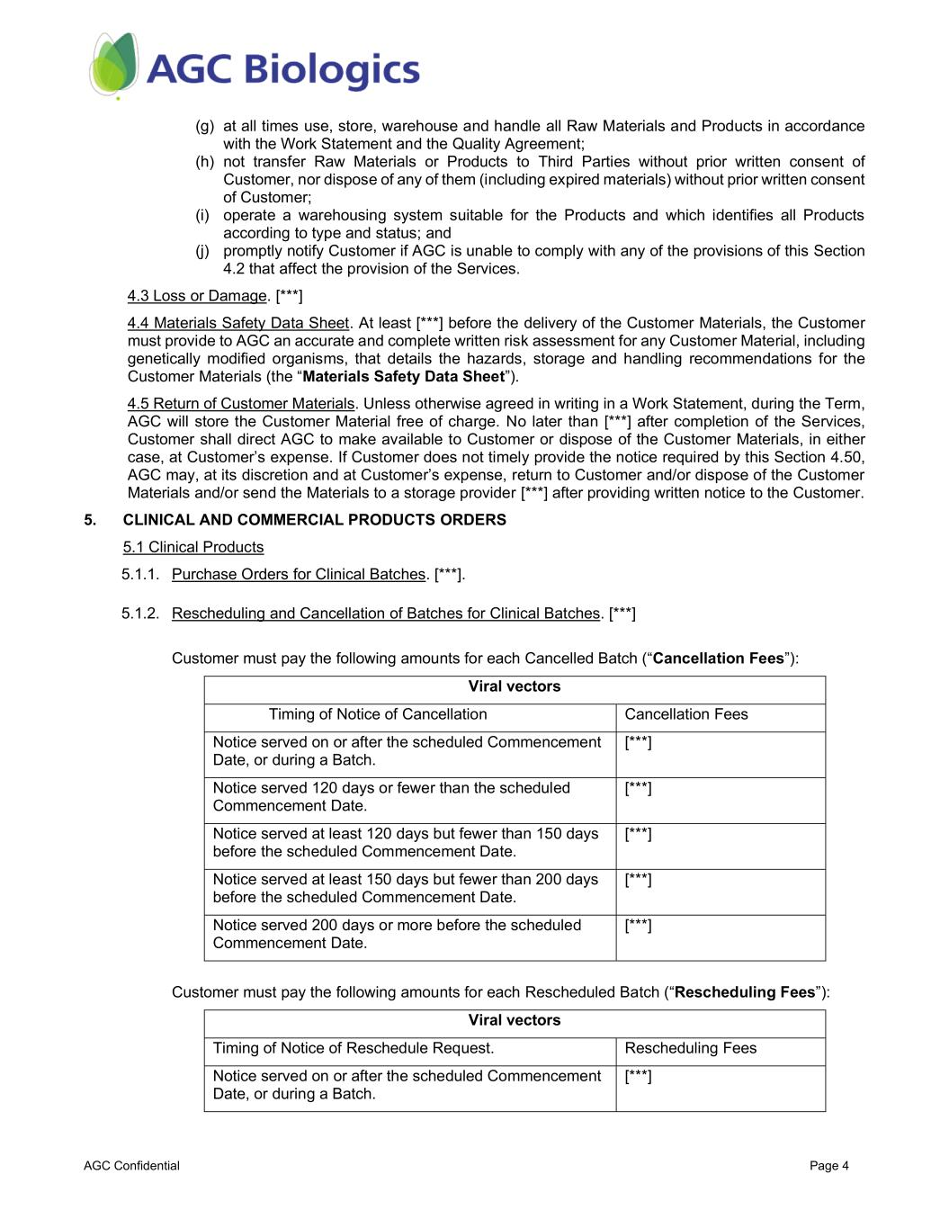
AGC Confidential Page 4 (g) at all times use, store, warehouse and handle all Raw Materials and Products in accordance with the Work Statement and the Quality Agreement; (h) not transfer Raw Materials or Products to Third Parties without prior written consent of Customer, nor dispose of any of them (including expired materials) without prior written consent of Customer; (i) operate a warehousing system suitable for the Products and which identifies all Products according to type and status; and (j) promptly notify Customer if AGC is unable to comply with any of the provisions of this Section 4.2 that affect the provision of the Services. 4.3 Loss or Damage. [***] 4.4 Materials Safety Data Sheet. At least [***] before the delivery of the Customer Materials, the Customer must provide to AGC an accurate and complete written risk assessment for any Customer Material, including genetically modified organisms, that details the hazards, storage and handling recommendations for the Customer Materials (the “Materials Safety Data Sheet”). 4.5 Return of Customer Materials. Unless otherwise agreed in writing in a Work Statement, during the Term, AGC will store the Customer Material free of charge. No later than [***] after completion of the Services, Customer shall direct AGC to make available to Customer or dispose of the Customer Materials, in either case, at Customer’s expense. If Customer does not timely provide the notice required by this Section 4.50, AGC may, at its discretion and at Customer’s expense, return to Customer and/or dispose of the Customer Materials and/or send the Materials to a storage provider [***] after providing written notice to the Customer. 5. CLINICAL AND COMMERCIAL PRODUCTS ORDERS 5.1 Clinical Products 5.1.1. Purchase Orders for Clinical Batches. [***]. 5.1.2. Rescheduling and Cancellation of Batches for Clinical Batches. [***] Customer must pay the following amounts for each Cancelled Batch (“Cancellation Fees”): Viral vectors Timing of Notice of Cancellation Cancellation Fees Notice served on or after the scheduled Commencement Date, or during a Batch. [***] Notice served 120 days or fewer than the scheduled Commencement Date. [***] Notice served at least 120 days but fewer than 150 days before the scheduled Commencement Date. [***] Notice served at least 150 days but fewer than 200 days before the scheduled Commencement Date. [***] Notice served 200 days or more before the scheduled Commencement Date. [***] Customer must pay the following amounts for each Rescheduled Batch (“Rescheduling Fees”): Viral vectors Timing of Notice of Reschedule Request. Rescheduling Fees Notice served on or after the scheduled Commencement Date, or during a Batch. [***]

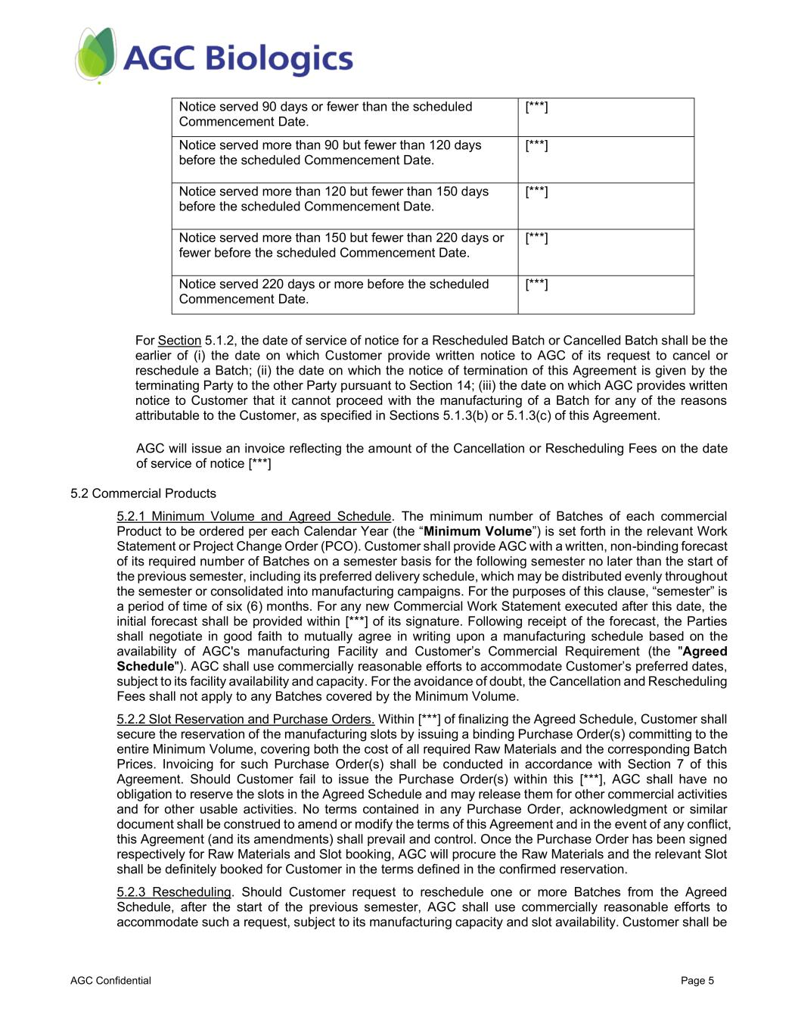
AGC Confidential Page 5 Notice served 90 days or fewer than the scheduled Commencement Date. [***] Notice served more than 90 but fewer than 120 days before the scheduled Commencement Date. [***] Notice served more than 120 but fewer than 150 days before the scheduled Commencement Date. [***] Notice served more than 150 but fewer than 220 days or fewer before the scheduled Commencement Date. [***] Notice served 220 days or more before the scheduled Commencement Date. [***] For Section 5.1.2, the date of service of notice for a Rescheduled Batch or Cancelled Batch shall be the earlier of (i) the date on which Customer provide written notice to AGC of its request to cancel or reschedule a Batch; (ii) the date on which the notice of termination of this Agreement is given by the terminating Party to the other Party pursuant to Section 14; (iii) the date on which AGC provides written notice to Customer that it cannot proceed with the manufacturing of a Batch for any of the reasons attributable to the Customer, as specified in Sections 5.1.3(b) or 5.1.3(c) of this Agreement. AGC will issue an invoice reflecting the amount of the Cancellation or Rescheduling Fees on the date of service of notice [***] 5.2 Commercial Products 5.2.1 Minimum Volume and Agreed Schedule. The minimum number of Batches of each commercial Product to be ordered per each Calendar Year (the “Minimum Volume”) is set forth in the relevant Work Statement or Project Change Order (PCO). Customer shall provide AGC with a written, non-binding forecast of its required number of Batches on a semester basis for the following semester no later than the start of the previous semester, including its preferred delivery schedule, which may be distributed evenly throughout the semester or consolidated into manufacturing campaigns. For the purposes of this clause, “semester” is a period of time of six (6) months. For any new Commercial Work Statement executed after this date, the initial forecast shall be provided within [***] of its signature. Following receipt of the forecast, the Parties shall negotiate in good faith to mutually agree in writing upon a manufacturing schedule based on the availability of AGC's manufacturing Facility and Customer’s Commercial Requirement (the "Agreed Schedule"). AGC shall use commercially reasonable efforts to accommodate Customer’s preferred dates, subject to its facility availability and capacity. For the avoidance of doubt, the Cancellation and Rescheduling Fees shall not apply to any Batches covered by the Minimum Volume. 5.2.2 Slot Reservation and Purchase Orders. Within [***] of finalizing the Agreed Schedule, Customer shall secure the reservation of the manufacturing slots by issuing a binding Purchase Order(s) committing to the entire Minimum Volume, covering both the cost of all required Raw Materials and the corresponding Batch Prices. Invoicing for such Purchase Order(s) shall be conducted in accordance with Section 7 of this Agreement. Should Customer fail to issue the Purchase Order(s) within this [***], AGC shall have no obligation to reserve the slots in the Agreed Schedule and may release them for other commercial activities and for other usable activities. No terms contained in any Purchase Order, acknowledgment or similar document shall be construed to amend or modify the terms of this Agreement and in the event of any conflict, this Agreement (and its amendments) shall prevail and control. Once the Purchase Order has been signed respectively for Raw Materials and Slot booking, AGC will procure the Raw Materials and the relevant Slot shall be definitely booked for Customer in the terms defined in the confirmed reservation. 5.2.3 Rescheduling. Should Customer request to reschedule one or more Batches from the Agreed Schedule, after the start of the previous semester, AGC shall use commercially reasonable efforts to accommodate such a request, subject to its manufacturing capacity and slot availability. Customer shall be

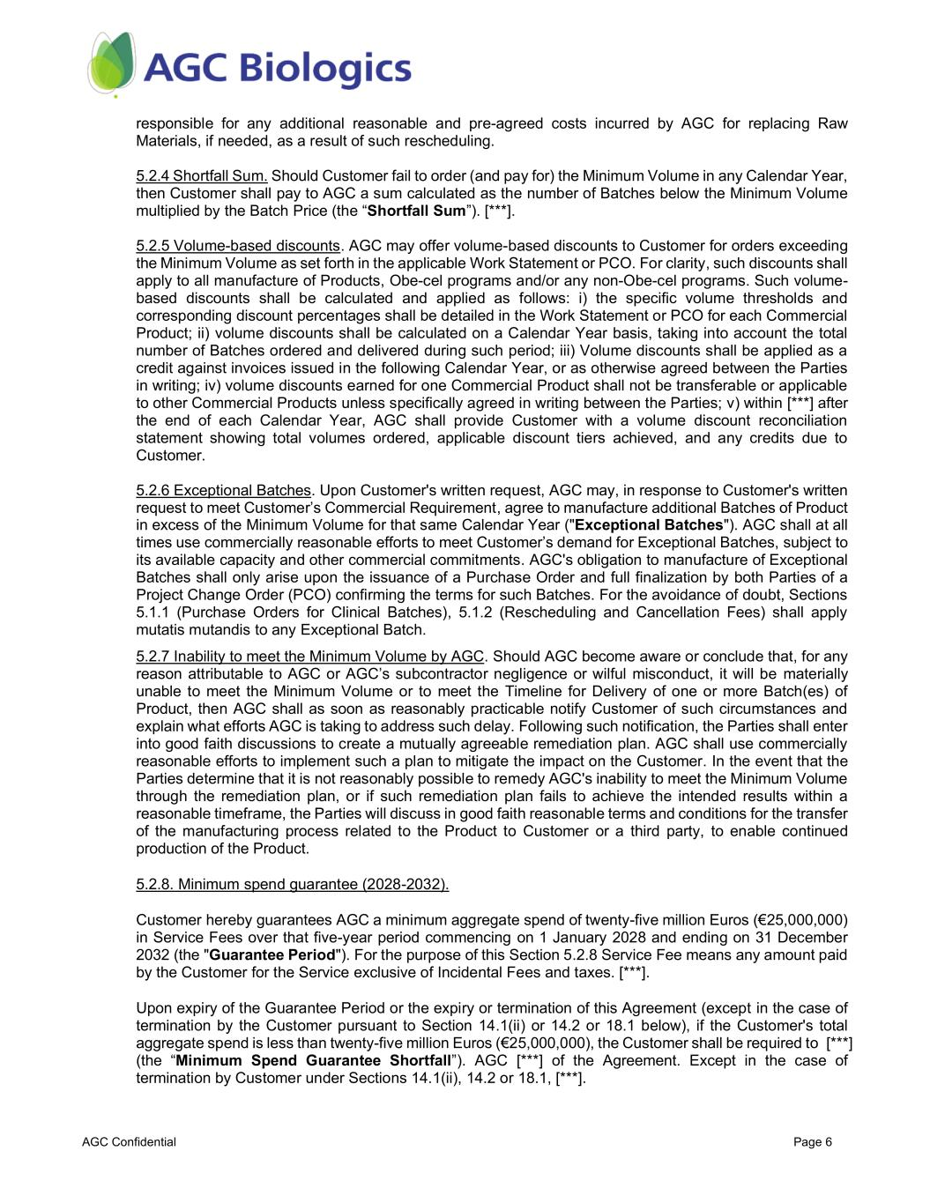
AGC Confidential Page 6 responsible for any additional reasonable and pre-agreed costs incurred by AGC for replacing Raw Materials, if needed, as a result of such rescheduling. 5.2.4 Shortfall Sum. Should Customer fail to order (and pay for) the Minimum Volume in any Calendar Year, then Customer shall pay to AGC a sum calculated as the number of Batches below the Minimum Volume multiplied by the Batch Price (the “Shortfall Sum”). [***]. 5.2.5 Volume-based discounts. AGC may offer volume-based discounts to Customer for orders exceeding the Minimum Volume as set forth in the applicable Work Statement or PCO. For clarity, such discounts shall apply to all manufacture of Products, Obe-cel programs and/or any non-Obe-cel programs. Such volume- based discounts shall be calculated and applied as follows: i) the specific volume thresholds and corresponding discount percentages shall be detailed in the Work Statement or PCO for each Commercial Product; ii) volume discounts shall be calculated on a Calendar Year basis, taking into account the total number of Batches ordered and delivered during such period; iii) Volume discounts shall be applied as a credit against invoices issued in the following Calendar Year, or as otherwise agreed between the Parties in writing; iv) volume discounts earned for one Commercial Product shall not be transferable or applicable to other Commercial Products unless specifically agreed in writing between the Parties; v) within [***] after the end of each Calendar Year, AGC shall provide Customer with a volume discount reconciliation statement showing total volumes ordered, applicable discount tiers achieved, and any credits due to Customer. 5.2.6 Exceptional Batches. Upon Customer's written request, AGC may, in response to Customer's written request to meet Customer’s Commercial Requirement, agree to manufacture additional Batches of Product in excess of the Minimum Volume for that same Calendar Year ("Exceptional Batches"). AGC shall at all times use commercially reasonable efforts to meet Customer’s demand for Exceptional Batches, subject to its available capacity and other commercial commitments. AGC's obligation to manufacture of Exceptional Batches shall only arise upon the issuance of a Purchase Order and full finalization by both Parties of a Project Change Order (PCO) confirming the terms for such Batches. For the avoidance of doubt, Sections 5.1.1 (Purchase Orders for Clinical Batches), 5.1.2 (Rescheduling and Cancellation Fees) shall apply mutatis mutandis to any Exceptional Batch. 5.2.7 Inability to meet the Minimum Volume by AGC. Should AGC become aware or conclude that, for any reason attributable to AGC or AGC’s subcontractor negligence or wilful misconduct, it will be materially unable to meet the Minimum Volume or to meet the Timeline for Delivery of one or more Batch(es) of Product, then AGC shall as soon as reasonably practicable notify Customer of such circumstances and explain what efforts AGC is taking to address such delay. Following such notification, the Parties shall enter into good faith discussions to create a mutually agreeable remediation plan. AGC shall use commercially reasonable efforts to implement such a plan to mitigate the impact on the Customer. In the event that the Parties determine that it is not reasonably possible to remedy AGC's inability to meet the Minimum Volume through the remediation plan, or if such remediation plan fails to achieve the intended results within a reasonable timeframe, the Parties will discuss in good faith reasonable terms and conditions for the transfer of the manufacturing process related to the Product to Customer or a third party, to enable continued production of the Product. 5.2.8. Minimum spend guarantee (2028-2032). Customer hereby guarantees AGC a minimum aggregate spend of twenty-five million Euros (€25,000,000) in Service Fees over that five-year period commencing on 1 January 2028 and ending on 31 December 2032 (the "Guarantee Period"). For the purpose of this Section 5.2.8 Service Fee means any amount paid by the Customer for the Service exclusive of Incidental Fees and taxes. [***]. Upon expiry of the Guarantee Period or the expiry or termination of this Agreement (except in the case of termination by the Customer pursuant to Section 14.1(ii) or 14.2 or 18.1 below), if the Customer's total aggregate spend is less than twenty-five million Euros (€25,000,000), the Customer shall be required to [***] (the “Minimum Spend Guarantee Shortfall”). AGC [***] of the Agreement. Except in the case of termination by Customer under Sections 14.1(ii), 14.2 or 18.1, [***].

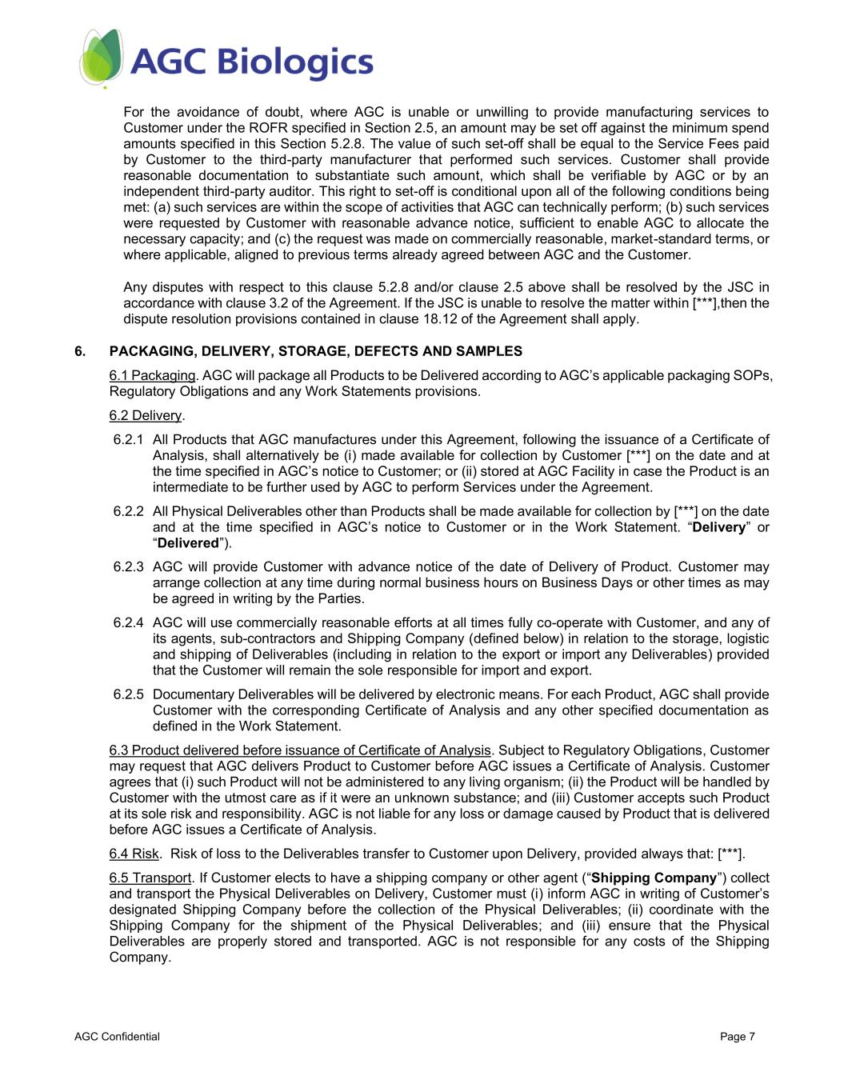
AGC Confidential Page 7 For the avoidance of doubt, where AGC is unable or unwilling to provide manufacturing services to Customer under the ROFR specified in Section 2.5, an amount may be set off against the minimum spend amounts specified in this Section 5.2.8. The value of such set-off shall be equal to the Service Fees paid by Customer to the third-party manufacturer that performed such services. Customer shall provide reasonable documentation to substantiate such amount, which shall be verifiable by AGC or by an independent third-party auditor. This right to set-off is conditional upon all of the following conditions being met: (a) such services are within the scope of activities that AGC can technically perform; (b) such services were requested by Customer with reasonable advance notice, sufficient to enable AGC to allocate the necessary capacity; and (c) the request was made on commercially reasonable, market-standard terms, or where applicable, aligned to previous terms already agreed between AGC and the Customer. Any disputes with respect to this clause 5.2.8 and/or clause 2.5 above shall be resolved by the JSC in accordance with clause 3.2 of the Agreement. If the JSC is unable to resolve the matter within [***],then the dispute resolution provisions contained in clause 18.12 of the Agreement shall apply. 6. PACKAGING, DELIVERY, STORAGE, DEFECTS AND SAMPLES 6.1 Packaging. AGC will package all Products to be Delivered according to AGC’s applicable packaging SOPs, Regulatory Obligations and any Work Statements provisions. 6.2 Delivery. 6.2.1 All Products that AGC manufactures under this Agreement, following the issuance of a Certificate of Analysis, shall alternatively be (i) made available for collection by Customer [***] on the date and at the time specified in AGC’s notice to Customer; or (ii) stored at AGC Facility in case the Product is an intermediate to be further used by AGC to perform Services under the Agreement. 6.2.2 All Physical Deliverables other than Products shall be made available for collection by [***] on the date and at the time specified in AGC’s notice to Customer or in the Work Statement. “Delivery” or “Delivered”). 6.2.3 AGC will provide Customer with advance notice of the date of Delivery of Product. Customer may arrange collection at any time during normal business hours on Business Days or other times as may be agreed in writing by the Parties. 6.2.4 AGC will use commercially reasonable efforts at all times fully co-operate with Customer, and any of its agents, sub-contractors and Shipping Company (defined below) in relation to the storage, logistic and shipping of Deliverables (including in relation to the export or import any Deliverables) provided that the Customer will remain the sole responsible for import and export. 6.2.5 Documentary Deliverables will be delivered by electronic means. For each Product, AGC shall provide Customer with the corresponding Certificate of Analysis and any other specified documentation as defined in the Work Statement. 6.3 Product delivered before issuance of Certificate of Analysis. Subject to Regulatory Obligations, Customer may request that AGC delivers Product to Customer before AGC issues a Certificate of Analysis. Customer agrees that (i) such Product will not be administered to any living organism; (ii) the Product will be handled by Customer with the utmost care as if it were an unknown substance; and (iii) Customer accepts such Product at its sole risk and responsibility. AGC is not liable for any loss or damage caused by Product that is delivered before AGC issues a Certificate of Analysis. 6.4 Risk. Risk of loss to the Deliverables transfer to Customer upon Delivery, provided always that: [***]. 6.5 Transport. If Customer elects to have a shipping company or other agent (“Shipping Company”) collect and transport the Physical Deliverables on Delivery, Customer must (i) inform AGC in writing of Customer’s designated Shipping Company before the collection of the Physical Deliverables; (ii) coordinate with the Shipping Company for the shipment of the Physical Deliverables; and (iii) ensure that the Physical Deliverables are properly stored and transported. AGC is not responsible for any costs of the Shipping Company.

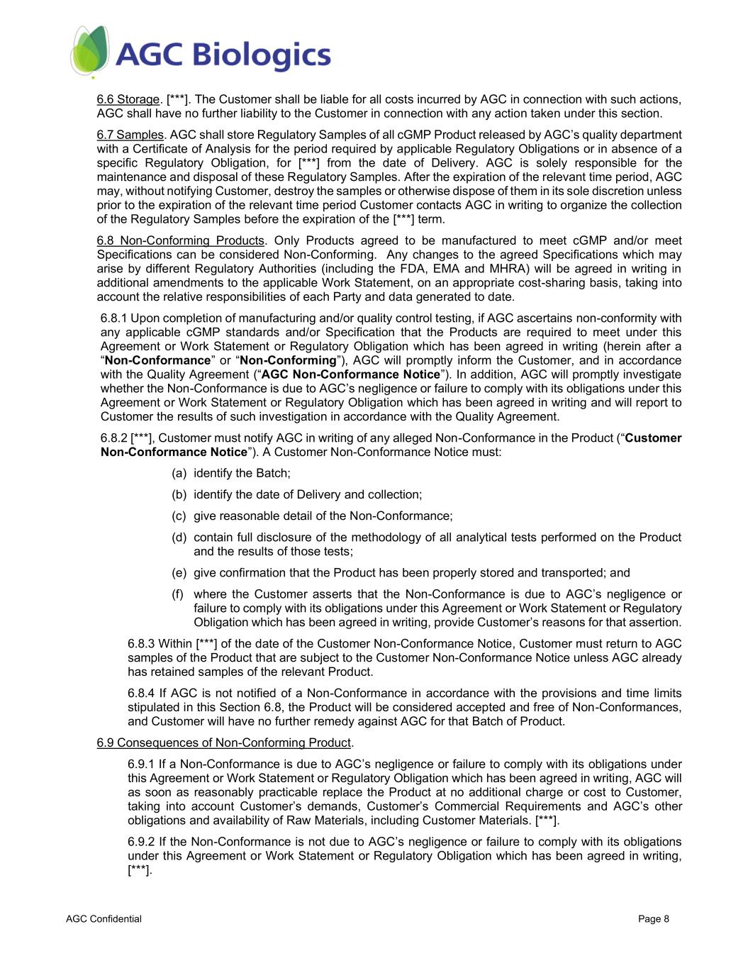
AGC Confidential Page 8 6.6 Storage. [***]. The Customer shall be liable for all costs incurred by AGC in connection with such actions, AGC shall have no further liability to the Customer in connection with any action taken under this section. 6.7 Samples. AGC shall store Regulatory Samples of all cGMP Product released by AGC’s quality department with a Certificate of Analysis for the period required by applicable Regulatory Obligations or in absence of a specific Regulatory Obligation, for [***] from the date of Delivery. AGC is solely responsible for the maintenance and disposal of these Regulatory Samples. After the expiration of the relevant time period, AGC may, without notifying Customer, destroy the samples or otherwise dispose of them in its sole discretion unless prior to the expiration of the relevant time period Customer contacts AGC in writing to organize the collection of the Regulatory Samples before the expiration of the [***] term. 6.8 Non-Conforming Products. Only Products agreed to be manufactured to meet cGMP and/or meet Specifications can be considered Non-Conforming. Any changes to the agreed Specifications which may arise by different Regulatory Authorities (including the FDA, EMA and MHRA) will be agreed in writing in additional amendments to the applicable Work Statement, on an appropriate cost-sharing basis, taking into account the relative responsibilities of each Party and data generated to date. 6.8.1 Upon completion of manufacturing and/or quality control testing, if AGC ascertains non-conformity with any applicable cGMP standards and/or Specification that the Products are required to meet under this Agreement or Work Statement or Regulatory Obligation which has been agreed in writing (herein after a “Non-Conformance” or “Non-Conforming”), AGC will promptly inform the Customer, and in accordance with the Quality Agreement (“AGC Non-Conformance Notice”). In addition, AGC will promptly investigate whether the Non-Conformance is due to AGC’s negligence or failure to comply with its obligations under this Agreement or Work Statement or Regulatory Obligation which has been agreed in writing and will report to Customer the results of such investigation in accordance with the Quality Agreement. 6.8.2 [***], Customer must notify AGC in writing of any alleged Non-Conformance in the Product (“Customer Non-Conformance Notice”). A Customer Non-Conformance Notice must: (a) identify the Batch; (b) identify the date of Delivery and collection; (c) give reasonable detail of the Non-Conformance; (d) contain full disclosure of the methodology of all analytical tests performed on the Product and the results of those tests; (e) give confirmation that the Product has been properly stored and transported; and (f) where the Customer asserts that the Non-Conformance is due to AGC’s negligence or failure to comply with its obligations under this Agreement or Work Statement or Regulatory Obligation which has been agreed in writing, provide Customer’s reasons for that assertion. 6.8.3 Within [***] of the date of the Customer Non-Conformance Notice, Customer must return to AGC samples of the Product that are subject to the Customer Non-Conformance Notice unless AGC already has retained samples of the relevant Product. 6.8.4 If AGC is not notified of a Non-Conformance in accordance with the provisions and time limits stipulated in this Section 6.8, the Product will be considered accepted and free of Non-Conformances, and Customer will have no further remedy against AGC for that Batch of Product. 6.9 Consequences of Non-Conforming Product. 6.9.1 If a Non-Conformance is due to AGC’s negligence or failure to comply with its obligations under this Agreement or Work Statement or Regulatory Obligation which has been agreed in writing, AGC will as soon as reasonably practicable replace the Product at no additional charge or cost to Customer, taking into account Customer’s demands, Customer’s Commercial Requirements and AGC’s other obligations and availability of Raw Materials, including Customer Materials. [***]. 6.9.2 If the Non-Conformance is not due to AGC’s negligence or failure to comply with its obligations under this Agreement or Work Statement or Regulatory Obligation which has been agreed in writing, [***].

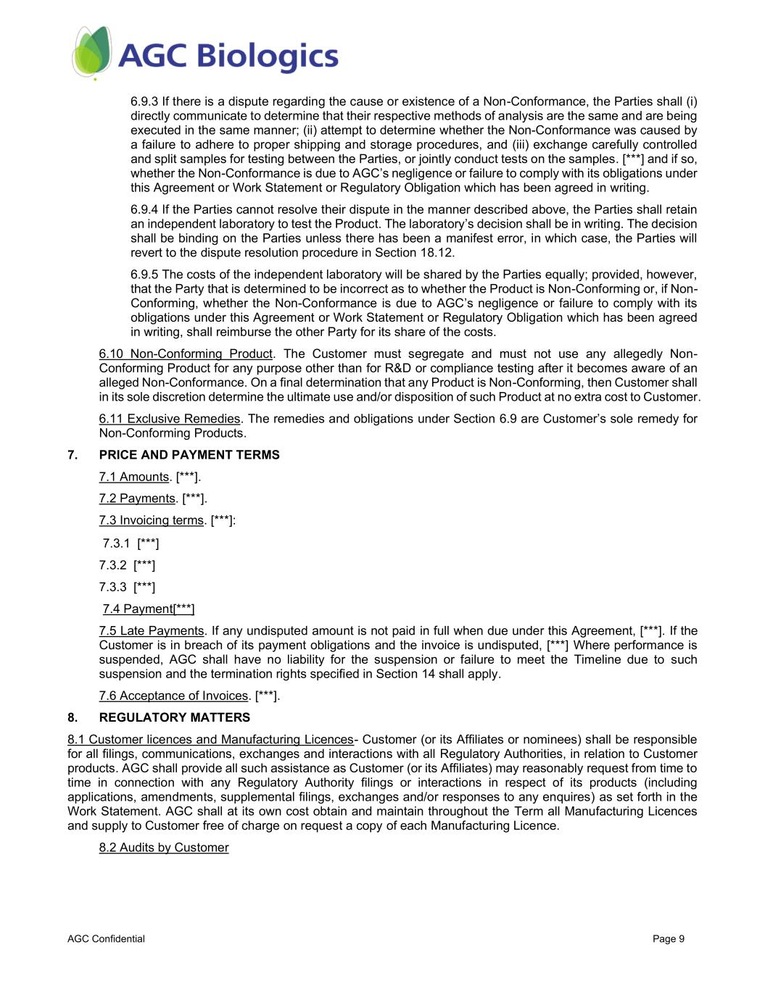
AGC Confidential Page 9 6.9.3 If there is a dispute regarding the cause or existence of a Non-Conformance, the Parties shall (i) directly communicate to determine that their respective methods of analysis are the same and are being executed in the same manner; (ii) attempt to determine whether the Non-Conformance was caused by a failure to adhere to proper shipping and storage procedures, and (iii) exchange carefully controlled and split samples for testing between the Parties, or jointly conduct tests on the samples. [***] and if so, whether the Non-Conformance is due to AGC’s negligence or failure to comply with its obligations under this Agreement or Work Statement or Regulatory Obligation which has been agreed in writing. 6.9.4 If the Parties cannot resolve their dispute in the manner described above, the Parties shall retain an independent laboratory to test the Product. The laboratory’s decision shall be in writing. The decision shall be binding on the Parties unless there has been a manifest error, in which case, the Parties will revert to the dispute resolution procedure in Section 18.12. 6.9.5 The costs of the independent laboratory will be shared by the Parties equally; provided, however, that the Party that is determined to be incorrect as to whether the Product is Non-Conforming or, if Non- Conforming, whether the Non-Conformance is due to AGC’s negligence or failure to comply with its obligations under this Agreement or Work Statement or Regulatory Obligation which has been agreed in writing, shall reimburse the other Party for its share of the costs. 6.10 Non-Conforming Product. The Customer must segregate and must not use any allegedly Non- Conforming Product for any purpose other than for R&D or compliance testing after it becomes aware of an alleged Non-Conformance. On a final determination that any Product is Non-Conforming, then Customer shall in its sole discretion determine the ultimate use and/or disposition of such Product at no extra cost to Customer. 6.11 Exclusive Remedies. The remedies and obligations under Section 6.9 are Customer’s sole remedy for Non-Conforming Products. 7. PRICE AND PAYMENT TERMS 7.1 Amounts. [***]. 7.2 Payments. [***]. 7.3 Invoicing terms. [***]: 7.3.1 [***] 7.3.2 [***] 7.3.3 [***] 7.4 Payment[***] 7.5 Late Payments. If any undisputed amount is not paid in full when due under this Agreement, [***]. If the Customer is in breach of its payment obligations and the invoice is undisputed, [***] Where performance is suspended, AGC shall have no liability for the suspension or failure to meet the Timeline due to such suspension and the termination rights specified in Section 14 shall apply. 7.6 Acceptance of Invoices. [***]. 8. REGULATORY MATTERS 8.1 Customer licences and Manufacturing Licences- Customer (or its Affiliates or nominees) shall be responsible for all filings, communications, exchanges and interactions with all Regulatory Authorities, in relation to Customer products. AGC shall provide all such assistance as Customer (or its Affiliates) may reasonably request from time to time in connection with any Regulatory Authority filings or interactions in respect of its products (including applications, amendments, supplemental filings, exchanges and/or responses to any enquires) as set forth in the Work Statement. AGC shall at its own cost obtain and maintain throughout the Term all Manufacturing Licences and supply to Customer free of charge on request a copy of each Manufacturing Licence. 8.2 Audits by Customer

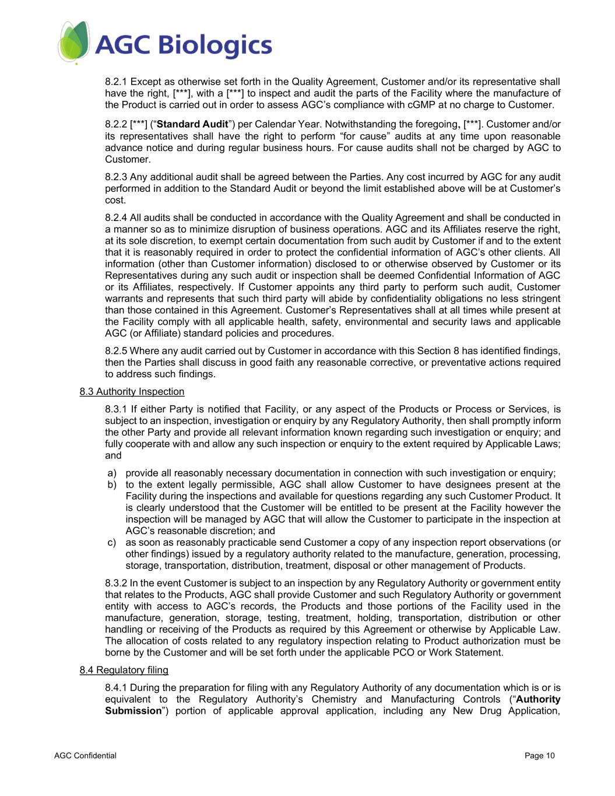
AGC Confidential Page 10 8.2.1 Except as otherwise set forth in the Quality Agreement, Customer and/or its representative shall have the right, [***], with a [***] to inspect and audit the parts of the Facility where the manufacture of the Product is carried out in order to assess AGC’s compliance with cGMP at no charge to Customer. 8.2.2 [***] (“Standard Audit”) per Calendar Year. Notwithstanding the foregoing, [***]. Customer and/or its representatives shall have the right to perform “for cause” audits at any time upon reasonable advance notice and during regular business hours. For cause audits shall not be charged by AGC to Customer. 8.2.3 Any additional audit shall be agreed between the Parties. Any cost incurred by AGC for any audit performed in addition to the Standard Audit or beyond the limit established above will be at Customer’s cost. 8.2.4 All audits shall be conducted in accordance with the Quality Agreement and shall be conducted in a manner so as to minimize disruption of business operations. AGC and its Affiliates reserve the right, at its sole discretion, to exempt certain documentation from such audit by Customer if and to the extent that it is reasonably required in order to protect the confidential information of AGC’s other clients. All information (other than Customer information) disclosed to or otherwise observed by Customer or its Representatives during any such audit or inspection shall be deemed Confidential Information of AGC or its Affiliates, respectively. If Customer appoints any third party to perform such audit, Customer warrants and represents that such third party will abide by confidentiality obligations no less stringent than those contained in this Agreement. Customer’s Representatives shall at all times while present at the Facility comply with all applicable health, safety, environmental and security laws and applicable AGC (or Affiliate) standard policies and procedures. 8.2.5 Where any audit carried out by Customer in accordance with this Section 8 has identified findings, then the Parties shall discuss in good faith any reasonable corrective, or preventative actions required to address such findings. 8.3 Authority Inspection 8.3.1 If either Party is notified that Facility, or any aspect of the Products or Process or Services, is subject to an inspection, investigation or enquiry by any Regulatory Authority, then shall promptly inform the other Party and provide all relevant information known regarding such investigation or enquiry; and fully cooperate with and allow any such inspection or enquiry to the extent required by Applicable Laws; and a) provide all reasonably necessary documentation in connection with such investigation or enquiry; b) to the extent legally permissible, AGC shall allow Customer to have designees present at the Facility during the inspections and available for questions regarding any such Customer Product. It is clearly understood that the Customer will be entitled to be present at the Facility however the inspection will be managed by AGC that will allow the Customer to participate in the inspection at AGC’s reasonable discretion; and c) as soon as reasonably practicable send Customer a copy of any inspection report observations (or other findings) issued by a regulatory authority related to the manufacture, generation, processing, storage, transportation, distribution, treatment, disposal or other management of Products. 8.3.2 In the event Customer is subject to an inspection by any Regulatory Authority or government entity that relates to the Products, AGC shall provide Customer and such Regulatory Authority or government entity with access to AGC’s records, the Products and those portions of the Facility used in the manufacture, generation, storage, testing, treatment, holding, transportation, distribution or other handling or receiving of the Products as required by this Agreement or otherwise by Applicable Law. The allocation of costs related to any regulatory inspection relating to Product authorization must be borne by the Customer and will be set forth under the applicable PCO or Work Statement. 8.4 Regulatory filing 8.4.1 During the preparation for filing with any Regulatory Authority of any documentation which is or is equivalent to the Regulatory Authority’s Chemistry and Manufacturing Controls (“Authority Submission”) portion of applicable approval application, including any New Drug Application,

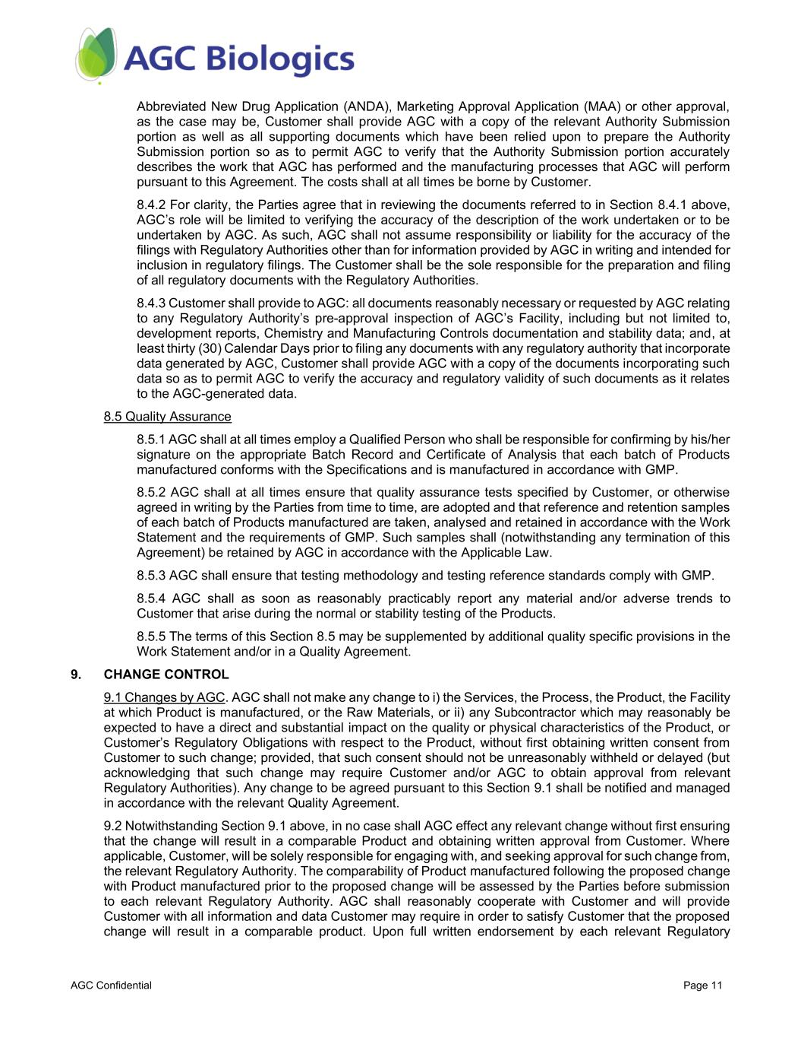
AGC Confidential Page 11 Abbreviated New Drug Application (ANDA), Marketing Approval Application (MAA) or other approval, as the case may be, Customer shall provide AGC with a copy of the relevant Authority Submission portion as well as all supporting documents which have been relied upon to prepare the Authority Submission portion so as to permit AGC to verify that the Authority Submission portion accurately describes the work that AGC has performed and the manufacturing processes that AGC will perform pursuant to this Agreement. The costs shall at all times be borne by Customer. 8.4.2 For clarity, the Parties agree that in reviewing the documents referred to in Section 8.4.1 above, AGC’s role will be limited to verifying the accuracy of the description of the work undertaken or to be undertaken by AGC. As such, AGC shall not assume responsibility or liability for the accuracy of the filings with Regulatory Authorities other than for information provided by AGC in writing and intended for inclusion in regulatory filings. The Customer shall be the sole responsible for the preparation and filing of all regulatory documents with the Regulatory Authorities. 8.4.3 Customer shall provide to AGC: all documents reasonably necessary or requested by AGC relating to any Regulatory Authority’s pre-approval inspection of AGC’s Facility, including but not limited to, development reports, Chemistry and Manufacturing Controls documentation and stability data; and, at least thirty (30) Calendar Days prior to filing any documents with any regulatory authority that incorporate data generated by AGC, Customer shall provide AGC with a copy of the documents incorporating such data so as to permit AGC to verify the accuracy and regulatory validity of such documents as it relates to the AGC-generated data. 8.5 Quality Assurance 8.5.1 AGC shall at all times employ a Qualified Person who shall be responsible for confirming by his/her signature on the appropriate Batch Record and Certificate of Analysis that each batch of Products manufactured conforms with the Specifications and is manufactured in accordance with GMP. 8.5.2 AGC shall at all times ensure that quality assurance tests specified by Customer, or otherwise agreed in writing by the Parties from time to time, are adopted and that reference and retention samples of each batch of Products manufactured are taken, analysed and retained in accordance with the Work Statement and the requirements of GMP. Such samples shall (notwithstanding any termination of this Agreement) be retained by AGC in accordance with the Applicable Law. 8.5.3 AGC shall ensure that testing methodology and testing reference standards comply with GMP. 8.5.4 AGC shall as soon as reasonably practicably report any material and/or adverse trends to Customer that arise during the normal or stability testing of the Products. 8.5.5 The terms of this Section 8.5 may be supplemented by additional quality specific provisions in the Work Statement and/or in a Quality Agreement. 9. CHANGE CONTROL 9.1 Changes by AGC. AGC shall not make any change to i) the Services, the Process, the Product, the Facility at which Product is manufactured, or the Raw Materials, or ii) any Subcontractor which may reasonably be expected to have a direct and substantial impact on the quality or physical characteristics of the Product, or Customer’s Regulatory Obligations with respect to the Product, without first obtaining written consent from Customer to such change; provided, that such consent should not be unreasonably withheld or delayed (but acknowledging that such change may require Customer and/or AGC to obtain approval from relevant Regulatory Authorities). Any change to be agreed pursuant to this Section 9.1 shall be notified and managed in accordance with the relevant Quality Agreement. 9.2 Notwithstanding Section 9.1 above, in no case shall AGC effect any relevant change without first ensuring that the change will result in a comparable Product and obtaining written approval from Customer. Where applicable, Customer, will be solely responsible for engaging with, and seeking approval for such change from, the relevant Regulatory Authority. The comparability of Product manufactured following the proposed change with Product manufactured prior to the proposed change will be assessed by the Parties before submission to each relevant Regulatory Authority. AGC shall reasonably cooperate with Customer and will provide Customer with all information and data Customer may require in order to satisfy Customer that the proposed change will result in a comparable product. Upon full written endorsement by each relevant Regulatory

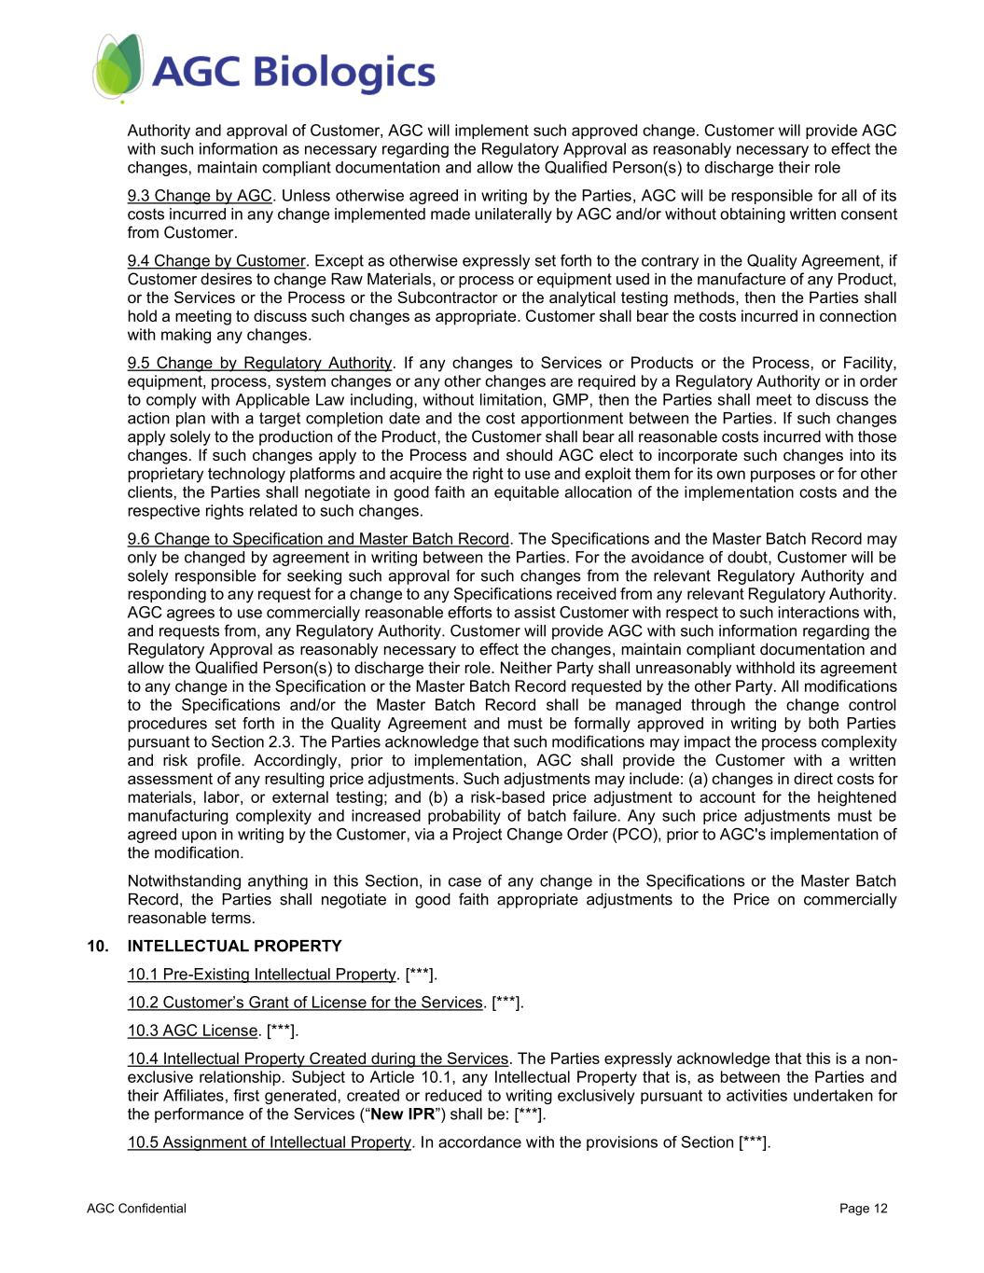
AGC Confidential Page 12 Authority and approval of Customer, AGC will implement such approved change. Customer will provide AGC with such information as necessary regarding the Regulatory Approval as reasonably necessary to effect the changes, maintain compliant documentation and allow the Qualified Person(s) to discharge their role 9.3 Change by AGC. Unless otherwise agreed in writing by the Parties, AGC will be responsible for all of its costs incurred in any change implemented made unilaterally by AGC and/or without obtaining written consent from Customer. 9.4 Change by Customer. Except as otherwise expressly set forth to the contrary in the Quality Agreement, if Customer desires to change Raw Materials, or process or equipment used in the manufacture of any Product, or the Services or the Process or the Subcontractor or the analytical testing methods, then the Parties shall hold a meeting to discuss such changes as appropriate. Customer shall bear the costs incurred in connection with making any changes. 9.5 Change by Regulatory Authority. If any changes to Services or Products or the Process, or Facility, equipment, process, system changes or any other changes are required by a Regulatory Authority or in order to comply with Applicable Law including, without limitation, GMP, then the Parties shall meet to discuss the action plan with a target completion date and the cost apportionment between the Parties. If such changes apply solely to the production of the Product, the Customer shall bear all reasonable costs incurred with those changes. If such changes apply to the Process and should AGC elect to incorporate such changes into its proprietary technology platforms and acquire the right to use and exploit them for its own purposes or for other clients, the Parties shall negotiate in good faith an equitable allocation of the implementation costs and the respective rights related to such changes. 9.6 Change to Specification and Master Batch Record. The Specifications and the Master Batch Record may only be changed by agreement in writing between the Parties. For the avoidance of doubt, Customer will be solely responsible for seeking such approval for such changes from the relevant Regulatory Authority and responding to any request for a change to any Specifications received from any relevant Regulatory Authority. AGC agrees to use commercially reasonable efforts to assist Customer with respect to such interactions with, and requests from, any Regulatory Authority. Customer will provide AGC with such information regarding the Regulatory Approval as reasonably necessary to effect the changes, maintain compliant documentation and allow the Qualified Person(s) to discharge their role. Neither Party shall unreasonably withhold its agreement to any change in the Specification or the Master Batch Record requested by the other Party. All modifications to the Specifications and/or the Master Batch Record shall be managed through the change control procedures set forth in the Quality Agreement and must be formally approved in writing by both Parties pursuant to Section 2.3. The Parties acknowledge that such modifications may impact the process complexity and risk profile. Accordingly, prior to implementation, AGC shall provide the Customer with a written assessment of any resulting price adjustments. Such adjustments may include: (a) changes in direct costs for materials, labor, or external testing; and (b) a risk-based price adjustment to account for the heightened manufacturing complexity and increased probability of batch failure. Any such price adjustments must be agreed upon in writing by the Customer, via a Project Change Order (PCO), prior to AGC's implementation of the modification. Notwithstanding anything in this Section, in case of any change in the Specifications or the Master Batch Record, the Parties shall negotiate in good faith appropriate adjustments to the Price on commercially reasonable terms. 10. INTELLECTUAL PROPERTY 10.1 Pre-Existing Intellectual Property. [***]. 10.2 Customer’s Grant of License for the Services. [***]. 10.3 AGC License. [***]. 10.4 Intellectual Property Created during the Services. The Parties expressly acknowledge that this is a non- exclusive relationship. Subject to Article 10.1, any Intellectual Property that is, as between the Parties and their Affiliates, first generated, created or reduced to writing exclusively pursuant to activities undertaken for the performance of the Services (“New IPR”) shall be: [***]. 10.5 Assignment of Intellectual Property. In accordance with the provisions of Section [***].

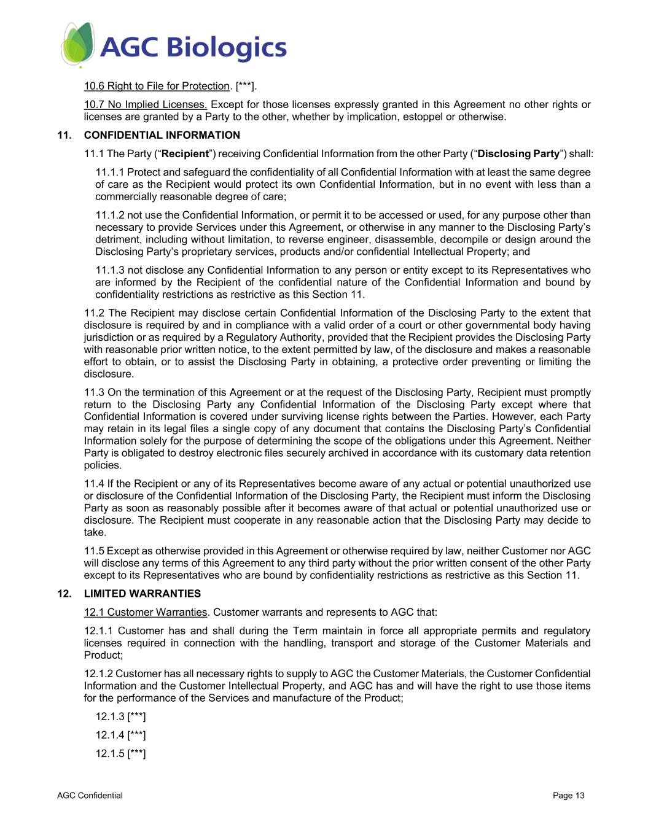
AGC Confidential Page 13 10.6 Right to File for Protection. [***]. 10.7 No Implied Licenses. Except for those licenses expressly granted in this Agreement no other rights or licenses are granted by a Party to the other, whether by implication, estoppel or otherwise. 11. CONFIDENTIAL INFORMATION 11.1 The Party (“Recipient”) receiving Confidential Information from the other Party (“Disclosing Party”) shall: 11.1.1 Protect and safeguard the confidentiality of all Confidential Information with at least the same degree of care as the Recipient would protect its own Confidential Information, but in no event with less than a commercially reasonable degree of care; 11.1.2 not use the Confidential Information, or permit it to be accessed or used, for any purpose other than necessary to provide Services under this Agreement, or otherwise in any manner to the Disclosing Party’s detriment, including without limitation, to reverse engineer, disassemble, decompile or design around the Disclosing Party’s proprietary services, products and/or confidential Intellectual Property; and 11.1.3 not disclose any Confidential Information to any person or entity except to its Representatives who are informed by the Recipient of the confidential nature of the Confidential Information and bound by confidentiality restrictions as restrictive as this Section 11. 11.2 The Recipient may disclose certain Confidential Information of the Disclosing Party to the extent that disclosure is required by and in compliance with a valid order of a court or other governmental body having jurisdiction or as required by a Regulatory Authority, provided that the Recipient provides the Disclosing Party with reasonable prior written notice, to the extent permitted by law, of the disclosure and makes a reasonable effort to obtain, or to assist the Disclosing Party in obtaining, a protective order preventing or limiting the disclosure. 11.3 On the termination of this Agreement or at the request of the Disclosing Party, Recipient must promptly return to the Disclosing Party any Confidential Information of the Disclosing Party except where that Confidential Information is covered under surviving license rights between the Parties. However, each Party may retain in its legal files a single copy of any document that contains the Disclosing Party’s Confidential Information solely for the purpose of determining the scope of the obligations under this Agreement. Neither Party is obligated to destroy electronic files securely archived in accordance with its customary data retention policies. 11.4 If the Recipient or any of its Representatives become aware of any actual or potential unauthorized use or disclosure of the Confidential Information of the Disclosing Party, the Recipient must inform the Disclosing Party as soon as reasonably possible after it becomes aware of that actual or potential unauthorized use or disclosure. The Recipient must cooperate in any reasonable action that the Disclosing Party may decide to take. 11.5 Except as otherwise provided in this Agreement or otherwise required by law, neither Customer nor AGC will disclose any terms of this Agreement to any third party without the prior written consent of the other Party except to its Representatives who are bound by confidentiality restrictions as restrictive as this Section 11. 12. LIMITED WARRANTIES 12.1 Customer Warranties. Customer warrants and represents to AGC that: 12.1.1 Customer has and shall during the Term maintain in force all appropriate permits and regulatory licenses required in connection with the handling, transport and storage of the Customer Materials and Product; 12.1.2 Customer has all necessary rights to supply to AGC the Customer Materials, the Customer Confidential Information and the Customer Intellectual Property, and AGC has and will have the right to use those items for the performance of the Services and manufacture of the Product; 12.1.3 [***] 12.1.4 [***] 12.1.5 [***]

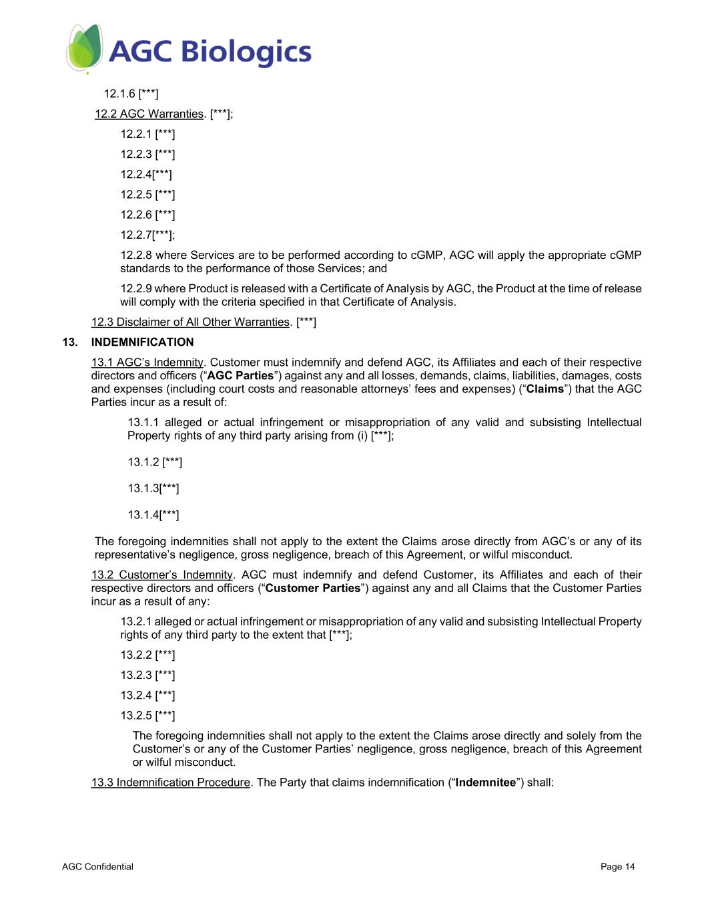
AGC Confidential Page 14 12.1.6 [***] 12.2 AGC Warranties. [***]; 12.2.1 [***] 12.2.3 [***] 12.2.4[***] 12.2.5 [***] 12.2.6 [***] 12.2.7[***]; 12.2.8 where Services are to be performed according to cGMP, AGC will apply the appropriate cGMP standards to the performance of those Services; and 12.2.9 where Product is released with a Certificate of Analysis by AGC, the Product at the time of release will comply with the criteria specified in that Certificate of Analysis. 12.3 Disclaimer of All Other Warranties. [***] 13. INDEMNIFICATION 13.1 AGC’s Indemnity. Customer must indemnify and defend AGC, its Affiliates and each of their respective directors and officers (“AGC Parties”) against any and all losses, demands, claims, liabilities, damages, costs and expenses (including court costs and reasonable attorneys’ fees and expenses) (“Claims”) that the AGC Parties incur as a result of: 13.1.1 alleged or actual infringement or misappropriation of any valid and subsisting Intellectual Property rights of any third party arising from (i) [***]; 13.1.2 [***] 13.1.3[***] 13.1.4[***] The foregoing indemnities shall not apply to the extent the Claims arose directly from AGC’s or any of its representative’s negligence, gross negligence, breach of this Agreement, or wilful misconduct. 13.2 Customer’s Indemnity. AGC must indemnify and defend Customer, its Affiliates and each of their respective directors and officers (“Customer Parties”) against any and all Claims that the Customer Parties incur as a result of any: 13.2.1 alleged or actual infringement or misappropriation of any valid and subsisting Intellectual Property rights of any third party to the extent that [***]; 13.2.2 [***] 13.2.3 [***] 13.2.4 [***] 13.2.5 [***] The foregoing indemnities shall not apply to the extent the Claims arose directly and solely from the Customer’s or any of the Customer Parties’ negligence, gross negligence, breach of this Agreement or wilful misconduct. 13.3 Indemnification Procedure. The Party that claims indemnification (“Indemnitee”) shall:

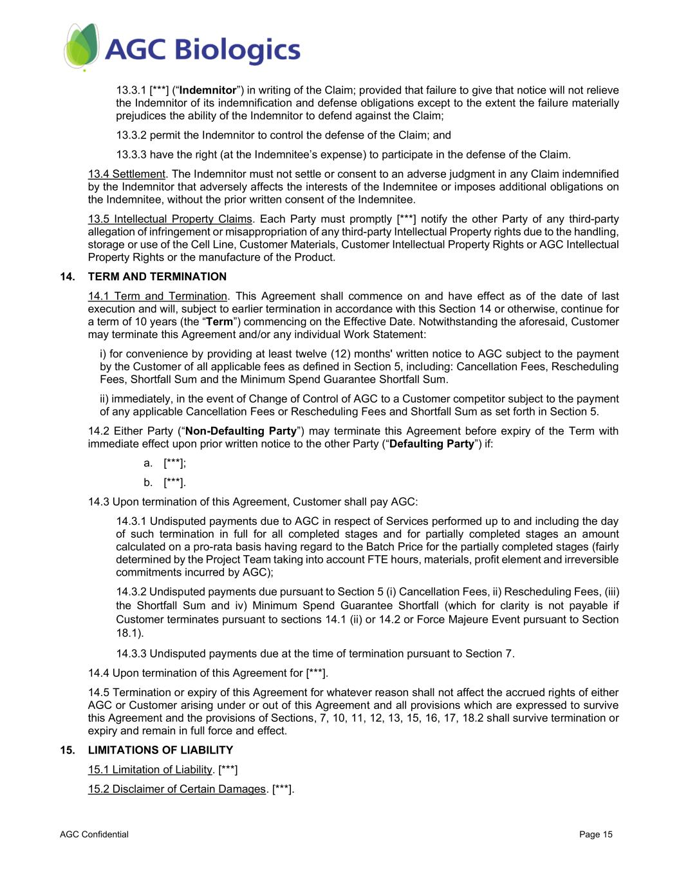
AGC Confidential Page 15 13.3.1 [***] (“Indemnitor”) in writing of the Claim; provided that failure to give that notice will not relieve the Indemnitor of its indemnification and defense obligations except to the extent the failure materially prejudices the ability of the Indemnitor to defend against the Claim; 13.3.2 permit the Indemnitor to control the defense of the Claim; and 13.3.3 have the right (at the Indemnitee’s expense) to participate in the defense of the Claim. 13.4 Settlement. The Indemnitor must not settle or consent to an adverse judgment in any Claim indemnified by the Indemnitor that adversely affects the interests of the Indemnitee or imposes additional obligations on the Indemnitee, without the prior written consent of the Indemnitee. 13.5 Intellectual Property Claims. Each Party must promptly [***] notify the other Party of any third-party allegation of infringement or misappropriation of any third-party Intellectual Property rights due to the handling, storage or use of the Cell Line, Customer Materials, Customer Intellectual Property Rights or AGC Intellectual Property Rights or the manufacture of the Product. 14. TERM AND TERMINATION 14.1 Term and Termination. This Agreement shall commence on and have effect as of the date of last execution and will, subject to earlier termination in accordance with this Section 14 or otherwise, continue for a term of 10 years (the “Term”) commencing on the Effective Date. Notwithstanding the aforesaid, Customer may terminate this Agreement and/or any individual Work Statement: i) for convenience by providing at least twelve (12) months' written notice to AGC subject to the payment by the Customer of all applicable fees as defined in Section 5, including: Cancellation Fees, Rescheduling Fees, Shortfall Sum and the Minimum Spend Guarantee Shortfall Sum. ii) immediately, in the event of Change of Control of AGC to a Customer competitor subject to the payment of any applicable Cancellation Fees or Rescheduling Fees and Shortfall Sum as set forth in Section 5. 14.2 Either Party (“Non-Defaulting Party”) may terminate this Agreement before expiry of the Term with immediate effect upon prior written notice to the other Party (“Defaulting Party”) if: a. [***]; b. [***]. 14.3 Upon termination of this Agreement, Customer shall pay AGC: 14.3.1 Undisputed payments due to AGC in respect of Services performed up to and including the day of such termination in full for all completed stages and for partially completed stages an amount calculated on a pro-rata basis having regard to the Batch Price for the partially completed stages (fairly determined by the Project Team taking into account FTE hours, materials, profit element and irreversible commitments incurred by AGC); 14.3.2 Undisputed payments due pursuant to Section 5 (i) Cancellation Fees, ii) Rescheduling Fees, (iii) the Shortfall Sum and iv) Minimum Spend Guarantee Shortfall (which for clarity is not payable if Customer terminates pursuant to sections 14.1 (ii) or 14.2 or Force Majeure Event pursuant to Section 18.1). 14.3.3 Undisputed payments due at the time of termination pursuant to Section 7. 14.4 Upon termination of this Agreement for [***]. 14.5 Termination or expiry of this Agreement for whatever reason shall not affect the accrued rights of either AGC or Customer arising under or out of this Agreement and all provisions which are expressed to survive this Agreement and the provisions of Sections, 7, 10, 11, 12, 13, 15, 16, 17, 18.2 shall survive termination or expiry and remain in full force and effect. 15. LIMITATIONS OF LIABILITY 15.1 Limitation of Liability. [***] 15.2 Disclaimer of Certain Damages. [***].

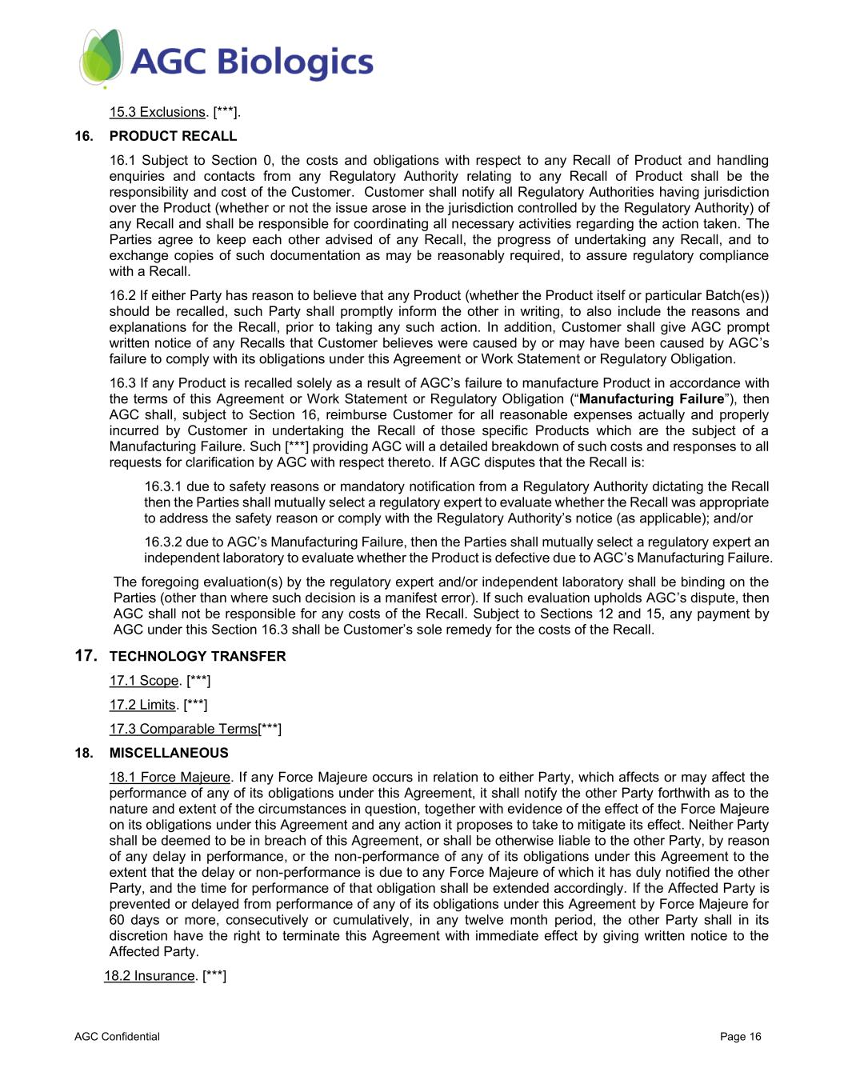
AGC Confidential Page 16 15.3 Exclusions. [***]. 16. PRODUCT RECALL 16.1 Subject to Section 0, the costs and obligations with respect to any Recall of Product and handling enquiries and contacts from any Regulatory Authority relating to any Recall of Product shall be the responsibility and cost of the Customer. Customer shall notify all Regulatory Authorities having jurisdiction over the Product (whether or not the issue arose in the jurisdiction controlled by the Regulatory Authority) of any Recall and shall be responsible for coordinating all necessary activities regarding the action taken. The Parties agree to keep each other advised of any Recall, the progress of undertaking any Recall, and to exchange copies of such documentation as may be reasonably required, to assure regulatory compliance with a Recall. 16.2 If either Party has reason to believe that any Product (whether the Product itself or particular Batch(es)) should be recalled, such Party shall promptly inform the other in writing, to also include the reasons and explanations for the Recall, prior to taking any such action. In addition, Customer shall give AGC prompt written notice of any Recalls that Customer believes were caused by or may have been caused by AGC’s failure to comply with its obligations under this Agreement or Work Statement or Regulatory Obligation. 16.3 If any Product is recalled solely as a result of AGC’s failure to manufacture Product in accordance with the terms of this Agreement or Work Statement or Regulatory Obligation (“Manufacturing Failure”), then AGC shall, subject to Section 16, reimburse Customer for all reasonable expenses actually and properly incurred by Customer in undertaking the Recall of those specific Products which are the subject of a Manufacturing Failure. Such [***] providing AGC will a detailed breakdown of such costs and responses to all requests for clarification by AGC with respect thereto. If AGC disputes that the Recall is: 16.3.1 due to safety reasons or mandatory notification from a Regulatory Authority dictating the Recall then the Parties shall mutually select a regulatory expert to evaluate whether the Recall was appropriate to address the safety reason or comply with the Regulatory Authority’s notice (as applicable); and/or 16.3.2 due to AGC’s Manufacturing Failure, then the Parties shall mutually select a regulatory expert an independent laboratory to evaluate whether the Product is defective due to AGC’s Manufacturing Failure. The foregoing evaluation(s) by the regulatory expert and/or independent laboratory shall be binding on the Parties (other than where such decision is a manifest error). If such evaluation upholds AGC’s dispute, then AGC shall not be responsible for any costs of the Recall. Subject to Sections 12 and 15, any payment by AGC under this Section 16.3 shall be Customer’s sole remedy for the costs of the Recall. 17. TECHNOLOGY TRANSFER 17.1 Scope. [***] 17.2 Limits. [***] 17.3 Comparable Terms[***] 18. MISCELLANEOUS 18.1 Force Majeure. If any Force Majeure occurs in relation to either Party, which affects or may affect the performance of any of its obligations under this Agreement, it shall notify the other Party forthwith as to the nature and extent of the circumstances in question, together with evidence of the effect of the Force Majeure on its obligations under this Agreement and any action it proposes to take to mitigate its effect. Neither Party shall be deemed to be in breach of this Agreement, or shall be otherwise liable to the other Party, by reason of any delay in performance, or the non-performance of any of its obligations under this Agreement to the extent that the delay or non-performance is due to any Force Majeure of which it has duly notified the other Party, and the time for performance of that obligation shall be extended accordingly. If the Affected Party is prevented or delayed from performance of any of its obligations under this Agreement by Force Majeure for 60 days or more, consecutively or cumulatively, in any twelve month period, the other Party shall in its discretion have the right to terminate this Agreement with immediate effect by giving written notice to the Affected Party. 18.2 Insurance. [***]

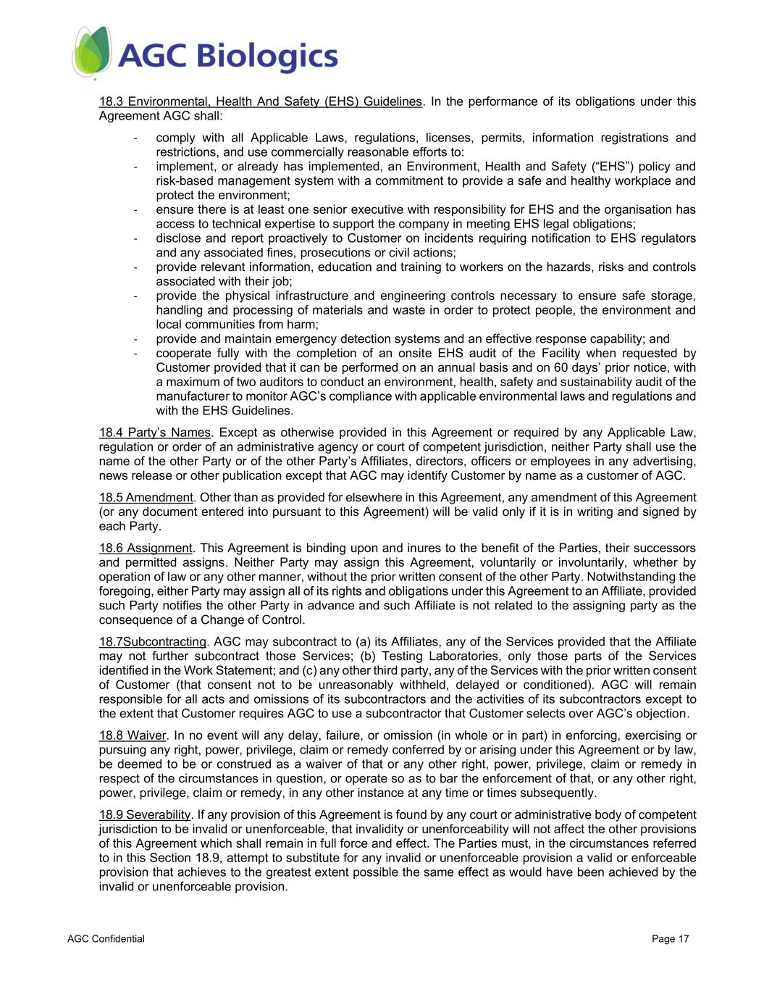
AGC Confidential Page 17 18.3 Environmental, Health And Safety (EHS) Guidelines. In the performance of its obligations under this Agreement AGC shall: - comply with all Applicable Laws, regulations, licenses, permits, information registrations and restrictions, and use commercially reasonable efforts to: - implement, or already has implemented, an Environment, Health and Safety (“EHS”) policy and risk-based management system with a commitment to provide a safe and healthy workplace and protect the environment; - ensure there is at least one senior executive with responsibility for EHS and the organisation has access to technical expertise to support the company in meeting EHS legal obligations; - disclose and report proactively to Customer on incidents requiring notification to EHS regulators and any associated fines, prosecutions or civil actions; - provide relevant information, education and training to workers on the hazards, risks and controls associated with their job; - provide the physical infrastructure and engineering controls necessary to ensure safe storage, handling and processing of materials and waste in order to protect people, the environment and local communities from harm; - provide and maintain emergency detection systems and an effective response capability; and - cooperate fully with the completion of an onsite EHS audit of the Facility when requested by Customer provided that it can be performed on an annual basis and on 60 days’ prior notice, with a maximum of two auditors to conduct an environment, health, safety and sustainability audit of the manufacturer to monitor AGC’s compliance with applicable environmental laws and regulations and with the EHS Guidelines. 18.4 Party’s Names. Except as otherwise provided in this Agreement or required by any Applicable Law, regulation or order of an administrative agency or court of competent jurisdiction, neither Party shall use the name of the other Party or of the other Party’s Affiliates, directors, officers or employees in any advertising, news release or other publication except that AGC may identify Customer by name as a customer of AGC. 18.5 Amendment. Other than as provided for elsewhere in this Agreement, any amendment of this Agreement (or any document entered into pursuant to this Agreement) will be valid only if it is in writing and signed by each Party. 18.6 Assignment. This Agreement is binding upon and inures to the benefit of the Parties, their successors and permitted assigns. Neither Party may assign this Agreement, voluntarily or involuntarily, whether by operation of law or any other manner, without the prior written consent of the other Party. Notwithstanding the foregoing, either Party may assign all of its rights and obligations under this Agreement to an Affiliate, provided such Party notifies the other Party in advance and such Affiliate is not related to the assigning party as the consequence of a Change of Control. 18.7Subcontracting. AGC may subcontract to (a) its Affiliates, any of the Services provided that the Affiliate may not further subcontract those Services; (b) Testing Laboratories, only those parts of the Services identified in the Work Statement; and (c) any other third party, any of the Services with the prior written consent of Customer (that consent not to be unreasonably withheld, delayed or conditioned). AGC will remain responsible for all acts and omissions of its subcontractors and the activities of its subcontractors except to the extent that Customer requires AGC to use a subcontractor that Customer selects over AGC’s objection. 18.8 Waiver. In no event will any delay, failure, or omission (in whole or in part) in enforcing, exercising or pursuing any right, power, privilege, claim or remedy conferred by or arising under this Agreement or by law, be deemed to be or construed as a waiver of that or any other right, power, privilege, claim or remedy in respect of the circumstances in question, or operate so as to bar the enforcement of that, or any other right, power, privilege, claim or remedy, in any other instance at any time or times subsequently. 18.9 Severability. If any provision of this Agreement is found by any court or administrative body of competent jurisdiction to be invalid or unenforceable, that invalidity or unenforceability will not affect the other provisions of this Agreement which shall remain in full force and effect. The Parties must, in the circumstances referred to in this Section 18.9, attempt to substitute for any invalid or unenforceable provision a valid or enforceable provision that achieves to the greatest extent possible the same effect as would have been achieved by the invalid or unenforceable provision.

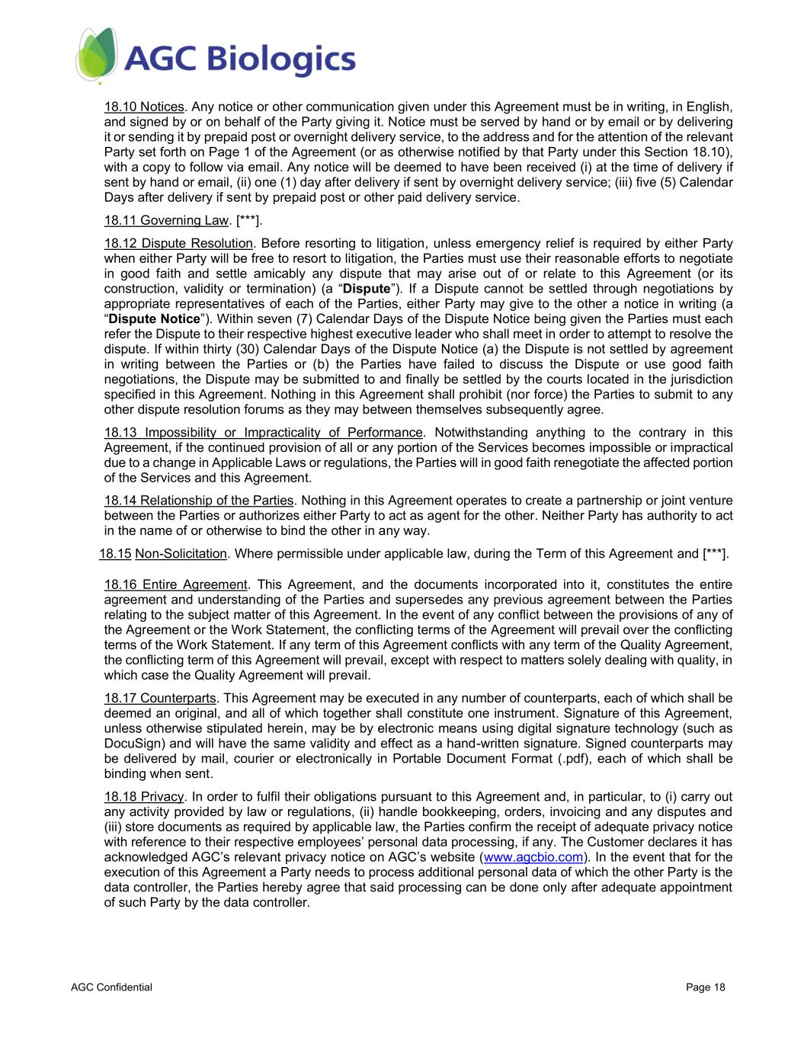
AGC Confidential Page 18 18.10 Notices. Any notice or other communication given under this Agreement must be in writing, in English, and signed by or on behalf of the Party giving it. Notice must be served by hand or by email or by delivering it or sending it by prepaid post or overnight delivery service, to the address and for the attention of the relevant Party set forth on Page 1 of the Agreement (or as otherwise notified by that Party under this Section 18.10), with a copy to follow via email. Any notice will be deemed to have been received (i) at the time of delivery if sent by hand or email, (ii) one (1) day after delivery if sent by overnight delivery service; (iii) five (5) Calendar Days after delivery if sent by prepaid post or other paid delivery service. 18.11 Governing Law. [***]. 18.12 Dispute Resolution. Before resorting to litigation, unless emergency relief is required by either Party when either Party will be free to resort to litigation, the Parties must use their reasonable efforts to negotiate in good faith and settle amicably any dispute that may arise out of or relate to this Agreement (or its construction, validity or termination) (a “Dispute”). If a Dispute cannot be settled through negotiations by appropriate representatives of each of the Parties, either Party may give to the other a notice in writing (a “Dispute Notice”). Within seven (7) Calendar Days of the Dispute Notice being given the Parties must each refer the Dispute to their respective highest executive leader who shall meet in order to attempt to resolve the dispute. If within thirty (30) Calendar Days of the Dispute Notice (a) the Dispute is not settled by agreement in writing between the Parties or (b) the Parties have failed to discuss the Dispute or use good faith negotiations, the Dispute may be submitted to and finally be settled by the courts located in the jurisdiction specified in this Agreement. Nothing in this Agreement shall prohibit (nor force) the Parties to submit to any other dispute resolution forums as they may between themselves subsequently agree. 18.13 Impossibility or Impracticality of Performance. Notwithstanding anything to the contrary in this Agreement, if the continued provision of all or any portion of the Services becomes impossible or impractical due to a change in Applicable Laws or regulations, the Parties will in good faith renegotiate the affected portion of the Services and this Agreement. 18.14 Relationship of the Parties. Nothing in this Agreement operates to create a partnership or joint venture between the Parties or authorizes either Party to act as agent for the other. Neither Party has authority to act in the name of or otherwise to bind the other in any way. 18.15 Non-Solicitation. Where permissible under applicable law, during the Term of this Agreement and [***]. 18.16 Entire Agreement. This Agreement, and the documents incorporated into it, constitutes the entire agreement and understanding of the Parties and supersedes any previous agreement between the Parties relating to the subject matter of this Agreement. In the event of any conflict between the provisions of any of the Agreement or the Work Statement, the conflicting terms of the Agreement will prevail over the conflicting terms of the Work Statement. If any term of this Agreement conflicts with any term of the Quality Agreement, the conflicting term of this Agreement will prevail, except with respect to matters solely dealing with quality, in which case the Quality Agreement will prevail. 18.17 Counterparts. This Agreement may be executed in any number of counterparts, each of which shall be deemed an original, and all of which together shall constitute one instrument. Signature of this Agreement, unless otherwise stipulated herein, may be by electronic means using digital signature technology (such as DocuSign) and will have the same validity and effect as a hand-written signature. Signed counterparts may be delivered by mail, courier or electronically in Portable Document Format (.pdf), each of which shall be binding when sent. 18.18 Privacy. In order to fulfil their obligations pursuant to this Agreement and, in particular, to (i) carry out any activity provided by law or regulations, (ii) handle bookkeeping, orders, invoicing and any disputes and (iii) store documents as required by applicable law, the Parties confirm the receipt of adequate privacy notice with reference to their respective employees’ personal data processing, if any. The Customer declares it has acknowledged AGC’s relevant privacy notice on AGC’s website (www.agcbio.com). In the event that for the execution of this Agreement a Party needs to process additional personal data of which the other Party is the data controller, the Parties hereby agree that said processing can be done only after adequate appointment of such Party by the data controller.

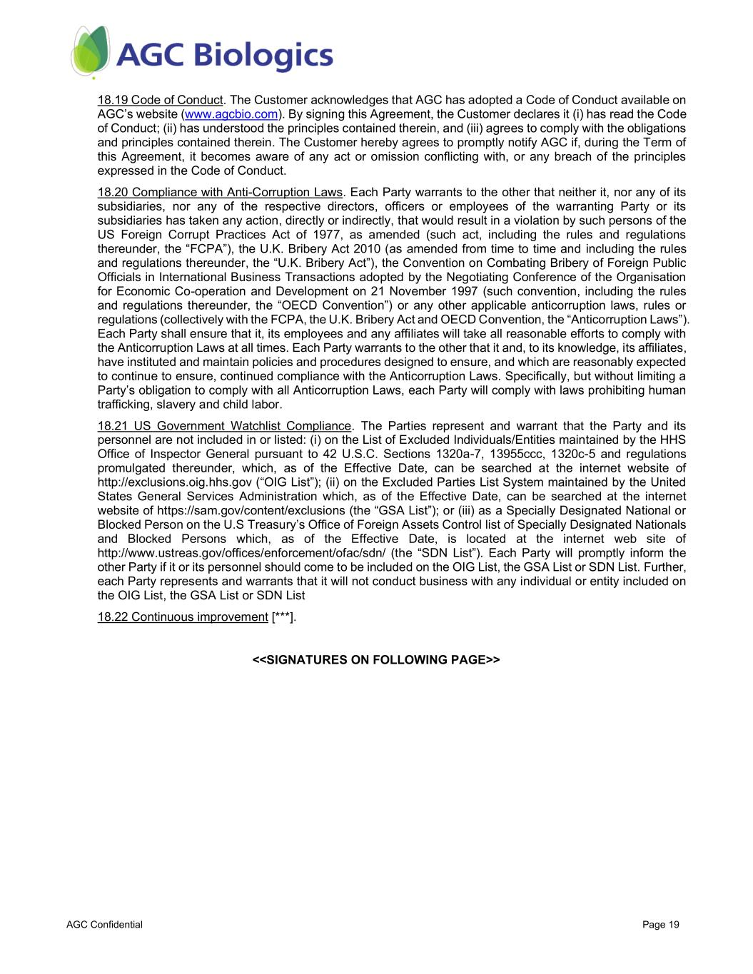
AGC Confidential Page 19 18.19 Code of Conduct. The Customer acknowledges that AGC has adopted a Code of Conduct available on AGC’s website (www.agcbio.com). By signing this Agreement, the Customer declares it (i) has read the Code of Conduct; (ii) has understood the principles contained therein, and (iii) agrees to comply with the obligations and principles contained therein. The Customer hereby agrees to promptly notify AGC if, during the Term of this Agreement, it becomes aware of any act or omission conflicting with, or any breach of the principles expressed in the Code of Conduct. 18.20 Compliance with Anti-Corruption Laws. Each Party warrants to the other that neither it, nor any of its subsidiaries, nor any of the respective directors, officers or employees of the warranting Party or its subsidiaries has taken any action, directly or indirectly, that would result in a violation by such persons of the US Foreign Corrupt Practices Act of 1977, as amended (such act, including the rules and regulations thereunder, the “FCPA”), the U.K. Bribery Act 2010 (as amended from time to time and including the rules and regulations thereunder, the “U.K. Bribery Act”), the Convention on Combating Bribery of Foreign Public Officials in International Business Transactions adopted by the Negotiating Conference of the Organisation for Economic Co-operation and Development on 21 November 1997 (such convention, including the rules and regulations thereunder, the “OECD Convention”) or any other applicable anticorruption laws, rules or regulations (collectively with the FCPA, the U.K. Bribery Act and OECD Convention, the “Anticorruption Laws”). Each Party shall ensure that it, its employees and any affiliates will take all reasonable efforts to comply with the Anticorruption Laws at all times. Each Party warrants to the other that it and, to its knowledge, its affiliates, have instituted and maintain policies and procedures designed to ensure, and which are reasonably expected to continue to ensure, continued compliance with the Anticorruption Laws. Specifically, but without limiting a Party’s obligation to comply with all Anticorruption Laws, each Party will comply with laws prohibiting human trafficking, slavery and child labor. 18.21 US Government Watchlist Compliance. The Parties represent and warrant that the Party and its personnel are not included in or listed: (i) on the List of Excluded Individuals/Entities maintained by the HHS Office of Inspector General pursuant to 42 U.S.C. Sections 1320a-7, 13955ccc, 1320c-5 and regulations promulgated thereunder, which, as of the Effective Date, can be searched at the internet website of http://exclusions.oig.hhs.gov (“OIG List”); (ii) on the Excluded Parties List System maintained by the United States General Services Administration which, as of the Effective Date, can be searched at the internet website of https://sam.gov/content/exclusions (the “GSA List”); or (iii) as a Specially Designated National or Blocked Person on the U.S Treasury’s Office of Foreign Assets Control list of Specially Designated Nationals and Blocked Persons which, as of the Effective Date, is located at the internet web site of http://www.ustreas.gov/offices/enforcement/ofac/sdn/ (the “SDN List”). Each Party will promptly inform the other Party if it or its personnel should come to be included on the OIG List, the GSA List or SDN List. Further, each Party represents and warrants that it will not conduct business with any individual or entity included on the OIG List, the GSA List or SDN List 18.22 Continuous improvement [***]. <<SIGNATURES ON FOLLOWING PAGE>>

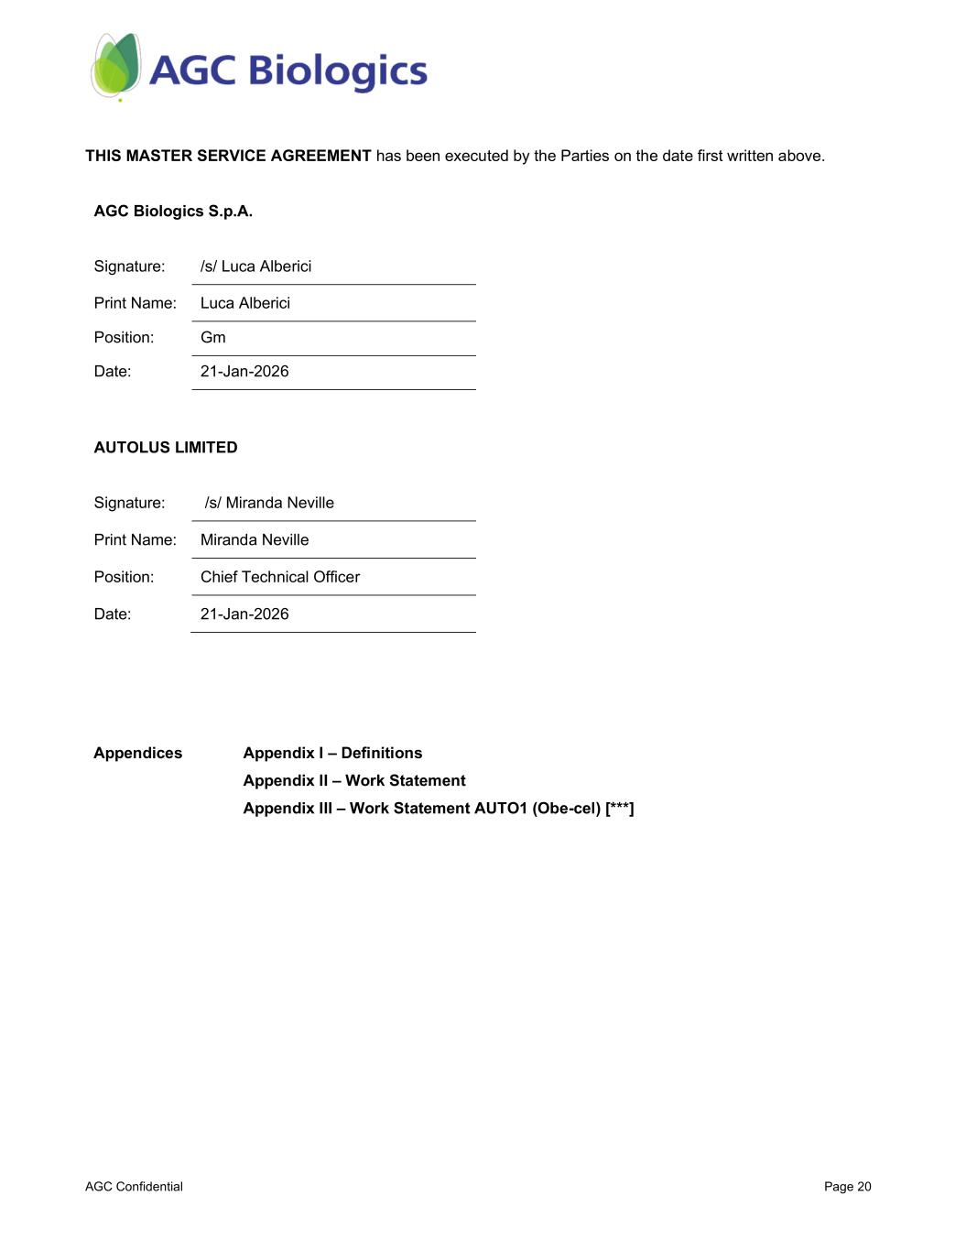
AGC Confidential Page 20 THIS MASTER SERVICE AGREEMENT has been executed by the Parties on the date first written above. AGC Biologics S.p.A. Signature: /s/ Luca Alberici Print Name: Luca Alberici Position: Gm Date: 21-Jan-2026 AUTOLUS LIMITED Signature: /s/ Miranda Neville Print Name: Miranda Neville Position: Chief Technical Officer Date: 21-Jan-2026 Appendices Appendix I – Definitions Appendix II – Work Statement Appendix III – Work Statement AUTO1 (Obe-cel) [***]

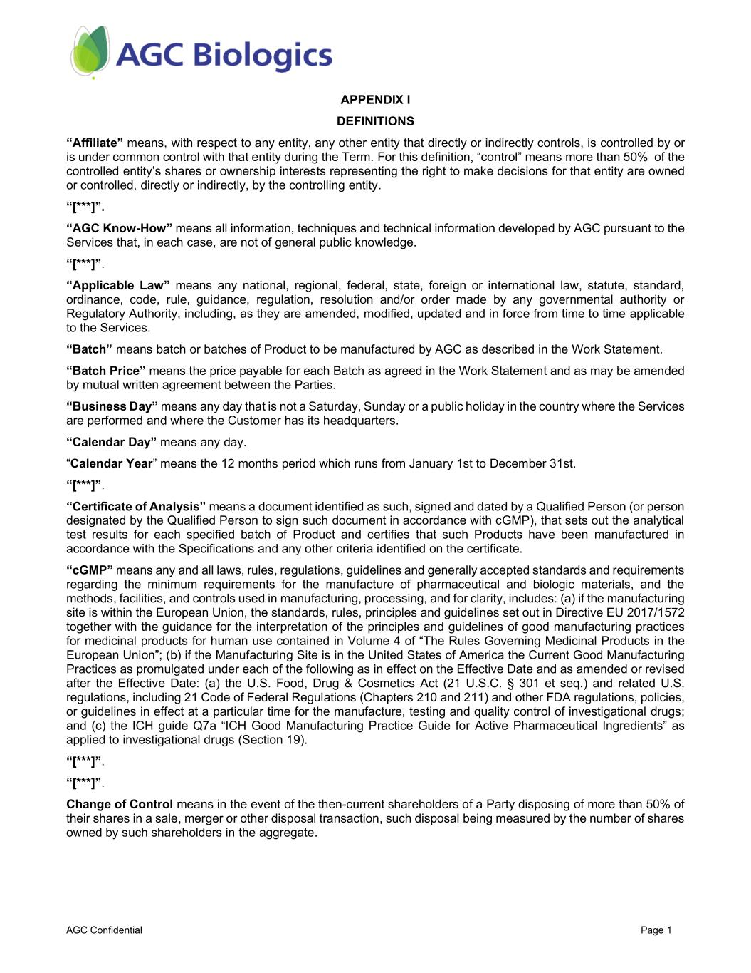
AGC Confidential Page 1 APPENDIX I DEFINITIONS “Affiliate” means, with respect to any entity, any other entity that directly or indirectly controls, is controlled by or is under common control with that entity during the Term. For this definition, “control” means more than 50% of the controlled entity’s shares or ownership interests representing the right to make decisions for that entity are owned or controlled, directly or indirectly, by the controlling entity. “[***]”. “AGC Know-How” means all information, techniques and technical information developed by AGC pursuant to the Services that, in each case, are not of general public knowledge. “[***]”. “Applicable Law” means any national, regional, federal, state, foreign or international law, statute, standard, ordinance, code, rule, guidance, regulation, resolution and/or order made by any governmental authority or Regulatory Authority, including, as they are amended, modified, updated and in force from time to time applicable to the Services. “Batch” means batch or batches of Product to be manufactured by AGC as described in the Work Statement. “Batch Price” means the price payable for each Batch as agreed in the Work Statement and as may be amended by mutual written agreement between the Parties. “Business Day” means any day that is not a Saturday, Sunday or a public holiday in the country where the Services are performed and where the Customer has its headquarters. “Calendar Day” means any day. “Calendar Year” means the 12 months period which runs from January 1st to December 31st. “[***]”. “Certificate of Analysis” means a document identified as such, signed and dated by a Qualified Person (or person designated by the Qualified Person to sign such document in accordance with cGMP), that sets out the analytical test results for each specified batch of Product and certifies that such Products have been manufactured in accordance with the Specifications and any other criteria identified on the certificate. “cGMP” means any and all laws, rules, regulations, guidelines and generally accepted standards and requirements regarding the minimum requirements for the manufacture of pharmaceutical and biologic materials, and the methods, facilities, and controls used in manufacturing, processing, and for clarity, includes: (a) if the manufacturing site is within the European Union, the standards, rules, principles and guidelines set out in Directive EU 2017/1572 together with the guidance for the interpretation of the principles and guidelines of good manufacturing practices for medicinal products for human use contained in Volume 4 of “The Rules Governing Medicinal Products in the European Union”; (b) if the Manufacturing Site is in the United States of America the Current Good Manufacturing Practices as promulgated under each of the following as in effect on the Effective Date and as amended or revised after the Effective Date: (a) the U.S. Food, Drug & Cosmetics Act (21 U.S.C. § 301 et seq.) and related U.S. regulations, including 21 Code of Federal Regulations (Chapters 210 and 211) and other FDA regulations, policies, or guidelines in effect at a particular time for the manufacture, testing and quality control of investigational drugs; and (c) the ICH guide Q7a “ICH Good Manufacturing Practice Guide for Active Pharmaceutical Ingredients” as applied to investigational drugs (Section 19). “[***]”. “[***]”. Change of Control means in the event of the then-current shareholders of a Party disposing of more than 50% of their shares in a sale, merger or other disposal transaction, such disposal being measured by the number of shares owned by such shareholders in the aggregate.

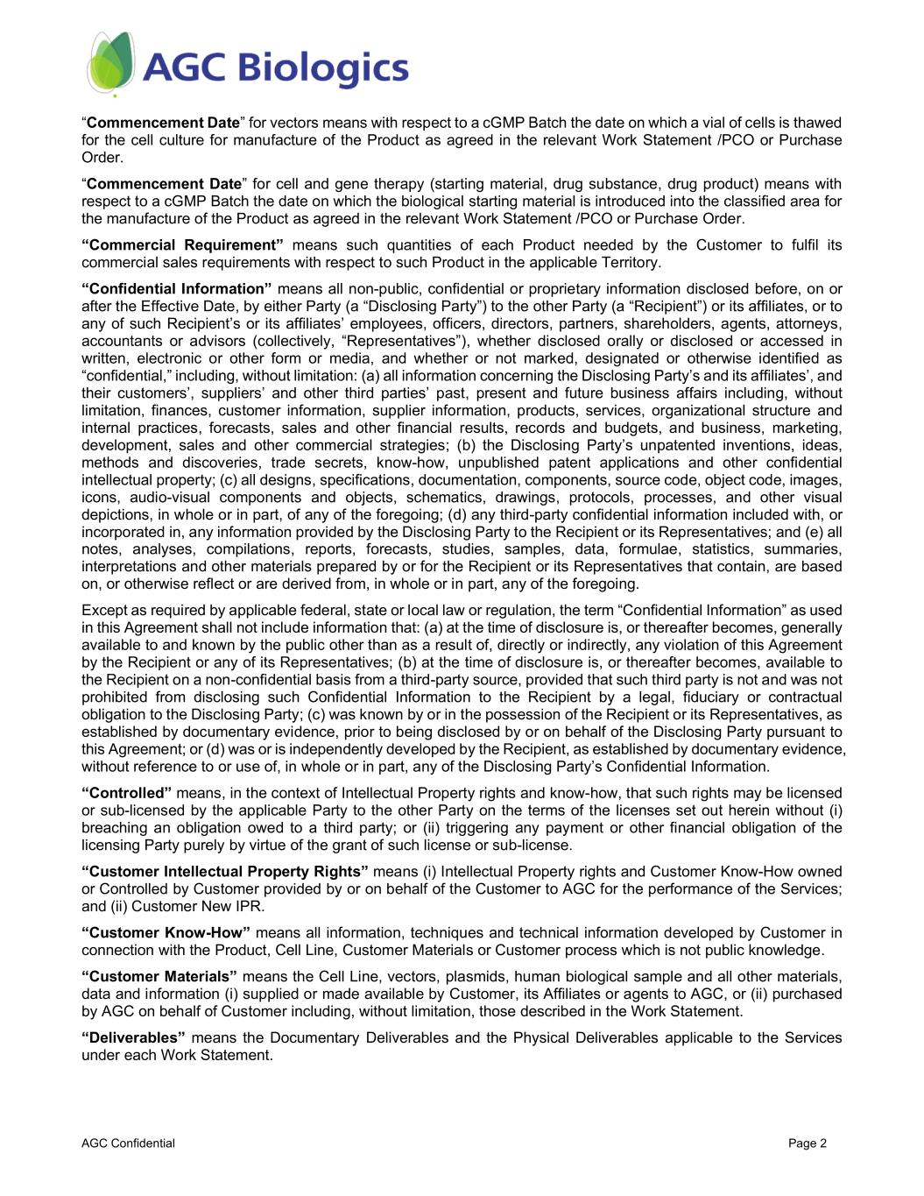
AGC Confidential Page 2 “Commencement Date” for vectors means with respect to a cGMP Batch the date on which a vial of cells is thawed for the cell culture for manufacture of the Product as agreed in the relevant Work Statement /PCO or Purchase Order. “Commencement Date” for cell and gene therapy (starting material, drug substance, drug product) means with respect to a cGMP Batch the date on which the biological starting material is introduced into the classified area for the manufacture of the Product as agreed in the relevant Work Statement /PCO or Purchase Order. “Commercial Requirement” means such quantities of each Product needed by the Customer to fulfil its commercial sales requirements with respect to such Product in the applicable Territory. “Confidential Information” means all non-public, confidential or proprietary information disclosed before, on or after the Effective Date, by either Party (a “Disclosing Party”) to the other Party (a “Recipient”) or its affiliates, or to any of such Recipient’s or its affiliates’ employees, officers, directors, partners, shareholders, agents, attorneys, accountants or advisors (collectively, “Representatives”), whether disclosed orally or disclosed or accessed in written, electronic or other form or media, and whether or not marked, designated or otherwise identified as “confidential,” including, without limitation: (a) all information concerning the Disclosing Party’s and its affiliates’, and their customers’, suppliers’ and other third parties’ past, present and future business affairs including, without limitation, finances, customer information, supplier information, products, services, organizational structure and internal practices, forecasts, sales and other financial results, records and budgets, and business, marketing, development, sales and other commercial strategies; (b) the Disclosing Party’s unpatented inventions, ideas, methods and discoveries, trade secrets, know-how, unpublished patent applications and other confidential intellectual property; (c) all designs, specifications, documentation, components, source code, object code, images, icons, audio-visual components and objects, schematics, drawings, protocols, processes, and other visual depictions, in whole or in part, of any of the foregoing; (d) any third-party confidential information included with, or incorporated in, any information provided by the Disclosing Party to the Recipient or its Representatives; and (e) all notes, analyses, compilations, reports, forecasts, studies, samples, data, formulae, statistics, summaries, interpretations and other materials prepared by or for the Recipient or its Representatives that contain, are based on, or otherwise reflect or are derived from, in whole or in part, any of the foregoing. Except as required by applicable federal, state or local law or regulation, the term “Confidential Information” as used in this Agreement shall not include information that: (a) at the time of disclosure is, or thereafter becomes, generally available to and known by the public other than as a result of, directly or indirectly, any violation of this Agreement by the Recipient or any of its Representatives; (b) at the time of disclosure is, or thereafter becomes, available to the Recipient on a non-confidential basis from a third-party source, provided that such third party is not and was not prohibited from disclosing such Confidential Information to the Recipient by a legal, fiduciary or contractual obligation to the Disclosing Party; (c) was known by or in the possession of the Recipient or its Representatives, as established by documentary evidence, prior to being disclosed by or on behalf of the Disclosing Party pursuant to this Agreement; or (d) was or is independently developed by the Recipient, as established by documentary evidence, without reference to or use of, in whole or in part, any of the Disclosing Party’s Confidential Information. “Controlled” means, in the context of Intellectual Property rights and know-how, that such rights may be licensed or sub-licensed by the applicable Party to the other Party on the terms of the licenses set out herein without (i) breaching an obligation owed to a third party; or (ii) triggering any payment or other financial obligation of the licensing Party purely by virtue of the grant of such license or sub-license. “Customer Intellectual Property Rights” means (i) Intellectual Property rights and Customer Know-How owned or Controlled by Customer provided by or on behalf of the Customer to AGC for the performance of the Services; and (ii) Customer New IPR. “Customer Know-How” means all information, techniques and technical information developed by Customer in connection with the Product, Cell Line, Customer Materials or Customer process which is not public knowledge. “Customer Materials” means the Cell Line, vectors, plasmids, human biological sample and all other materials, data and information (i) supplied or made available by Customer, its Affiliates or agents to AGC, or (ii) purchased by AGC on behalf of Customer including, without limitation, those described in the Work Statement. “Deliverables” means the Documentary Deliverables and the Physical Deliverables applicable to the Services under each Work Statement.

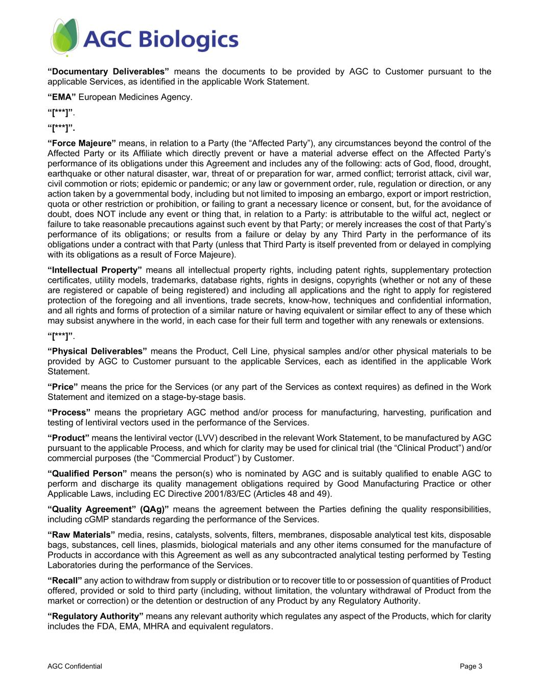
AGC Confidential Page 3 “Documentary Deliverables” means the documents to be provided by AGC to Customer pursuant to the applicable Services, as identified in the applicable Work Statement. “EMA” European Medicines Agency. “[***]”. “[***]”. “Force Majeure” means, in relation to a Party (the “Affected Party”), any circumstances beyond the control of the Affected Party or its Affiliate which directly prevent or have a material adverse effect on the Affected Party’s performance of its obligations under this Agreement and includes any of the following: acts of God, flood, drought, earthquake or other natural disaster, war, threat of or preparation for war, armed conflict; terrorist attack, civil war, civil commotion or riots; epidemic or pandemic; or any law or government order, rule, regulation or direction, or any action taken by a governmental body, including but not limited to imposing an embargo, export or import restriction, quota or other restriction or prohibition, or failing to grant a necessary licence or consent, but, for the avoidance of doubt, does NOT include any event or thing that, in relation to a Party: is attributable to the wilful act, neglect or failure to take reasonable precautions against such event by that Party; or merely increases the cost of that Party’s performance of its obligations; or results from a failure or delay by any Third Party in the performance of its obligations under a contract with that Party (unless that Third Party is itself prevented from or delayed in complying with its obligations as a result of Force Majeure). “Intellectual Property” means all intellectual property rights, including patent rights, supplementary protection certificates, utility models, trademarks, database rights, rights in designs, copyrights (whether or not any of these are registered or capable of being registered) and including all applications and the right to apply for registered protection of the foregoing and all inventions, trade secrets, know-how, techniques and confidential information, and all rights and forms of protection of a similar nature or having equivalent or similar effect to any of these which may subsist anywhere in the world, in each case for their full term and together with any renewals or extensions. “[***]”. “Physical Deliverables” means the Product, Cell Line, physical samples and/or other physical materials to be provided by AGC to Customer pursuant to the applicable Services, each as identified in the applicable Work Statement. “Price” means the price for the Services (or any part of the Services as context requires) as defined in the Work Statement and itemized on a stage-by-stage basis. “Process” means the proprietary AGC method and/or process for manufacturing, harvesting, purification and testing of lentiviral vectors used in the performance of the Services. “Product” means the lentiviral vector (LVV) described in the relevant Work Statement, to be manufactured by AGC pursuant to the applicable Process, and which for clarity may be used for clinical trial (the “Clinical Product”) and/or commercial purposes (the “Commercial Product”) by Customer. “Qualified Person” means the person(s) who is nominated by AGC and is suitably qualified to enable AGC to perform and discharge its quality management obligations required by Good Manufacturing Practice or other Applicable Laws, including EC Directive 2001/83/EC (Articles 48 and 49). “Quality Agreement” (QAg)” means the agreement between the Parties defining the quality responsibilities, including cGMP standards regarding the performance of the Services. “Raw Materials” media, resins, catalysts, solvents, filters, membranes, disposable analytical test kits, disposable bags, substances, cell lines, plasmids, biological materials and any other items consumed for the manufacture of Products in accordance with this Agreement as well as any subcontracted analytical testing performed by Testing Laboratories during the performance of the Services. “Recall” any action to withdraw from supply or distribution or to recover title to or possession of quantities of Product offered, provided or sold to third party (including, without limitation, the voluntary withdrawal of Product from the market or correction) or the detention or destruction of any Product by any Regulatory Authority. “Regulatory Authority” means any relevant authority which regulates any aspect of the Products, which for clarity includes the FDA, EMA, MHRA and equivalent regulators.

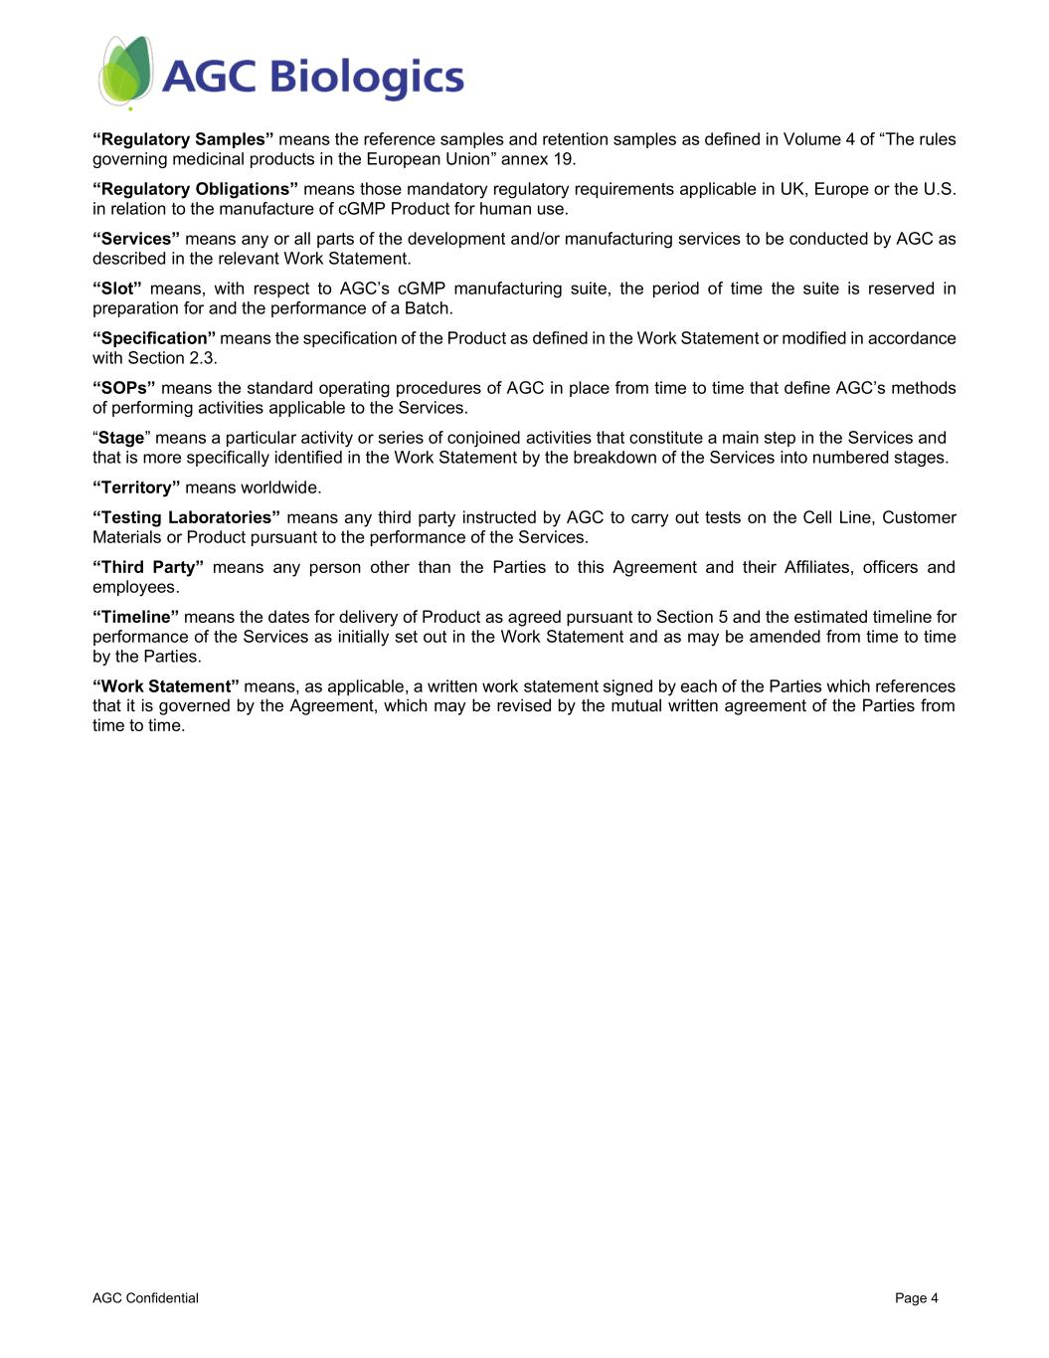
AGC Confidential Page 4 “Regulatory Samples” means the reference samples and retention samples as defined in Volume 4 of “The rules governing medicinal products in the European Union” annex 19. “Regulatory Obligations” means those mandatory regulatory requirements applicable in UK, Europe or the U.S. in relation to the manufacture of cGMP Product for human use. “Services” means any or all parts of the development and/or manufacturing services to be conducted by AGC as described in the relevant Work Statement. “Slot” means, with respect to AGC’s cGMP manufacturing suite, the period of time the suite is reserved in preparation for and the performance of a Batch. “Specification” means the specification of the Product as defined in the Work Statement or modified in accordance with Section 2.3. “SOPs” means the standard operating procedures of AGC in place from time to time that define AGC’s methods of performing activities applicable to the Services. “Stage” means a particular activity or series of conjoined activities that constitute a main step in the Services and that is more specifically identified in the Work Statement by the breakdown of the Services into numbered stages. “Territory” means worldwide. “Testing Laboratories” means any third party instructed by AGC to carry out tests on the Cell Line, Customer Materials or Product pursuant to the performance of the Services. “Third Party” means any person other than the Parties to this Agreement and their Affiliates, officers and employees. “Timeline” means the dates for delivery of Product as agreed pursuant to Section 5 and the estimated timeline for performance of the Services as initially set out in the Work Statement and as may be amended from time to time by the Parties. “Work Statement” means, as applicable, a written work statement signed by each of the Parties which references that it is governed by the Agreement, which may be revised by the mutual written agreement of the Parties from time to time.

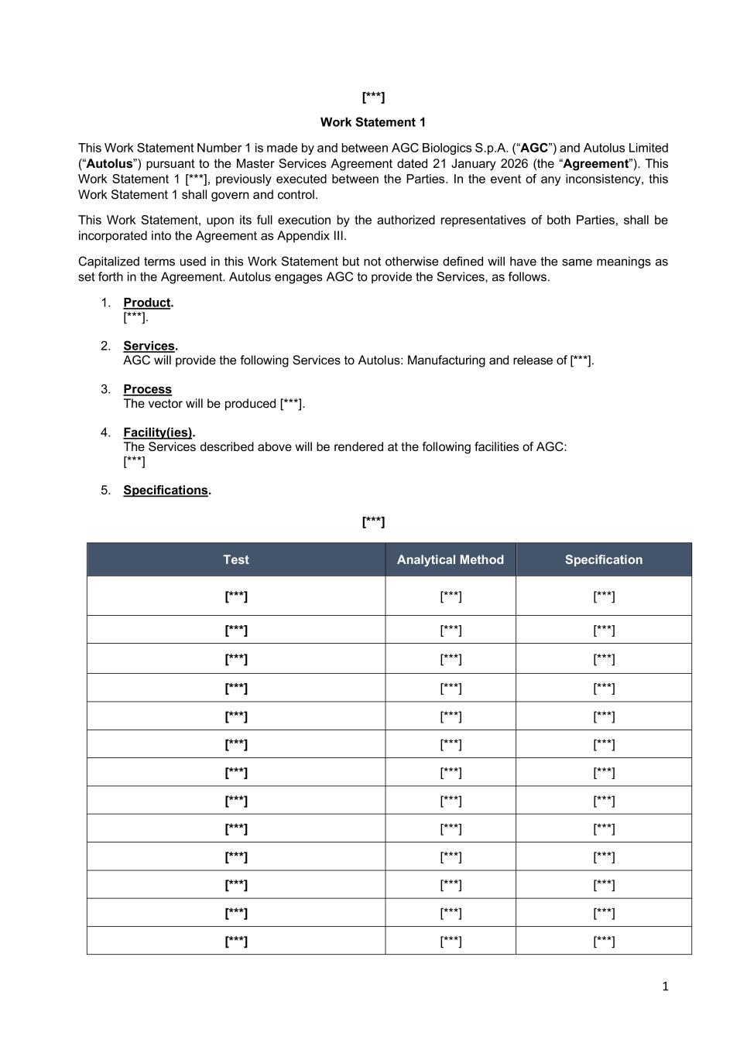
1 [***] Work Statement 1 This Work Statement Number 1 is made by and between AGC Biologics S.p.A. (“AGC”) and Autolus Limited (“Autolus”) pursuant to the Master Services Agreement dated 21 January 2026 (the “Agreement”). This Work Statement 1 [***], previously executed between the Parties. In the event of any inconsistency, this Work Statement 1 shall govern and control. This Work Statement, upon its full execution by the authorized representatives of both Parties, shall be incorporated into the Agreement as Appendix III. Capitalized terms used in this Work Statement but not otherwise defined will have the same meanings as set forth in the Agreement. Autolus engages AGC to provide the Services, as follows. 1. Product. [***]. 2. Services. AGC will provide the following Services to Autolus: Manufacturing and release of [***]. 3. Process The vector will be produced [***]. 4. Facility(ies). The Services described above will be rendered at the following facilities of AGC: [***] 5. Specifications. [***] Test Analytical Method Specification [***] [***] [***] [***] [***] [***] [***] [***] [***] [***] [***] [***] [***] [***] [***] [***] [***] [***] [***] [***] [***] [***] [***] [***] [***] [***] [***] [***] [***] [***] [***] [***] [***] [***] [***] [***] [***] [***] [***]

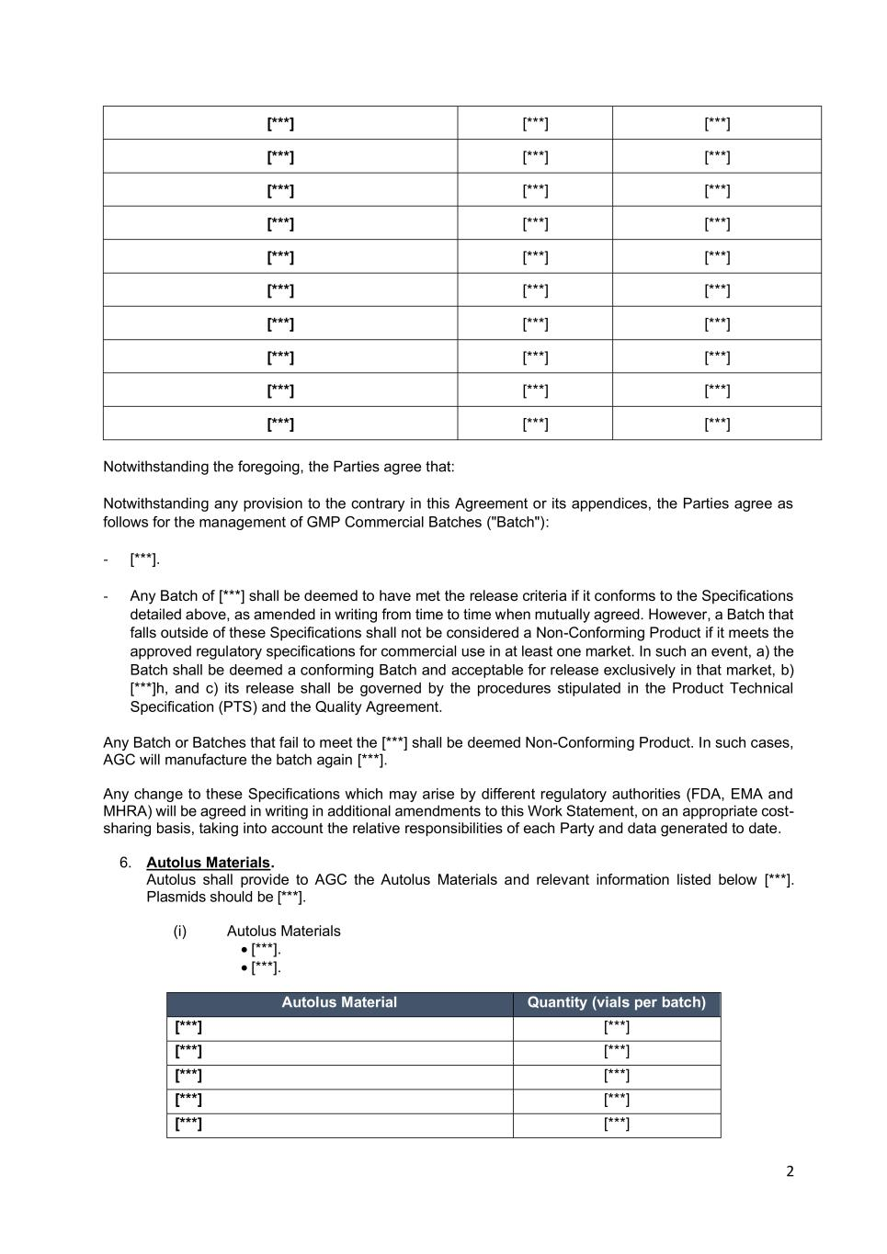
2 [***] [***] [***] [***] [***] [***] [***] [***] [***] [***] [***] [***] [***] [***] [***] [***] [***] [***] [***] [***] [***] [***] [***] [***] [***] [***] [***] [***] [***] [***] Notwithstanding the foregoing, the Parties agree that: Notwithstanding any provision to the contrary in this Agreement or its appendices, the Parties agree as follows for the management of GMP Commercial Batches ("Batch"): - [***]. - Any Batch of [***] shall be deemed to have met the release criteria if it conforms to the Specifications detailed above, as amended in writing from time to time when mutually agreed. However, a Batch that falls outside of these Specifications shall not be considered a Non-Conforming Product if it meets the approved regulatory specifications for commercial use in at least one market. In such an event, a) the Batch shall be deemed a conforming Batch and acceptable for release exclusively in that market, b) [***]h, and c) its release shall be governed by the procedures stipulated in the Product Technical Specification (PTS) and the Quality Agreement. Any Batch or Batches that fail to meet the [***] shall be deemed Non-Conforming Product. In such cases, AGC will manufacture the batch again [***]. Any change to these Specifications which may arise by different regulatory authorities (FDA, EMA and MHRA) will be agreed in writing in additional amendments to this Work Statement, on an appropriate cost- sharing basis, taking into account the relative responsibilities of each Party and data generated to date. 6. Autolus Materials. Autolus shall provide to AGC the Autolus Materials and relevant information listed below [***]. Plasmids should be [***]. (i) Autolus Materials • [***]. • [***]. Autolus Material Quantity (vials per batch) [***] [***] [***] [***] [***] [***] [***] [***] [***] [***]

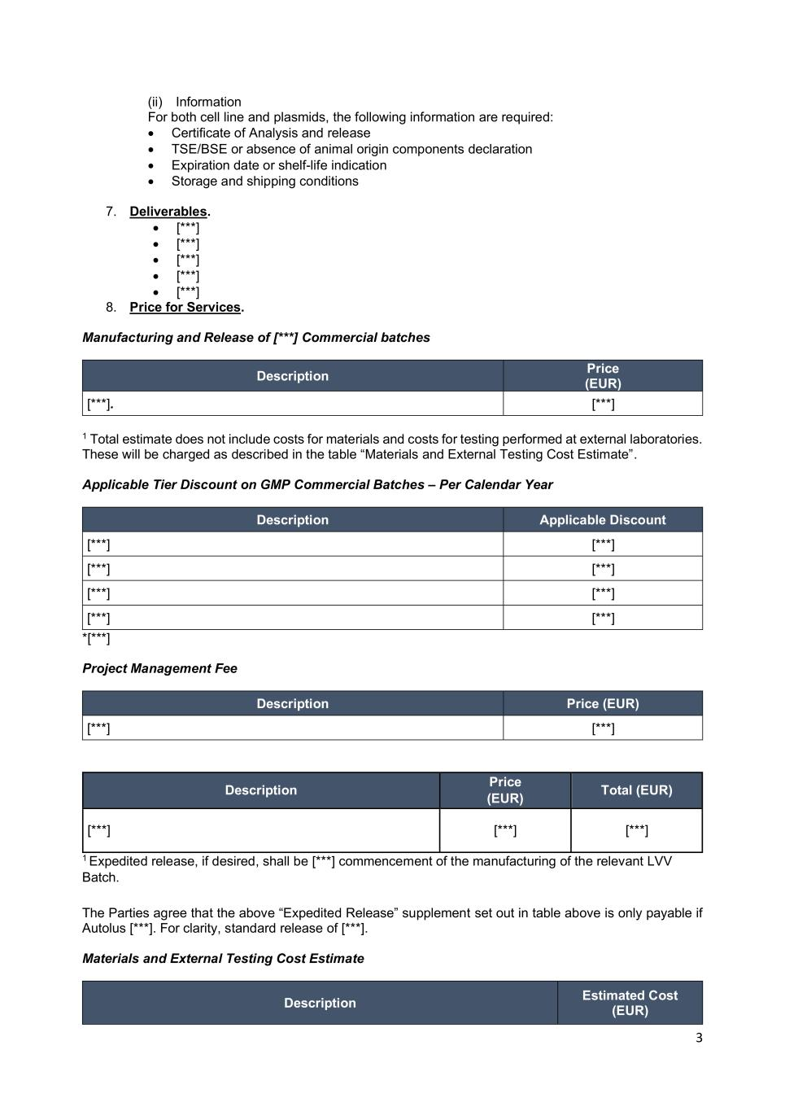
3 (ii) Information For both cell line and plasmids, the following information are required: • Certificate of Analysis and release • TSE/BSE or absence of animal origin components declaration • Expiration date or shelf-life indication • Storage and shipping conditions 7. Deliverables. • [***] • [***] • [***] • [***] • [***] 8. Price for Services. Manufacturing and Release of [***] Commercial batches Description Price (EUR) [***]. [***] 1 Total estimate does not include costs for materials and costs for testing performed at external laboratories. These will be charged as described in the table “Materials and External Testing Cost Estimate”. Applicable Tier Discount on GMP Commercial Batches – Per Calendar Year Description Applicable Discount [***] [***] [***] [***] [***] [***] [***] [***] *[***] Project Management Fee Description Price (EUR) [***] [***] Description Price (EUR) Total (EUR) [***] [***] [***] 1 Expedited release, if desired, shall be [***] commencement of the manufacturing of the relevant LVV Batch. The Parties agree that the above “Expedited Release” supplement set out in table above is only payable if Autolus [***]. For clarity, standard release of [***]. Materials and External Testing Cost Estimate Description Estimated Cost (EUR)

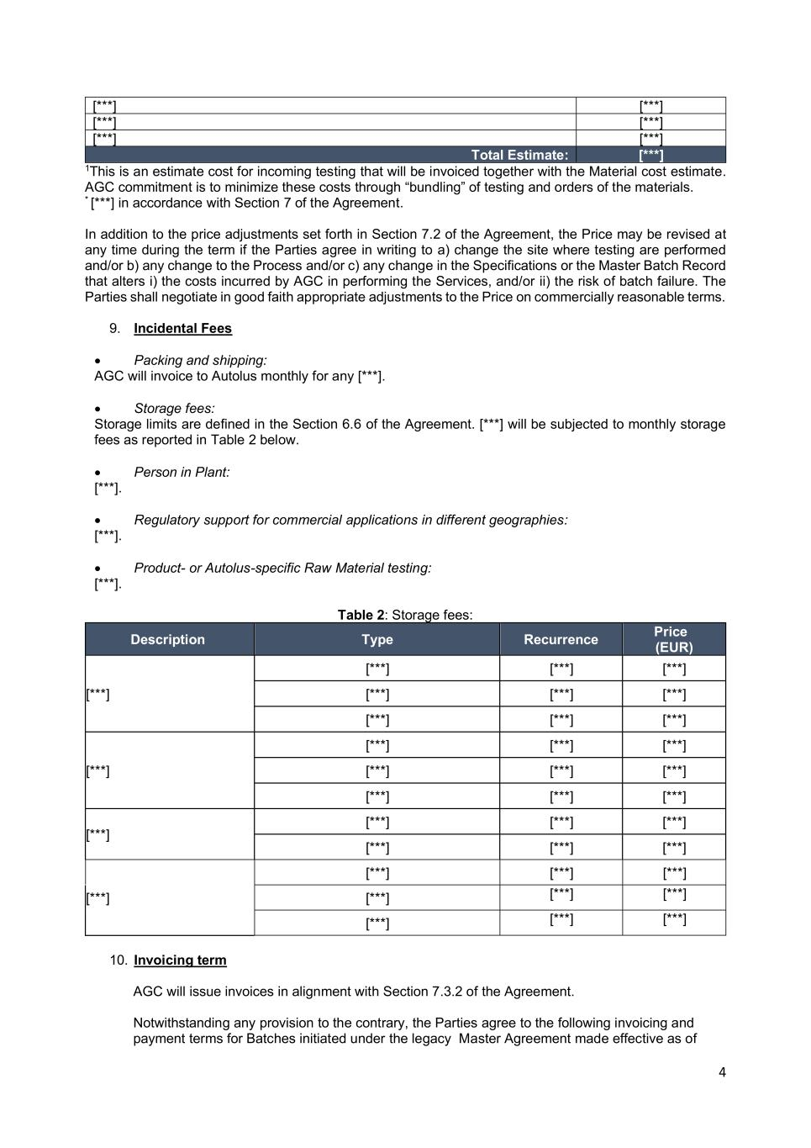
4 [***] [***] [***] [***] [***] [***] Total Estimate: [***] 1This is an estimate cost for incoming testing that will be invoiced together with the Material cost estimate. AGC commitment is to minimize these costs through “bundling” of testing and orders of the materials. * [***] in accordance with Section 7 of the Agreement. In addition to the price adjustments set forth in Section 7.2 of the Agreement, the Price may be revised at any time during the term if the Parties agree in writing to a) change the site where testing are performed and/or b) any change to the Process and/or c) any change in the Specifications or the Master Batch Record that alters i) the costs incurred by AGC in performing the Services, and/or ii) the risk of batch failure. The Parties shall negotiate in good faith appropriate adjustments to the Price on commercially reasonable terms. 9. Incidental Fees • Packing and shipping: AGC will invoice to Autolus monthly for any [***]. • Storage fees: Storage limits are defined in the Section 6.6 of the Agreement. [***] will be subjected to monthly storage fees as reported in Table 2 below. • Person in Plant: [***]. • Regulatory support for commercial applications in different geographies: [***]. • Product- or Autolus-specific Raw Material testing: [***]. Table 2: Storage fees: Description Type Recurrence Price (EUR) [***] [***] [***] [***] [***] [***] [***] [***] [***] [***] [***] [***] [***] [***] [***] [***] [***] [***] [***] [***] [***] [***] [***] [***] [***] [***] [***] [***] [***] [***] [***] [***] [***] [***] [***] [***] [***] 10. Invoicing term AGC will issue invoices in alignment with Section 7.3.2 of the Agreement. Notwithstanding any provision to the contrary, the Parties agree to the following invoicing and payment terms for Batches initiated under the legacy Master Agreement made effective as of

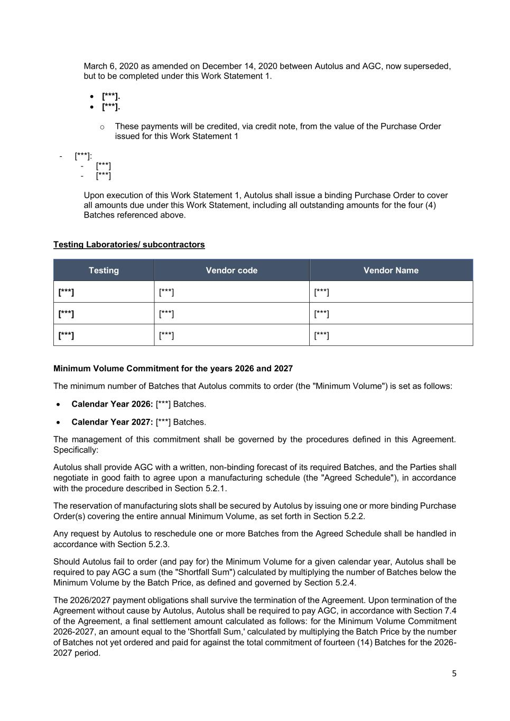
5 March 6, 2020 as amended on December 14, 2020 between Autolus and AGC, now superseded, but to be completed under this Work Statement 1. • [***]. • [***]. o These payments will be credited, via credit note, from the value of the Purchase Order issued for this Work Statement 1 - [***]: - [***] - [***] Upon execution of this Work Statement 1, Autolus shall issue a binding Purchase Order to cover all amounts due under this Work Statement, including all outstanding amounts for the four (4) Batches referenced above. Testing Laboratories/ subcontractors Testing Vendor code Vendor Name [***] [***] [***] [***] [***] [***] [***] [***] [***] Minimum Volume Commitment for the years 2026 and 2027 The minimum number of Batches that Autolus commits to order (the "Minimum Volume") is set as follows: • Calendar Year 2026: [***] Batches. • Calendar Year 2027: [***] Batches. The management of this commitment shall be governed by the procedures defined in this Agreement. Specifically: Autolus shall provide AGC with a written, non-binding forecast of its required Batches, and the Parties shall negotiate in good faith to agree upon a manufacturing schedule (the "Agreed Schedule"), in accordance with the procedure described in Section 5.2.1. The reservation of manufacturing slots shall be secured by Autolus by issuing one or more binding Purchase Order(s) covering the entire annual Minimum Volume, as set forth in Section 5.2.2. Any request by Autolus to reschedule one or more Batches from the Agreed Schedule shall be handled in accordance with Section 5.2.3. Should Autolus fail to order (and pay for) the Minimum Volume for a given calendar year, Autolus shall be required to pay AGC a sum (the "Shortfall Sum") calculated by multiplying the number of Batches below the Minimum Volume by the Batch Price, as defined and governed by Section 5.2.4. The 2026/2027 payment obligations shall survive the termination of the Agreement. Upon termination of the Agreement without cause by Autolus, Autolus shall be required to pay AGC, in accordance with Section 7.4 of the Agreement, a final settlement amount calculated as follows: for the Minimum Volume Commitment 2026-2027, an amount equal to the 'Shortfall Sum,' calculated by multiplying the Batch Price by the number of Batches not yet ordered and paid for against the total commitment of fourteen (14) Batches for the 2026- 2027 period.

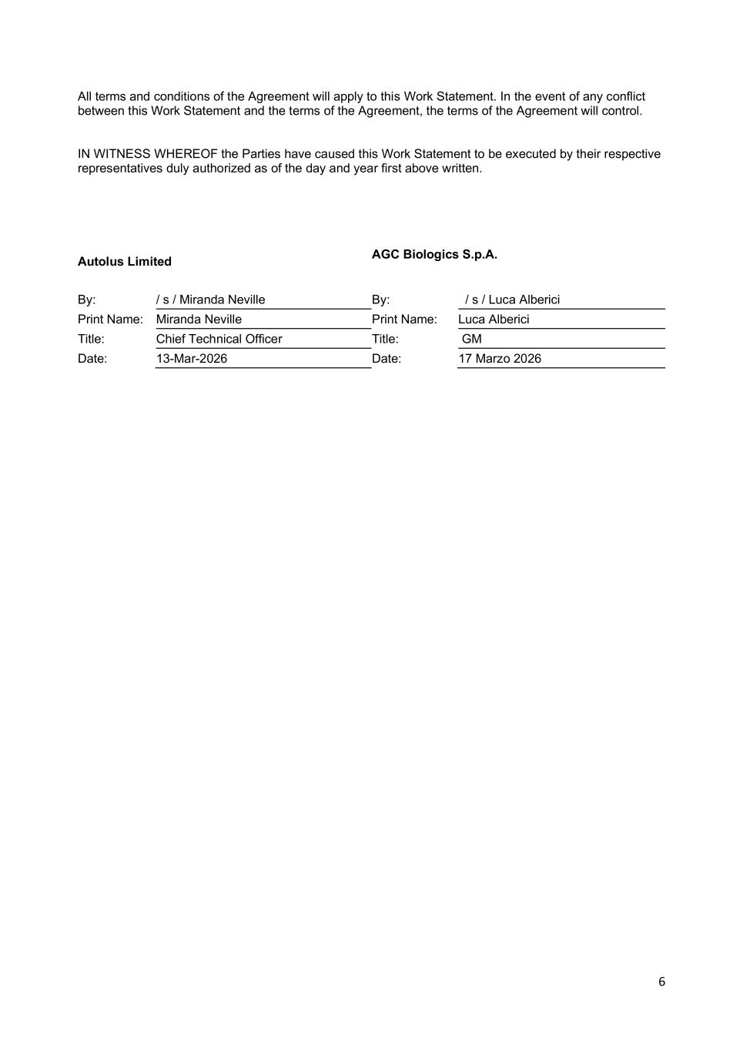
6 All terms and conditions of the Agreement will apply to this Work Statement. In the event of any conflict between this Work Statement and the terms of the Agreement, the terms of the Agreement will control. IN WITNESS WHEREOF the Parties have caused this Work Statement to be executed by their respective representatives duly authorized as of the day and year first above written. Autolus Limited AGC Biologics S.p.A. By: / s / Miranda Neville By: / s / Luca Alberici Print Name: Miranda Neville Print Name: Luca Alberici Title: Chief Technical Officer Title: GM Date: 13-Mar-2026 Date: 17 Marzo 2026

Exhibit 31.1
Certification by the Principal Executive Officer pursuant to
Securities Exchange Act Rules 13a-14(a) and 15d-14(a)
as adopted pursuant to Section 302 of the Sarbanes-Oxley Act of 2002

I, Christian Itin, certify that:
1. |  |  | I have reviewed this Quarterly Report on Form 10-Q of Autolus Therapeutics plc;
2. |  |  | Based on my knowledge, this report does not contain any untrue statement of a material fact or omit to state a material fact necessary to make the statements made, in light of the circumstances under which such statements were made, not misleading with respect to the period covered by this report;
3. |  |  | Based on my knowledge, the financial statements, and other financial information included in this report, fairly present in all material respects the financial condition, results of operations and cash flows of the registrant as of, and for, the periods presented in this report;
4. |  |  | The registrant’s other certifying officer and I are responsible for establishing and maintaining disclosure controls and procedures (as defined in Exchange Act Rules 13a-15(e) and 15d-15(e)) and internal control over financial reporting (as defined in Exchange Act Rules 13a-15(f) and 15d-15(f)) for the registrant and have:
 |  |  | (a) |  |  | Designed such disclosure controls and procedures, or caused such disclosure controls and procedures to be designed under our supervision, to ensure that material information relating to the registrant, including its consolidated subsidiaries, is made known to us by others within those entities, particularly during the period in which this report is being prepared;
 |  |  | (b) |  |  | Designed such internal control over financial reporting, or caused such internal control over financial reporting to be designed under our supervision, to provide reasonable assurance regarding the reliability of financial reporting and the preparation of financial statements for external purposes in accordance with generally accepted accounting principles;
 |  |  | (c) |  |  | Evaluated the effectiveness of the registrant’s disclosure controls and procedures and presented in this report our conclusions about the effectiveness of the disclosure controls and procedures, as of the end of the period covered by this report based on such evaluation; and
 |  |  | (d) |  |  | Disclosed in this report any change in the registrant’s internal control over financial reporting that occurred during the registrant’s most recent fiscal quarter (the registrant’s fourth fiscal quarter in the case of an annual report) that has materially affected, or is reasonably likely to materially affect, the registrant’s internal control over financial reporting; and
5. |  |  |  |  |  | The registrant’s other certifying officer and I have disclosed, based on our most recent evaluation of internal control over financial reporting, to the registrant’s auditors and the audit committee of the registrant’s board of directors (or persons performing the equivalent functions):
 |  |  | (a) |  |  | All significant deficiencies and material weaknesses in the design or operation of internal control over financial reporting which are reasonably likely to adversely affect the registrant’s ability to record, process, summarize and report financial information; and
 |  |  | (b) |  |  | Any fraud, whether or not material, that involves management or other employees who have a significant role in the registrant’s internal control over financial reporting.

Date: May 14, 2026 |  |  | /s/ Christian Itin, Ph.D.
 |  |  | Name: Christian Itin, Ph.D.
 |  |  | Title: Chief Executive Officer
 |  |  | (Principal Executive Officer)

Exhibit 31.2
Certification by the Principal Financial Officer pursuant to
Securities Exchange Act Rules 13a-14(a) and 15d-14(a)
as adopted pursuant to Section 302 of the Sarbanes-Oxley Act of 2002

I, Robert Dolski, certify that:
1. |  |  | I have reviewed this Quarterly Report on Form 10-Q of Autolus Therapeutics plc;
2. |  |  | Based on my knowledge, this report does not contain any untrue statement of a material fact or omit to state a material fact necessary to make the statements made, in light of the circumstances under which such statements were made, not misleading with respect to the period covered by this report;
3. |  |  | Based on my knowledge, the financial statements, and other financial information included in this report, fairly present in all material respects the financial condition, results of operations and cash flows of the registrant as of, and for, the periods presented in this report;
4. |  |  | The registrant’s other certifying officer and I are responsible for establishing and maintaining disclosure controls and procedures (as defined in Exchange Act Rules 13a-15(e) and 15d-15(e)) and internal control over financial reporting (as defined in Exchange Act Rules 13a-15(f) and 15d-15(f)) for the registrant and have:
 |  |  | (a) |  |  | Designed such disclosure controls and procedures, or caused such disclosure controls and procedures to be designed under our supervision, to ensure that material information relating to the registrant, including its consolidated subsidiaries, is made known to us by others within those entities, particularly during the period in which this report is being prepared;
 |  |  | (b) |  |  | Designed such internal control over financial reporting, or caused such internal control over financial reporting to be designed under our supervision, to provide reasonable assurance regarding the reliability of financial reporting and the preparation of financial statements for external purposes in accordance with generally accepted accounting principles;
 |  |  | (c) |  |  | Evaluated the effectiveness of the registrant’s disclosure controls and procedures and presented in this report our conclusions about the effectiveness of the disclosure controls and procedures, as of the end of the period covered by this report based on such evaluation; and
 |  |  | (d) |  |  | Disclosed in this report any change in the registrant’s internal control over financial reporting that occurred during the registrant’s most recent fiscal quarter (the registrant’s fourth fiscal quarter in the case of an annual report) that has materially affected, or is reasonably likely to materially affect, the registrant’s internal control over financial reporting; and
5. |  |  |  |  |  | The registrant’s other certifying officer and I have disclosed, based on our most recent evaluation of internal control over financial reporting, to the registrant’s auditors and the audit committee of the registrant’s board of directors (or persons performing the equivalent functions):
 |  |  | (a) |  |  | All significant deficiencies and material weaknesses in the design or operation of internal control over financial reporting which are reasonably likely to adversely affect the registrant’s ability to record, process, summarize and report financial information; and
 |  |  | (b) |  |  | Any fraud, whether or not material, that involves management or other employees who have a significant role in the registrant’s internal control over financial reporting.

Date: May 14, 2026 |  |  | /s/ Robert Dolski
 |  |  | Name: Robert Dolski
 |  |  | Title: Chief Financial Officer
 |  |  | (Principal Financial Officer)

Exhibit 32.1
Certification pursuant to
18 U.S.C. Section 1350, as adopted pursuant to
Section 906 of the Sarbanes-Oxley Act of 2002

Pursuant to the requirement set forth in Rule 13a-14(b) of the Securities Exchange Act of 1934, as amended, (the “Exchange Act”) and Section 1350 of Chapter 63 of Title 18 of the United States Code (18 U.S.C. §1350), Christian Itin, Chief Executive Officer of Autolus Therapeutics plc (the “Company”), and Robert Dolski, Chief Financial Officer of the Company, each hereby certifies that, to the best of his or her knowledge:
(1) |  |  | The Company’s Quarterly Report on Form 10-Q for the quarter ended March 31, 2026, to which this Certification is attached as Exhibit 32.1 (the “Periodic Report”) fully complies with the requirements of Section 13(a) or 15(d) of the Securities Exchange Act of 1934, as amended; and
(2) |  |  | The information contained in the Quarterly Report fairly presents, in all material respects, the financial condition and results of operations of the Company.

Date: May 14,2026

/s/ Christian Itin, Ph.D. |  |  |  |  |  | /s/ Robert Dolski
Name: Christian Itin, Ph.D. |  |  |  |  |  | Name: Robert Dolski
Title: Chief Executive Officer |  |  |  |  |  | Title: Chief Financial Officer
(Principal Executive Officer) |  |  |  |  |  | (Principal Financial Officer)

This certification accompanies the Form 10-Q to which it relates, is not deemed filed with the Securities and Exchange Commission and is not to be incorporated by reference into any filing of Autolus Therapeutics plc under the Securities Act of 1933, as amended, or the Securities Exchange Act of 1934, as amended (whether made before or after the date of the Form 10-Q), irrespective of any general incorporation language contained in such filing.

